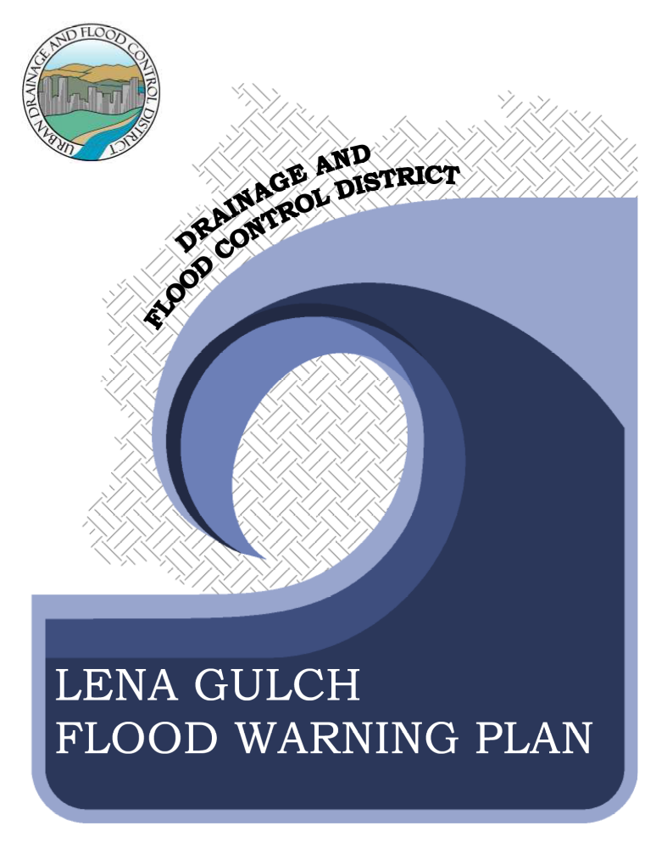
LENA GULCH FLOOD WARNING PLAN

TABLE OF CONTENTS
I. INTRODUCTION I-1
II. THE LENA GULCH DRAINAGE BASIN II-1
Drainage Basin Description II-1
Maple Grove Dam and Reservoir II-5
Flood History II-7
Flood Hydrology II-9
Flooding Extent (100-Year Floodplain) II-17
Warning Time II-18
III. DECISION AIDS III-1
General III-1
The Decision Making Process III-5
IV. REQUIRED ELEMENTS OF THE WARNING PLAN IV-1
Detection and Evaluation of the Flood Threat IV-1
Dissemination of Warnings, Watches and Advisories to the Public IV-3
Response of the Public to the Warning IV-5
V. COMMUNICATIONS V-1
Telephone Numbers and Radio Frequencies V-3
VI. METEOROLOGICAL SUPPORT VI-1
VII. FLOOD THREAT RECOGNITION AND WARNING PROCESS VII-1
Detection and Evaluation of the Flood Threat VII-1
Dissemination of the Warning VII-2
Step-By-Step Procedure VII-2
VIII. PROCEDURES AND GENERAL RESPONSIBILITIES VIII-1
National Weather Service and Private Meteorological Service VIII-1
Jefferson County Sheriff’s Office VIII-3
Jefferson County Emergency Management VIII-4
Jefferson County Development and Transportation VIII-4
Jefferson County Health and Environment VIII-4
Jefferson County Human Services VIII-4
Jefferson County R1 School District VIII-4
West Metro and Pleasant View Fire Districts VIII-5
Individual Weather Spotters VIII-5
General Administration & Logistics VIII-5
City of Lakewood VIII-6
City of Wheat Ridge VIII-7
City of Golden VIII-9
The Consolidated Mutual Water Company VIII-11
Multi-Agency Coordinating System (MACS) VIII-12
Flood Modes VIII-13
IX. PUBLIC DISSEMINATION IX-1
X. MEDIA CONTACTS X-1
XI. ANNUAL REVISIONS AND PRACTICES XI-1
LENA GULCH FLOOD WARNING PLAN

LIST OF FIGURES

Figure II-1 Lena Gulch Watershed II-4
Figure II-2 Modeled Reservoir Routing with Inflow/Outflow Comparison (Cotton, 2007) II-12
Figure II-3 Maple Grove Outflow 500-year event (Cotton 2007) II-13
Figure II-4 Discharge Profiles, Pleasant View to Maple Grove Reservoir (Boyle, 1993) II-14
Figure II-5 Discharge Profiles, Heritage Square to S. Golden Road (Boyle, 1993) II-15
Figure II-6 Discharge Profiles, Maple Grove Reservoir to Clear Creek (Cotton, 2007) II-16

Figure III-1 Upper Lena Gulch Floodplain Boundary and Flood Hazard Areas III-3
Figure III-2 Lower Lena Gulch Floodplain Boundary and Flood Hazard Areas III-4
Figure III-3 Lena Gulch Flood Detection Network III-6
Figure III-4 Lena Gulch Hydrologic Forecast Point Guidance III-8
Figure III-5 Typical ALERT Stream Gage Graphics III-16

Figure V-1 Internal Communications Flow Chart V-2

LIST OF TABLES

Table II-1 Maple Grove Reservoir, Stage vs. Volume/Surface Area (date: October 2007) II-5
Table II-2 Maple Grove Reservoir, Stage vs. Discharge II-6
Table II-3 Historic Flooding on Lena Gulch II-8
Table II-4 Precipitation Depths (inches) II-9
Table II-5 Design Rainfall Distribution (UDFCD, Vol 1, Ch 4, 18-05-07) II-10
Table II-6 Modeled Peak Flow (cfs) II-11
Table II-7 Description of 100-Year Flood Hazard II-17
Table II-8 Time Interval from Flood Producing Rainfall to Peak Runoff II-18

Table III-1 Lena Gulch Flood Detection Network III-7
Table III-2 Urban Flash Flood Guidance III-7
Table III-3 Convective Storm Characteristics (All depths in inches) III-7
Table III-4 Lena Gulch Hydrologic Forecast Point Guidance III-9

INTRODUCTION
A flash flood on Lena Gulch would result in significant damage, and possibly, the loss of life. A flooding event would affect the City of Wheat Ridge, the City of Golden, the City of Lakewood, Jefferson County, the Consolidated Mutual Water Company and the Urban Drainage and Flood Control District (District). Drainages such as Lena Gulch, which emanate in the higher elevation foothills and flow east into highly populated areas, are among the most dangerous in terms of the potential for loss-of-life from flash flooding in Colorado. This flood warning plan was prepared with this in mind.
The flood warning plan for the Lena Gulch drainage basin is supplemental to local emergency operation plans. As such, it provides a set of operational procedures to be carried out before and during a flood on Lena Gulch and its tributaries. The Lena Gulch drainage basin is located in Jefferson County, Golden, Lakewood and Wheat Ridge. Therefore, planning and emergency response must be multi-jurisdictional.
The Lena Gulch Flood Warning Plan is designed primarily to reduce the potential for loss of life resulting from flash floods on Lena Gulch. This plan has been prepared by Urban Drainage and Flood Control District (UDFCD), Wheat Ridge, Lakewood, Jefferson County and The Consolidated Mutual Water Company in cooperation with the National Weather Service (NWS). UDFCD acknowledges the valuable contributions of many individuals that assisted in preparing this plan.
Users of this plan should be aware of the area-wide meteorological support services provided through UDFCD's Flash Flood Prediction Program; the weather and flood forecast information available via the Internet, fax and email communications; and the real-time rainfall and stream level data from the automated flood detection network known as the ALERT System.
Plan holders should read the entire plan carefully to be aware of all of its elements. Users should also understand the following:

The local governments participating in this flood warning plan believe that the early flood detection system described herein is a key component of the complete flood warning system. They recognize, however, that the possibility of inadvertent error in design or failure of equipment to function may prevent the system from operating perfectly at all times. Therefore, nothing contained herein may be construed as a guarantee of the system or its operation, or create any liability on the part of any party or its directors, officers, employees or agents for any damage that may be alleged to result from either operating or failing to operate the detection system or any of its component parts.
NOTE: Similar language found in Agreement No. 82-02.03

THE LENA GULCH DRAINAGE BASIN
This section provides an overview of the watersheds and flood hazards associated with Lena Gulch including descriptions of the drainage basin, historic floods, flood hydrology and flooding extents. Much of the information in this section of the warning plan was excerpted from the following flood studies:
- Urban Drainage and Flood Control District, Flood Hazard Area Delineation, Lower Lena Gulch, prepared by George K. Cotton Consulting, Inc., October 2007.
- Urban Drainage and Flood Control District, Flood Hazard Area Delineation, Upper Lena Gulch, prepared by Boyle Engineering Corporation, January 1993.
- Urban Drainage and Flood Control District, Lena Gulch Master Drainage Plan, prepared by Wright-McLaughlin Engineers, June 1975.
- FEMA, Digital Flood Insurance Rate Map (FIRM) and Flood Insurance Study for Lena Gulch, June 2003.
- NOAA, National Climatic Data Center, Flood Event Record Details, Lena Gulch.

Drainage Basin Description
Lena Gulch is a tributary of Clear Creek with its confluence near 41st Avenue and Kipling Street in Wheat Ridge. The Lena Gulch drainage originates in Apex Gulch and Jackson Gulch on the southeast slopes of Lookout Mountain in Golden. From Lookout Mountain, the stream flows approximately 11 miles to its confluence with Clear Creek.
Lena Gulch drains 13.3 square miles at its confluence with Clear Creek (Figure II-1). The natural stream is rugged and steep in the foothills where Jackson Gulch and Apex Gulch join to form Lena Gulch. Channel slopes in the upper basin exceed 400 feet per mile. In the central portion of the basin, above Maple Grove Reservoir, slopes average 80 feet per mile (Boyle Engineering Corporation, January 1993).
The Lena Gulch main channel follows a northerly alignment, along U.S. Highway 40 from near the intersection with Interstate 70 (I-70), to a point downstream where it joins with Apex Gulch and crosses through a hogback. The channel continues downstream in an easterly direction, crossing several streets and mixed residential and commercial areas in Golden, until it empties into a rectangular concrete-lined channel upstream of 6th Avenue. The channel passes through a culvert under 6th Avenue. Downstream of 6th Avenue, the channel continues northeasterly through various residential and undeveloped properties in unincorporated Jefferson County and then crosses under South Golden Road. Below South Golden Road, the channel crosses open space in Camp George West and is joined by the Pleasant View and Green Mountain tributaries just upstream of the Denver West Office Park and I-70. The channel passes through box culverts under I-70 and into a series of ponds in the lower portion of the Denver West Office Park. Downstream of Denver West, the channel consists of various improved sections and meanders through residential areas and then under Youngfield Street into Lakewood. Downstream of Youngfield Street, the unimproved channel continues downstream through residential properties to an improved crossing under 20th Avenue and into Maple Grove Reservoir.
Substantial development has occurred in the floodplain upstream of Maple Grove Reservoir. In some locations, development has severely restricted the flood carrying capacity of the channel and floodplain. Newer, more recent, developments have been more cognizant of the need to address the flood hazard but developed areas exist which remain subject to significant hazard within the 100-year floodplain.
Maple Grove Reservoir, with a tributary area of 10.5 square miles, is a significant feature in the Lena Gulch basin. Improvements completed in 1977, on the dam and spillway, allow for safe passage of the Standard Project Flood (SPF) while allowing for the attenuation of incoming flood peaks up through the 100-year flood.
Flowing from the Maple Grove Dam spillway, Lena Gulch enters Portsmouth Park and flows to a drop structure at 29th Avenue. The main channel falls 29 feet from the dam spillway to 32nd Avenue, which gives an average channel gradient of 1.2 percent. The valley is narrow, steep and the channel is an improved boulder-lined rectangular section. The channel velocities are swift (10 to 13 ft/s) and flood stage will change quickly once the spillway is in operation.
The culvert at 32nd Avenue is sufficient to convey the 100-year flood in Lena Gulch. The valley is slightly wider below 32nd Avenue to Union Street but it is still narrow and steep. The main channel has an improved boulder-lined main channel very similar to the reach upstream of 32nd Avenue. The main channel falls over 14 feet from 32nd Avenue to Union Street, which gives an average channel gradient of 1.2 percent. Channel velocities are still high, in the range of 9 to 12 ft/s.
From Union Street to Simms Street, Lena Gulch enters the Lewis Meadows open space, where velocity slows and width of inundation significantly increases. The main channel is eroded, irregular and narrow. Channel velocities are high due to the lack of vegetation and bare earth banks. The channel capacity is decreased relative to the improved upper reaches. The main channel falls nearly 16 feet from Union to Simms Street, which gives an average gradient of 0.7 percent.
From Simms Street to Parfet Street, Lena Gulch passes through undeveloped land and open space. The main channel is eroded, irregular and narrow. Overbank areas are dry meadows used as pasture. Channel velocities are high and the average slope is 0.8 percent. There are three drop structures between Simms and Parfet Street: at Quail Street, 400 feet downstream, and at Quail Court. Below Quail Street, Lena Gulch is effectively channelized.
At Parfet Street, Lena Gulch transitions to a confined channel that is between two retaining walls. The channel varies between a rectangular section and a trapezoidal section. There are seven bridges, all with vertical abutments between Parfet and Kipling Street. The rectangular channel sections are a transition in and out of each bridge. The average channel gradient between Parfet Street and Kipling Street is 0.8 percent.
Downstream of Kipling Street to the Lena Gulch confluence with Clear Creek, the channel is improved and graded to provide a wetland. Upstream of 41st Avenue there is a drop structure. From Kipling Street to this drop there is less than one foot of fall in the channel and the channel gradient is less than 0.1 percent. Below the drop structure, Lena Gulch enters a constructed wetland that is flat. The drop structure separates Lena Gulch from the backwater of the Clear Creek except for during the largest floods.
Land use in the basin is largely low density residential (80%), parks and open space (9%), commercial (5%), medium density residential (4%), and schools (2%). The lower portion of the basin (east of Parfet Street) is higher density. Between Maple Grove Reservoir and Parfet Street, the land use is entirely low density residential and parks and open space. From Parfet Street to the Clear Creek confluence, the land use consists of medium density residential and commercial.
Since completion of the Master Planning study for Lena Gulch in 1975, significant improvements have been made in the stream corridor. The channel was improved from the Clear Creek confluence to Parfet Street and from Maple Grove Reservoir to Union Street. UDFCD and the City of Wheat Ridge have also performed a number of maintenance projects to address local channel erosion problems in the basin.
Figure II-1 Lena Gulch Watershed

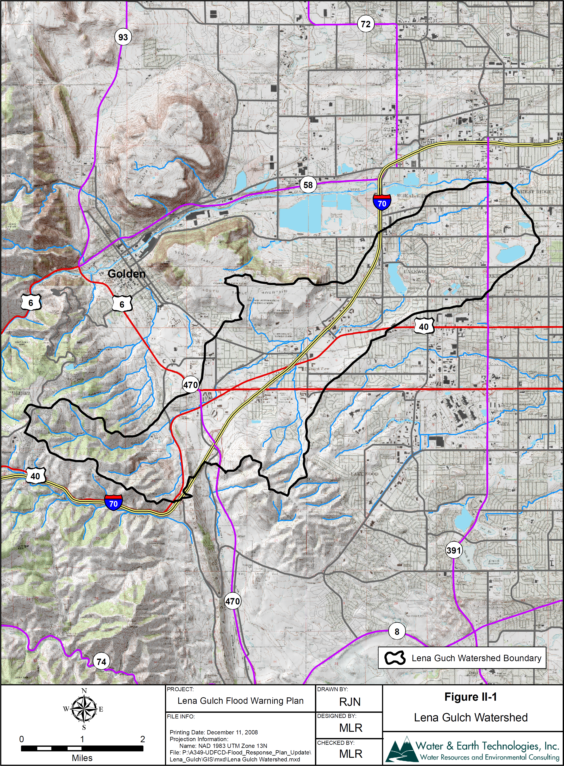

Maple Grove Dam and Reservoir
All of the information in this section was excerpted from the Flood Hazard Area Delineation for Lower Lena Gulch, prepared by George K. Cotton Consulting, Inc., October 2007.
During flood events, inflow to Maple Grove Reservoir is temporarily stored in the reservoir as flow overtops the gates on the dam spillway. This routing of flood flows through the reservoir significantly reduces the peak flow to the lower reach of Lena Gulch. The release from the reservoir combines with runoff from the lower basin, which results in the lower basin flood hydrology.
Maple Grove Reservoir provides water conservation storage for the Consolidated Mutual Water Company (CMWC). An additional 252.6 acre-feet of reservoir storage is available above the conservation pool for flood inflows. Two steel crest gates control the flood stage in the reservoir. Gate #1 is a 10-foot high by 40-foot long gate and gate #2 is a 6-foot high by 30-foot long gate. These gates rest on the crest of the dam and remain up until a high water level of 11.0 feet is reached above the spillway. When the water in the reservoir reaches the high water level, the gates automatically drop. The reservoir discharge and storage as a function of water surface elevation are summarized below.
Table II-1 Maple Grove Reservoir, Stage vs. Volume/Surface Area (date: October 2007)

Reservoir Level  (CMWC datum) | Volume  (acre-ft) | Surface Area  (acres) | Comments
5520.00 | 826.90 | 47.5 | Dam spillway
5521.00 | 874.65 | 47.9
5522.00 | 922.97 | 48.2
5523.00 | 971.94 | 48.7
5524.00 | 1021.57 | 49.1
5525.00 | 1071.86 | 49.5 | Top of conservation pool
5526.00 | 1122.70 | 49.9 | Top of crest gate No. 2
5527.00 | 1163.21 | 50.3
5528.00 | 1216.29 | 50.7
5529.00 | 1271.10 | 51.1
5530.00 | 1322.90 | 51.5 | Top of crest gate No. 1
5531.00 | 1375.30 | 51.9
5532.00 | 1427.41 | 52.3

Table II-2 Maple Grove Reservoir, Stage vs. Discharge

Reservoir Level (CMWC datum) | Depth (ft) | Discharge (cfs)
Reservoir Level (CMWC datum) | Depth (ft) | Gate No. 1 | Gate No. 2 | Total
5526.0 | 6.0 | 0 | 0 | 0
5526.5 | 6.5 | 0 | 37 | 37
5527.0 | 7.0 | 0 | 104 | 104
5527.5 | 7.5 | 0 | 190 | 190
5528.0 | 8.0 | 0 | 293 | 293
5528.5 | 8.5 | 0 | 409 | 409
5529.0 | 9.0 | 0 | 538 | 538
5529.5 | 9.5 | 0 | 678 | 678
5530.0 | 10.0 | 0 | 828 | 828
5530.5 | 10.5 | 49 | 988 | 1,037
5531.0 | 11.0 | 138 | 1,157 | 1,295
5531.5 | 11.5 | 254 | 1,335 | 1,589
5532.0 | 12.0 | 390 | 1,521 | 1,911
5532.5 | 12.5 | 545 | 1,715 | 2,261

Normal automatic control of the crest gates is as follows (see note on CMWC vertical datum):
- Elevation 5520.0 (CMWC datum) is the reservoir spillway elevation. Reservoir volume is 826.9 acre-feet.
- Elevation 5526.0 (CMWC datum) is the maximum conservation-pool elevation for Maple Grove Reservoir. Reservoir volume is 1122.7 acre-feet.
- Elevation 5526.0 to 5530.0 (CMWC datum) flood release is made from Gate #2. Reservoir volume is 1322.9 acre-feet.
- Elevation 5530.0 to 5531.0 (CMWC datum) flood release is made from both Gate #2 and Gate #1. Reservoir volume is 1375.3 acre-feet.
- Elevation 5531.0 (CMWC datum) is the high water elevation. Both crest gates will automatically begin to drop to elevation 5520.0 (CMWC datum).

Stored flood volume from the spillway to the high water elevation is 548.4 acre-feet. According to CMWC it takes approximately 45 minutes for the crest gates to automatically lower. In the analysis of the 500-year flood, the gates were assumed to fall at the rate of 1 foot every 5 minutes.
[Note on CMWC vertical datum. The storage and rating curves for the reservoir are in a local datum used by CMWC. According to CMWC, the local datum is approximately the old Lakewood datum + 0.5 feet. This project provides a new monument on the dam, which is approximately 2.1 feet higher than the CMWC datum. By comparison, the vertical datum conversion from NGVD 29 to NAVD 88 at the dam crest is 3.2 feet (i.e. NAVD 88 = NGVD 29 + 3.2).]

Flood History
Historically, little information is available on the frequency or severity of flooding in the Lena Gulch basin. Development within the basin began in the 1940s, so little flood history is available in the archives for the early part of the 20th century.
1973, May. A flood of less than a 10-year frequency resulted in flooding below Maple Grove Reservoir through Wheat Ridge.
1977. An inflatable Fabridam was installed at Maple Grove Reservoir. At the time, Maple Grove Reservoir had the only inflatable dam located at a high risk facility.
1979, March 17. Approximately 1,500 residents were evacuated from their homes when heavy rains filled Maple Grove Reservoir to capacity and the inflatable dam failed. Vandals had slashed the dam, which contributed to its failure.
1980, May 5. A flood caused numerous damage in the basin, especially in the reaches above Maple Grove Reservoir. The estimate flow for the event was approximately 430 cfs, a little more than half of the 2-year flood.
1987, June 8. Flooding occurred which reportedly had water overtopping 20th Avenue by 3 to 4 feet and had water overtopping the dam crests of the Denver West ponds by 1 to 2 feet. The estimated flow for this event was about 600 cfs measured at Alkire Street, which is slightly less than the 2-year flood.
1991, June 1. Heavy rains fell across the Colorado Front Range and the metro area. Up to 4 inches of rain fell in Boulder and Jefferson County, with peak rainfall rates near 2-inches per hour. Lena Gulch at Isabell Street was overtopped, blocking access into and out of the nearby residential subdivision. Officials evacuated the Pleasant View Mobile Home Park at 15100 Mount Vernon Road at 5:00 pm due to heavy flooding in Lena Gulch.
1991, July 12. The NWS issued an urban and small stream flood advisory for Jefferson County and Golden including Lena Gulch. Ten vehicles were in waist-high water at 5:00 pm and passengers had to be evacuated by the Golden Police Department. The NWS radar estimated more than 2 inches fell in Golden.
1994, August 10. Strong thunderstorms moved through the Denver area and all along the Front Range in the late evening. High water stranded automobiles in low water crossings and power was lost to 20,000 Denver-area customers. The NWS issued an urban and small stream flood advisory for all of the metro area from 10:00 pm to midnight. The heavy rain caused flooding of Lena Gulch at the corner of Mount Vernon Road and Ulysses Street in northern Jefferson County.
1997, July 27. Heavy rain caused Lena Gulch to surge 2 feet over its banks. The fire department had to rescue one man when his van stalled in high water. Lena Gulch overflowed into the Pleasant View Mobile Home Park causing the evacuation of many residents. Most of the 43 mobile homes in the Pleasant View Mobile Home Park were constructed in 1970s. They are wedged between I-70 and Camp George West, a facility for juvenile offenders. Many of the mobile homes back onto Lena Gulch and are at risk from flash flooding. Two people lost their lives in Wheat Ridge after they were ejected from their automobile when it hydroplaned on I-70 near Kipling Street at 6:20 pm.
1998, August 10. Heavy rain caused flooding and flash flooding in Lakewood. One observer in Lakewood recorded 3.26 inches of rainfall in one hour. Several streets were flooded in central Lakewood and a trailer park along Lena Gulch was evacuated.
1999, August 4. County-wide flooding and flash flooding developed from a slow moving thunderstorm that dumped from 2.0 to 3.5 inches of rain in a 3 hour period.
2004, June 8. Heavy rain and large hail caused flooding and flash flooding across northeast Jefferson County. In Golden, heavy rains triggered a small mudslide on U.S. Highway 6, near the intersection of Colorado Highway 119. Automated gages in the area registered 2 to 3 inches of rain in one hour. Near the Colorado Mills Mall, numerous intersections were inundated from 1 to 3 feet of water and hail, stranding several vehicles, including a fire engine. Approximately 30 basements were flooded in Golden and Lakewood and many auto and home windows were broken by large hail.
The Maple Grove ALERT station (ID 1003), located at the dam, attained its record high water measurement during this event. It recorded an elevation of 5428.24 feet (Lakewood Datum), which is 2.2 feet above the elevation of the lower crest gate. Given the configuration of the gates at that time, it is estimated that the corresponding release was approximately 310 cfs (George K. Cotton Consulting, Inc., October 2007).
2004, June 27. A deluge of very heavy rain from nearly stationary thunderstorms caused flooding and flash flooding problems over parts of Douglas and Jefferson County. In Jefferson County, an automated rain gauge in Golden measure 3.6 inches of rain in one hour. Numerous homes were flooded in Golden. In addition, State Highway 93 had to be closed from the Pine Ridge subdivision to Golden Gate Canyon Road. At the height of the storm, about 4 feet of water covered Colorado 93 through Golden, forcing its temporary closure. Rock and mudslides were reported in Golden Gate Canyon. Several intersections were flooded and impassable. At the Deer Creek Golf Course, at Colorado 470 and Kipling, the greens were completely inundated by floodwaters. Some backyards near the golf course were partially washed out.
Table II-3 Historic Flooding on Lena Gulch

Date | Discharge (cfs) | Location of Discharge Estimate
May 1973 | 190* | Below Maple Grove Reservoir
March 17, 1979 | Unknown | Dam failure
May 5, 1980 | 430* | Above Maple Grove Reservoir
June 8, 1987 | 600* | At Alkire Street
June 1, 1991 | Unknown
July 12, 1991 | Unknown
August 10, 1994 | Unknown
July 27, 1997 | Unknown
August 10, 1998 | Unknown
August 4, 1999 | Unknown
June 8, 2004 | 310** | Maple Grove Outflow
June 27, 2004 | Unknown
*-FHAD, Upper Lena Gulch, Boyle, 1993.
**-FHAD, Lower Lena Gulch, Cotton, 2007.

Flood Hydrology
The UDFCD has authorized three major hydrologic studies on Lena Gulch: 1). Lena Gulch Master Drainage Plan, by Wright-McLaughlin Engineers, June 1975, 2). Flood Hazard Area Delineation, Lena Gulch (Lower), by George K. Cotton Consulting, October 2007, and 3). Flood Hazard Area Delineation, Upper Lena Gulch, by Boyle Engineering Corporation, January 1993. The purpose of these studies was to prepare and update flood hazard data for Lena Gulch, to produce new floodplain delineations and profiles for the 100-year event, to produce new profile information for the 10-year event and to define floodways for the stream.
The two most recent studies have developed new hydrology for the watershed considering future conditions for the upper basin and existing conditions for the lower basin. The lower basin is fully developed so there is no future development scenario. Floodways were computed assuming both 0.5 foot and 1.0 foot rise criteria, which are consistent with both FEMA and local jurisdiction regulations. The Colorado Water Conservation Board has designated and approved both studies. Stakeholders adopted the new floodplain resolution, which was sent to FEMA.
The recent hydrologic analyses for Lena Gulch were conducted in accordance with the procedures outlined in the UDFCD’s Urban Storm Drainage Criteria Manual. These analyses update previous studies performed as part of the Lena Gulch Drainage Master Plan, June 1975.
Runoff hydrographs were generated for the 10-, 50-, 100- and 500-year frequency floods using the Colorado Urban Hydrograph Procedure. Rainfall depths for both the upper and lower basin hydrology studies were obtained from the City of Wheat Ridge development manual (version 4/06).
Point rainfall depths for the 1-hour duration are shown (Table II-4), along with the temporal distribution of rainfall (Table II-5), used in the hydrology studies.
Table II-4 Precipitation Depths (inches)

 | Frequency
Depth | 2-year | 5-year | 10-year | 25-year | 50-year | 100-year | 500-year
1-hour | 1.04 | 1.44 | 1.72 | 2.07 | 2.35 | 2.60 | 3.24

Table II-5 Design Rainfall Distribution (UDFCD, Vol 1, Ch 4, 18-05-07)

Time  (min) | Percent of 1-hr point rainfall depth
Time  (min) | 2-year | 5-year | 10-year | 25-year | 50-year | 100-year | 500-year
5 | 2.0 | 2.0 | 2.0 | 1.3 | 1.3 | 1.0 | 1.0
10 | 4.0 | 3.7 | 3.7 | 3.5 | 3.5 | 3.0 | 3.0
15 | 8.4 | 8.7 | 8.2 | 5.0 | 5.0 | 4.6 | 4.6
20 | 16.0 | 15.3 | 15.0 | 8.0 | 8.0 | 8.0 | 8.0
25 | 2.5 | 25.0 | 25.0 | 15.0 | 15.0 | 14.0 | 14.0
30 | 14.0 | 13.0 | 12.0 | 25.0 | 25.0 | 25.0 | 25.0
35 | 6.3 | 5.8 | 5.6 | 12.0 | 12.0 | 14.0 | 14.0
40 | 5.0 | 4.4 | 4.3 | 8.0 | 8.0 | 8.0 | 8.0
45 | 3.0 | 3.6 | 3.8 | 5.0 | 5.0 | 6.2 | 6.2
50 | 3.0 | 3.6 | 3.2 | 5.0 | 5.0 | 5.0 | 5.0
55 | 3.0 | 3.0 | 3.2 | 3.2 | 3.2 | 4.0 | 4.0
60 | 3.0 | 3.0 | 3.2 | 3.2 | 3.2 | 4.0 | 4.0
65 | 3.0 | 3.0 | 3.2 | 3.21 | 3.21 | 4.0 | 4.0
70 | 2.0 | 3.0 | 3.2 | 2.4 | 2.4 | 2.0 | 2.0
75 | 2.0 | 2.5 | 3.2 | 2.4 | 2.4 | 2.0 | 2.0
80 | 2.0 | 2.5 | 2.5 | 1.8 | 1.8 | 1.2 | 1.2
85 | 2.0 | 2.2 | 1.9 | 1.8 | 1.8 | 1.2 | 1.2
90 | 2.0 | 2.2 | 1.9 | 1.4 | 1.4 | 1.2 | 1.2
95 | 2.0 | 2.2 | 1.9 | 1.4 | 1.4 | 1.2 | 1.2
100 | 2.0 | 1.5 | 1.9 | 1.4 | 1.4 | 1.2 | 1.2
105 | 2.0 | 1.5 | 1.9 | 1.4 | 1.4 | 1.2 | 1.2
110 | 2.0 | 1.5 | 1.9 | 1.4 | 1.4 | 1.2 | 1.2
115 | 1.0 | 1.5 | 1.7 | 1.4 | 1.4 | 1.2 | 1.2
120 | 1.0 | 1.3 | 1.3 | 1.4 | 1.4 | 1.2 | 1.2

The 100-year design storm rainfall totaled 2.6 inches over a 2-hour period with the majority falling in the first hour. While flash flood rainfall can have greater intensities than the maximum of 2.6 inches per hour, it was felt that this rainfall is reasonable as input to a hydrology model used to estimate lead times. The Flood Hazard Area Delineation reports projected the runoff associated with the design rainfall for several frequency events for key points along the stream channel.
Table II-6 Modeled Peak Flow (cfs)

Location | 10-year | 50-year | 100-year | 500-year
Lena Gulch at Hogback* | 510 | 1,320 | 1,770 | 3,900
Lena Gulch at 6th Avenue* | 800 | 1,740 | 2,270 | 4,500
Lena Gulch at I-70* | 1,440 | 3,920 | 3,810 | 7,700
Inflow to Maple Grove Reservoir* | 1,580 | 3,080 | 3,980 | 7,800
Outflow from Maple Grove Reservoir** | 190 | 970 | 1,920 | 7,560
Lena Gulch at 32nd Street** | 220 | 980 | 1,920 | 7,570
Lena Gulch at Union Avenue** | 280 | 980 | 1,930 | 7,560
Lena Gulch at Brookside Ditch** | 315 | 980 | 1,930 | 7,550
Lena Gulch at Simms Street** | 350 | 980 | 1,930 | 7,540
Lena Gulch at Quail Hollow** | 850 | 1,530 | 1,940 | 7,540
Lena Gulch at Quail Street** | 1,020 | 1,860 | 2,190 | 7,540
Lena Gulch at Parfet Street** | 1,010 | 1,840 | 2,180 | 7,520
Lena Gulch at Nelson Street** | 1,025 | 1,870 | 2,210 | 7,520
Lena Gulch at Miller Culvert** | 1,040 | 1,900 | 2,240 | 7,520
Lena Gulch at 38th Street** | 1,080 | 1,980 | 2,340 | 7,520
Lena Gulch at Recreation Center** | 1,280 | 2,340 | 2,770 | 7,540
Lena Gulch at Kipling Street** | 1,370 | 2,550 | 3,040 | 7,690
Lena Gulch at Outfall** | 1,370 | 2,550 | 3,040 | 7,690
*-FHAD, Upper Lena Gulch, Boyle, 1993.
**-FHAD, Lower Lena Gulch, Cotton, 2007.

Maple Grove reservoir attenuates the inflow hydrograph as it moves through the reservoir (Figure II-2). The 1975 master planning study showed that reservoir routing attenuated the 100-year flood peak from about 3,800 cfs to 1,500 cfs. However, this attenuation was not reproduced in the current hydrology studies given information on reservoir storage and the current gate discharge rating. Given the current reservoir storage, gate configuration and gate operations, the outflow for the 1975 study is approximately 1,730 cfs. Routing of the current reservoir inflow hydrograph shows a peak outflow of 1,920 cfs.
Figure II-2 Modeled Reservoir Routing with Inflow/Outflow Comparison (Cotton, 2007)

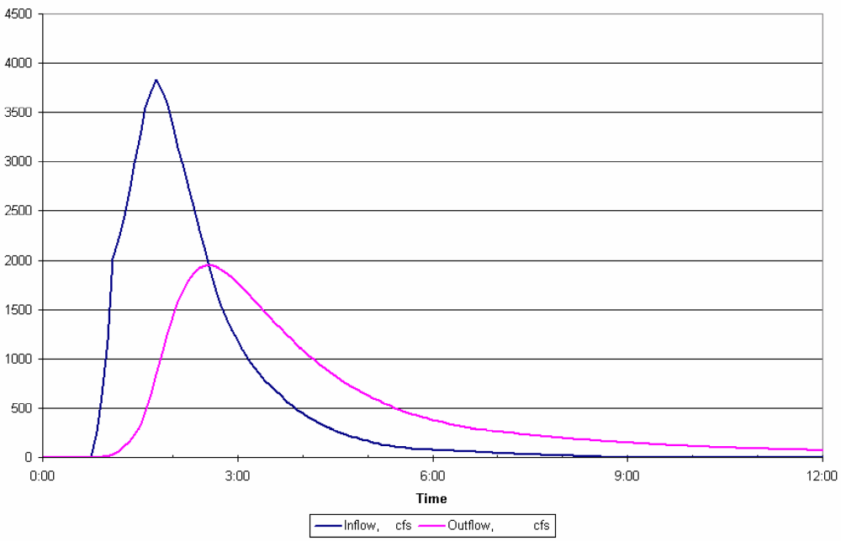

Releases from Maple Grove reservoir dominate the stream flow until approaching Quail Street where several of the larger lower basin tributaries reach the main channel. For larger floods (the 100-year), the Maple Grove release dominates the stream flow until near Kipling Street. Flood peak flows along the lower reach of Lena Gulch are similar to those calculated in the 1975 study. For example, the 100-year discharge at the Lena Gulch outfall to Clear Creek reported in the 1975 study is 2,800 cfs, which compares to 3,000 cfs estimated by the current study.
Amplification of the 500-year flood results by the lowering of the Maple Grove crest gates as required by flood operations for the dam. A release of both floodwater and a portion of the reservoir conservation pool occurs during the 500-year event. The rapid rate at which the crest gate drops is also a factor in the large rate of release and adds to the reservoir inflow to produce a large 500-year release to lower Lena Gulch (Figure II-3).

Figure II-3 Maple Grove Outflow 500-year event (Cotton 2007)

The following figure (Figure II-4) presents the peak discharge profile along the main channel of Lena Gulch for various design floods with differing return frequencies.
Figure II-4 Discharge Profiles, Pleasant View to Maple Grove Reservoir (Boyle, 1993)

Figure II-5 Discharge Profiles, Heritage Square to S. Golden Road (Boyle, 1993)

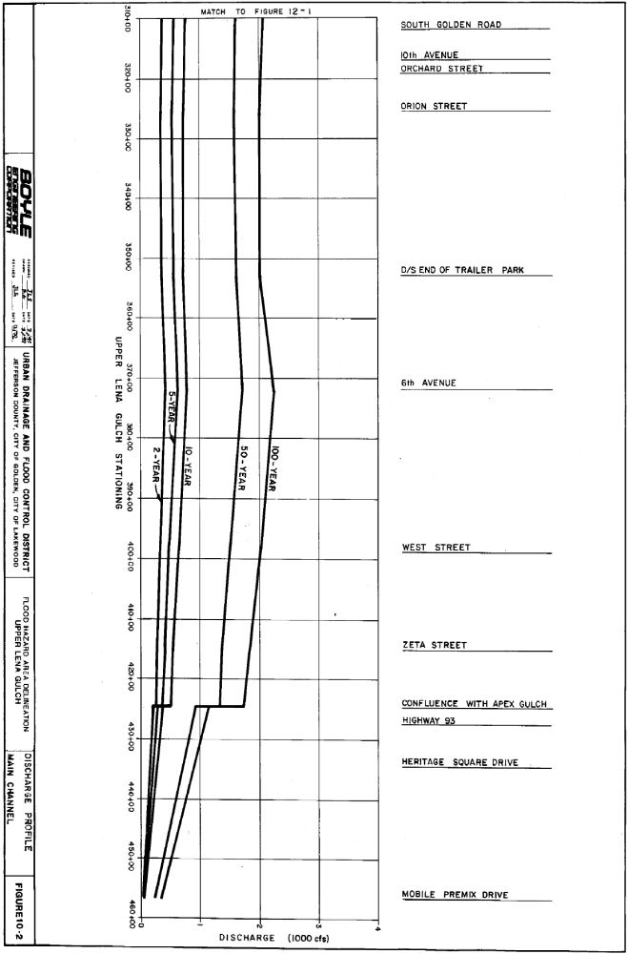
Figure II-6 Discharge Profiles, Maple Grove Reservoir to Clear Creek (Cotton, 2007)
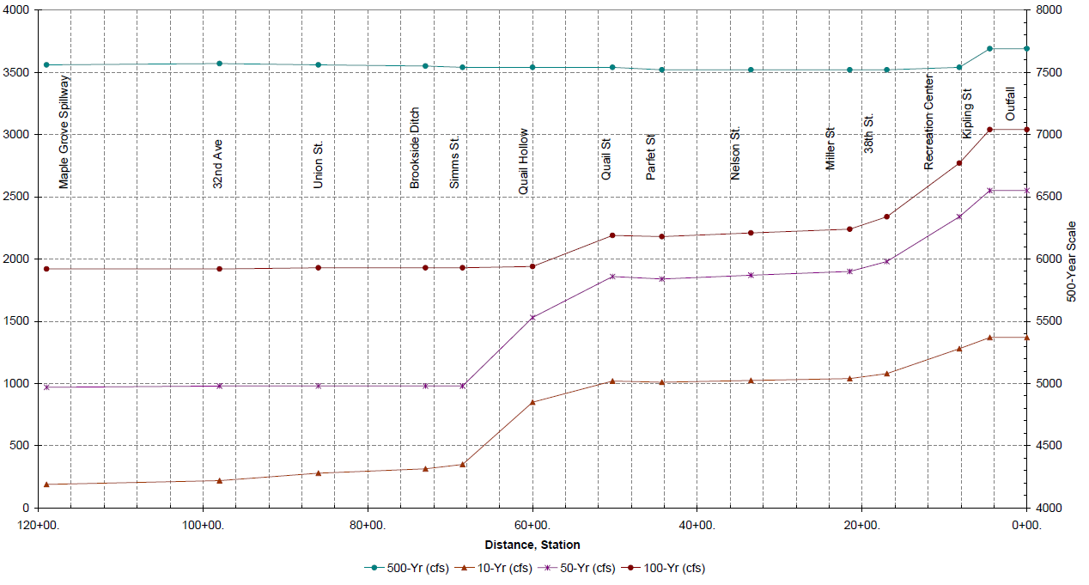

Flooding Extent (100-Year Floodplain)
A number of residential and commercial structures are located within the floodplain of Lena Gulch. Due to split flow conditions, some areas along Lena Gulch may become isolated by surrounding floodwaters. A large flood would cut off access in and out of some areas. This would exacerbate problems and affect the use and movement of emergency vehicles and equipment. The following locations are at risk during a flooding event (Table II-7).
Table II-7 Description of 100-Year Flood Hazard
Location | Comments
Heritage Square development (Apex Gulch) and Highway 93 | The Heritage Square development will experience sheet flow up to 1 foot in depth. Water will overtop Highway 93.
Upstream of the intersection between U.S. Highway 40 and State Highway 93 | The floodplain is narrow. Channel slopes and flow velocities are high. No structures located in the floodplain. Some road damage will occur due to overtopping.
Mobile Premix driveway | Water will overtop the driveway.
Zeta Street | Water will overtop the roadway. One residential property located in floodplain upstream of Zeta Street.
East Tincup Village Campground along U.S. Hwy 40  (at risk in a 10-year event) | Inundation of campground will occur due to an undersized 5’x8’ concrete box culvert downstream of Zeta Drive.
U.S. Highway 40 | Overtopping of Hwy 40 to the south will cause flooding at the Amoco Gas Station.
Violet Street | Two residential/commercial structures upstream of Violet Street have encroached into the floodplain and are at risk.
Mountain Side Mobile Estates | High damage potential exists in this reach due to heavy encroachment of the floodplain by the mobile home park and inadequate channel capacity. The floodplain covers most of the mobile home park.
Orion Street | Water will overtop the roadway for a length of 600 feet. Several residential properties located in floodplain are at risk.
Orchard Street/10th Avenue | Inundation of several residential properties located in the floodplain will occur due to undersized corrugated metal culverts.
South Golden Road  (at risk in a 10-year event) | Inundation of several residential properties located in the floodplain will occur due to undersized 20’x3’ concrete box culvert.
Camp George West (below South Golden Road) | Two undersized bridges create backwater that inundates a large extent of land causing damage to several residential properties just upstream.
West 13th Avenue and Isabell Street | Inundation of residential properties in the floodplain will occur due to undersized culvert at Isabell Street.
Denver West Office Park downstream of I-70 | Minor flooding will result from overland flow. The flooding will be shallow creating minimal damage.
Agricultural Ditch, Alkire Street, Arbutus Street  (at risk in a 10-year event) | High damage potential exists to several single-family homes in the floodplain below the Agricultural Ditch. The channel capacity in this reach is adequate only for the 2-year flow.
Youngfield Street  (at risk in a 50-year event) | Concrete box culvert under Youngfield is undersized causing flooding in a 50-year event. Single-family homes in the floodplain are at risk downstream of Youngfield.
Orchard Street | Residential structures located immediately adjacent to the floodplain are at risk just of upstream of Orchard Street.
29th Avenue to 32nd Avenue | Seven residential structures between 29th Avenue and 32nd Avenue are in the floodplain.
32nd Avenue to Union Street | Three residential structures between 32nd Avenue and Union Street are in the floodplain.
Union Street to Simms Street | Fifteen residential structures between Tabor Court and Simms Street are in the floodplain.

The approximate 100-year floodplain for Lena Gulch and surrounding areas is shown along with a description of the flood hazard locations (Table II-7).

Warning Time
The amount of warning time available after flood-producing rainfall occurs for Lena Gulch is shown (Table II-8). Review of the information summarized indicates that a relatively short amount of time is available between the occurrence of flood producing rainfall and peak runoff.
The short response times will require quick mobilization. The potential for false warnings is increased considering the quick response time of the basin and the existing low channel capacity in several areas.
Table II-8 Time Interval from Flood Producing Rainfall to Peak Runoff

UDFCD ALERT Gage ID | Location | Time (Minutes)
1043 | U.S. Hwy 6 (West 6th Avenue) | 30
1023 | Nolte Pond (12430 Willow Lane) | 50
 | Maple Grove Reservoir Inflow | 60
1003 | Maple Grove Reservoir Outflow | 120
 | 32nd Avenue | Less than 20 minutes from area below reservoir  And  125 minutes from area above reservoir
 | Parfet Street | 25 minutes from area below reservoir  And  140 minutes from area above reservoir
 | Clear Creek | 30 minutes from area below reservoir  And  150 minutes from area above reservoir

* NOTE: See Section III of this flood warning plan for locations of automated rain and stream gages.

DECISION AIDS

General
A private meteorologist service (PMS), retained by Urban Drainage and Flood Control District (UDFCD) will use decision aids for issuing appropriate messages in accordance with standard operating procedures and the supplemental information contained in this flood warning plan. Flood conditions can be anticipated from the forecast. Measured rainfall and the site-specific decision aids and urban flash flood guidance are provided herein. Updates to the decision aids included with this warning plan will be made as experience is gained and more data become available.
An automated flood detection network, known as the ALERT System, has been installed for Lena Gulch. It consists of self-reporting rain gages, stream gages and reservoir gages that relay data using battery-powered VHF radios. The Lena Gulch flood detection network consists of seven stations that measure rainfall, stream and reservoir levels. These gages are part of a much larger network operated by UDFCD. ALERT base stations located at UDFCD’s main office, the UDFCD Flood Prediction Center (FPC) and the Consolidated Mutual Water Company (Consolidated) collect and display data from the gaging network in real-time. The UDFCD base stations also host web services that allow users to view information over the Internet. Rainfall and stream level alarms will alert users of threatening conditions. Alarm notifications can be emailed automatically to warning plan participants. Data from the gaging network are used to update flood peak forecasts, estimate flow arrival times and predict flood impacts at specific locations.
PMS is responsible for monitoring the FPC base station, evaluating the real-time data and updating forecasts with the use of available decision aids. Simplified charts, tables, computer graphics and hydrologic models are the principle decision aids used to forecast flood conditions for specific problem areas. Sections IV through VIII contain additional information concerning PMS operations and responsibilities.
Jefferson County, Lakewood and Wheat Ridge personnel have access to the current PMS forecast (pager, email, fax, or Internet…http://f2p2.udfcd.org). ALERT gage data are available from Internet websites maintained by UDFCD (http://alert.udfcd.org and http://alert2.udfcd.org). Users can also monitor ALERT rain and stream gage data using the ALERT base station at Consolidated when the Situation Information Center (SIC) is activated. Individuals should make their own assessments of the flood threat by using the gage data, the PMS and NWS forecasts and any observations obtained from field personnel (police, sheriff, fire, public works, etc.) or other reliable sources. Close coordination with public safety agencies should be maintained throughout this process.
The following decision aids are contained in this section of the warning plan:
- Approximate Flood Hazard Areas (Figure III-7 and Figure III-8). These maps show the approximate boundary of the 100-year floodplain for Lena Gulch and significant tributaries. Brochures prepared from these GIS maps are distributed annually by the District to residences and businesses located in or near the respective floodplains.
- Lena Gulch Flood Detection Network (Figure III-9). This map shows the location of all ALERT gaging stations within Lena Gulch.
- ALERT System Summary (Table III-9). This table provides basic information regarding each gage in the Lena Gulch drainage basin.
- Urban Flash Flood Guidance (Table III-10). This table provides very basic rule-of-thumb guidance to associate forecast or measured rainfall amounts with the type of flooding produced from heavy rainstorms that occur over urban areas.
- Two Hour Convective Storm Characteristics. (Table III-3). This table is used to estimate the frequency of either forecast or measured point rainfall. Both the total rainfall and intensity columns need to be carefully considered in making this estimate. This table is designed for use by trained technical personnel (hydrologists and hydro-meteorologists). In translating an estimate of precipitation frequency into a flood prediction for a specific point, the user must also estimate the spatial distribution of rain from the ALERT gages, radar, or detailed quantitative precipitation forecast (QPF); and then calculate either a total basin average or contributing drainage area relative to storm size. Hydrologic Forecast Point (HFP) Guidance can then be used to predict flooding for specific locations along Lena Gulch.
- Hydrologic Forecast Point (HFP) Guidance. A location map showing each HFPs within the Lena Gulch drainage basin is shown (Table III-12). Site-specific flash flood guidance for each HFP is provided on subsequent pages. Certain HFPs are co-located with ALERT stream gages. HFP decision aids can be used with either forecast or measured rainfall to anticipate flooding for known problem areas (i.e. developed floodplains, road crossings, depressions, low-lying areas, reservoirs, detention basins, etc.).
- Stage Sensor Computer Graphics. Real-time displays of current water levels and basin rainfall have been developed for ALERT base station operations. These displays update automatically as data are received. Each graphics templet provides information regarding local problem areas, historic floods, flood frequency data, alarm levels, elevation data and structure dimensions.
Figure III-7 Upper Lena Gulch Floodplain Boundary and Flood Hazard Areas

Figure III-8 Lower Lena Gulch Floodplain Boundary and Flood Hazard Areas

The Decision Making Process
The earliest indication of a potential problem will likely be the forecast from PMS or NWS. When the threat of heavy rainfall exists, PMS will provide a Quantitative Precipitation Forecast (QPF) that estimates probabilities for various precipitation amounts and identifies where the greater amounts are most likely. If Lena Gulch is included, Table III-2 should be used to estimate the flood potential and decision-makers should consider the recommended actions. Table III-3 and the HFP decision aids (Table III-12) should than be checked to determine if the forecast rainfall will cause problems at or near the HFPs. If no problems are anticipated based on this review, a normal level of vigilance should be maintained. However, if the decision aids indicate a dangerous flood potential, a higher level of awareness should be maintained.
Decision makers should analyze flood threat once rainfall has begun and the gages are reporting. To update flood predictions, determine the maximum 10-, 30- and 60-minute rainfall amounts that have occurred or are projected based on measured rainfall and other meteorological information (radar, satellite imagery, upper air soundings, surface weather data, etc.). Continue to make projections until the rainfall event has passed, problems have occurred or the threat no longer exists.
The final confirmation that the drainage basin is indeed responding to significant rainfall is the rising stage measured by the ALERT stream gages and field reports from police, fire, public works personnel or other reliable sources. Although it is tempting to wait for this final confirmation, doing so will severely limit the time available to warn floodplain occupants and dispatch emergency personnel to critical areas.
It is imperative to implement the warning and response elements of this plan once a significant flood hazard exists.

Figure III-9 Lena Gulch Flood Detection Network

Table III-9 Lena Gulch Flood Detection Network

I.D. # | STATION NAME | GAGE TYPE | Install Date | Elevation (ft) | Location (Lat./Long.)
1000 | Maple Grove Reservoir | Rain | 1985/06/02 | 5519 | 39:45:20 N 105:08:12 W
1000 [+3] | Maple Grove Reservoir | Stream | 1985/06/02 | 5519 | 39:45:20 N 105:08:12 W
1010 | Denver West | Rain | 2002/05/30** | 5805 | 39:43:54 N 105:09:08 W
1023 | Lena at Nolte Pond | Stream | 1985/06/07 | 5546 | 39:44:40 N 105:08:16 W
1030 | NREL/S. Table Mnt. | Rain | 1985/04/01 | 6000 | 39:44:26 N 105:10:34 W
1040 | Lena at US Highway 6 | Rain | 1985/06/02 | 5920 | 39:43:31 N 105:11:34 W
1040 [+3] | Lena at US Highway 6 | Stream | 1985/06/02 | 5920 | 39:43:31 N 105:11:34 W
1050 | Jeffco Fairgrounds | Rain | 1985/04/01 | 5920 | 39:43:14 N 105:10:04 W
1060 | Heritage Square | Rain | 1985/04/01 | 5519 | 39:45:20 N 105:08:12 W

Table III-10 Urban Flash Flood Guidance

FORECAST RAINFALL | FLOOD POTENTIAL | RECOMMENDED ACTIONS
Total Amt less than 1.0” | Streets, low-lying areas, intersections | Prepare for routine nuisance
Total Amt = 1.0 to 2.0” | All of the above plus small streams, bankfull | Prepare for flooding of frequent problem areas
Total Amt = 2.0 to 3.0” | All of the above plus floodplain inundation | Prepare for street closures
Total Amt more than 3.0” | Major overbank flooding expected | Prepare for floodplain evacuations
Note: Rainfall amounts and guidance information apply to short duration storms (<= 1-hour) | Note: refer to basin flood warning plans for site specific data | Note: use judgement on when to warn public, maintain contact with meteorologist

Table III-11 Convective Storm Characteristics (All depths in inches)

Rainfall  Frequency / Probability | 10-minute  Rainfall Depth | 30-minute  Rainfall Depth | 1-hour  Rainfall Depth | 2-hour  Rainfall Depth
2-year / 50% | 0.4 | 0.8 | 1.0 | 1.2
5-year / 20% | 0.5 | 1.0 | 1.4 | 1.6
10-year / 10% | 0.6 | 1.2 | 1.6 | 1.9
25-year / 4% | 0.7 | 1.4 | 1.9 | 2.2
50-year / 2% | 0.8 | 1.6 | 2.2 | 2.6
100-year / 1% | 1.0 | 1.9 | 2.6 | 3.0
NOTES:
1) For "rainfall frequency" to equal "flood frequency," the coverage of rainfall must be over the entire upstream basin.
2) Tables III-2 and III-3 were developed to provide generalized guidance for estimating flood conditions in urban areas and for small streams draining less than 10 square miles. Site-specific guidance should be used where appropriate.
Figure III-10 Lena Gulch Hydrologic Forecast Point Guidance

Table III-12 Lena Gulch Hydrologic Forecast Point Guidance

Hydrologic Forecast Point (HPF) | Description
HFP No. 1 | Lena Gulch/Apex Gulch confluence in Golden near intersection of Colorado Highway 93, U.S. Highway 40 and Heritage Square entrance.
HFP No. 2 | Lena Gulch at U.S. Highway 6 (ALERT Stream Sensor 1043) in Golden near its intersection with Ulysses Street
HFP No. 3 | Lena Gulch at I-70 crossing west of the Denver West Blvd. interchange.
HFP No. 4 | Lena Gulch at Nolte Pond (ALERT Stream Sensor 1023), in Lakewood near West 18th Drive and Winfield, east of Youngfield crossing.
HFP No. 5 | Maple Grove Reservoir (ALERT Stream Sensor 1003), in Lakewood near West 27th Avenue and Youngfield.
HFP No. 6 | Fairgrounds Gulch (formerly Lena Gulch Tributary G) at U.S. Highway 40 (Colfax Avenue) interchange with I-70 in Pleasant View.

The following pages contain site-specific flash flood guidance nomographs for each HFP. Certain HFPs are co-located with ALERT stream gages. The nomograph anticipates flooding for known problem areas (i.e. developed floodplains, road crossings, depressions, low-lying areas, reservoirs, detention basins, etc.) using forecast rainfall or measured rainfall. The output from the nomograph provides a decision aid to support the evaluation of flooding for critical areas.
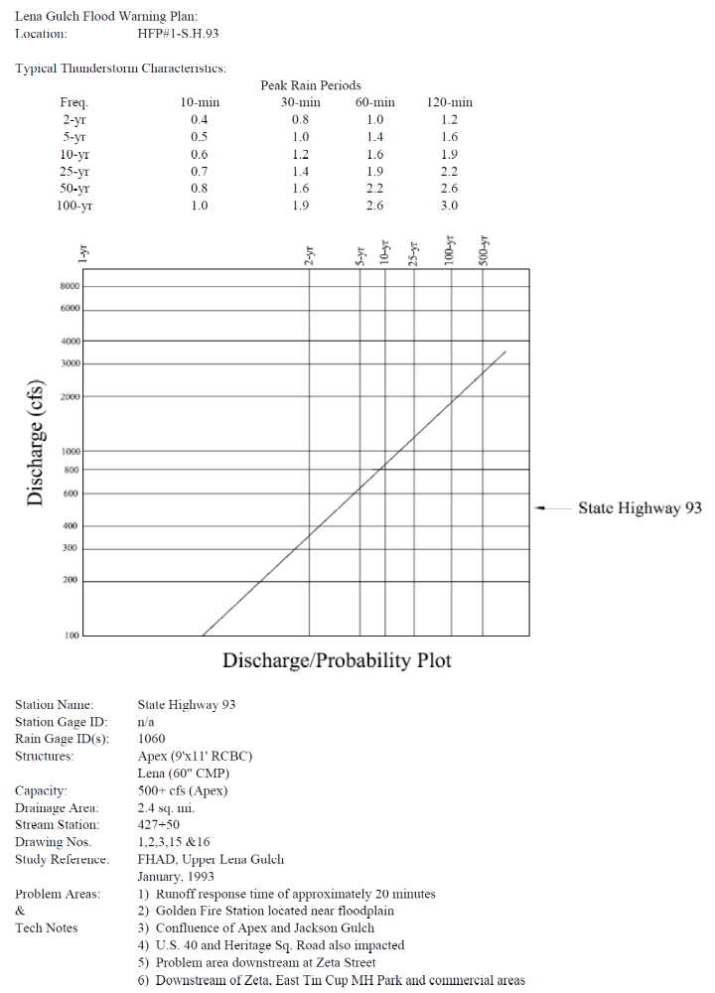
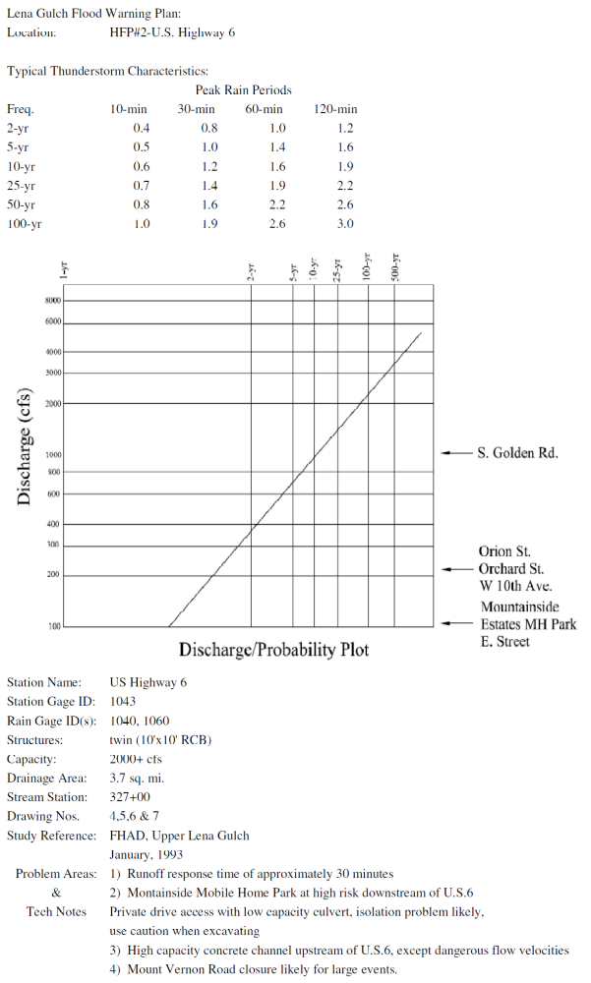
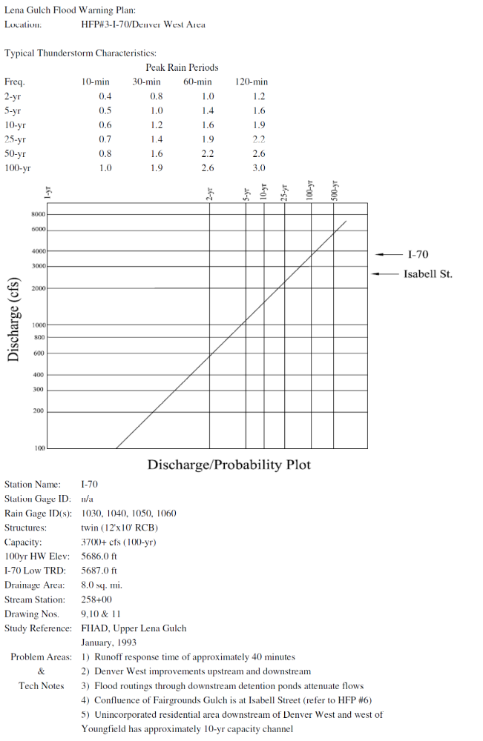
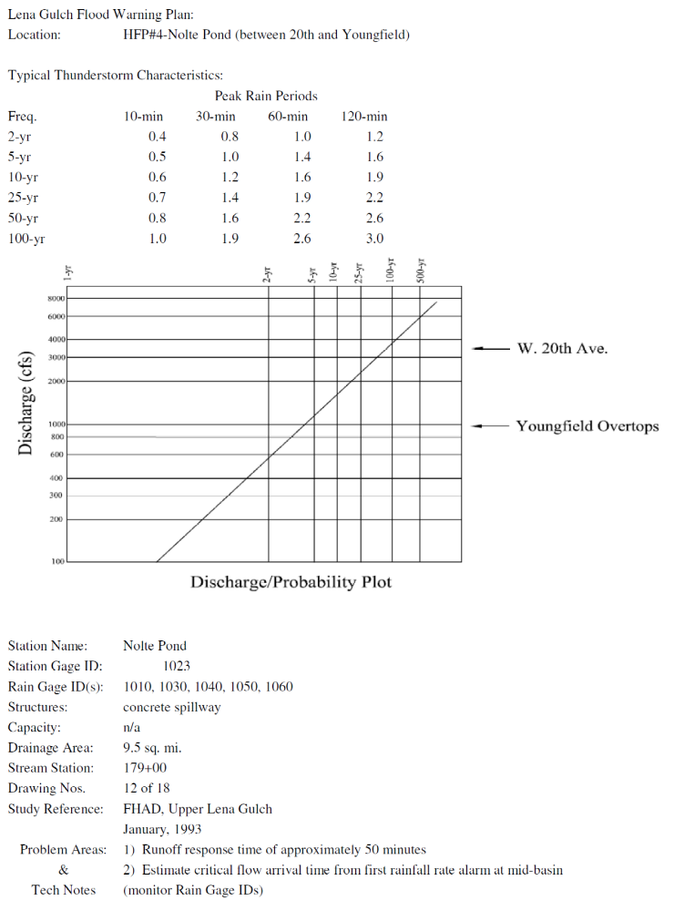
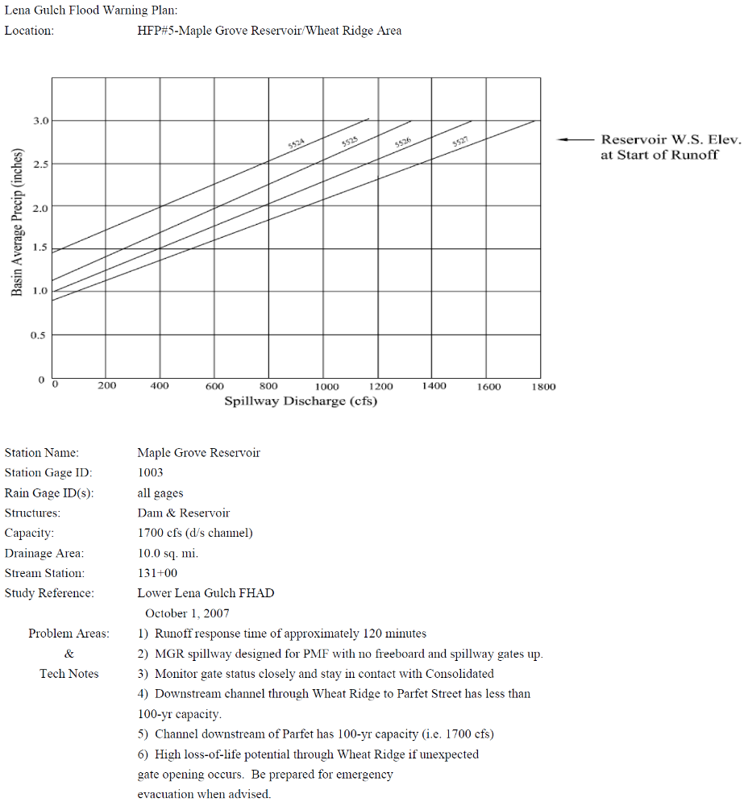
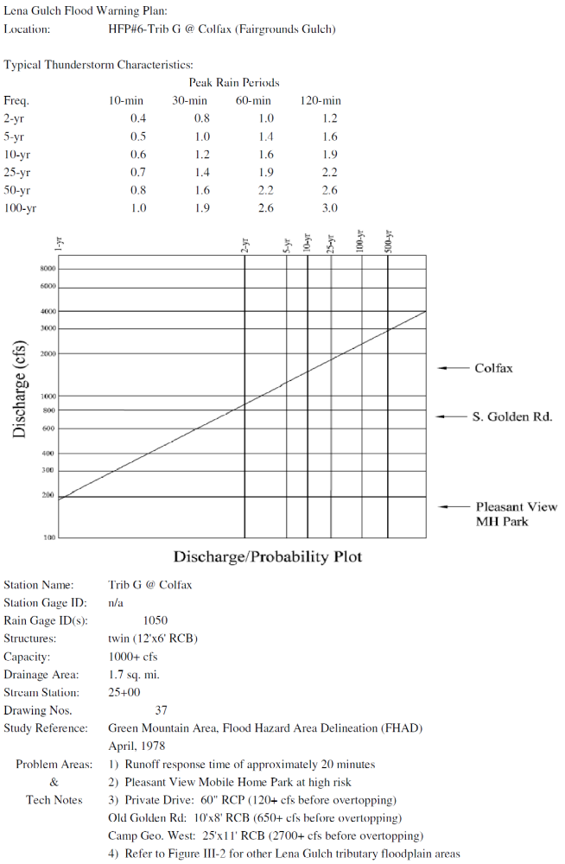

Figure III-11 Typical ALERT Stream Gage Graphics

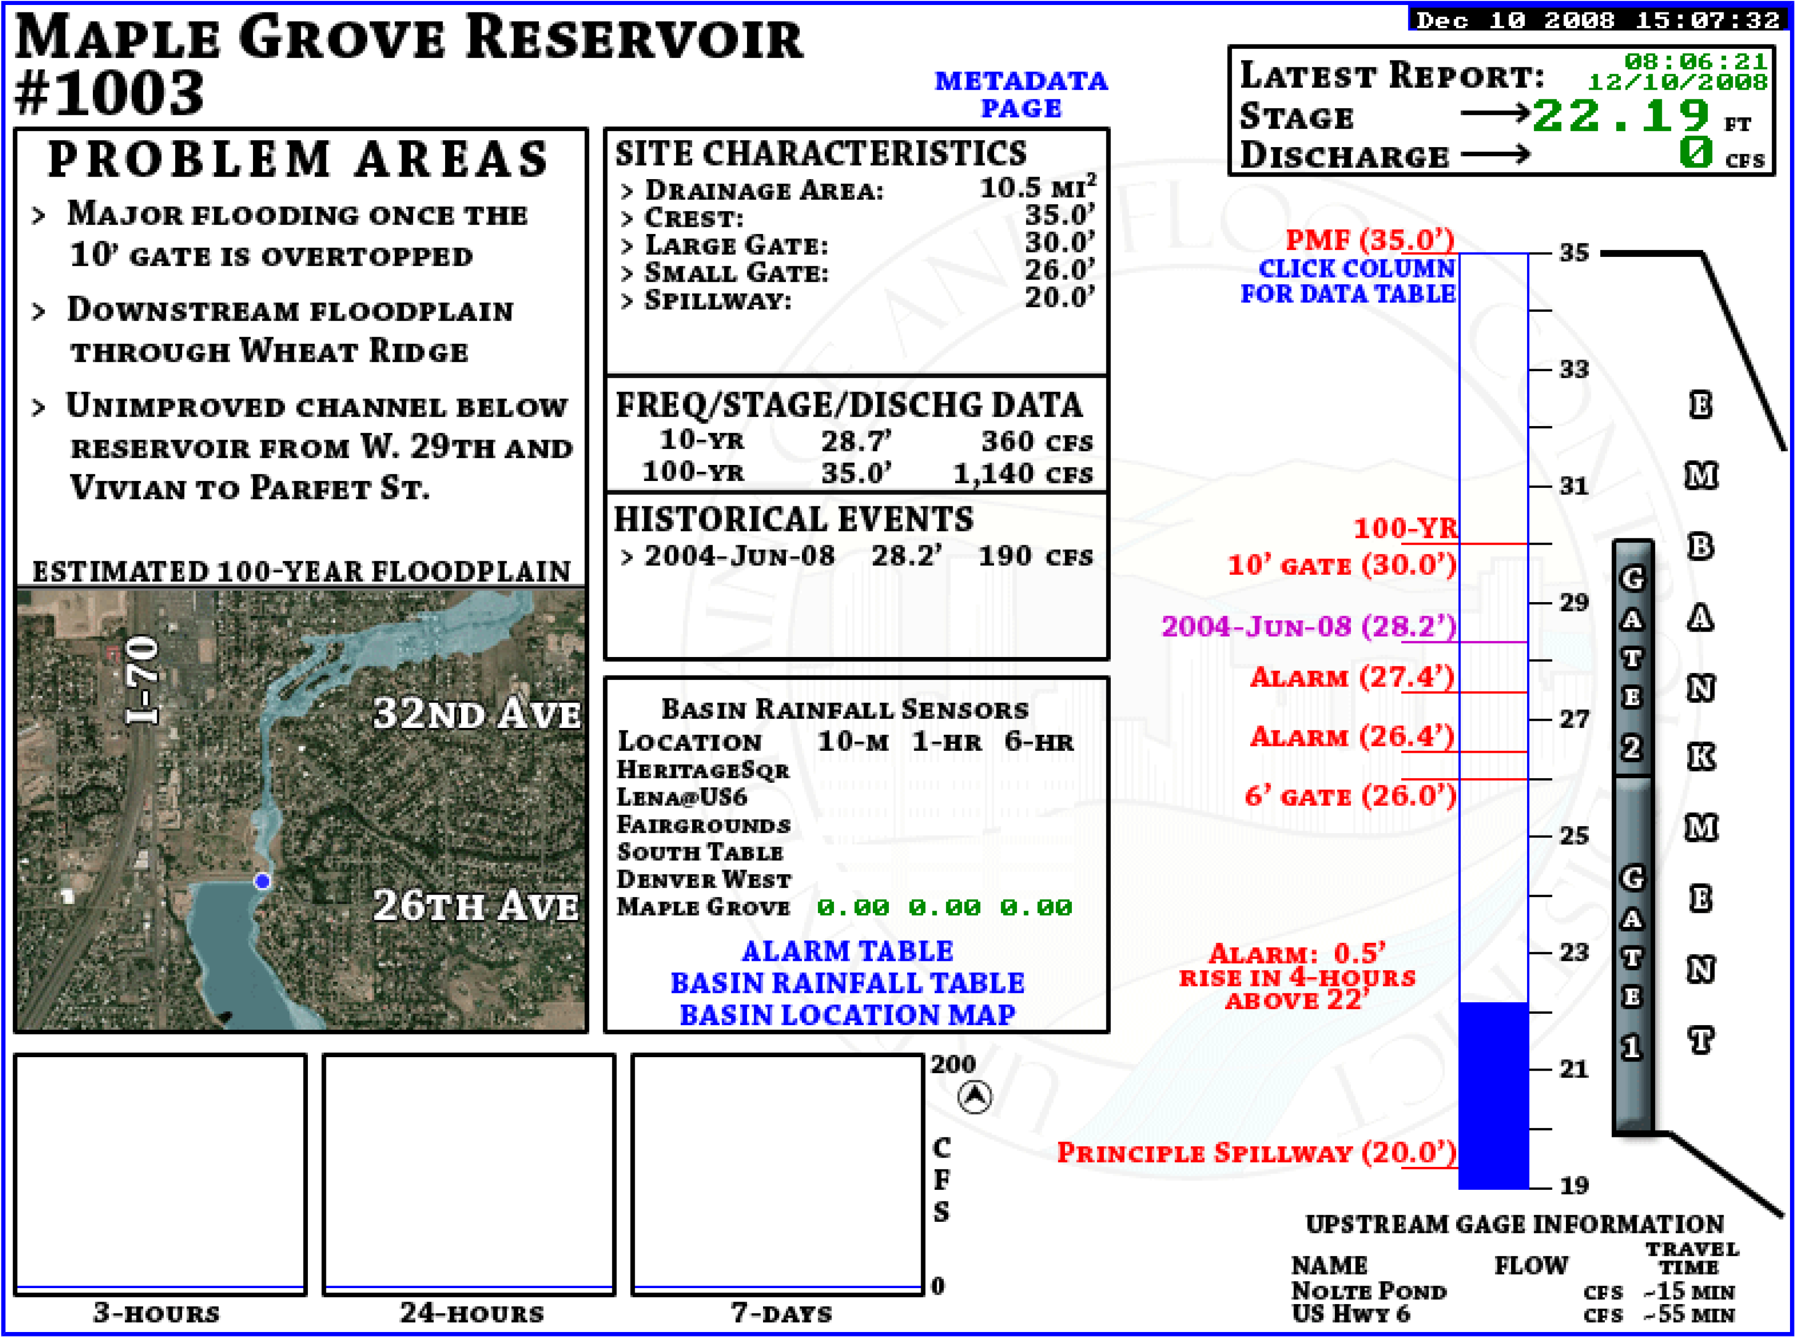

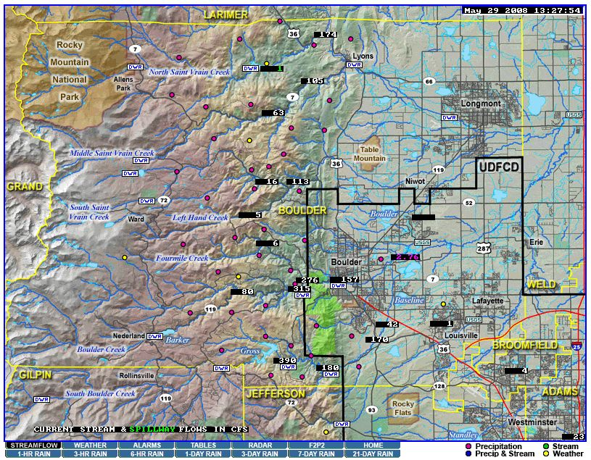
Note: Graphic displays like the one above for ALERT stream gages may be viewed by clicking on flow rate or water level values on the streamflow map – http://alert2.udfcd.org/cgi-bin/gdview?tpt=map21qweb

REQUIRED ELEMENTS OF THE WARNING PLAN
A complete flood warning plan consists of three basic elements

  - Detection and evaluation of the flood threat.
  - Dissemination of the flood warnings to the public.
  - Response of the public to the warnings.

All three parts must function properly or the warning plan will fail. The main purpose of the warning plan is to minimize the potential for loss-of-life. Public safety agencies will make decisions concerning floodplain evacuations and road closures. Individuals must also make appropriate decisions to protect themselves and their families. In some instances, a limited amount of emergency flood proofing by property owners can be accomplished. For residences and businesses along Lena Gulch and its tributaries, a flash flood warning would not likely provide enough lead-time to safely effect damage prevention measures such as sandbagging. Emergency property protection would probably be limited to turning off main gas and electricity connections.
The following pages provide a brief description of each of the three required elements listed above relative to this flood warning plan.

Detection and Evaluation of the Flood Threat
The early flood threat detection and evaluation element consists of the following items:

Organizations, Resources and Procedures
1. The National Weather Service (NWS) Weather Forecast Office at Boulder and their NEXRAD Doppler Radar stations located near Denver, Cheyenne and Pueblo.
2. A private meteorologist service (PMS), retained by Urban Drainage and Flood Control District (UDFCD) to coordinate with NWS; collect and analyze all pertinent weather and flood data; prepare daily heavy precipitation outlooks; provide affected jurisdictions with early notification of flood potentials; and update jurisdictions as conditions change.
3. A Flood Prediction Center (FPC) located in Denver at UDFCD providing a central data collection point and communications center staffed by PMS when flood potentials exist.
4. The Jefferson County Sheriff's Department Communications Center (JCC) that receives and disseminates all incoming weather and flood information. JCC is the primary communications link between PMS, NWS and other flood warning plan participants.
5. Communication arrangements defined to insure adequate communications between all parties at all times. Primary communications are by telephone. Amateur radio operators may be contacted to provide backup communications.
6. Standard messages used by PMS to provide information to JCC Communications for relay to affected jurisdictions.
7. A Situation Information Center (SIC) overlooking Maple Grove Reservoir that can be activated to closely monitor weather and flood conditions; coordinate with field and technical support personnel; and facilitate public warning decision-making.
8. Emergency Operation Centers (EOCs) in Jefferson County, Lakewood and Wheat Ridge activated in a pre-emergency mode to coordinate with the SIC; maintain contacts with meteorologists, hydrologists and other support personnel; take early preparedness actions; mobilize field resources; and make warning decisions.
9. Officials from Jefferson County, Golden, Lakewood, Wheat Ridge and Consolidated who receive all critical weather and flood information and respond according to their respective internal procedures.
10. Field personnel from various response agencies (Sheriff, police, fire departments, public works and others) dispatched to pre-determined monitoring locations to report rainfall amounts, stream and reservoir water levels and general flood conditions to appropriate jurisdictions.
11. Standard operating procedures and guidelines that are maintained, practiced and routinely updated by each participating local government agency, forecast service and support organization.

Equipment, Data Sources and Decision Aids
1. Satellite imagery display equipment located at NWS and FPC enabling meteorologists to see approaching weather systems and estimate arrival times.
2. Automated weather stations used to forecast flood potentials and predict storm development and movement.
3. Data communications equipment, computers and software used to collect and analyze pertinent upper air and surface data.
4. Radar product display equipment at NWS and FPC enabling meteorologists to evaluate current weather conditions; update heavy precipitation forecasts; estimate rainfall amounts at specific locations; predict storm movement, duration, and aerial coverage; refine flood predictions; and anticipate specific flood problems.
5. Automated rain gages, stream gages and weather stations that transmit data in real-time to base stations located at JCC Communications, FPC and UDFCD.
6. Internet webservers located at UDFCD that make the gaging station data available to NWS, local governments, news media and the public; and set off alarms when rainfall and stream level thresholds are exceeded.
7. Decision aids and automated processes used to quickly analyze the gaging station data, refine flood forecasts and predict impacts.

Dissemination of Warnings, Watches and Advisories to the Public
Several ways exist to disseminate flash flood warnings, watches and advisories to the public. The delivery of public warnings is dependent, to a large extent, upon the electronic news media (i.e. local radio and television) with NWS being primarily responsible for the initial release of the warning and its content. Local governments are also responsible for disseminating public warning information within their political boundaries.

Three basic types of flood information are disseminated to the public:

1. Advisory…meaning that nuisance or minor flooding of a "less serious" nature is either possible or occurring;
2. Watch…meaning that weather conditions are such that a hazardous flood may occur; and
3. Warning…meaning that a flood that poses a significant threat to life or property is either occurring, is imminent or has a very high probability of occurrence.

The above types of information can be issued by NWS, the local governments or both. NWS uses the following to convey flood information to the public and to cooperating agencies:

1. Special Weather Statement. This frequently issued statement may contain advisory information indicating a potential for heavy precipitation and possible flooding. It is also used to amplify watches, warnings and advisories by reinforcing the message, indicating what is expected and outlining appropriate response actions.
2. Urban and Small Stream Flood Advisory. This advisory is typically used to indicate that low impact flooding of small streams, streets, intersections and low-lying areas is imminent or occurring.
3. Flash Flood Watch. The watch means that flooding or flash flooding is possible within the geographic area described, but occurrence is uncertain.
4. Flash Flood Warning. The warning means that hazardous flooding or flash flooding is imminent or occurring within the geographic area described.

All NWS forecasts and warnings described above are disseminated using NOAA Weather Radio and NOAA Weather Wire. Flash flood watches, warnings, and urban/small stream flood advisories are disseminated over NAWAS. The use of METS is limited to flash flood warnings and other types of weather warnings. EMWIN can be used to automatically send forecasts and warnings to pagers, cell phones and email addresses. These and other dissemination methods are described later in this section.
Local governments can initiate flash flood warnings and provide the public at risk with emergency information prior to an NWS issuance. PMS messages, current rain and stream level data from the ALERT system and manual field observations can be used by officials for making warning decisions (Sections III and VI). Local warnings can be disseminated over METS. NWS will receive the information from METS and re-transmit the information as necessary and practical. Also, NWS can be contacted directly by local governments with additional dissemination requests.
The following briefly describes several public dissemination methods mentioned in the above paragraphs along with some other available warning options:
1. National Warning System (NAWAS) consists of full-period, private line voice circuits. NWS uses NAWAS to disseminate flood advisories, flash flood watches and warnings to "Warning Points" in Colorado. JCC Communications is one 24-hour "Warning Point" in this system.
2. Metropolitan Emergency Telephone System (METS) is a telephone network to which government agencies and the media can subscribe. JCC, the Jefferson County Department of Emergency Management and NWS can quickly pass information to the media subscribers for broadcast on radio and TV. NWS uses METS for warnings but not for watches or advisories.
3. Emergency Managers Weather Information Network (EMWIN) is a NWS-supported satellite downlink/rebroadcast system implemented locally by Denver metropolitan area emergency management agencies to customize delivery of critical weather information and warnings, and other emergency information. More information about EMWIN-Denver is available at http://denver.emwin.org.
4. NOAA Weather Wire is a satellite or Teletype-based communications system over which NWS can pass information to local governments or media subscribers for broadcast.
5. NOAA Weather Radio is a radio station operated by NWS (Frequencies: 162.550, 162.475 and 162.450 MHz). Special weather radio receivers or scanners can be purchased by anyone who is interested.
6. Emergency Alert System (EAS) consists of radio, television, and cable outlets throughout the United States who are linked together to provide live broadcasts of presidential messages during times of national emergency. On a voluntary basis, the system may also be used for broadcasting state and local emergency warnings and information. Locally, radio station KOA (850 AM) is the primary entry point for the system. Jefferson County and NWS have input capability into the system along with the Colorado State Patrol and the Colorado Office of Emergency Management.
7. Automated Emergency Call System is a telephone notification method, also known as the Emergency Warning and Evacuation System/Emergency Preparedness Network, uses the 9-1-1 Qwest phone number database to automatically dial and warn homes and businesses within affected areas concerning floods and other emergencies. The system is capable of handling up to 1200 calls per minute.
8. Cable Television Interrupt is a warning method used by communications personnel to voice over-ride all cable TV programming for emergency messages.
9. Outdoor Warning Systems are fixed-location, outdoor siren/voice systems in Lakewood used to warn people in and near the floodplain of an approaching flash flood and order evacuations if deemed necessary.
10. Emergency Vehicles may be dispatched by local law enforcement agencies and fire departments to circulate through assigned portions of the floodplain using sirens and mobile public address systems to advise occupants to evacuate. Standard messages to be used on the public address systems are given in Section IX.

Once the decision to warn or evacuate has been made, it is necessary to quickly and efficiently disseminate the warning to floodplain occupants, motorists and others at risk. Dissemination should be made by as many different means as possible but care should be taken to insure that warnings from different sources are similar in content. The warning message should clearly communicate the danger and recommend specific protective actions. Flood warnings can be issued by the broadcast media, loud speaker equipped vehicles and fixed-location, outdoor sirens and siren/voice warning systems. Confirmation of the initial warning is desirable whenever possible. People tend to seek confirmation before reacting to a warning.
All warning dissemination agencies, including the broadcast media, should have copies of the standard warning messages in Section IX. The media must be informed beforehand of the existing hazard and the details of the warning system and they should be contacted periodically to insure their readiness.

Response of the Public to the Warning
If the desired response of the people in the flood hazard area to a warning is not obtained, the whole warning plan will have failed. Cultivation of the desired response must begin well in advance of any flood threat by heightening the public awareness of the flood hazard.
These steps will be taken annually to try to cultivate the desired response:
1. UDFCD will annually mail or deliver a brochure to all occupants within the Lena Gulch drainage basin. The brochure will provide directions for obtaining a detailed map with an aerial photograph showing the approximate flood hazard area and provide information on steps to take prior to flooding (plan evacuation routes, buy flood insurance, etc.) or in the event of a flood warning.
2. Local governments will distribute a similar publication.
3. Media coverage of the flood hazard, including the annual practice of the warning plan, will be sought.

COMMUNICATIONS
Communications among personnel within participating agencies will be by normal methods now in operation. The Jefferson County Sheriff's Department Communications Center (JCC) is the primary contact for all communications concerning Lena Gulch and is responsible for relaying weather and flood information to other flood warning plan participants.
During emergency operations, field personnel from one agency wishing to communicate with personnel from another agency should follow their own jurisdiction's incident command system. This will assure a system of managed communication and information flow. If an Emergency Operations Center (EOC) is activated in Jefferson County, Lakewood or Wheat Ridge, communications will include the EOCs.
In addition to the EOCs, local authorities at The Consolidated Mutual Water Company (Consolidated) may activate a Situation Information Center (SIC). The SIC overlooks Maple Grove Reservoir and is equipped with an ALERT Base Station, making this an ideal facility for evaluating flood conditions and establishing a field command post.
Primary communications between the National Weather Service (NWS), the private meteorological service (PMS), JCC, Lakewood and Wheat Ridge will be by telephone. When conditions warrant, amateur radio operators can be called into each location to establish alternate communications according to previous agreements. Jefferson County, Golden, Lakewood, Wheat Ridge, Consolidated and the fire districts will use assigned radio frequencies to communicate with field personnel.
PMS initiated communications require special emphasis. During normal operating conditions (EOC not activated), PMS will contact JCC for relaying weather-related messages. When an EOC is activated, local authorities may request that PMS include the EOC as an additional or alternate contact point. Any warning plan participant may initiate calls to PMS or send personnel to the EOC if continuous monitoring of the situation is desired.
The following page contains pertinent telephone numbers and radio frequencies. The "Internal Communications Flow Chart" (Figure V-1) illustrates the collection and dissemination of weather information from various sources and shows the intended inter-agency flow paths for data and voice communications.
Figure V-12 Internal Communications Flow Chart

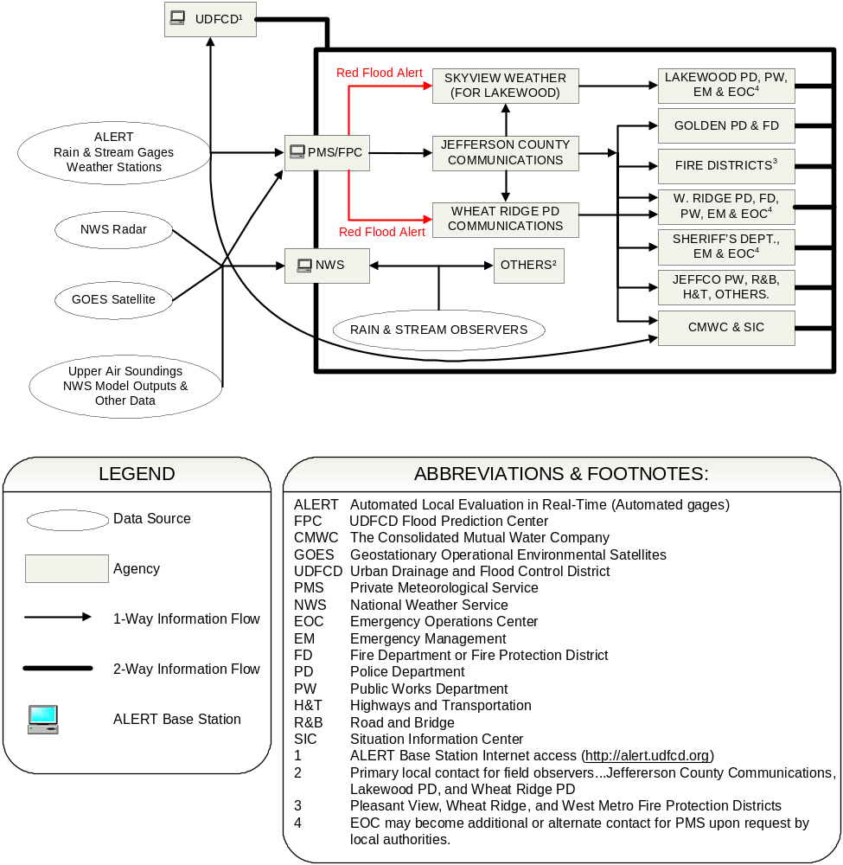

Telephone Numbers and Radio Frequencies
Organization Phone Number Frequency
* Jefferson County Communications (JCC) 303-277-0211
Jefferson County Emergency Management 303-271-4900
Jefferson County Highways and Transportation 303-271-8480
Golden Police and Fire Departments 303-384-8045 155.910
Lakewood Police Communications 303-987-7140
emergency 303-987-7111
* Wheat Ridge Police Department Communications 303-237-2220
alternate for dispatch 303-235-2900
police emergency 303-232-4357
fire emergency 303-233-3473
* The Consolidated Mutual Water Company and the SIC 303-238-0451 173.250
after hours 303-238-0453
West Metro Fire Protection District 303-969-0245 154.190
Pleasant View Fire Protection District 303-279-4361 45.080
Wheat Ridge Fire Protection District 303-424-7323 46.120

* National Weather Service (NWS)
coordination (duty forecaster) 303-494-4479
severe weather reports 303-494-2884
administration 303-494-3210
public weather information 303-494-4221

* Skyview Weather (for relay to Lakewood) 303-688-9175

* Urban Drainage and Flood Control District (UDFCD) 303-455-6277
ALERT Base & Weather Bulletin Board 303-433-1247
Private Meteorological Service (PMS) at
UDFCD Flood Prediction Center (FPC) 303-458-0789
FPC fax 303-458-5309
* Principle contact for PMS (Genesis Weather Solutions with Skyview Weather is the PMS for 2009)

Commonly Shared Emergency Radio Frequencies
CLEER "Colorado Law Enforcement Emergency Radio" 460.425
FERN "Fire Emergency Radio Network" 154.280
NLEC "National Law Enforcement Channel" 155.475

Other Radio Frequencies
ALERT repeaters (Blue Mountain & Smoky Hill) 171.875
ALERT gaging stations 169.525
NOAA Weather Radio (Denver) 162.550
NWR alternate 1 (Longmont/Mead) 162.475
NWR alternate 2 (Fort Collins) 162.450
Ham severe weather spotter network 146.940
alternate 147.120

METEOROLOGICAL SUPPORT
The National Weather Service (NWS) and the UDFCD private meteorological service (PMS) provide meteorological support to local governments participating in this flood warning plan. The following is the process by which NWS and PMS should coordinate with local government agencies to exchange information and gear up for potential flood situations:
1. PMS will prepare a daily heavy precipitation outlook (HPO) from April 15 through September 15. When warranted, a more detailed quantitative precipitation forecast (QPF) will also be developed by PMS. The current HPO and QPF are available from the Internet at http://f2p2.udfcd.org and may also be sent by email or fax to warning plan participants. Many NWS products are also available from the Internet at http://www.crh.noaa.gov/den including urban and small stream flood advisories, flash flood watches and flash flood warnings. Email dissemination of NWS products is possible from a variety of sources like the Emergency Managers Weather Information Network (EMWIN). When a flood potential exists, NWS and PMS will carry out weather discussions as necessary to evaluate the situation.
2. When nuisance flooding rainfall is possible, PMS will issue MESSAGE 1 by phone and fax to Jefferson County Sheriff’s Department Communications Center (JCC). JCC will forward the message by phone to Golden, Lakewood, Wheat Ridge, Consolidated and Jefferson County Emergency Management. The JCC dispatcher will disseminate MESSAGE 1 following standard protocol. Designated personnel will prepare to respond. When a MESSAGE 1 threat is considered imminent by PMS, it will be identified as a RED FLOOD ALERT (RFA) and a storm track (ST) prediction may be disseminated by PMS using the methods described in Item 1 above. A description of PMS messages is available at http://f2p2.udfcd.org along with examples of the forecast products referenced in this section.
3. NWS and PMS continue their weather discussion. If the flood potential increases one of the following actions will occur:
a. NWS will issue a Special Weather Statement or Urban and Small Stream Flood Advisory through normal channels (NAWAS, weather wire, weather radio) and/or PMS will send a MESSAGE UPDATE to MESSAGE 1 (RFA if warranted) to JCC Communications; or
b. NWS will issue a Flash Flood Watch through normal channels (NAWAS, weather wire, NOAA weather radio) and PMS will send MESSAGE 2 to JCC Communications; or
- PMS will send a MESSAGE 2 to JCC Communications indicating an increase in flood potential.
JCC Communications will execute a Multi-Agency Coordinating System (MACS) page and recipients will respond according to internal procedures. Designated personnel will staff the Emergency Operations Center (EOC) and begin active monitoring of weather and flood conditions in support of field operations.
4. The senior dispatcher on duty or the EOC Situation Officer will assign field observers within each jurisdiction and collect all available rainfall and stream stage data. The person-in-charge will call PMS and/or NWS to report observations, exchange data and coordinate future actions. At this point, consideration should be given to establishing alternative communications by requesting that volunteer Ham radio operators report to all critical locations including PMS and NWS.
5. Regular coordination between NWS, PMS and EOC personnel will continue. PMS will send MESSAGE UPDATES (RFA if warranted) by phone or Ham radio operator as required.
6. When conditions warrant, NWS will issue a Flash Flood Warning through normal channels and PMS will send a MESSAGE 3 to JCC Communications. PMS may issue a MESSAGE 3 prior to the issuance of a NWS warning if PMS believes that a life-threatening flood is imminent.
7. EOC staff will continue to monitor the situation and begin public dissemination of warnings when necessary. PMS will continue to send MESSAGE UPDATES as warranted.
8. When the hazard has passed, PMS will send a MESSAGE 4 to JCC Communications.

Throughout all of the above activities, NWS and PMS will coordinate as necessary. It must be remembered that events may occur so rapidly that it may not be possible to carry out all of the above steps. Personnel on duty must be prepared for this possibility and pick up the process as best they can.
Also, when NWS determines very early that a high potential for flash flooding will exist later that same day, a Flash Flood Watch and corresponding MESSAGE 2 will likely be the first notice issued. In this case, the notices should be communicated well ahead of any heavy rainfall activity, thus allowing more time to make ready.
RFA is used when PMS believes that a flooding rainstorm is imminent. A storm track prediction may accompany the RFA (see Item 2 above). When MESSAGE 2 is in effect, RFA may be used with a MESSAGE UPDATE to indicate that nuisance or minor flooding is expected that does not warrant a MESSAGE 3. When a MESSAGE 3 is in effect, RFA may be used with a MESSAGE UPDATE to indicate that an approaching storm may cause nuisance flooding outside the warning area. In summary, an RFA is typically short lead (0-30 minute) notification of an imminent flood threat not generally considered life-threatening. Flooding will likely be localized and not wide-spread. However, fast moving water even at relatively shallow depths of 2-feet or less should always be considered dangerous, particularly along rivers, streams, and normally dry gulches or drainageways. Given the short lead nature of an RFA, it should be disseminated as quickly as possible.
Standard message forms will be completed by PMS and faxed to JCC Communications immediately prior to placing a phone call to JCC Communications. This procedure is designed to insure the rapid flow of information with minimum chance for error or misunderstanding.

FLOOD THREAT RECOGNITION AND WARNING PROCESS
The first element of a local flood warning system is the ability to detect and evaluate a flood threat in its early stages and make the decision to warn before flood damages or deaths occur. The second element is the dissemination of the warning to the public at risk. The third element is the public response to the warning. This section deals with the first two elements and includes a step-by-step illustration of how the early flood threat recognition and warning process is intended to function.

Detection and Evaluation of the Flood Threat
The earliest recognition of a potential flood threat will be a heavy precipitation forecast by a meteorologist. The private meteorological service (PMS), retained by Urban Drainage and Flood Control District (UDFCD), provides the meteorological support for this plan among other responsibilities. This service supplements National Weather Service (NWS) activities by focusing its support for the seven-county geographically area comprising UDFCD and tailoring communications to the individual concerns of each local government within this area. Section VI describes the meteorological support provided by NWS and PMS.
PMS forecasts are coordinated with the NWS Weather Forecast Office at Boulder and provided to the Jefferson County Sheriff’s Department Communications Center (JCC) for subsequent dissemination. JCC's principal contacts for Lena Gulch flood notifications are: Lakewood, Wheat Ridge, Golden, The Consolidated Mutual Water Company (Consolidated), Pleasant View Fire Protection District, West Metro Fire Protection District and Jefferson County Emergency Management. JCC Communications will relay the PMS flood threat notifications by executing a Multi-Agency Coordinating System (MACS) page and/or by other means following standard protocols. Participating organizations will respond according to respective internal procedures.
Automated rain gages, stream gages and weather stations within the Lena Gulch drainage basin use battery-operated radios to transmit data in real-time to ALERT base stations located at UDFCD, NWS and Consolidated. PMS uses this and other hydro-meteorological data (radar, satellite imagery, upper air soundings and other in-situ weather data) with the decision aids in Section III to predict flood potentials and update local officials concerning anticipated flood problems.
A Situation Information Center (SIC) may be activated at Consolidated where one ALERT base station is located. The facility overlooks Maple Grove Reservoir making it an ideal staging area for collecting information, evaluating flood conditions and directing field operations. The decision to activate the SIC will not be the responsibility of Consolidated but will rest with each local jurisdiction involved with this warning plan. If activated, SIC personnel will have the opportunity to analyze current ALERT data, interact directly with PMS and NWS and use the decision aids provided in Section III. SIC personnel may access the ALERT system via the Internet. SIC personnel may also assume the primary flood prediction role should communication links with PMS and NWS fail.

Emergency Operation Centers (EOCs) may also be activated at Jefferson County, Lakewood and Wheat Ridge. The decision to activate the EOCs rests with each respective jurisdiction. EOC personnel should establish routine communications with PMS, the SIC and NWS. Local authorities and NWS are responsible for making decisions concerning public warning.
This flood warning plan calls for higher levels of readiness as the potential for flash flooding increases. The different readiness levels are designated as Modes and defined as follows:

MODE 0: Normal Operations
MODE 1: The meteorological potential for flash flood producing storms has been observed.
MODE 2: A high probability of flooding exists.
MODE 3: Flooding is imminent in the judgment of EOC personnel.
MODE 4: Flooding is occurring.

Section VIII provides further discussion regarding procedures and general responsibilities of the principle organizations involved with this flood warning plan. A more detailed discussion of each Mode is also provided.

Dissemination of the Warning
Dissemination of warning information to the public will be accomplished through both the electronic media and by each local government (Lakewood, Wheat Ridge, Jefferson County and Golden). Dissemination by the media may be channeled through NWS by local authorities or the media may be contacted directly. NWS will use NAWAS, METS, NOAA Weather Wire, NOAA Weather Radio and/or EAS at their option to issue the public warning. Section IV describes the various methods for disseminating flood warnings to the public.
Each local government is responsible for providing flood warnings directly to the public at risk within their respective jurisdictions according to internal procedures. Standardized messages to be used by local governments are included in Section IX.

Step-By-Step Procedure
The following step-by-step procedure is an idealized summary of how the flood threat recognition and warning process is supposed to function. THE USER MUST BE AWARE THAT THE SYSTEM WILL NOT ALWAYS FUNCTION AS PLANNED. THE USER MUST BE PREPARED TO FUNCTION WITHIN THE OUTLINED FRAMEWORK, EVEN IF ALL STEPS LISTED HEREIN DO NOT OCCUR OR OCCUR OUT OF ORDER.
A. Normal Operations (MODE 0):
1. PMS will be monitoring weather conditions on a routine basis, including appropriate coordination with NWS. It should be noted that PMS, NWS and UDFCD have an on-going relationship which involves forecasts of flood potential for the entire Denver/Boulder metro area; and the Lena Gulch Warning Plan is an add-on responsibility for meteorologists and other technical support personnel.
2. When weather conditions warrant, and after consultation with NWS, PMS will issue a MESSAGE 1 by telephone to JCC. If PMS considers the threat imminent, the message will be identified as a RED FLOOD ALERT. The official in charge should consider calling for Mode 1 operations upon notification of a RED FLOOD ALERT. Section V contains details regarding weather-related communications and the flow of critical information. Section VI contains a detailed description of the messages and terms used by the PMS.
3. JCC will forward the MESSAGE 1 by executing a MACS page in accordance with MACS procedures. REMEMBER THAT A MESSAGE 1 IS A FORECAST OF A POTENTIAL FOR FLOODING. IT IS NOT INTENDED FOR PUBLIC DISSEMINATION SIMPLY BECAUSE IT IS TOO EARLY TO TELL WHAT WILL ACTUALLY DEVELOP.

B. Increased Awareness (MODE 1):
1. PMS will continue to monitor the situation and will issue appropriate MESSAGE UPDATES (RED FLOOD ALERT if warranted) to keep local officials advised of significant changes since the previous message.
2. NWS may issue a Special Weather Statement or other appropriate communication concerning heavy precipitation through normal channels described in Section IV. PMS may follow this with a MESSAGE UPDATE providing a more detailed interpretation of how this affects Lena Gulch.
3. JCC will execute a MACS page and each subsequent contact should follow internal procedures for updating key people concerning the increased flood potential.
4. Contingency plans should be established to ensure that future steps in this warning plan can be carried out if needed and the Situation Officer should consider activating the EOC.

C. Flash Flood Watch (MODE 2):
1. As the flood potential becomes more apparent or threatening, NWS will issue a Flash Flood Watch for a geographic area. The Flash Flood Watch will be issued on NAWAS, Weather Radio and Weather Wire.
2. PMS will issue a MESSAGE 2 to JCC for MACS page execution. MESSAGE 2 will not only indicate the issuance of a Flash Flood Watch by NWS but will also attempt to provide additional information concerning severity of the threat and a more definitive identification of areas at risk. PMS may also issue a MESSAGE 2 without a NWS issuance of a Flash Flood Watch if PMS feels the risk is high that a life-threatening flood may occur later in the day.
3. The emergency service official in charge will consider calling for Mode 2 operations.
4. PMS will continue to monitor all available data and will initiate an analysis of potential flood peaks based on predicted rainfall and decision aids provided in Section III.
5. As additional data (including rainfall and stream gage data) become available, PMS will update rainfall forecasts and flood peak projections and will provide information to JCC in the form of MESSAGE UPDATES (RED FLOOD ALERT if warranted).
6. JCC will relay all updates by executing a MACS page.
7. Local authorities will send rain and stream observers to pre-determined locations. Stream gage readings and field observations will be reported to PMS and NWS through JCC or EOC personnel.
8. PMS will confer as needed with NWS. When rainfall estimates or measurements and flood peak predictions indicate an imminent flood danger; or when automated stream gages or field observations confirm the threat, a Flash Flood Warning will be issued by NWS and EOC personnel will call for Mode 3 operations.

D. Flash Flood Warning (MODE 3):
1. NWS will issue a Flash Flood Warning through NAWAS, METS, Weather Radio, Weather Wire and perhaps EAS. A Flash Flood Warning means that flooding is imminent or occurring.
2. PMS will issue a MESSAGE 3 to JCC for MACS page execution. PMS may also issue a MESSAGE 3 without a NWS issuance of a Flash Flood Warning if PMS feels that a life-threatening flood is imminent.
3. Responsible JCC or EOC officials should then disseminate the warning according to internal procedures using standard public messages where appropriate (Section IX).
4. PMS, NWS and stream observers will continue to monitor the situation to either confirm flooding or determine that the hazard has passed.
5. When the threat of flooding has passed, whether a flood has occurred or not, PMS will issue a MESSAGE 4.
6. If flooding has occurred, EOC personnel will call for Mode 4 operations and follow their disaster response plan.

E. Other Considerations:
1. As noted above, this is an idealized scenario. It is unlikely that any flood event would be handled exactly as outlined. Each entity must be cognizant of the probable necessity to deviate from their respective plan in order to react to the real situation.
2. NWS is the only federal agency that can officially issue a Flash Flood Watch or Flash Flood Warning to the public. In the event of a difference of opinion between NWS and PMS, PMS will advise JCC or EOC officials of the difference of opinion as follows:
a. If PMS feels a watch or warning should be issued but NWS doesn't agree, PMS will use a MESSAGE 2 or MESSAGE 3 to inform local authorities of their forecast and prompt each jurisdiction to make their own warning decision.
b. If NWS issues a watch or warning but PMS doesn't feel it is warranted, PMS will still issue the appropriate MESSAGE 2 or MESSAGE 3, but indicate their misgivings. The standard message forms in Section VI are designed to clearly indicate either concurrence or disagreement between PMS and NWS.
3. In the event of a local decision to warn, the EOC official in charge should immediately contact NWS to avoid public confusion. Also, NWS may be the quickest means of notifying the public via the electronic news media. NWS may acknowledge the involvement of local authorities when issuing their warning.
4. Flood warnings for Lena Gulch can be issued by local officials using the siren/public address systems, emergency vehicle loud speakers, door-to-door notification and other methods deemed appropriate.

PROCEDURES AND GENERAL RESPONSIBILITIES
Procedures and general responsibilities for the operational elements of this flood warning plan are contained in this section. Three points regarding these procedures need to be emphasized:
1. The operating procedure for each organization addresses only those actions and activities that organization must accomplish in order to effect a coordinated response to a flood situation.
2. Every individual responsible for the implementation of any part of this warning plan should be familiar with the entire plan.
3. This section does not contain detailed operating procedures but provides an overview of technical support activities, communications, emergency operations and general responsibilities of each participating organization. Specific task assignments and responsibilities are described in local emergency operation plans, agency procedures and other supplemental documents maintained by local governments. Similarly, the technical support organizations including National Weather Service (NWS) and Urban Drainage and Flood Control District (UDFCD) and their private meteorological service (PMS) routinely update their own internal operating procedures, policies and duty manuals.

National Weather Service and Private Meteorological Service
The NWS Weather Forecast Office at Boulder has the responsibility for issuing Flash Flood Watches, Flash Flood Warnings, general Flood Warnings, and many other types of weather warnings, advisories and forecasts for northeastern Colorado, including those counties within the UDFCD. PMS supplements NWS flood-related activities within UDFCD boundaries. PMS is responsible for monitoring weather and flood conditions, forecasting flood potential, issuing standardized internal messages, and directly advising local officials concerning specific flood threats. UDFCD provides PMS with access to weather radar, satellite data, lightning data and ALERT base stations, that collect real-time rain, stream levels, and surface weather data from within the UDFCD and other detection networks operating in or near the Denver metropolitan area. PMS acquires additional meteorological data, performs their own analyses and prepares forecasts tailored to local government needs. Coordination between NWS and PMS will be as follows:
1. Coordination between NWS and PMS may be initiated by either party when it is deemed that the potential for flash flood producing storms exists. A private line at the Flood Prediction Center (FPC) located at UDFCD in Denver has been established for this purpose. NWS and PMS will consult on when to issue a MESSAGE 1 (see Section VI for MESSAGE descriptions). MESSAGE 1 will be communicated by phone and fax. PMS personnel will establish support operations at the FPC either before or soon after a MESSAGE is issued.
2. If PMS believes the MESSAGE 1 concerns an imminent threat, the message will be identified as a RED FLOOD ALERT and the information should be disseminated as soon as possible.
3. Coordination between NWS and PMS will continue at two-hour intervals or less as needed until the potential passes or a more serious situation develops. NWS may issue a Special Weather Statement or Urban and Small Stream Flood Advisory through normal channels if conditions warrant. Section IV describes these and other NWS products.
4. If the situation is upgraded to a Flash Flood Watch by NWS, they will notify PMS and put the watch out on NOAA Weather Wire, NOAA Weather Radio, and NAWAS. After being contacted by NWS, PMS will immediately issue a MESSAGE 2.
5. If PMS feels the flood potential has increased but NWS does not want to issue a Flash Flood Watch, PMS can either issue a MESSAGE UPDATE indicating an increase in flood potential or upgrade the message status to a MESSAGE 2 if they feel a life-threatening flood potential exists.
6. Following receipt of a MESSAGE 2 or MESSAGE UPDATE, local entities should pass along any rainfall or other data available to them and inform PMS and NWS of such observations.
7. Communications between NWS, PMS and local jurisdictions will continue as needed.
8. If the situation is upgraded to a Flash Flood Warning by NWS, they will notify PMS and put the warning out on NOAA Weather Wire, NOAA Weather Radio, NAWAS and METS. After being contacted by NWS, PMS will immediately issue a MESSAGE 3. PMS can also issue a MESSAGE 3 without a NWS Flash Flood Warning if PMS believes a life-threatening flood is imminent.
9. PMS can issue a MESSAGE UPDATE (RED FLOOD ALERT if warranted) at any time an update of the current message in effect is warranted but the next higher or lower message is not appropriate.
10. Local government officials may recognize the equivalent of a Flash Flood Warning, independent of NWS or PMS, if they feel the situation warrants. NWS and PMS should be immediately advised of this circumstance.
11. Local government officials will make their own decision to evacuate floodplains, close roads or take some other appropriate emergency action. NWS and PMS will be informed of the situation immediately. NWS will disseminate this information over their communications network wherever possible.
12. Consultations between NWS, PMS, local authorities and other flood warning plan participants should continue as needed until the potential has passed or a flood is occurring.
13. When NWS and PMS agree that the potential has passed, PMS should issue a MESSAGE 4.

PMS will have forecaster(s) on duty from 7 AM until 10 PM each day. If a flash flood potential exists at 10 PM, PMS will continue to staff the FPC until the potential has ended. If weather conditions change after 10 PM and a potential flood situation develops, NWS will notify the PMS duty person. This individual will respond to the FPC and begin the coordination process described above.

Jefferson County Sheriff’s Office
JCC has the responsibility and authority to maintain an orderly flow of information between all agencies involved in the warning plan. Specific responsibilities of JCC are as follows:
1. During normal conditions JCC will be in its normal working configuration.
2. Upon receipt of MESSAGE 1 (See Section VI of this plan for MESSAGE descriptions), duty dispatchers will immediately report to the Director of Emergency Management and notify local jurisdictions and The Consolidated Mutual Water Company (Consolidated) of the alert.
3. Upon receipt of MESSAGE 2 (NWS Flash Flood Watch or equivalent), or information indicating an increased flood potential (e.g., MESSAGE 1/RED FLOOD ALERT or MESSAGE UPDATE/RED FLOOD ALERT), entire area affected will be notified immediately by duty dispatcher. This will include the Cities of Lakewood, Wheat Ridge and Golden; Pleasant View Fire Protection District, West Metro Fire Protection District and Consolidated. The Jefferson County Department of Highways and Transportation, Highway Design and Development Review Section will also be immediately notified of this situation. Watch commander should consider activating and dispatching personnel to the Situation Information Center (SIC) at Consolidated.
4. Patrol cars, as deemed necessary, will be dispatched to potential flood areas to report on the level of Lena Gulch, warn individuals in the flood hazard area and assist fire districts concerned where feasible.
5. Upon receipt of MESSAGE 3 (NWS Flash Flood Warning or equivalent), or information from other reliable sources to that effect, the Sheriff's Department will take immediate steps to secure designated and/or unincorporated areas involved; establish traffic control; assist with evacuation; preserve law and order; activate Field Command Post, if required; carry out search and rescue operations as necessary; and activate warning sirens upon approval.
6. If flooding occurs in an incorporated area, Sheriff's Department resources will stand by to assist municipal emergency response agencies within Jefferson County as needed.
7. Information received from fire district weather spotters will be consolidated and forwarded to PMS, NWS and the SIC, if activated.
8. The Sheriff's Department will establish a Field Command Post in the disaster area, if required, upon receipt of information that an evacuation due to floods has been initiated. Until such time that a Jefferson County command post is established, the fire district involved will be in control of its jurisdictional area. Once established, the overall control of the flood area will revert to the Jefferson County Field Command Post.
9. Aircraft control and aviation support will be coordinated.
10. Consolidated, pertinent fire districts and the Cities of Lakewood, Wheat Ridge and Golden will be provided with rain and stream stage information and PMS forecasts on a timely basis when potential flooding conditions exist.

Jefferson County Emergency Management
1. Upon receipt of MESSAGE 2 (NWS Flash Flood Watch or equivalent) or information to that effect from Sheriff's Department; notify the County Administrator or Board of County Commissioners, Human Services Division, Public Works Division, Department of Health and Environment; and activate the Jefferson County Emergency Operations Center (EOC) if appropriate.
2. Determine resources needed for disaster area and coordinate emergency response activities with county departments.
3. Establish communications with Field Command Post and Colorado Office of Emergency Management.
4. If appropriate, notify R1 School District of designated schools required for temporary housing of flood evacuees and coordinate opening as evacuation centers.
5. Establish communications within the SIC at Consolidated if activated.

Jefferson County Development and Transportation
1. Upon notification of flooding conditions, be prepared to provide crews and equipment to assist in rescue operations, provide necessary transportation, establish barricades as needed and restore county facilities in the quickest possible manner.
2. Upon activation of the Jefferson County EOC, provide a representative thereto.
3. Consider providing representative(s) to the SIC at Consolidated if activated.

Jefferson County Health and Environment
1. Upon notification of flooding conditions, provide representatives(s) on site to determine requirements for preservation of county health standards.
2. Upon activation of the Jefferson County EOC, provide a representative thereto.

Jefferson County Human Services
1. Upon notification of flooding conditions, activate resources and emergency support agencies to house, clothe and feed flood evacuees at designated evacuation centers.
2. Upon activation of the Jefferson County EOC, provide a representative thereto.

Jefferson County R1 School District
1. Upon notification of potential flood conditions, be prepared to open designated schools for use as evacuation centers when required.

West Metro and Pleasant View Fire Districts
1. Provide information to the Jefferson County Sheriff's Department, EOC and/or SIC concerning all potential and actual flood conditions in jurisdictional areas on a timely basis.
2. Upon receipt of MESSAGE 1 (Internal Weather Alert), notify required personnel for potential action.
3. Upon receipt of MESSAGE 2 (NWS Flash Flood Watch or equivalent) or other warning indicators (e.g., MESSAGE 1/RED FLOOD ALERT or MESSAGE UPDATE/RED FLOOD ALERT), alert all personnel for flood observation and warning requirements within jurisdictional area. Warnings should be issued to endangered individuals and residences should a flash appear imminent. Consider dispatching personnel to the SIC at Consolidated, if activated.
4. Upon receipt of MESSAGE 3 (NWS Flash Flood Warning or equivalent) or warning from the Sheriff's Department, be prepared to evacuate threatened area by the quickest possible means. NOTE: Fire District Chiefs will use own discretion when to initiate appropriate observations, warning or evacuation at any time conditions so warrant action.
5. Consolidate weather spotter information received and transmit to Sheriff's Department and the SIC, if activated, on a timely basis.
6. Provide initial search and rescue operations as required.
7. Notify Sheriff's Department immediately upon flood evacuation initiation.

Individual Weather Spotters
1. Provide fire districts with rainfall and stream level information on a timely basis during a major rain storm or when flooding conditions exist.
2. If not under supervision of a fire district, provide such information directly to the Sheriff's Department, the Jefferson County Department of Emergency Management, the SIC at Consolidated or NWS.

General Administration & Logistics
1. All emergency response agencies will utilize their own resources until exhausted.
2. Requests for needed additional supplies, equipment and other resources will be made to Jefferson County Department of Emergency Management.
3. Jefferson County Department of Emergency Management will coordinate the acquisitions of all resources necessary to the existing emergency.

City of Lakewood
The City of Lakewood maintains a flood warning plan specific to Lena Gulch. The revised Lakewood plan will be incorporated into this section when available.
In order to maintain confidentiality, Lakewood's resident notification list is excluded from this section of the warning plan. If further information is required, contact the Lakewood Police Department.

City of Wheat Ridge
1. General: It shall be the responsibility of the Wheat Ridge Police Department to provide for the orderly response of emergency service units throughout its jurisdictional boundaries during times of flood emergency. The Police Department shall, during such times, strive to maintain obedience to law and order, conduct door-to-door notifications, provide a vehicle for emergency medical treatment of injured persons, secure shelter for persons who are evacuated, and provide security of property left behind by those persons. The Police Department shall be responsible for providing communications capabilities for those persons/units involved in the actual emergency operation.
The Wheat Ridge Police Department shall also dispatch for the Wheat Ridge Fire Protection District (WRFPD) and be responsible for providing direction and assignment of personnel and equipment to specific duties, with the exception of situations dictating specific expertise such as fire control. In those cases, responsibility will be with those agencies during the time this expertise is needed. WRFPD can also assist with neighborhood flood warnings using their emergency vehicle loud speakers. The Police Department's responsibility will include the decision to or not to activate the Situation Information Center (SIC) at The Consolidated Mutual Water Company (Consolidated) or to assign personnel with appropriate communications equipment to the SIC, if activated by others.
2. Field Supervisor: In the event of a flood emergency, the on-duty police patrol Field Supervisor will be responsible for the initial control of the situation. His initial actions could dictate how successful the Police Department is in dealing with the disaster. The Field Supervisor shall:
A. Immediately respond to the scene of any major disaster.
B. Assess the situation and arrange necessary emergency service units, additional manpower, equipment, emergency shelters, etc.
C. Make the appropriate notifications to police command personnel, civil defense personnel, etc.
D. Select a suitable site for establishing a Field Command Post (F.C.P.) and arrange for the transportation of the mobile command/communication van to that location (e.g., SIC at Consolidated's, Maple Grove Reservoir offices).
E. Establish immediate communication with responding units, dispatch, station commander(s), etc., via radio and/or open telephone lines.
F. Initiate a chronological log of operational activities.
G. Take whatever action deemed necessary for the protection and preservation of life and property.
H. Upon being relieved by a Police Department command officer, be prepared to fully advise on situation, stating what has been done and recommendations for future action.
3. Command Officer:
A. Immediately respond to the F.C.P. site.
B. Receive briefing from Field Supervisor.
C. Assume as appropriate, command of the field operations and begin coordinating and directing all requests for or assignments of manpower, equipment, volunteers, etc., including detailed analysis of situation.
D. Immediately establish communications with the Jefferson County Emergency Operations Center (EOC) or with the Chief of Police or his designee and provide detail analysis as known, of the situation status or extent of flooding, including specific needs and recommendations.
4. Chief of Police or Designee:
A. Arrange notification of necessary heads of government, and other heads of agencies.
B. Arrange collective meeting at a mutual location such as the EOC or the SIC at Consolidated with those persons.
C. Arrange for the necessary support/relief equipment, personnel, etc.
D. Establish a location away form the disaster area to handle news media inquiries and announcements.
E. Prepare plans for follow-up to disaster such as debris cleanup, removal of the dead, and general return to normal operation.
F. Supervise a debriefing with units involved, of the disaster and method of handling upon return to normal.
G. Activate cable television audio override if necessary to warn or advise residents.

City of Golden
The City Manager or Designee has the administrative responsibility for a Lena Gulch flood crisis within the boundaries of the City of Golden. The following specific responsibilities are primarily to reduce the potential for loss of life resulting from flash floods on Lena Gulch:
1. Action: If the Golden Communications Center is notified or becomes aware of either of the following two actions, this plan will go into effect:
A. Jeffco EOC notifies the Communications Center of flood waters approaching Golden.
B. The City becomes aware of flooding or potential flooding conditions along Lena Gulch.
The Communication Center shall notify:
(See Emergency Call List Directory for telephone numbers)
1. Police Department Shift Supervisor
2. Fire Department by Paging System
3. Police Support Lieutenant/Patrol Lieutenant (call or page)
4. Chief of Police
5. City Manager or Designee
6. Public Works Director
7. Water Superintendent
8. Others as deemed necessary by City Manager
2. Command: The overall control of the flooded area within the Golden city limits will be that of the City Manager or Designee who shall assume Command. Functional responsibility for the flooded area within the city limits will remain with the Fire Department and Police Department. The City Manager or Designee shall consider activating and dispatching personnel to the Situation Information Center (SIC) at The Consolidated Mutual Water Company. If the SIC has already been activated by others, the City Manager or Designee shall consider dispatching personnel to the SIC with appropriate communications equipment.
3. Field Command Post: Depending on flood conditions, the Field Command Post should be established at a location deemed appropriate by the on-scene officer. The highest Police and/or Fire Official available shall be in charge of the Field Command Post located at about West 4th Avenue and Zeta Street.
4. Warning: It will be the responsibility of the City of Golden Police/Fire Departments to warn all residents in the floodplain, or those citizens who are, or could be, in danger from the flood waters.
5. Traffic Control: The Police Department shall assign patrol units to control traffic in and around Lena Gulch. The suggested traffic control locations are:
1. U.S. Highway 40 and State Highway 93 (entrance to Heritage Square)
2. State Highway 93 and U.S. Highway 6
3. State Highway 93 and West 4th Avenue
4. U.S. Highway 6 and U.S. Highway 40
5. Ulysses Street and South (Old) Golden Road
6. Ulysses Street and West 10th Avenue
7. Ulysses Street and Mt. Vernon Road
8. Rooney Road at I-70
6. Coordination: Administration and functional command will be coordinated with neighboring jurisdictions.
7. Evacuation: Bell Junior High School and St. Joseph's Catholic Church and School shall be used as an evacuation and relocation centers. For area evacuees, the secondary relocation area shall be the clubhouse located within Golden Terrace for those residents unable to leave the area.
8. Supplemental Resources: Requests for additional supplies, equipment, and other resources will be made to the Golden City Manager.
9. Recovery: The City and its agencies shall coordinate those activities necessary to feed, shelter, clothe, and provide medical assistance to those persons affected through resource lists available.

The Consolidated Mutual Water Company
The Consolidated Mutual Water Company (Consolidated) is responsible for the operation of Maple Grove Dam and Reservoir. Emergency procedures have been established by Consolidated for the operation of two crest gates located in the Maple Grove Dam spillway. Specifics concerning the actual operating procedures for the crest gates must remain confidential for security reasons. The general concept of the emergency operation procedure follows:
1. Under normal operating conditions the crest gates will remain fully up and continually monitored by Filter Plant personnel. The spillway is designed to pass the 100-year flood without requiring lowering of the crest gates.
2. If water is overtopping the gates, emergency calls (Levels I, II or III as required) will be made to appropriate Consolidated personnel (see Emergency Radio Communications Directory below).
3. Under conditions of water overtopping the gates, Consolidated shall immediately contact the Wheat Ridge Police Department, Lakewood Police Department and JCC and/or EOC.
4. One ALERT base station is located at Consolidated to provide back-up support for the Lena Gulch Flood Detection Network. This affords the opportunity to activate a Situation Information Center (SIC) at Consolidated if conditions warrant. Consolidated shall make its facilities available, but, it is not the responsibility of Consolidated to activate the SIC or make any decisions relative to emergency actions other than their own. The responsibility for activating the SIC will rest with each local jurisdiction involved with this warning plan. Should any one of the local jurisdictions decide to activate the SIC, they shall notify Consolidated and all other jurisdictions, including PMS and NWS. The SIC, when activated, will serve as a focal point for communications. All communications will continue according to this plan and individual operating procedures. Local jurisdictions will have the option of locating a Field Command Post or EOC at Consolidated. Each local jurisdiction will be responsible for their own communications needs. Consolidated will make available a limited number of telephones at the SIC for use by participants.
5. Upon activation of the Jefferson County EOC and if the SIC has not been activated, Consolidated should consider providing a representative thereto. Consolidated's primary responsibility at the EOC will be to keep personnel advised of the Fabridam status and confirm reservoir level.

THE CONSOLIDATED MUTUAL WATER COMPANY
EMERGENCY RADIO COMMUNICATIONS DIRECTORY

MT500 Monitor Individual Group
Level Title Radio Pager Number Number

I President X X 431 411
Vice-President
Eng. & Oper. X X 441
Superint./Dist. X X 451
Superint./Supply X X 421
*****************************************************************
II Dist. Foreman X 412 422
Dist. Foreman X 462
Pump Controlman X X 452
Plant Oper. Foreman X 442
Plant Maint. Mechanic X 432
*****************************************************************
III Emergency Duty Man X 413 433
Vehicle Maint. Mechanic X 443
Asst. Pump Controlman X 453

Multi-Agency Coordinating System (MACS)
Flash flood detection, rainfall and streamflow forecasting for Jefferson County and its municipalities are performed on a centralized basis through MACS. The purpose of the operation is to collect, evaluate, analyze and display information pertaining to the potential occurrence of flooding and to make that information available on a timely basis to persons charged with making decisions affecting the safety of the public.
Flood detection functions involve two of the three MACS branches: the Emergency Operations Center (EOC) and the Facilitator. EOC staff is primarily responsible for monitoring the event and reducing available information to location, probability and time of potential flooding. The facilitator function is responsible for coordinating the flow of information to and from EOC, initiating and maintaining communications with affected jurisdiction heads and representatives, overseeing the dissemination of information to the public, and documenting MACS activities.
The MACS flood detection function is staffed by emergency agency personnel available at the time of the incident, typically from the Sheriff's Department, City Police, Fire, or Public Works Departments.
The principles of organization and management utilized in the Incident Command System apply to the MACS flood detection operation, with the facilitator being analogous to the incident commander, and the incident mission being flood detection. However, MACS' role is limited to informing affected jurisdictions of the probable time, location and severity of flooding. Each jurisdiction is responsible for activating the public safety response it determines to be appropriate for the situation.

Flood Modes
The rapidity with which flash floods can occur requires that public safety agencies mobilize to prepare for warning well before the necessity of disseminating warnings is known. This has led to a staged mobilization effort known as MODES. Each succeeding mode is a higher degree of mobilization, with a greater range of agencies involved. The following describes the operational status relative to current weather or flood conditions for each mode:
MODE 0: Normal operations and monitoring are in effect. Local entities are responsible for monitoring NWS radar, ALERT gage rainfall and stream levels, PMS messages, NWS advisories and field reports.

MODE 1: The meteorological potential of a flood producing storm is being observed. Rain may or may not be occurring, and stream levels are substantially below flood levels. However, weather conditions warrant transfer of flood detection responsibility from local entities to the Emergency Services Group (ESG). ESG personnel then make decisions on further mobilization and staffing of EOC.

MODE 2: The possibility of flooding in the near future is recognized, and mobilization of public safety agencies in the affected floodplains is required in preparation for warning or to secure flood prone facilities. Responsibility for preparatory mobilization is transferred to the various agencies affected.

MODE 3: In the judgment of EOC personnel, flooding will occur on specific drainages at roughly estimated levels of severity. Affected jurisdictions will be advised, and will determine and execute appropriate warning and evacuation measures. EOC personnel assist in the preparation and dissemination of warning messages and evacuation orders and monitors progress.

MODE 4: Flooding is occurring, and the flood detection phase is complete. The MACS operation shifts to coordination of jurisdictional flood search, rescue and recovery operations. The MACS organization expands to include the Board of Directors and Resource Allocation Center, if not already activated.

PUBLIC DISSEMINATION
The first response of many people when they hear a warning is to try to confirm it from another source. Therefore, it is very important that all public messages present the same information. The messages in this Section are written to insure that consistent information is given from all possible sources. Public messages will be disseminated by the designated public information officer (PIO) whenever possible according the local emergency operation plans and standard agency procedures. The final message wording is the responsibility of the PIO or local official in charge.
This Section contains two types of messages:
1. Messages provided to the media or broadcast directly to the public; and
2. Messages used by public address systems or emergency vehicles circulating through the floodplain.

The following messages are fill-in-the-blank formatted. Inserted information will be provided by local authorities.

CITIZEN ALERT MESSAGE A1

The following message may be used when the National Weather Service has issued a Flash Flood Watch:

THE NATIONAL WEATHER SERVICE HAS ISSUED A FLASH FLOOD WATCH FOR

(geographic area)
A FLASH FLOOD WATCH MEANS FLOODING IS POSSIBLE WITHIN THE WATCH AREA. PERSONS IN THE WATCH AREA ARE ADVISED TO PREPARE FOR POSSIBILE FLASH FLOODING, KEEP INFORMED, AND BE READY FOR QUICK ACTION IF FLASH FLOODING IS OBSERVED OR A FLASH FLOOD WARNING IS ISSUED.

CITIZEN ALERT MESSAGE A2

The following message may be used if the National Weather Service has not issued a Flash Flood Watch but local government officials believe that flash flooding is possible:

PERSONNEL
(local government agency or agencies)
HAVE DETERMINED THAT A FLASH FLOOD IS POSSIBLE WITHIN

(geographic area)
PERSONS WITHIN THIS AREA ARE ADVISED TO PREPARE FOR POSSIBLE FLASH FLOODING, KEEP INFORMED, AND BE READY FOR QUICK ACTION IF FLASH FLOODING IS OBSERVED OR A FLASH FLOOD WARNING IS ISSUED.

EVACUATION MESSAGE

The following message may be used if a decision has been made to warn people in the floodplain to evacuate:

THE WARNS
(responsible agency)
THAT FLOODING WILL BEGIN AT AT
(location)
APPROXIMATELY .
(estimated time)
HAS URGED EVERYONE IN THE
(person in authority)
FLOOD HAZARD AREAS TO EVACUATE THE AREA IMMEDIATELY. PERSONS EVACUATING THE AREA SHOULD MOVE AWAY FROM THE CREEK. DO NOT ATTEMPT TO OUT-RUN A FLOOD IN YOUR VEHICLE. DISPLACED PERSONS SHOULD GO TO
. (Add any confirmed reports of flooding or heavy rainfall). (place)
DO NOT ATTEMPT TO CROSS A FLOODED AREA ON FOOT OR IN YOUR VEHICLE.

SUPPLEMENTAL (check appropriate statements):

DO NOT ENTER BARRICADED AREAS.

ABANDON YOUR VEHICLE IMMEDIATELY WHEN WATER RISES ABOVE THE ROAD ON WHICH YOU ARE DRIVING.

IF YOU ARE DRIVING IN A MOUNTAIN CANYON, ABANDON YOUR VEHICLE IMMEDIATELY AND CLIMB TO HIGH GROUND.

EMERGENCY VEHICLE/PUBLIC ADDRESS MESSAGE

The following message may be used over public address systems or by emergency vehicles circulating in the floodplain:

THIS IS
(emergency service agency)
FLOODING WILL BEGIN AT AT
(location)
APPROXIMATELY .
(estimated time)

HAS URGED EVERYONE IN THE FLOOD
(person in authority)
HAZARD AREAS TO EVACUATE THE AREA IMMEDIATELY. PERSONS EVACUATING THE AREA SHOULD MOVE AWAY FROM THE CREEK. DO NOT ATTEMPT TO OUT-RUN A FLOOD IN YOUR VEHICLE. DISPLACED PERSONS SHOULD GO TO
. (Add any confirmed reports of
(place)
flooding or heavy rainfall.) DO NOT ATTEMPT TO CROSS A FLOODED AREA ON FOOT OR IN YOUR VEHICLE.

SUPPLEMENTAL (check appropriate statements):

DO NOT ENTER BARRICADED AREAS.

ABANDON YOUR VEHICLE IMMEDIATELY WHEN WATER RISES ABOVE THE ROAD ON WHICH YOU ARE DRIVING.

MEDIA CONTACTS
Each year, prior to the flood season, the Urban Drainage and Flood Control District (UDFCD) will inform the news media of the flood hazard associated with drainage basin and its tributaries. The media will be requested to publicize the hazard by providing information about this flood warning plan, including steps occupants of the hazard area should take when a flash flood warning is issued.
UDFCD will also, on an annual basis, work with local public information offices to make the broadcast media aware of how the sample advisory and warning messages contained in Section IX may be used. Brochures will be created and distributed to help educate the media and citizens regarding the dangers of flash floods and the associated response actions in the event of a flash flood.
Each year, after the end of the active flood season, the local entities should compile precipitation and stage data and review records of flood incidents and response activities to inform revisions to this document, consulting with affected emergency managers and other appropriate local officials, as required.

Annual training and tabletop exercises are an excellent way to train personnel and to pin point deficiencies in incident command communications protocols. The exercise may take various forms including tabletop simulations, message dissemination/communication tests, functional exercises involving field operations, combinations of the preceding examples, or a less complex orientation meeting with appropriate staff. Using the media to publicize the training exercise will further increase public awareness of the flood hazard and help attain the desired public response to flash flood warnings.

Public education activities should address flood preparation and flood proofing, as well as the issue of secondary flood impacts, or hazards that accrue as the result of flooding. Moving water, typical of flash flooding causes safety problems as anything that is stored outside and not securely anchored to the ground can be carried away; toys, firewood, fuel tanks, structures, boulders, tools or vehicles. Floods become more forceful as they acquire debris, which can batter or impale people and structures. Fuel tanks provide an additional combustion hazard and floodwaters can conduct electrical currents from damaged or submerged electrical transmitting equipment.

ANNUAL REVISIONS AND PRACTICES
Each year, prior to the beginning of the active flood season, the Urban Drainage and Flood Control District (UDFCD) will issue appropriate revisions to this document, after consulting with affected emergency managers and other appropriate local officials. If no revisions are needed, UDFCD will inform plan holders, accordingly.
UDFCD will also schedule at least one annual practice exercise. The exercise may take various forms including tabletop simulations, message dissemination/communication tests, functional exercises involving field operations, combinations of the preceding examples, or a less complex orientation meeting. The exercise may be publicized by local public information offices or by UDFCD to further increase public awareness of the flood hazard and help attain the desired public response when flash flood warnings are issued.

