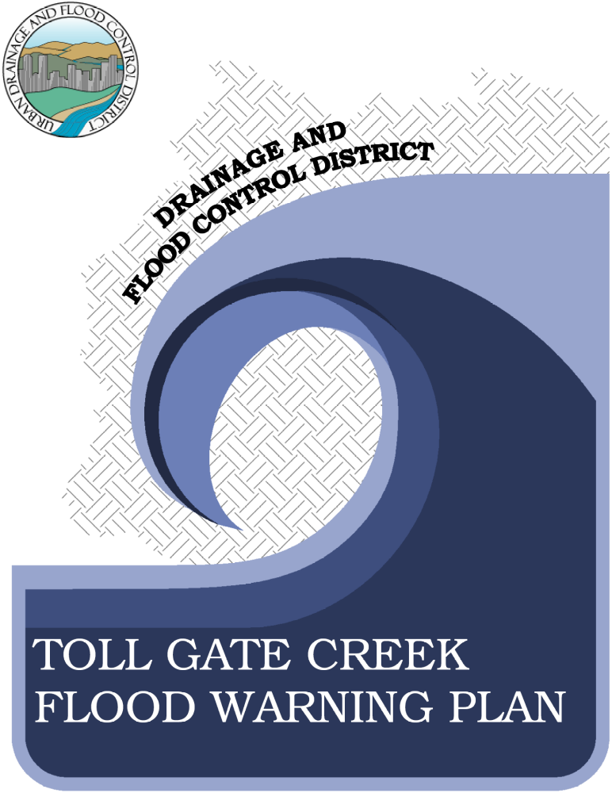
TOLL GATE CREEK FLOOD WARNING PLAN

TABLE OF CONTENTS
I. INTRODUCTION I-1
II. THE DRAINAGE BASIN II-1
Drainage Basin Description II-1
Existing flood control facilities II-5
Flood History II-6
Flood Hydrology II-7
Flooding Extent (100-Year Floodplain) II-24
III. DECISION AIDS III-1
General III-1
The Decision Making Process III-3
Problem Areas & Runoff Response Timing III-7
IV. REQUIRED ELEMENTS OF THE WARNING PLAN IV-1
Detection and Evaluation of the Flood Threat IV-1
Dissemination of Warnings, Watches and Advisories to the Public IV-2
Response of the Public to the Warning IV-5
V. COMMUNICATIONS V-1
VI. METEOROLOGICAL SUPPORT VI-1
VII. FLOOD THREAT RECOGNITION AND WARNING PROCESS VII-1
Detection and Evaluation of the Flood Threat VII-1
Dissemination of the Warning VII-2
Step by Step Procedure VII-2
VIII. PROCEDURES AND GENERAL RESPONSIBILITIES VIII-1
National Weather Service and Private Meteorological Service VIII-1
City of Aurora VIII-3
IX. PUBLIC DISSEMINATION IX-1
X. MEDIA CONTACTS X-1
XI. ANNUAL REVISIONS AND PRACTICES XI-1

TOLL GATE CREEK FLOOD WARNING PLAN

LIST OF FIGURES

Figure II-1 Toll Gate Creek Watershed II-4
Figure II-2 East Toll Gate Creek Peak Discharge (Existing Conditions) II-8
Figure II-3 West Toll Gate Creek Peak Discharge (Existing Conditions) II-9
Figure II-4 East Toll Gate Creek Peak Discharge (Future Conditions) II-10
Figure II-5 West Toll Gate Creek Peak Discharge (Future Conditions) II-11
Figure II-6 Toll Gate Creek Watershed – Modeled Peak Flows (cfs) II-12
Figure II-7 Lower Toll Gate Creek Hydrographs (Existing and Future Conditions) II-13
Figure II-8 Lower Toll Gate Creek Hydrographs (cont.) II-14
Figure II-9 West Toll Gate Creek Hydrographs (Existing and Future Conditions) II-15
Figure II-10 West Toll Gate Creek Hydrographs (cont.) II-16
Figure II-11 West Toll Gate Creek Hydrographs (cont.) II-17
Figure II-12 West Toll Gate Creek Hydrographs (cont.) II-18
Figure II-13 East Toll Gate Creek Hydrographs (Existing and Future Conditions) II-19
Figure II-14 East Toll Gate Creek Hydrographs (cont.) II-20
Figure II-15 East Toll Gate Creek Hydrographs (cont.) II-21
Figure II-16 East Toll Gate Creek Hydrographs (cont.) II-22
Figure II-17 Granby Drainageway Hydrographs (Existing and Future Conditions) II-23
Figure II-18 Toll Gate at 6th Avenue II-25
Figure II-19 West Toll Gate at Mexico Avenue II-26
Figure II-20 West Toll Gate at Confluence Pond II-27
Figure II-21 No Name Tributary at Quincy Avenue II-28
Figure II-22 Sable Ditch at 18th Avenue II-29
Figure II-23 Granby Ditch at 6th Avenue II-30
Figure II-24 East Toll Gate at Buckley Road II-31

Figure III-1 ALERT Flood Detection Network III-4
Figure III-2 Hydrologic Forecast Point Guidance III-6
Figure III-3 Approximate Location of Flood Hazard Areas III-8
Figure III-4 Typical ALERT Stream Gage Graphics III-17
Figure III-5 Storm Drainage Operations Response Areas (August 1992) III-18
Figure III-6 Storm Drainage Operations Plan (August 1992) III-19

Figure V-1 Internal Communications Flow Chart V-3

Figure VIII-1 Excerpt: Aurora – EOP - Flash Flood Annex (August 1992) VIII-4

LIST OF TABLES

Table II-1 Design Rainfall (total depths in inches) II-3
Table II-2 Quincy Reservoir Flood Detention Rating Curve II-5
Table II-3 Historic Flooding/High Water Measurements II-7

Table III-1 Toll Gate Creek ALERT Flood Detection Network III-5
Table III-2 Urban Flash Flood Guidance III-5
Table III-3 Convective Storm Characteristics (All depths in inches) III-5
Table III-4 Hydrologic Forecast Point Location Descriptions III-7

LIST OF NOMOGRAPHS

Nomograph III-1 HFP#1 – Toll Gate Creek at 6th Avenue III-9
Nomograph III-2 HFP #2 – West Toll Gate below Mexico at Horseshoe Drop Structure III-10
Nomograph III-3 HFP #3 – West Toll Gate Creek below Confluence Pond (1 of 2) III-11
Nomograph III-4 HFP #3 – West Toll gate at Confluence Pond (2 of 2) III-12
Nomograph III-5 HFP #4 – No Name Creek (Toll Gate) at Quincy Road III-13
Nomograph III-6 HFP #5 – Sable Ditch at 18th Avenue III-14
Nomograph III-7 HFP #6 – Granby Ditch at 6th Avenue Detention Pond Outlet III-15
Nomograph III-8 HFP #7 – East Toll Gate at Buckley Road III-16

INTRODUCTION
The flood warning plan for the Toll Gate Creek drainage basin is supplemental to local emergency operation plans. As such, it provides a set of operational procedures to be carried out before and during a flood. Flood response planning and emergency response must be a multi-jurisdictional effort between the City of Aurora and surrounding governmental entities.
The Toll Gate Creek Flood Warning Plan is designed primarily to reduce the potential for loss of life resulting from flash floods within the Toll Gate Creek drainage basin. This includes flood hazard areas located outside of defined floodplains. The Toll Gate Creek Flood Warning Plan addresses this possibility by recognizing critical rainfall thresholds capable of causing this type of problem. This plan was prepared by Urban Drainage and Flood Control District (UDFCD) and the City of Aurora in cooperation with the National Weather Service. UDFCD acknowledges the valuable contributions of many individuals that assisted in preparing this plan.
Users of this plan should be aware of the area wide meteorological support services provided through UDFCD's Flash Flood Prediction Program, the weather and flood forecast information available via the Internet, fax and email communications, and the real-time rainfall and stream level data from the automated flood detection network known as the ALERT System.
Plan holders should read the entire plan carefully to be aware of all of its elements. Users should also understand the following:

The Parties believe that the early flood detection system contemplated by this Agreement will be useful as a first step in developing a flood warning system. They recognize however, that the possibility of inadvertent error in design or failure of equipment to function may prevent the system from operating perfectly at all times. Therefore, nothing contained herein may be constructed as a guarantee of the system or its operation, or create any liability on the part of any party or its directors, officers, employees or agents for any damage that may be alleged to result from the operation, or failure to operate, of the system or any of its component parts.

By entering into this Agreement, none of the entities are assuming responsibility for flood detection or warning and expressly disclaim any legal duty to provide or participate in any plan or system of flood detection or warning. This Agreement shall constitute notice to any and all persons or parties that the DISTRICT and AURORA or any officer, agent or employee thereof, shall not be liable for any injuries or damages of what ever kind that may result from reliance on the terms and conditions of this Agreement and any system established pursuant thereto.
NOTE: Similar language found in Agreement No. 88-11.02

THE DRAINAGE BASIN
This section provides an overview of the watershed and flood hazards associated with Toll Gate Creek including descriptions of the drainage basin, historic floods, flood hydrology, and flooding extents. Much of the information in this section was excerpted from the following flood studies:
1. Federal Emergency Management Agency, September 15, 1989, Flood Insurance Study, City of Aurora, Colorado.
2. Kiowa Engineering Corporation, September 1990, Flood Hazard Area Delineation, Granby and Sable Drainageway.
3. Kiowa Engineering Corporation, August 1990, Upper Toll Gate Creek Basin, Outfall Planning Study.
4. Kiowa Engineering Corporation, August 2006, Toll Gate Creek Watershed, Hydrology Report.
5. NOAA, National Climatic Data Center, Flood Event Record Details, Toll Gate Creek.

Drainage Basin Description
Toll Gate Creek outfalls to Sand Creek south of Interstate 70. The watershed is generally bounded by Peoria Street to the west, E-470 to the east, Smoky Hill Road to the south, and I-70 to the north. The Toll Gate Creek watershed has a drainage area of 40.5 square miles and is a south bank tributary to Sand Creek. Figure II-1 shows the watershed location within the Denver metro area. The main channel extends upstream from its outfall at a slope of 0.5% for 3.3 miles to the confluence of East and West Toll Gate Creeks. The channel along East Toll Gate Creek has a length of 14 miles at a slope of 1% and the channel along West Toll Gate Creek has a length of 13 miles a slope of 1%.
The basin is heavily urbanized. Two-thirds of the surface land area has been developed and only 6% of the area is available for additional future development. Much of the existing open space is dedicated to parks, open space, drainage ways, and golf courses. Existing development within the study area is mixed use, including mostly single-family residential (55% impervious) and commercial development (85% impervious). The overall watershed imperviousness for existing conditions is 40%. The overall watershed imperviousness for future, fully-developed conditions is 47%.
The basin can be separated into three regional watersheds: Lower Toll Gate Creek, East Toll Gate Creek, and West Toll Gate Creek. Lower Toll Gate Creek is the drainage area between the confluence of the East and West branches and the outfall to Sand Creek. Both East and West Toll Gate Creeks have smaller tributary areas and sub-regions defined within each of them.

Lower Toll Gate Creek
Lower Toll Gate Creek has a direct drainage area of 3.6 square miles. The main channel has a length of 3.3 miles at a slope of 0.5%. Land use in this area is highly urbanized as 76% of the surface area is developed. This part of the watershed is nearly fully-developed as only 4% remains developable.
The main transportation features in this area are Interstate 225, Colfax Avenue, and 6th Avenue. The largest residential developments include Aurora Hills, Lynn Knoll, and Hoffman Heights subdivisions. Also included in this area are the Fitzsimons General Hospital (historical) and the Medical Center of Aurora. Dedicated undeveloped areas include Aurora Hills Golf Course, Bicentennial, Highline, Hoffman, and Sand Creek Parks.
In addition to receiving flows from East and West Toll Gate Creeks, Lower Toll Gate receives flows from Granby Drainageway, a 2.3 square mile tributary area.

east Toll Gate Creek
The East Toll Gate Creek watershed covers 11.1 square miles. The channel has a length of 14 miles at a slope of 1 %. The watershed shape is long and narrow. There are three tributaries that outfall to the main channel in the lower part of the study areas. The three tributaries are Buckley Tributary (0.8 sq.mi.), Columbia Creek (0.7 sq.mi.), and East Toll Gate Tributary (1.9 sq.mi.). Nearly 55% of this watershed remains undeveloped. However, only 10% of the watershed area is available for future development. The largest land areas are the Plains Conservation Center and Buckley Air Force Base (AFB), both of which are predominantly open space. Additional dedicated open lands are Signature Park, Centre Hills Golf Course, Great Plains Park, and Delaney Farms.
The existing development in the area is mixed use single-family residential, multi-family residential and commercial. The most notable development is the Community College of Aurora, Buckley AFB facilities, and the Southlands, and Saddle Rock Marketplace. The largest residential developments include Sorrel Ranch, Dove Hill, Tollgate Crossing, Quincy Highlands, Aurora Highlands, and Robinwood.

West Toll Gate Creek
The West Toll Gate Creek watershed covers 23.5 square miles. The main channel has a length of 13 miles at a slope of 1 %. There are six tributaries that outfall to the main channel. The six tributaries are Unnamed Tributary (6.0 sq.mi.), Quincy Reservoir (7.1 sq.mi.), Meadowood Tributary (2.6 sq.mi.), Cherry Creek Spillway (2.0 sq.mi.), Woodrim Tributary (0.6 sq.mi.), and Aurora Mall Drainageway (1.1 sq.mi.).
Nearly 20% of this watershed remains undeveloped. However, only 5% of the watershed area is available for future development. The largest land areas dedicated to open space are Quincy Reservoir, Cheer Creek Spillway, Horseshoe Park and Delaney Fanns.
The primary development in the area is single-family residential covering more than 50% of the drainage area. Multi-family residential and commercial comprises an additional 25%. The most notable development is the Aurora Mall and the City of Aurora municipal complex.

Rainfall
The design rainfall for the watershed was determined from the Urban Storm Drainage Criteria Manual. One-hour and six-hour point rainfall depths were taken from the Rainfall Figures RA-I through RA-I2. Through the UDFCD spreadsheets, the one-hour point rainfall depths were distributed over a two-hour duration. Due to the size of the watershed, aerial adjustments were applied to those reaches draining areas greater than 10 square miles. Aerial adjustments were analyzed for reaches receiving greater than 10 square miles and less than 20 square, and also for areas greater than 20 square miles.
Table II-1 Design Rainfall (total depths in inches)

Unadjusted [2-hour, less than 20 square miles]
2-year | 5-year | 10-year | 25- year | 50- year | 100- year | 500- year
1.12 | 1.60 | 1.87 | 2.31 | 2.67 | 3.08 | 4.10
Aerial Adjusted [6-hour, greater than 20 square miles]
1.35 | 1.89 | 2.15 | 2.72 | 2.96 | 3.37 | 4.39

Figure II-1 Toll Gate Creek Watershed

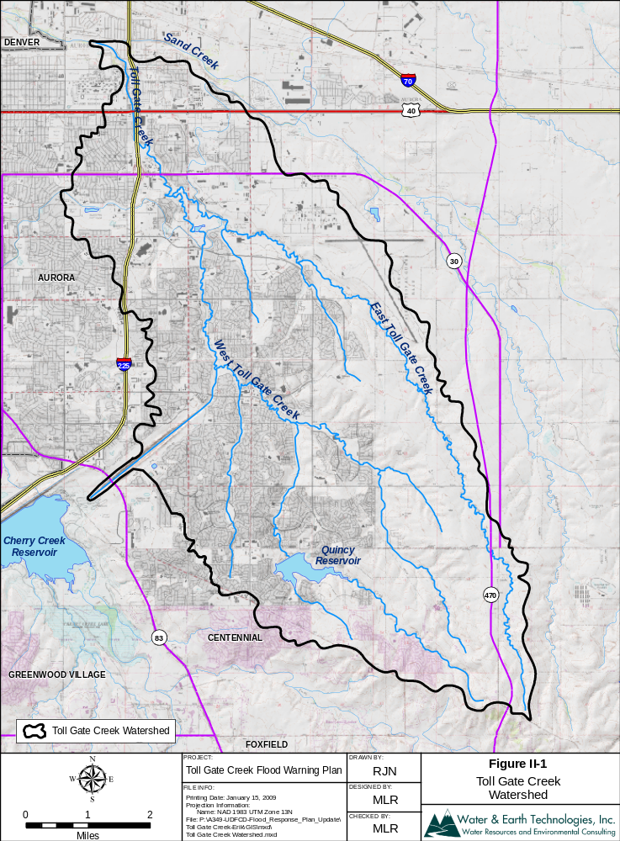

Existing flood control facilities
A total of seventeen flood detention facilities are located within the Toll Gate Creek drainage basin. These facilities provide some degree of flood protection in their immediate vicinity but have little effect on stream flows once the floodwaters leave the basin. There are two facilities within the Unnamed Tributary, two within East Toll Gate Creek, one within Aurora Mall Drainageway, one within Granby Drainageway and eleven facilities within Quincy Reservoir drainage area including Quincy Reservoir itself. The largest facility affecting flooding in the basin is Quincy Reservoir.

Quincy Reservoir
Quincy Reservoir is not a flood detention facility and is in no way regulated for flood control. However, the facility does inadvertently detain flood runoff from the upstream drainage area. Once floodwaters exceed the 5-year bypass channel, flows enter the reservoir. The hydrology developed for Toll Gate Creek considers no flood detention below the spillway elevation. The reservoir is assumed to be 100 percent full prior to any flood storage consideration. With that said, there is significant flood storage volume available between the spillway elevation and top of dam.
The spillway elevation is set at elevation 5712. When water in Quincy Reservoir reaches this point it is considered brim full and at maximum capacity for its intended use. At this point flood storage can be calculated as a secondary, unintended use. In modeling flood detention for Quincy Reservoir, the rating curve begins at elevation 5712 with zero available volume and zero outflow. Only during large flood events will water rise above 5712. When this occurs water spills through the spillway and storage begins to build in the reservoir. The spillway was a width of 180-feet. Outflow was calculated using the weir equation with a coefficient value of 3.0. The following table shows the rating curve used to develop the hydrology in Toll Gate Creek.
Table II-2 Quincy Reservoir Flood Detention Rating Curve

Elevation (ft) | Volume (acft) | Q (cfs) | Comment
5712 | 0 | 0 | Spillway Elevation
5714 | 294 | 1,527
5716 | 605 | 4,320
5718 | 938 | 7,936
5720 | 1,311 | 12,219
5722 | 1,727 | 114,316 | Top of Dam

Flood History
Little information is available on past flooding on Toll Gate Creek. Discharge measurements, high water marks and other flood data are limited. Historically floods have and will continue to occur in the basin.
1951, May. Major flooding produced a peak flow of 10,500 cfs at 6th Avenue. Three lives were lost along Toll Gate Creek.
1965, June 16th & 17th. Floods produced a peak flow of 17,000 cfs at 6th Avenue. Many bridges were damaged or destroyed and damages were estimated to be $688,000.
1973, May 9. The only known written account of flooding on Granby Drainageway was reported in the Aurora Advocate Sentinel on May 9, 1973. This flooding was caused by heavy rains leading to the failure of the Highline Canal bank upstream from Eighth Avenue and Hannibal Drive. Several basements and streets were flooded as a result.
1991, June 6. A tornado was sighted in Arapahoe County with 3-second wind gusts ranging from 79 to 117 mph. One inch of hail was recorded in Adams County.
1997, July 27. High waters from swollen creeks and streams washed out bridges and several sections of road in southeast Aurora. A 200-300 foot section of road was washed away where Picadilly Street dipped across Coal Creek. Three youths had to be rescued when they became stranded by rapidly rising water in another normally small creek.
1997, July 29. Heavy rain caused flooding and flash flooding problems in central portions of Adams and Arapahoe Counties. Quincy Road had to be blocked off between County Roads 129 and 137 in Arapahoe County. Up to 4 feet of water reportedly covered the roadway.
1999, August 19. Heavy rain, up to 5 inches in two hours, caused East Tollgate Creek to jump its banks. The bike path adjacent to the creek was underwater at several locations. Several underpasses were also flooded, halting traffic.
2001, July 8. Up to 4.5 inches of rain fell across portions of western Arapahoe County. The underpass of Interstate 25 and Parker Road was inundated with 5 feet of water. Several other streets and underpasses in Aurora were also closed due to the high water. Heavy rain caused extensive damage to several exhibits on display at the Cherry Creek Arts Festival.
Three inches of rain reportedly fell near the Greenwood Village Police Department in a span of 15 minutes. Heavy runoff caused Toll Gate Creek to jump its banks, flooding low lying areas of Parker Road.
2004, July 23. Heavy rain, up to 2 inches in 45 minutes, caused flash flooding problems east of Aurora. Floodwaters, ranging from 2 to 3 feet deep, forced the closure of Powhaten, Gun Club and Picadilly Roads.
2005, June 3. Thunderstorms brought heavy rain to parts of Arapahoe County. Up to 3 feet of standing water was reported over East Orchard Road. Several motorists were stranded in their vehicles and needed to be rescued.
2006, July 3. Heavy rainfall caused minor flooding along Murphy and Sand Creeks, just east of Buckley Air Force Base. Gun Club Road was closed between Alameda and Mississippi Avenues, north of Murphy Creek Golf Course, where three feet of standing water covered the road.
Table II-3 Historic Flooding/High Water Measurements

Station | ALERT  ID | Peak Stage  (ft) | Peak Flow  (cfs) | Date
Toll Gate at 6th Ave | 703 | 8.5 | 3,720 | July 3, 2006
Horseshoe Park Drop | 713 | 3.2 | 1,910 | June 3, 2005
WTG above Conf Pond | 723 | 1.8 | 510 | August 23, 1992
Confluence Pond | 724 | 3.7 | 1,080 | July 23, 2004
No Name @ Quincy | 733 | 7.1 | 620 | July 23, 2004
Sable Ditch @ 18th | 803 | 3.1 | 240 | June 6, 1991
Granby Ditch @ 6th | 813 | 11.0 | 52 | July 30, 1997
ETG @ Buckley | 823 | 3.7 | 1,610 | June 6, 1991

Flood Hydrology
It is important to remember that many different combinations of rainfall and runoff are possible. The information presented herein is considered reasonable for planning purposes, but is not intended as the only rainfall/runoff scenario possible.
The most recent hydrologic analysis for Toll Gate Creek was prepared by Kiowa Engineering Corporation, August 2006, Toll Gate Creek Watershed, Hydrology Report.
This study accounts for the recent changes in detention facilities and determines the peak discharges for the 2-, 5-, 10-, 25-, 50-, and 100-year floods at various points along the creek. The discharge profile plots for these design floods along East and West Toll Gate Creek are provided below and include both the present and future conditions.

Figure II-2 East Toll Gate Creek Peak Discharge (Existing Conditions)
Figure II-3 West Toll Gate Creek Peak Discharge (Existing Conditions)
Figure II-4 East Toll Gate Creek Peak Discharge (Future Conditions)
Figure II-5 West Toll Gate Creek Peak Discharge (Future Conditions)

Figure II-6 Toll Gate Creek Watershed – Modeled Peak Flows (cfs)

Figure II-7 Lower Toll Gate Creek Hydrographs (Existing and Future Conditions)
Figure II-8 Lower Toll Gate Creek Hydrographs (cont.)
Figure II-9 West Toll Gate Creek Hydrographs (Existing and Future Conditions)
Figure II-10 West Toll Gate Creek Hydrographs (cont.)
Figure II-11 West Toll Gate Creek Hydrographs (cont.)
Figure II-12 West Toll Gate Creek Hydrographs (cont.)
Figure II-13 East Toll Gate Creek Hydrographs (Existing and Future Conditions)
Figure II-14 East Toll Gate Creek Hydrographs (cont.)
Figure II-15 East Toll Gate Creek Hydrographs (cont.)
Figure II-16 East Toll Gate Creek Hydrographs (cont.)
Figure II-17 Granby Drainageway Hydrographs (Existing and Future Conditions)

Flooding Extent (100-Year Floodplain)
The 100-year floodplain and floodway have been delineated along Toll Gate Creek from the southern reaches of the watershed to its confluence with Sand Creek. The limits of the 100-year floodplain and floodway represent the area in which development is often regulated to prevent increases in water levels and increased damages during a flood. Federal and state agencies such as the Federal Emergency Management Agency (FEMA) and the Urban Drainage and Flood Control District use the floodplain and floodway delineations as a mechanism to identify areas particularly prone to damage from flooding and to oversee development activities in these floodplains.
The basis for this floodplain and floodway delineation is the hydrology, which has been summarized in an earlier section of this report. The delineation assumes full basin development, based on land use and zoning projections provided by the affected communities, and existing channel conditions. A hydraulic analysis has been performed for the 100-year discharge, the results of which were used to plot the 100-year floodplain. The following images show the extent of the 100-year floodplain near each Hydrologic Forecast Point.
Figure II-18 Toll Gate at 6th Avenue

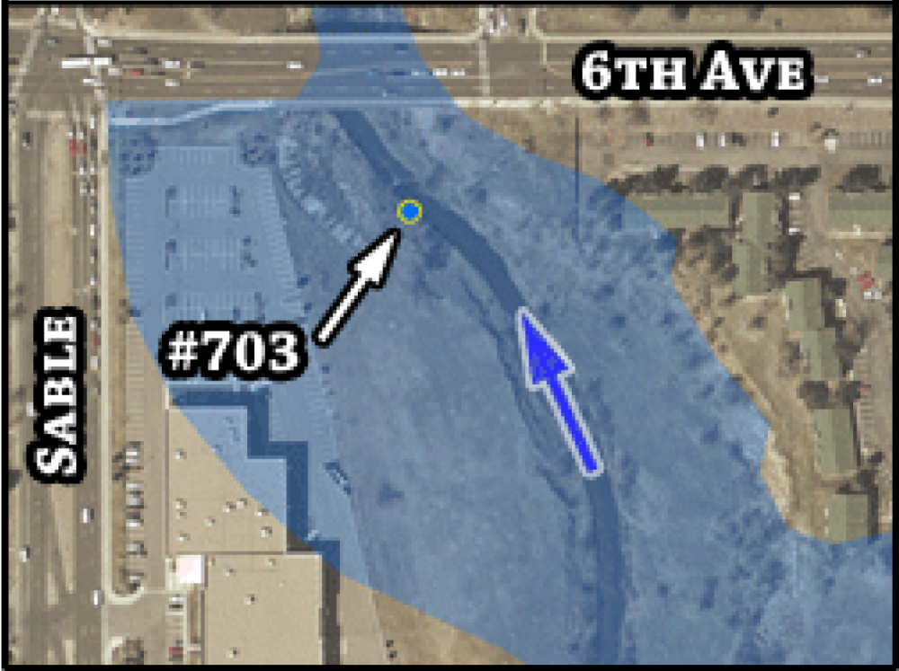

Figure II-19 West Toll Gate at Mexico Avenue

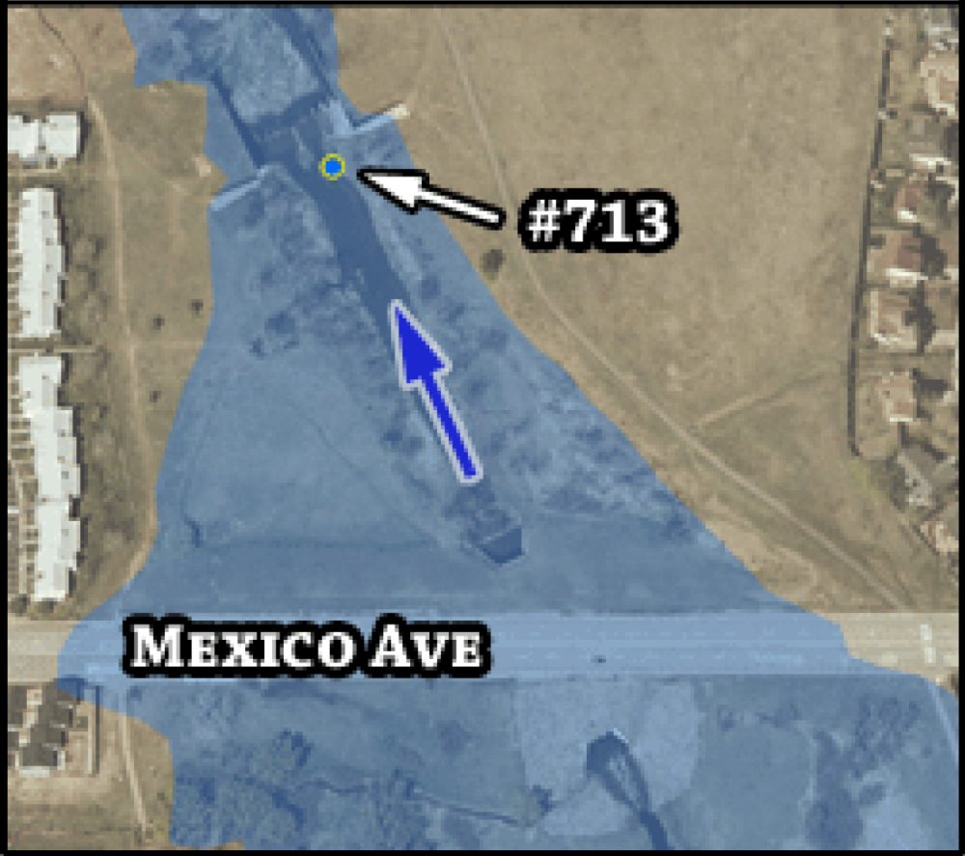
Figure II-20 West Toll Gate at Confluence Pond

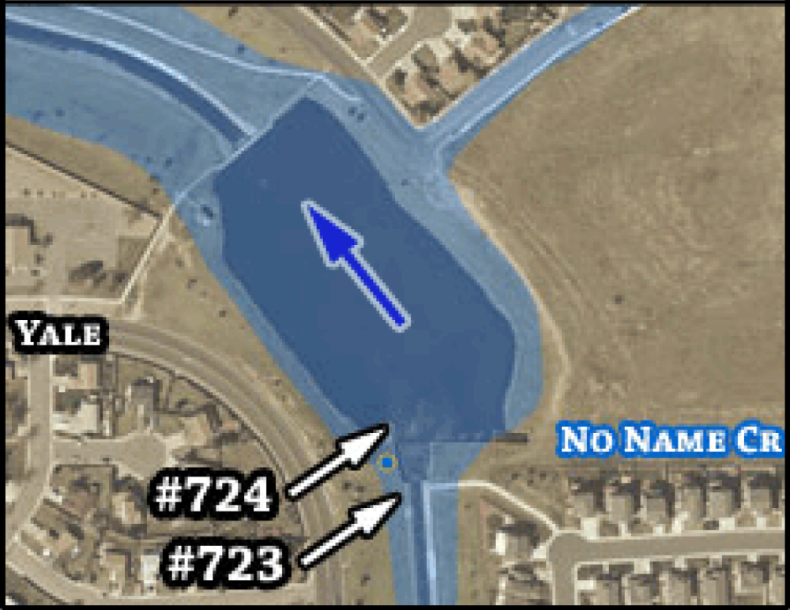

Figure II-21 No Name Tributary at Quincy Avenue

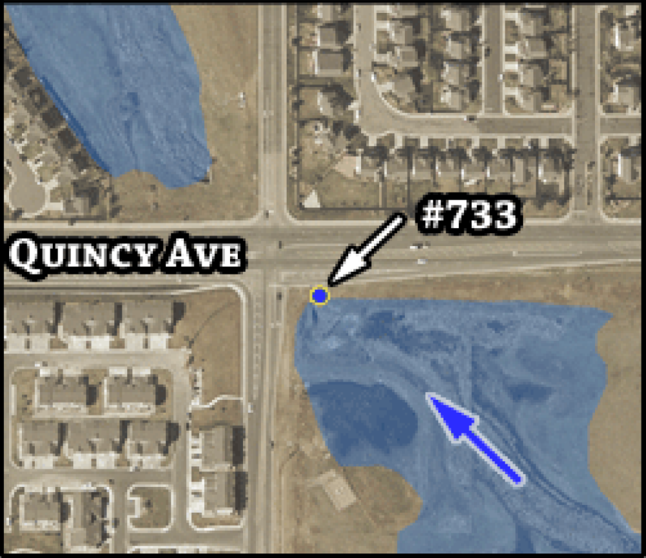

Figure II-22 Sable Ditch at 18th Avenue

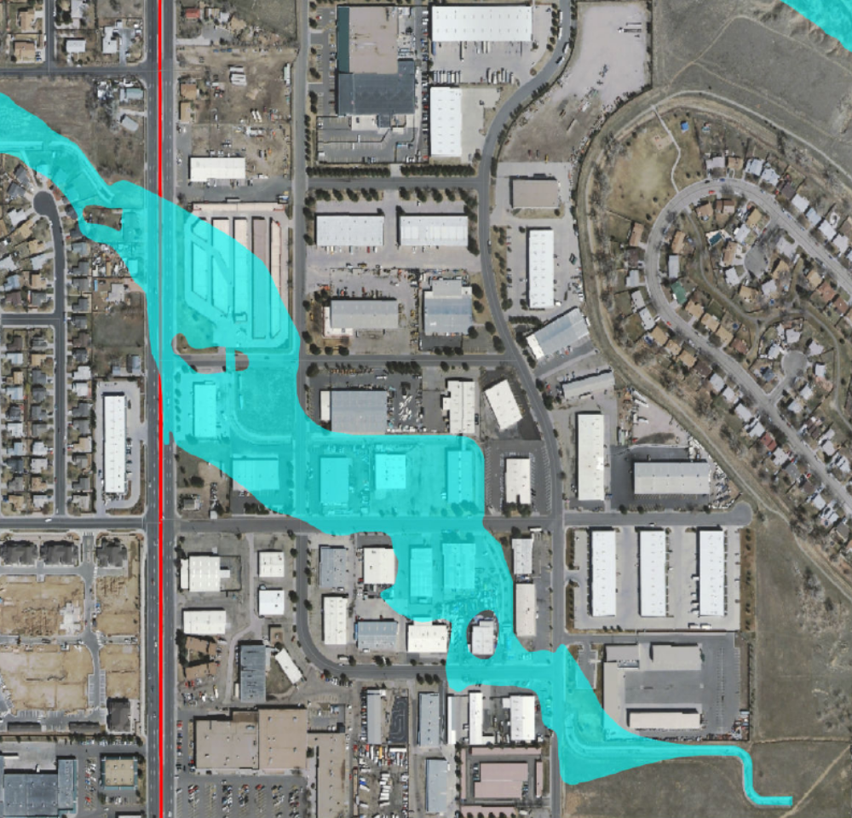
# 803
Chambers Road
18th Avenue

Figure II-23 Granby Ditch at 6th Avenue

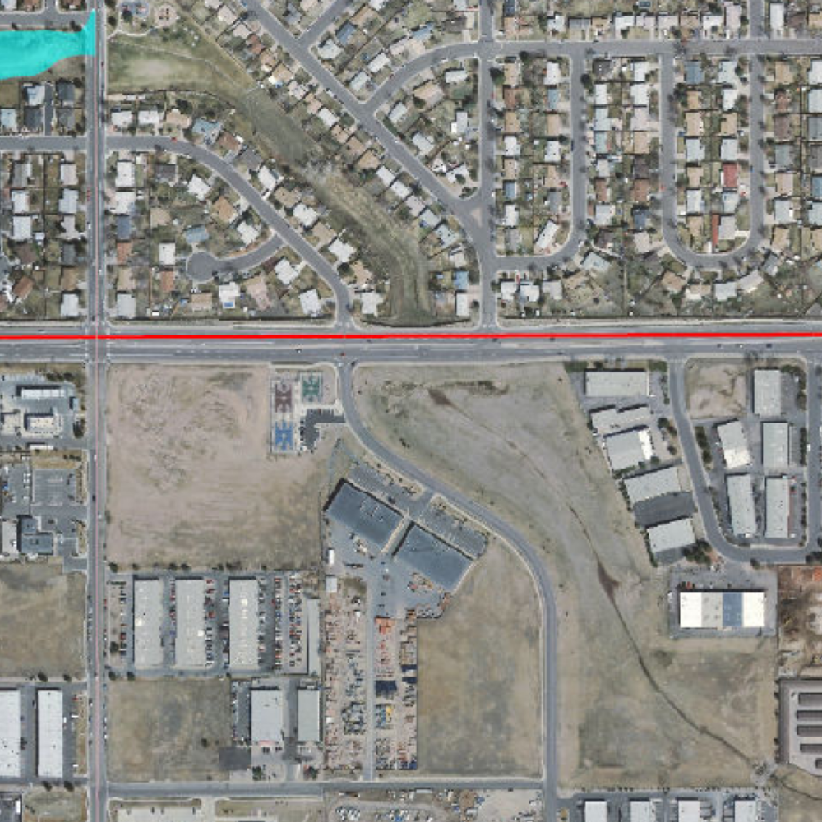
# 813
6th Avenue

Figure II-24 East Toll Gate at Buckley Road

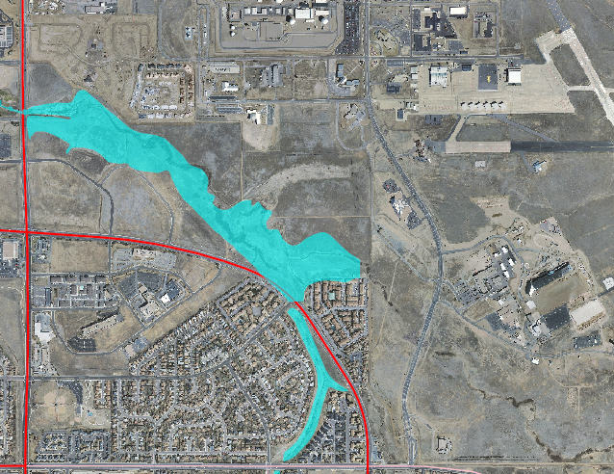
# 823
Buckley Road

DECISION AIDS

General
A private meteorological forecasting service (PMS), retained by Urban Drainage and Flood Control District (UDFCD) will use decision aids for issuing appropriate messages in accordance with standard operating procedures and the supplemental information contained in this flood warning plan. Flood conditions can be anticipated from the forecast. Measured rainfall and the site-specific decision aids and urban flash flood guidance are provided herein. Updates to the decision aids included with this warning plan will be made as experience is gained and more data become available.
The ALERT system is an automated flood detection network consisting of self-reporting rain, stream, weather, and reservoir gages that relay data using battery-powered VHF radios. The ALERT network in the basin consists of multiple stations that measure rainfall, stream, weather, and reservoir information. These gages are part of a much larger network operated by UDFCD. ALERT receiving base stations located at UDFCD’s main office and the UDFCD Flood Prediction Center (FPC) collect and display data from the ALERT network in real-time. The UDFCD base stations also host web services that allow users to view information over the Internet. Rainfall and stream level alarms will alert users of threatening conditions. Alarm notifications can be emailed automatically to warning plan participants. Data from the gaging network are used to update flood peak forecasts, estimate flow arrival times and predict flood impacts at specific locations.
PMS is responsible for monitoring the FPC base station, evaluating the real-time data and updating forecasts with the use of available decision aids. Simplified charts, tables, computer graphics and hydrologic models are the principle decision aids used to forecast flood conditions for specific problem areas. Sections IV through VIII contain additional information concerning PMS operations and responsibilities.
Flood warning plan participants and local emergency response personnel have access to the current PMS forecast (pager, email, fax, or Internet…http://f2p2.udfcd.org). ALERT gage data are available from Internet websites maintained by UDFCD (http://alert.udfcd.org and http://alert2.udfcd.org). Individuals should make their own assessments of the flood threat by using the gage data, the PMS and NWS forecasts and any observations obtained from field personnel (police, sheriff, fire, public works, etc.) or other reliable sources. Close coordination with public safety agencies should be maintained throughout this process.
The following decision aids are contained in this section of the warning plan:
- Approximate Flood Hazard Areas. This map shows the approximate flood hazard areas. Brochures prepared from these GIS maps are distributed annually by the District to residences and businesses located in or near the respective floodplains.
- ALERT Flood Detection Network. This map shows the location of all ALERT gaging stations within the basin and in surrounding areas.
- ALERT System Summary. This table provides basic information regarding each gage in the drainage basin.
- Urban Flash Flood Guidance. This table provides very basic rule-of-thumb guidance to associate forecast or measured rainfall amounts with the type of flooding produced from heavy rainstorms that occur over urban areas.
- Two Hour Convective Storm Characteristics. This table is used to estimate the frequency of either forecast or measured point rainfall. Both the total rainfall and intensity columns need to be carefully considered in making this estimate. This table is designed for use by trained technical personnel (hydrologists and hydro-meteorologists). In translating an estimate of precipitation frequency into a flood prediction for a specific point, the user must also estimate the spatial distribution of rain from the ALERT gages, radar, or detailed quantitative precipitation forecast (QPF); and then calculate either a total basin average or contributing drainage area relative to storm size. Hydrologic Forecast Point (HFP) Guidance can then be used to predict flooding for specific locations.
- Hydrologic Forecast Point (HFP) Guidance. A location map showing each HFP within the drainage basin is shown along with a description of each HFP location. Site-specific flash flood guidance for each HFP is provided on subsequent pages. Certain HFPs are co-located with ALERT stream gages. HFP decision aids can be used with either forecast or measured rainfall to anticipate flooding for known problem areas (i.e. developed floodplains, road crossings, depressions, low-lying areas, reservoirs, detention basins, etc.).
- Stage Sensor Computer Graphics. Real-time displays of current water levels and basin rainfall have been developed for ALERT base station operations. These displays update automatically as data are received. Each graphics template provides information regarding local problem areas, historic floods, flood frequency data, alarm levels, elevation data and structure dimensions.

The Decision Making Process
The earliest indication of a potential problem will likely be the forecast from PMS or NWS. When the threat of heavy rainfall exists, PMS will provide a Quantitative Precipitation Forecast (QPF) that estimates probabilities for various precipitation amounts and identifies where the greater amounts of precipitation are most likely to occur. Table III-2 should be used to estimate the flood potential and decision-makers should consider the recommended actions. Table III-3 and the HFP decision aids should than be checked to determine if the forecast rainfall will cause problems at or near the HFPs. If no problems are anticipated based on this review, a normal level of vigilance should be maintained. However, if the decision aids indicate a dangerous flood potential, a higher level of awareness should be maintained.
Decision makers should re-analyze flood threat once rainfall has begun and the gages are reporting. To generate a flood projection, determine the maximum 10-, 30- and 60-minute rainfall amounts that have occurred or are projected based on measured rainfall and other meteorological information (radar, satellite imagery, upper air soundings, surface weather data, etc.). Continue to make projections until the rainfall event has passed, problems have occurred, or the threat no longer exists.
The final confirmation that the drainage basin is indeed responding to significant rainfall is the rising stage measured by the ALERT stream gages and field reports from police, fire, public works personnel, or other reliable sources. Although it is tempting to wait for this final confirmation, doing so will severely limit the time available to warn floodplain occupants and dispatch emergency personnel to critical areas.
It is imperative to implement the warning and response elements of this plan once a significant flood hazard exists.

Figure III-25 ALERT Flood Detection Network

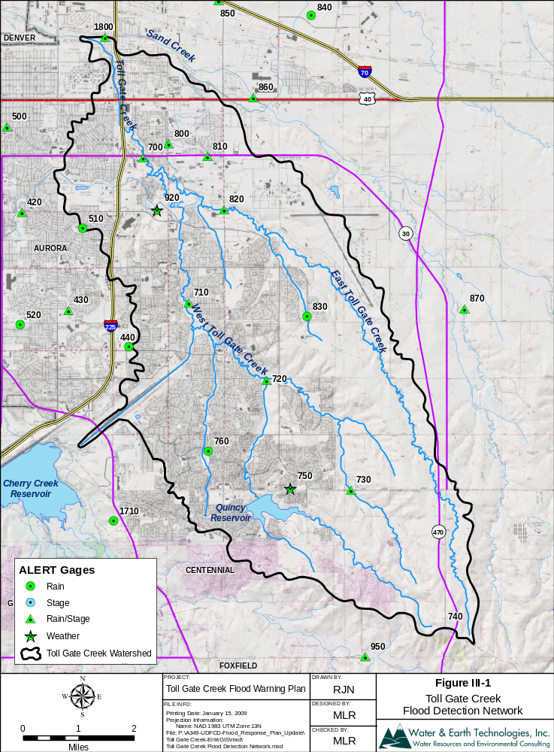

Table III-4 Toll Gate Creek ALERT Flood Detection Network

I.D. # | STATION NAME | GAGE TYPE | Install Date | Elev (ft) | Location (Lat./Long.)
700 | Toll Gate at 6th | Rain/Stage | 1989/11/07 | 5400 | 39:43:30 N 104:49:16 W
710 | Horseshoe Park Drop | Rain/Stage | 1989/07/17 | 6033 | 39:41:14 N 104:48:11 W
720 | Confluence Pond | Rain/Stage | 1989/07/25 | 5570 | 39:40:01 N 104:46:37 W
730 | No Name @ Quincy | Rain/Stage | 1990/08/13 | 5710 | 39:38:18 N 104:44:55 W
740 | Smoky Hill | Rain/Repeater | 1990/08/13 | 6080 | 39:36:15 N 104:42:59 W
750 | Quincy Reservoir | Weather | 1990/01/08 | 5750 | 39:38:20 N 104:46 08 W
760 | Mission Viejo Park | Rain | 1989/08/03 | 5660 | 39:38:55 N 104:47:47 W
800 | Sable Ditch @ 18th | Rain/Stage | 1989/08/02 | 5430 | 39:44:43 N 104:48:35 W
810 | Granby Ditch @ 6th | Rain/Stage | 1989/08/03 | 5455 | 39:43:31 N 104:47:48 W
820 | E. Toll Gate @ Buckley | Rain/Stage | 1989/08/03 | 5460 | 39:42:41 N 104:47:28 W
830 | Side Creek Park | Rain | 1989/08/03 | 5600 | 39:41:01 N 104:45:47 W
920 | Aurora Town Hall | Weather | 2007/10 | 5462 | 39:42:40 N 104:48:50 W

Table III-5 Urban Flash Flood Guidance

FORECAST RAINFALL | FLOOD POTENTIAL | RECOMMENDED ACTIONS
Total amount between 0.5” to 1.0” | Streets, low-lying areas, intersections | Prepare for routine nuisance flooding
Total amount = 1.0” to 2.0” | All of the above plus small streams will run bankfull | Prepare for flooding of frequent problem areas
Total amount = 2.0” to 3.0” | All of the above plus floodplain inundation | Prepare for street closures
Total amount more than 3.0” | Major overbank flooding expected | Prepare for floodplain evacuations
Note: Rainfall amounts and guidance information apply to short duration storms (<= 1-hour) | Note: Refer to basin flood warning plans for site specific data | Note: use judgment on when to warn public, maintain contact with meteorologist

Table III-6 Convective Storm Characteristics (All depths in inches)

Rainfall  Frequency / Probability | 10-minute  Rainfall Depth | 30-minute  Rainfall Depth | 1-hour  Rainfall Depth | 2-hour  Rainfall Depth
2-year / 50% | 0.4 | 0.8 | 1.0 | 1.2
5-year / 20% | 0.5 | 1.0 | 1.4 | 1.6
10-year / 10% | 0.6 | 1.2 | 1.6 | 1.9
25-year / 4% | 0.7 | 1.4 | 1.9 | 2.2
50-year / 2% | 0.8 | 1.6 | 2.2 | 2.6
100-year / 1% | 1.0 | 1.9 | 2.6 | 3.0
NOTES:
1) For "rainfall frequency" to equal "flood frequency," the coverage of rainfall must be over the entire upstream basin.
2) Tables III-2 and III-3 were developed to provide generalized guidance for estimating flood conditions in urban areas and for small streams draining less than 10 square miles. Site-specific guidance should be used where appropriate.

Figure III-26 Hydrologic Forecast Point Guidance

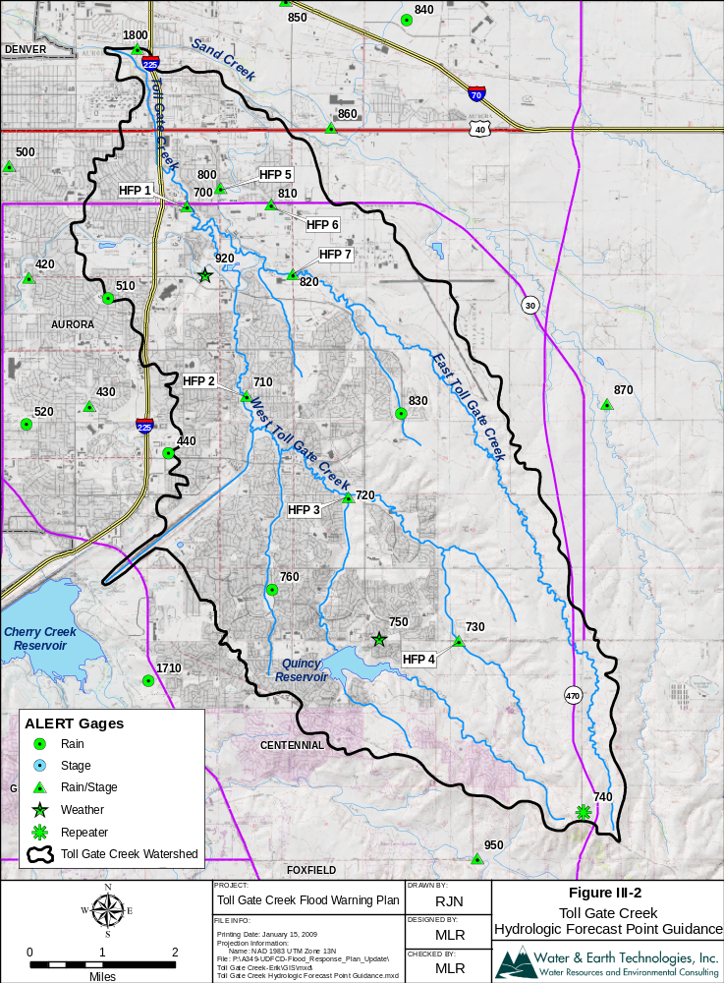
Table III-7 Hydrologic Forecast Point Location Descriptions

Hydrologic Forecast Point (HPF) | Description
HFP No. 1 | Toll Gate Creek at 6th Avenue (ID 703)
HFP No. 2 | West Toll Gate at Horseshoe Park Drop (ID 713)
HFP No. 3 (1 of 2) | West Toll Gate at Confluence Pond Outlet (ID 724)
HFP No. 3 (2 of 2) | West Toll Gate at Confluence Pond (ID 723)
HFP No. 4 | No Name Creek at Quincy Road (ID 733)
HFP No. 5 | Sable at 18th Avenue (ID 803)
HFP No. 6 | Granby Drainage at 6th Avenue Detention Pond Outlet (ID 813)
HFP No. 7 | East Toll Gate at Buckley Road (ID 823)

The following pages contain site-specific flash flood guidance nomographs for each HFP. Certain HFPs are co-located with ALERT stream gages. The nomograph anticipates flooding for known problem areas (i.e. developed floodplains, road crossings, depressions, low-lying areas, reservoirs, detention basins, etc.) using forecast rainfall or measured rainfall. The output from the nomograph provides a decision aid to support the evaluation of flooding for critical areas.

Problem Areas & Runoff Response Timing
This warning plan is geared toward overbank flooding from the main channels within the Toll Gate Creek drainage basin. The user should be aware that intense rainfall can overwhelm the local storm drainage system and cause minor flooding outside any identified flood hazard area.
Flooding occurs frequently where Toll Gate Creek flows under 6th Avenue. The bridge is undersized for a 100-year storm and will create large flood extents upstream of the bridge due to backwater conditions. This backwater effect will extend all the way to 1st Avenue and flood residential areas nearby.
Mexico Avenue will be overtopped at a discharge of 3,200 cfs or a stage of 4.5 feet during a 100-year storm event due to the limited capacity of the culvert that passes under the road.
Flooding will occur at Hampden Avenue, Uravan Street, Flanders Street, Tower Road, Chambers Road and Florida Avenue due to limited capacity of culverts or bridges in the 100-year event.
Flooding will occur at Granby Way due to backwater from the 6th Avenue bridge.
The flooding problem areas described are shown on the map below.
Figure III-27 Approximate Location of Flood Hazard Areas

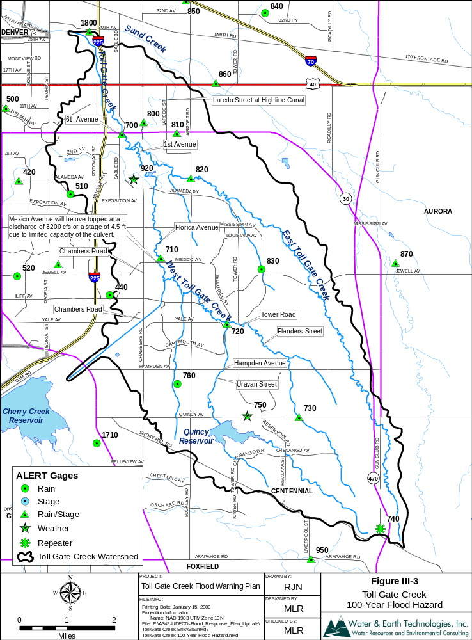

Nomograph III-1 HFP#1 – Toll Gate Creek at 6th Avenue
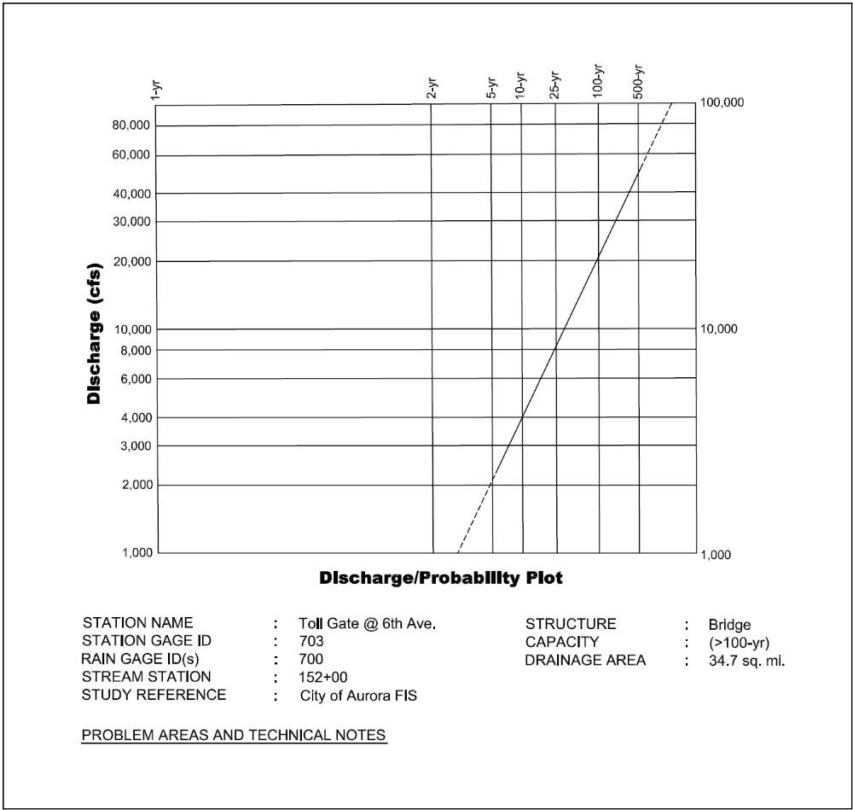

Nomograph III-2 HFP #2 – West Toll Gate below Mexico at Horseshoe Drop Structure
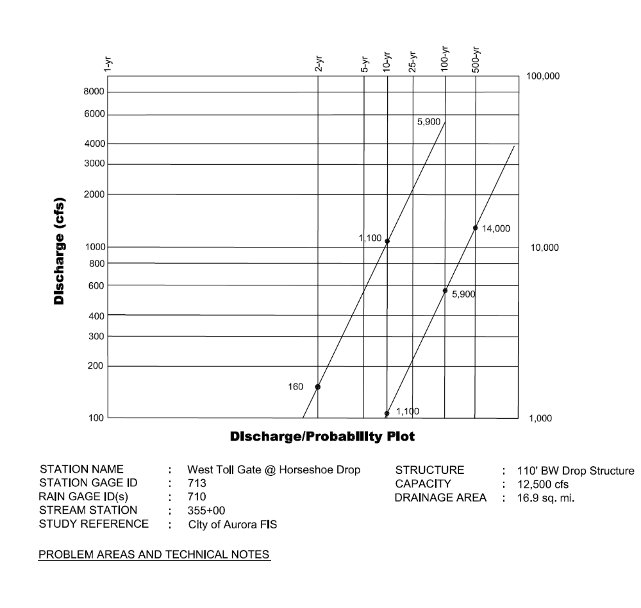

Nomograph III-3 HFP #3 – West Toll Gate Creek below Confluence Pond (1 of 2)
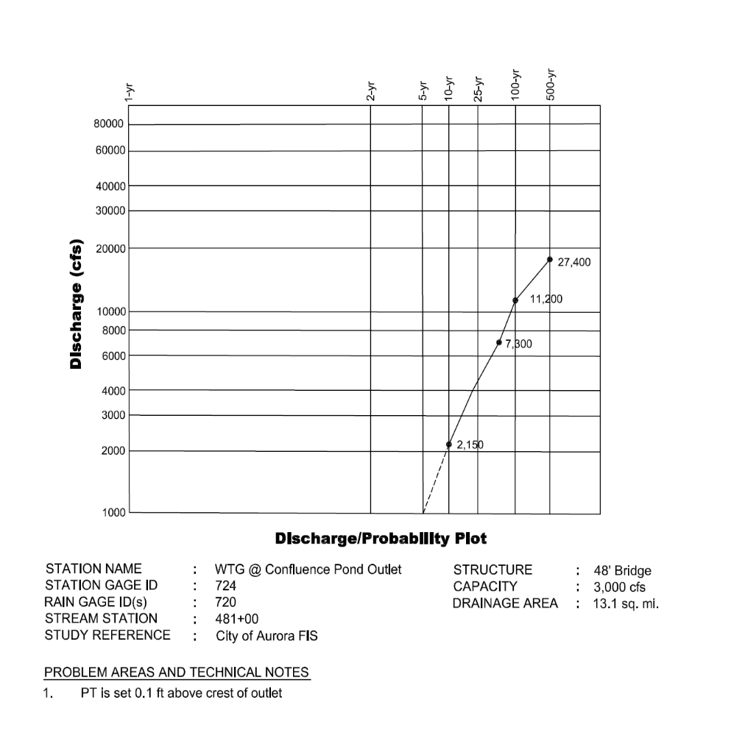

Nomograph III-4 HFP #3 – West Toll gate at Confluence Pond (2 of 2)
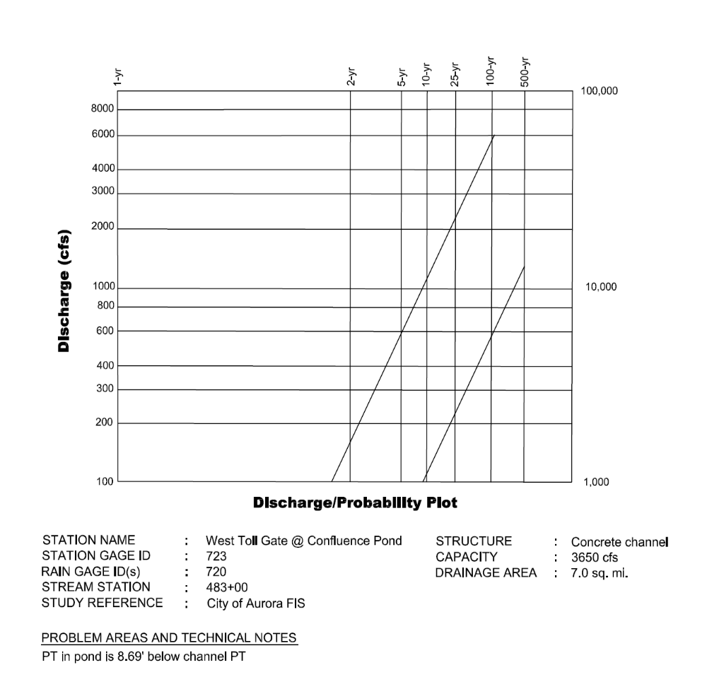

Nomograph III-5 HFP #4 – No Name Creek (Toll Gate) at Quincy Road
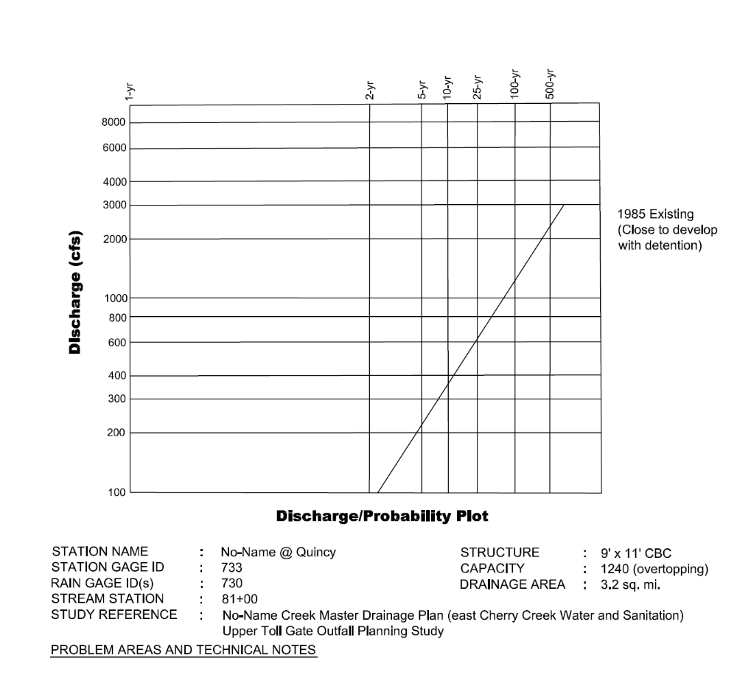

Nomograph III-6 HFP #5 – Sable Ditch at 18th Avenue

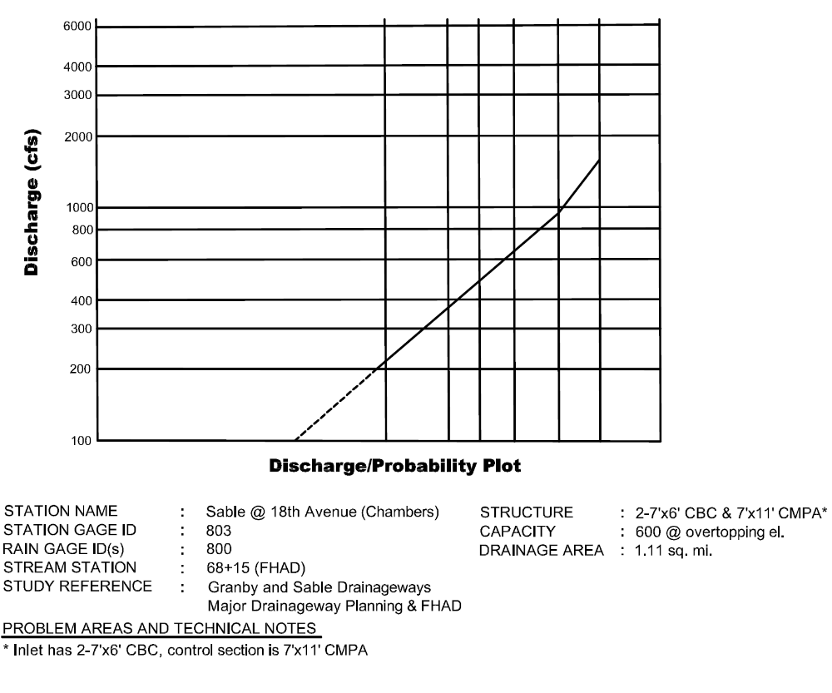

Nomograph III-7 HFP #6 – Granby Ditch at 6th Avenue Detention Pond Outlet

Nomograph III-8 HFP #7 – East Toll Gate at Buckley Road
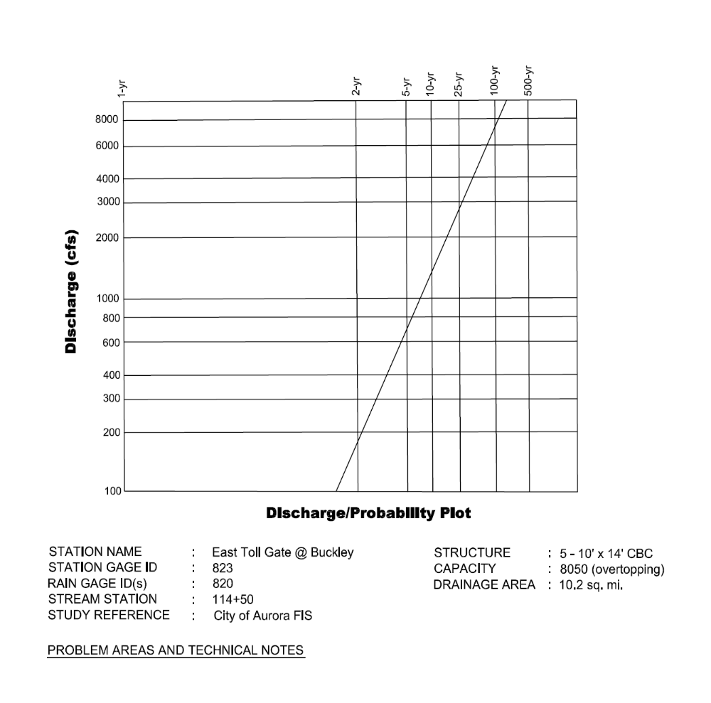
Figure III-28 Typical ALERT Stream Gage Graphics

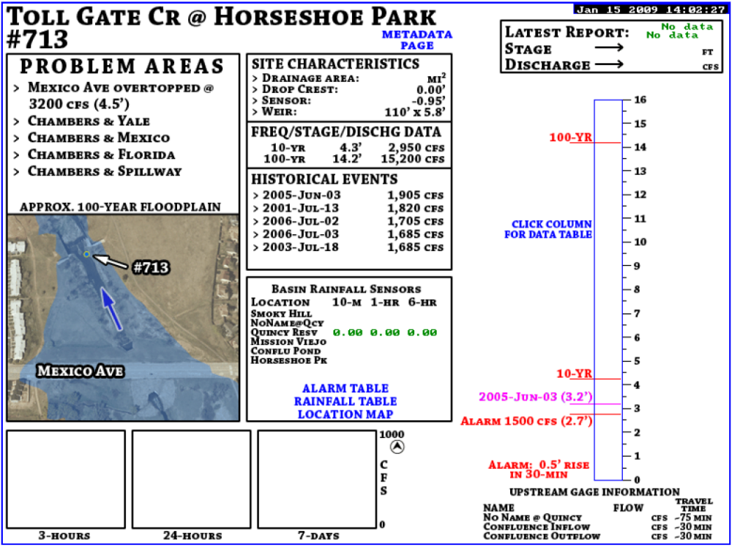

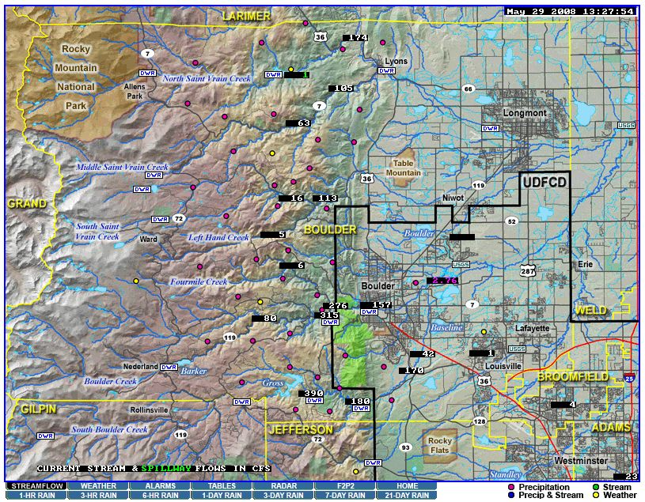
Note: Graphic displays like the one above for ALERT stream gages may be viewed by clicking on flow rate or water level values on the streamflow map – http://alert2.udfcd.org/cgi-bin/gdview?tpt=map21qweb

Figure III-29 Storm Drainage Operations Response Areas (August 1992)

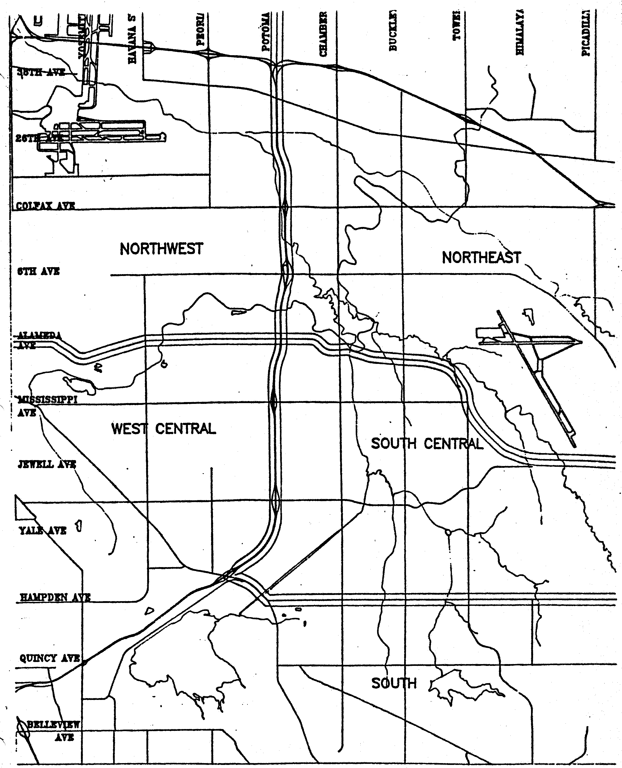
Figure III-30 Storm Drainage Operations Plan (August 1992)

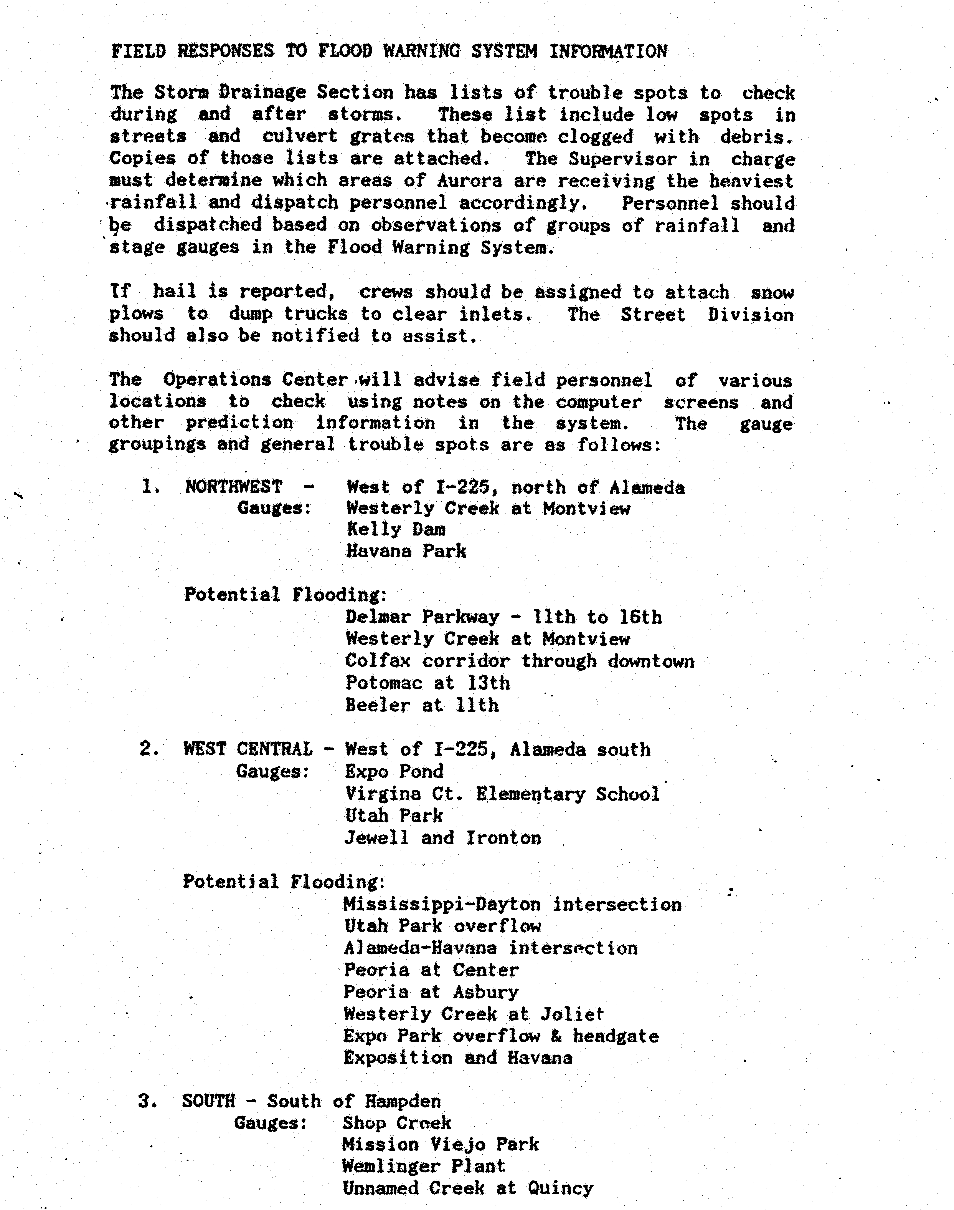
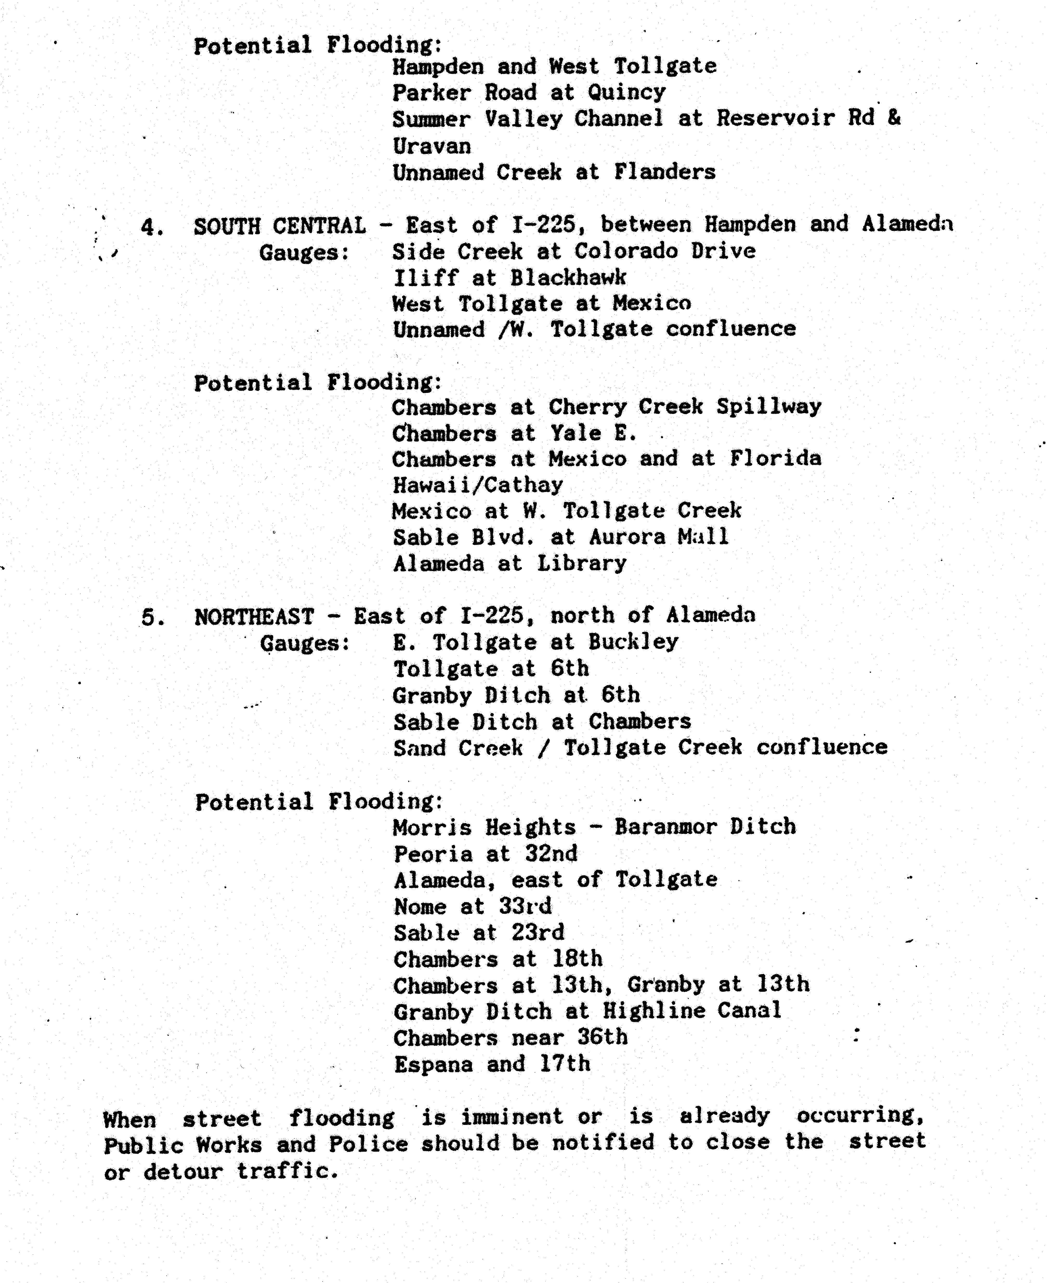
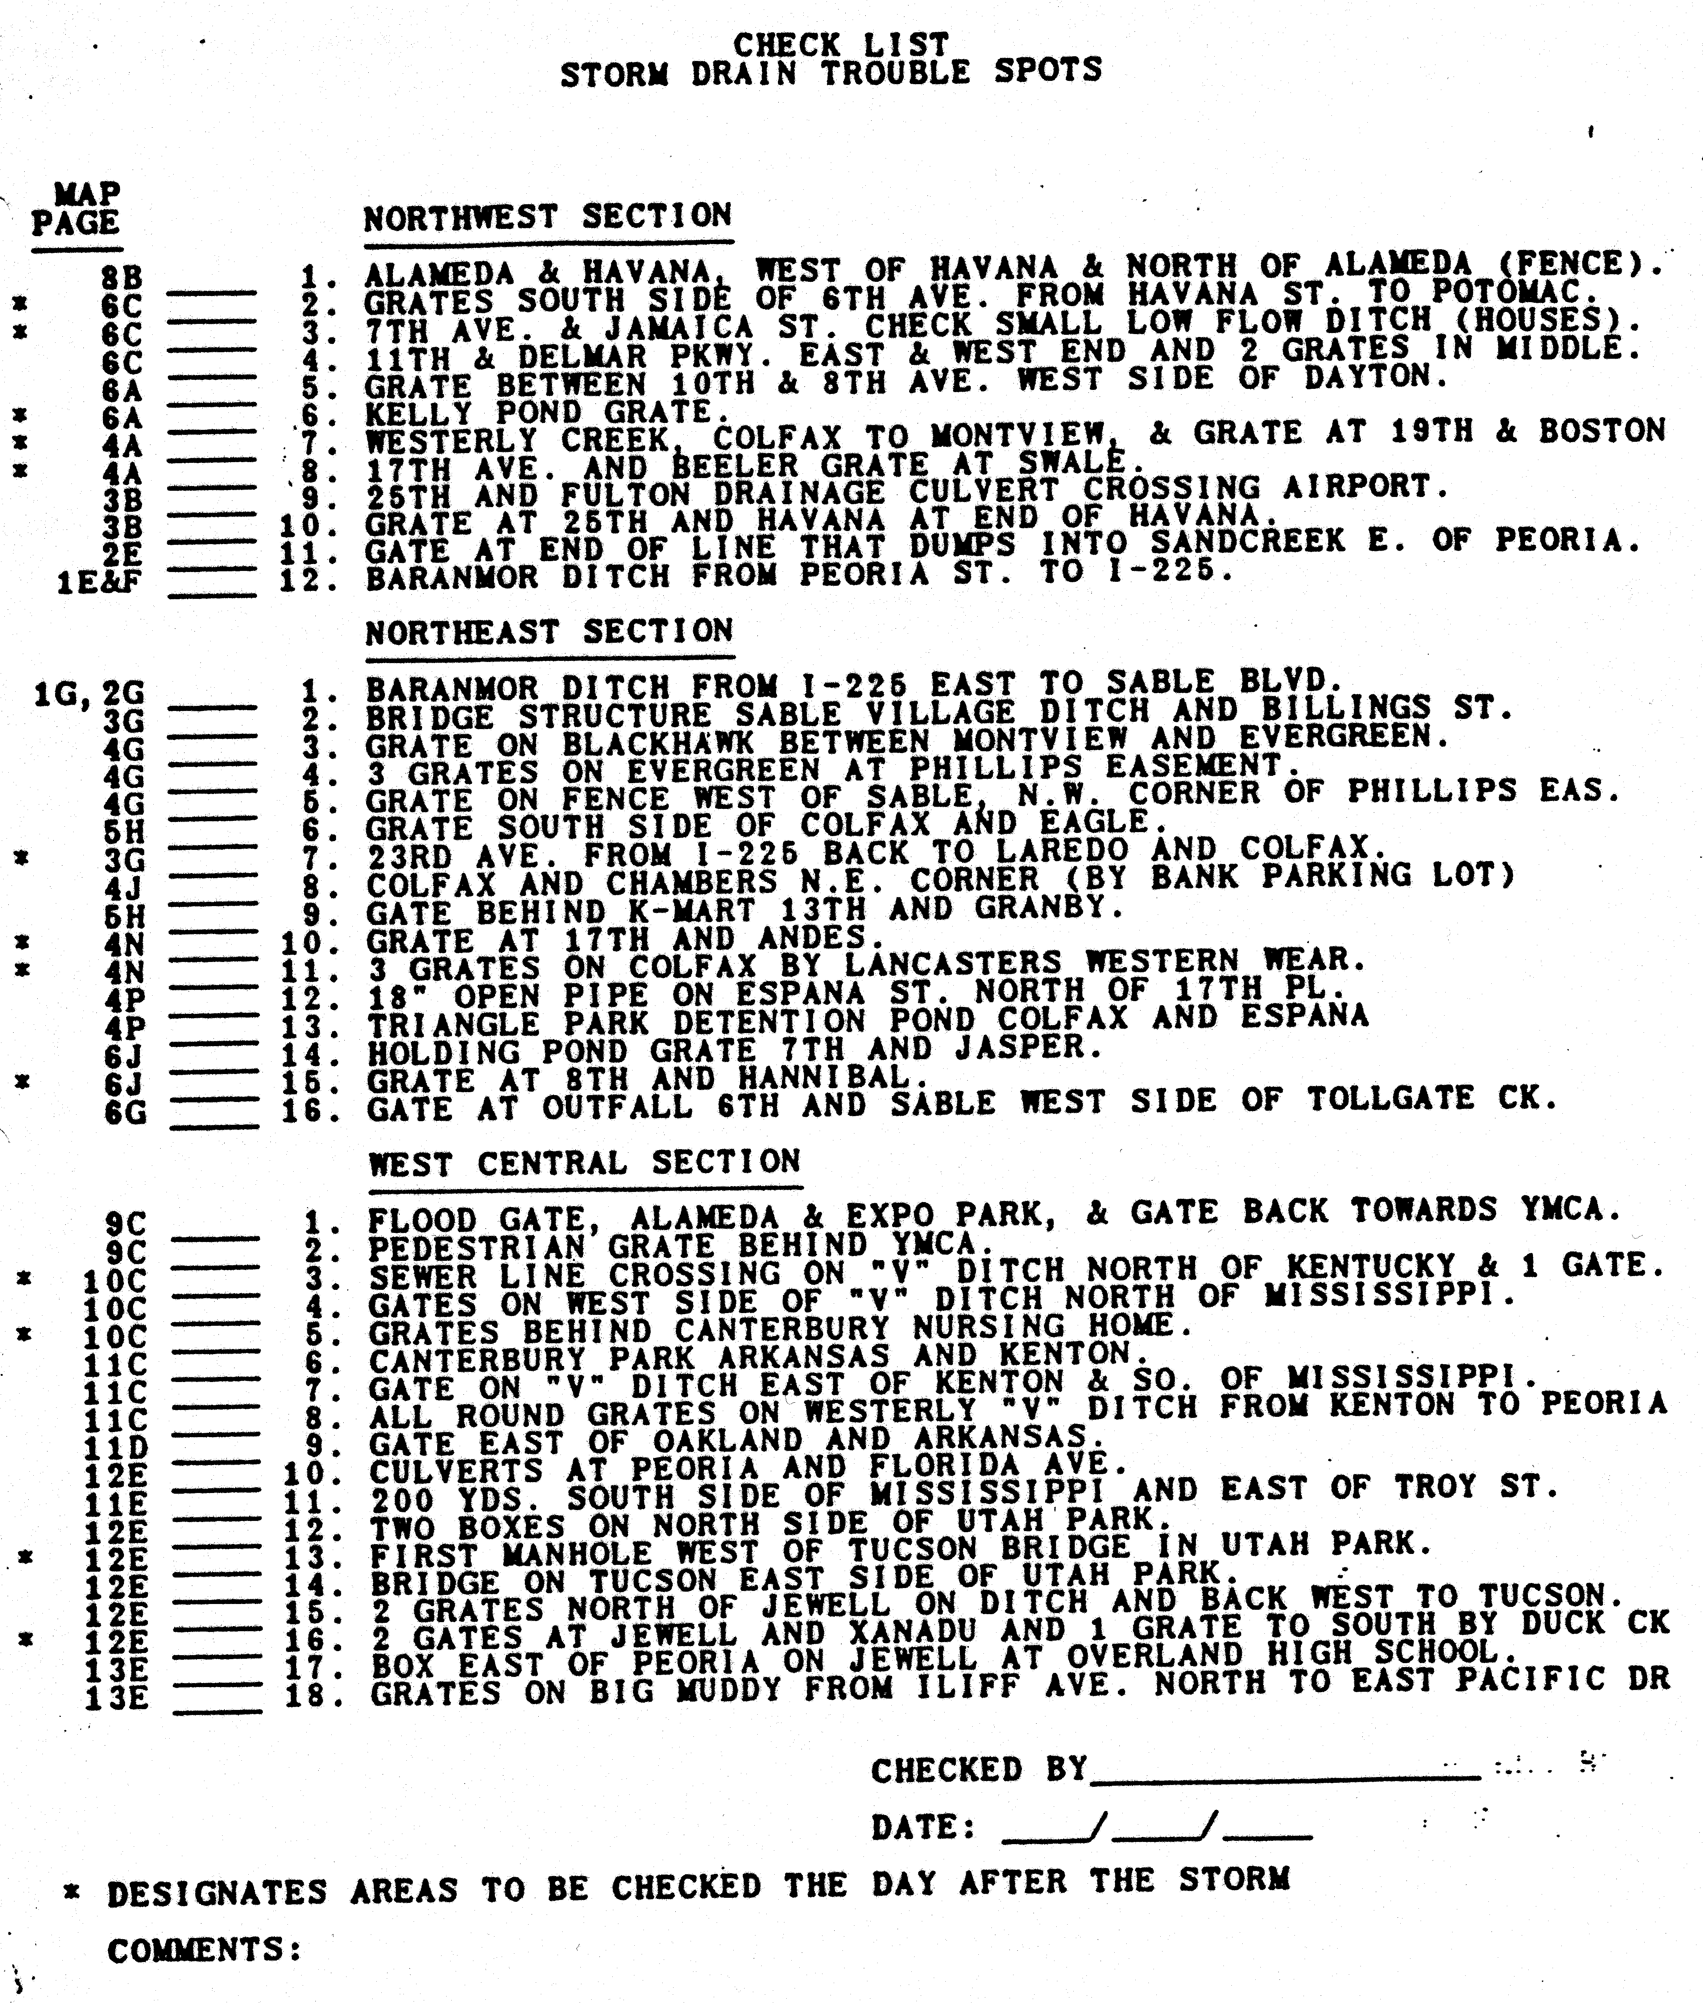
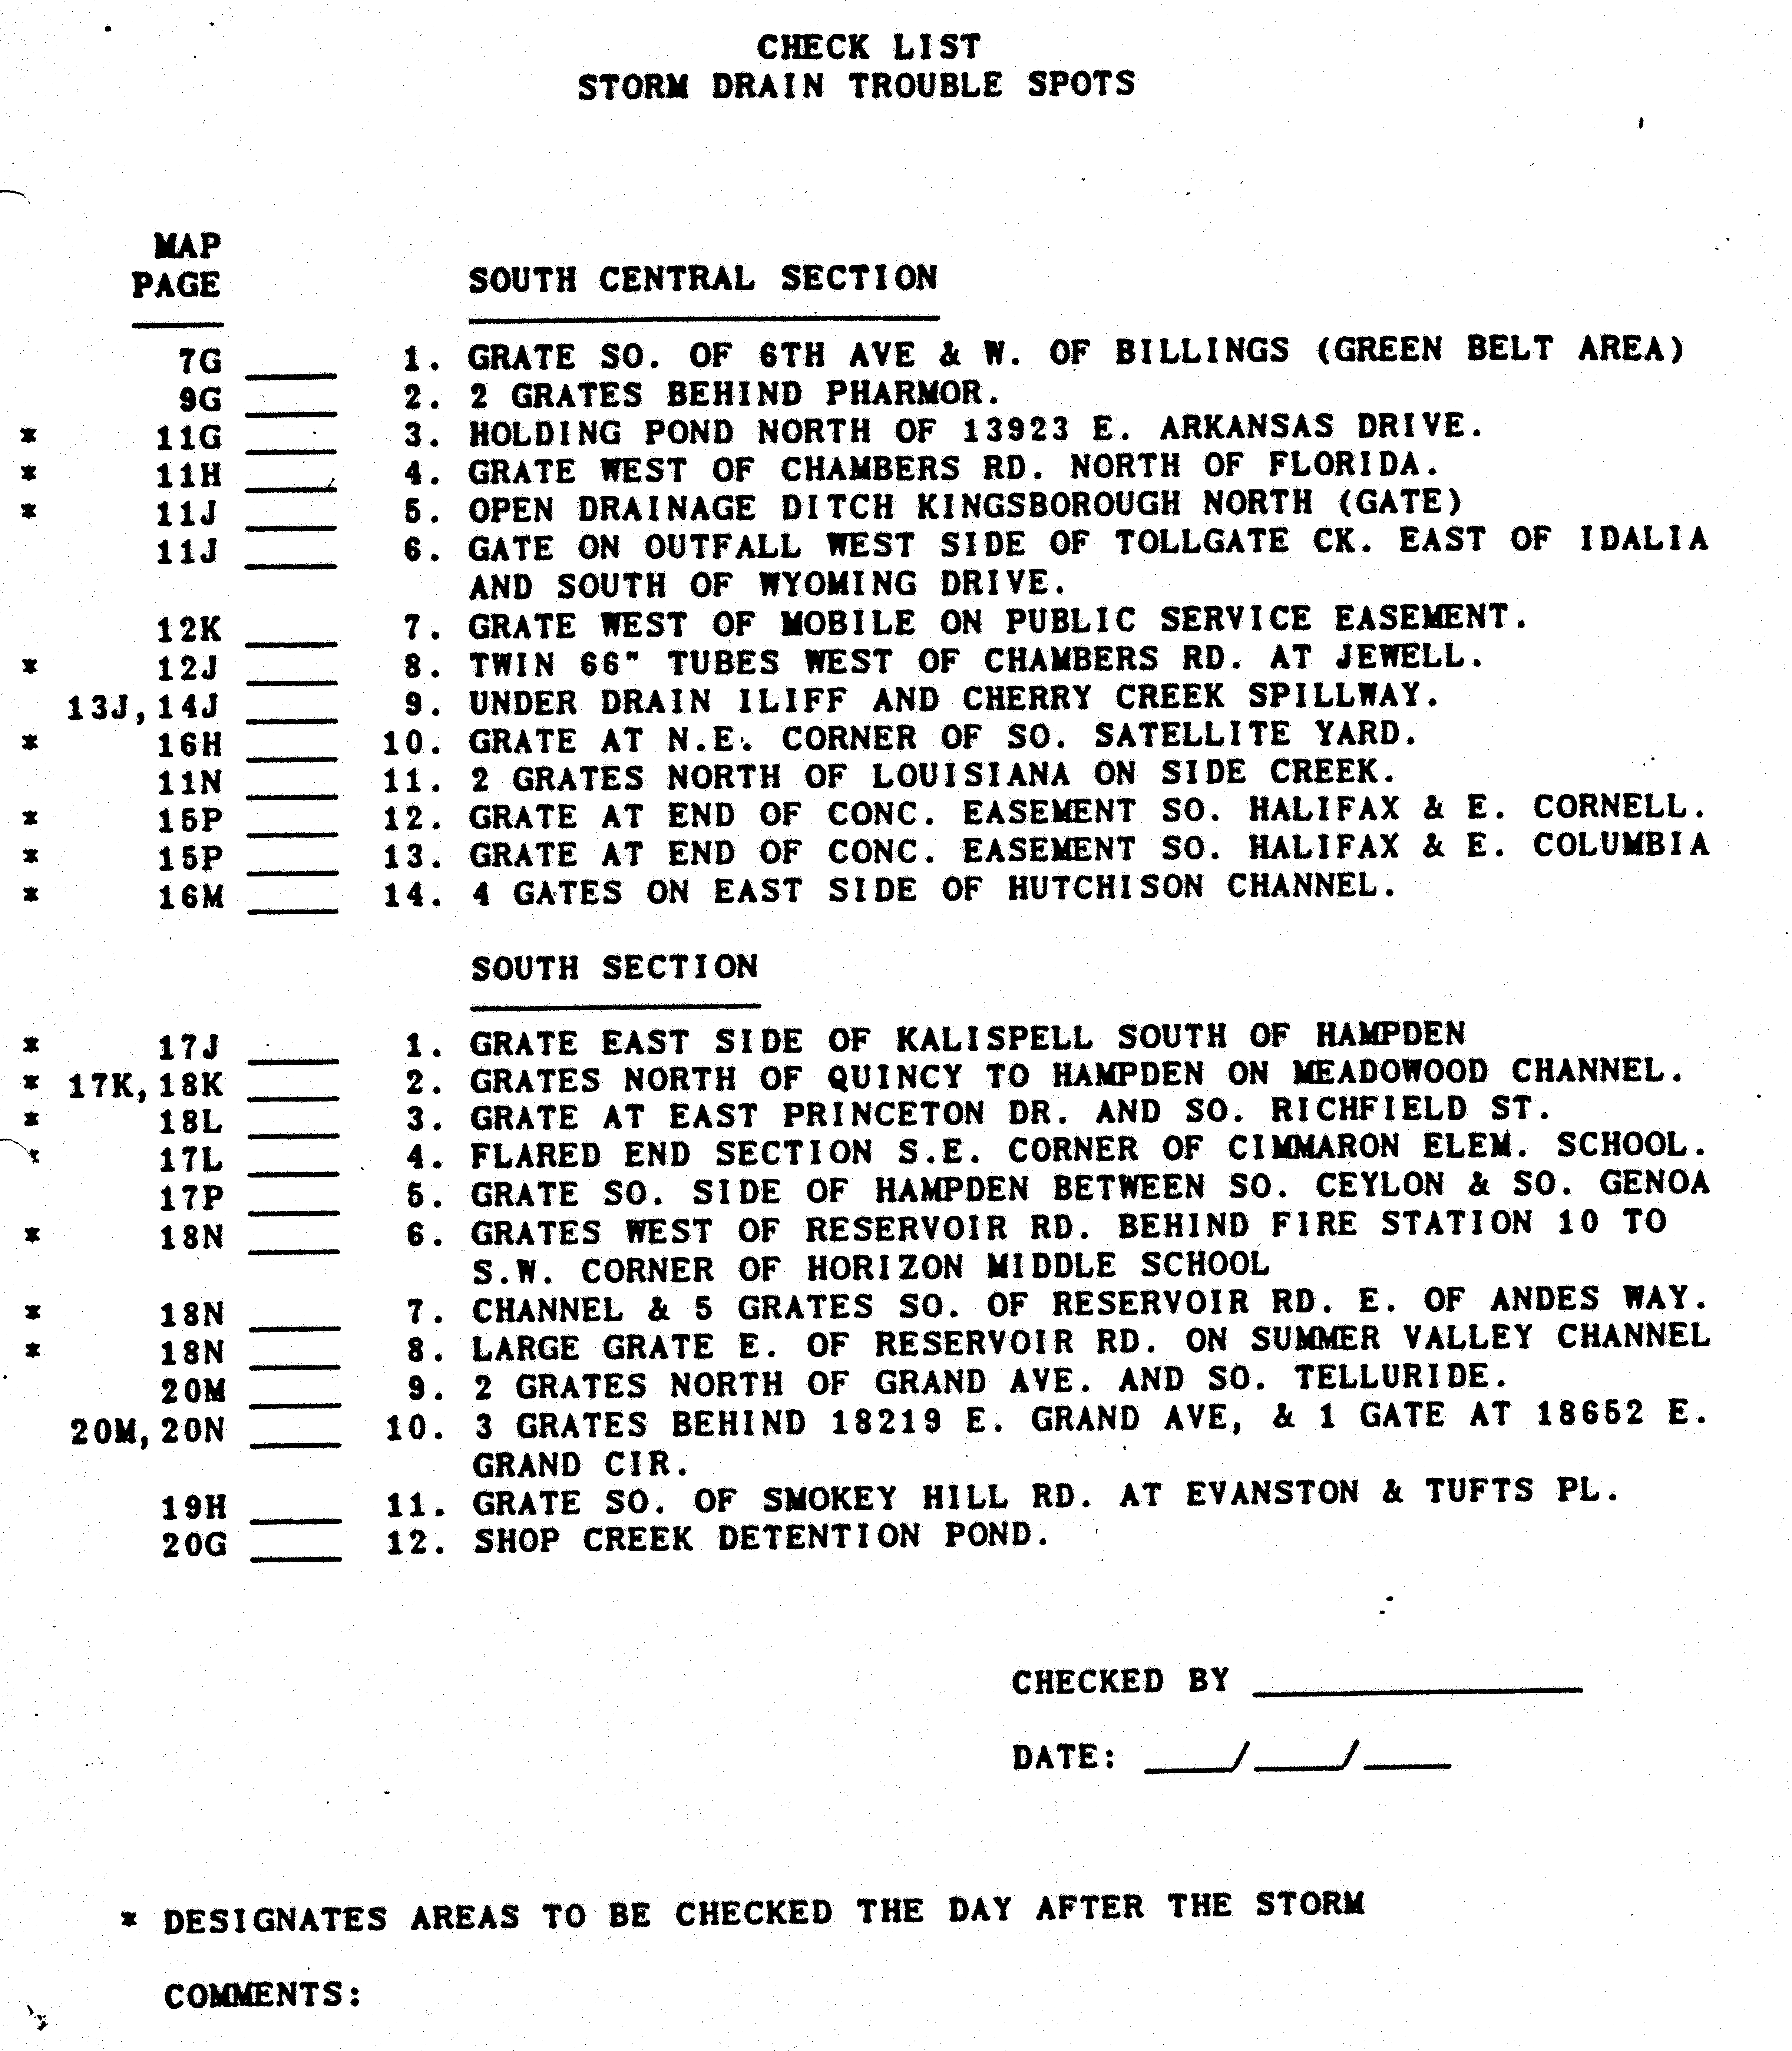

REQUIRED ELEMENTS OF THE WARNING PLAN
A complete flood warning plan consists of three basic elements:

1. Detection and evaluation of the flood threat.
2. Dissemination of the flood warnings to the public.
3. Response of the public to the warnings.

All three parts must function properly or the warning plan will fail. The main purpose of the warning plan is to minimize the potential for loss-of-life. Public safety agencies will make decisions concerning floodplain evacuations and road closures. Individuals must also make appropriate decisions to protect themselves and their families. In some instances, a limited amount of emergency floodproofing by property owners can be accomplished. For residences and businesses along Toll Gate Creek and its tributaries, a flash flood warning would not likely provide enough lead-time to safely effect damage prevention measures such as sandbagging. Emergency property protection would probably be limited to turning off main gas and electricity connections.

The following pages provide a brief description of each of the three required elements listed above relative to this flood warning plan for Toll Gate Creek.

Detection and Evaluation of the Flood Threat

The Toll Gate Creek early flood threat detection and evaluation element consists of the following items:

ORGANIZATIONS, RESOURCES AND PROCEDURES

1. The National Weather Service (NWS) Weather Forecast Office at Boulder and their NEXRAD Doppler Radar stations located at Denver, Cheyenne and Pueblo.
2. A private meteorological firm (PMS) retained by Urban Drainage and Flood Control District (UDFCD) to coordinate with NWS; collect and analyze all pertinent weather and flood data; prepare daily heavy precipitation outlooks; provide affected jurisdictions with early notification of flood potentials; and update jurisdictions as conditions change.
3. Aurora Fire Communications that receives and disseminates all incoming weather and flood information. Aurora Fire is the primary communications link between PMS, NWS and other flood warning plan participants.
4. Communication arrangements defined to insure adequate communications between all parties at all times. Primary communications are by telephone. Amateur radio operators may be contacted to provide backup communications.
5. Standard messages used by PMS to provide information to Aurora Fire for relay to affected departments and organizations.
6. An Emergency Operations Center (EOC) at Aurora activated in a pre-emergency mode to gather and analyze information concerning the flood potential; maintain contacts with meteorologists, hydrologists and other support personnel; take early preparedness actions; mobilize field resources; and make warning decisions.
7. A Flood Prediction Center (FPC) at UDFCD that is staffed by PMS when flood potentials exist.
8. Officials from Aurora who receive all critical weather and flood information and respond according to their respective internal procedures.
9. Field personnel from police, fire, public works and other agencies dispatched to monitoring locations to report rainfall amounts, stream levels, and general flood conditions.
10. Internal procedures and operating guidelines that are maintained, practiced and routinely updated by each participating local government agency, forecast service and support organization.

EQUIPMENT, DATA SOURCES AND DECISION GUIDANCE

1. Satellite imagery display equipment located at NWS and PMS enabling meteorologists to see approaching weather systems and estimate local arrival times.
2. Automated weather stations used to forecast flood potentials and predict storm development and movement.
3. Data communications equipment, computers and software used to collect and analyze pertinent upper air and surface data.
4. Radar product display equipment at NWS and PMS enabling meteorologists to evaluate current weather conditions; update heavy precipitation forecasts; estimate rainfall amounts at specific locations; predict storm movement, duration, and areal coverage; refine flood predictions; and anticipate specific flood problems.
5. Automated rain and stream gages that transmit real-time event data from the Toll Gate Creek basin to base stations located at PMS, NWS, UDFCD and Aurora Utilities.
6. Decision aids that are used to quickly analyze the real-time data, refine forecasts and predict specific flood impacts.

Dissemination of Warnings, Watches and Advisories to the Public

Several ways exist to disseminate flood warnings, watches and advisories to the public. The delivery of public flood warnings is dependent, to a large extent, upon the electronic news media (i.e., radio and television) with NWS being primarily responsible for the initial release of the warning and its content. Local governments are also responsible for disseminating public warning information within their political boundaries.

Three basic types of flood information are disseminated to the public:

1. Advisory (meaning that nuisance flooding or flooding of a "less serious" nature is either possible or occurring);
2. Watch (meaning that weather conditions are such that a hazardous flood may occur); and
3. Warning (meaning that a flood that poses a significant threat to life or property is either occurring, is imminent, or has a very high probability of occurrence). The above types of information can be issued by NWS, the local governments or both.

NWS uses the following products to convey flood information to the public and to cooperating agencies:

1. Special Weather Statement. This frequently issued statement may contain advisory information indicating a potential for heavy precipitation and possible flooding. It is also used to amplify watches, warnings, and advisories by reinforcing the message, indicating what is expected, and outlining appropriate response actions.
2. Urban/Small Stream Flood Advisory. This advisory is typically used to indicate that minor nuisance flooding of small streams, streets, intersections and low-lying areas is imminent or occurring.
3. Flood/Flash Flood Watch. This product means that flooding or flash flooding is possible within the geographic area described, but that the occurrence is neither certain nor imminent.
4. Flood/Flash Flood Warning. This product means that hazardous flooding or flash flooding is imminent or occurring within the geographic area described.

All NWS products described above will be disseminated using NOAA Weather Radio and NOAA Weather Wire. Flash flood watches, warnings, and urban/small stream flood advisories will also be disseminated over NAWAS. The use of METS is limited to flash flood warnings and other warning products.

Local governments can initiate flood warnings and provide the public at risk with emergency information prior to an NWS issuance. PMS messages, current rain and stream level data from the ALERT system, and manual field observations can be used by officials for making warning decisions (refer to Sections III and VI). Local warnings can be disseminated over METS. NWS will receive the information from METS and re-transmit the information as necessary and practicable. Also, NWS can be contacted directly by local governments with additional dissemination requests.

The following presents a brief description of the several public dissemination methods mentioned in the above paragraphs along with some other available warning options:

1. National Warning System (NAWAS). NAWAS consists of full-period, private line voice circuits. NWS uses NAWAS to disseminate flood advisories, flash flood watches and warnings to "Warning Points" in Colorado. One 24-hour Warning Point in this system is located at the Denver Office of the Colorado State Patrol.
2. Metropolitan Emergency Telephone System (METS). This is a telephone network which government agencies and the media can subscribe to. Aurora and the National Weather Service (NWS) can quickly pass information to the media subscribers for broadcast on radio and TV. NWS uses METS for warnings (but not watches or advisories).
3. NOAA Weather Wire. This is a satellite or Teletype-based communications system over which NWS can pass information to local governments or media subscribers for broadcast.
4. NOAA Weather Radio. This is a radio station operated by NWS (Frequencies: 162.550, 162.475, and 162.450 MHz). Special weather radio receivers or scanners can be purchased by anyone who is interested.
5. Emergency Alert System (EAS). The EAS consists of radio, television, and cable outlets throughout the United States who are linked together to provide live broadcasts of presidential messages during times of national emergency. On a voluntary basis, the system may also be used for broadcasting state and local emergency warnings and information. Locally, radio station KOA (850 AM) is the primary entry point for the system. Aurora and NWS have input capability into the system along with the Colorado State Patrol and the Colorado Office of Emergency Management.
6. Automated Emergency Call System. This telephone notification method, also known as the Emergency Preparedness Network, uses the 9-1-1 Qwest phone number database to automatically dial and warn homes and businesses within affected areas concerning floods and other emergencies. The system is capable of handling up to 1200 calls per minute.
7. Cable Television Interrupt. This warning method is used by communications personnel to voice over-ride all cable TV programming for emergency messages.
8. Public Warning Systems. Fixed-location outdoor siren/voice warning systems may be used to warn occupants in and near the floodplain of an approaching flash flood and order evacuations if deemed necessary.
9. Emergency Vehicles. When a decision to evacuate the floodplain has been made, local law enforcement agencies and fire departments may dispatch vehicles to circulate through assigned portions of the floodplain using sirens and mobile public address systems to advise occupants to evacuate. Standard messages to be used on the public address systems are given in Section IX.

Once the decision to warn and/or evacuate has been made, it is necessary to quickly and efficiently disseminate the warning to floodplain occupants, motorists and others at risk. Dissemination should be made by as many different means as possible, but care should be taken to insure that warnings from different sources are similar in content. The warning message should clearly communicate the danger and recommend specific protective actions. Toll Gate Creek flood warnings can be issued by the broadcast media, by loud speaker equipped vehicles and by Aurora's fixed-location outdoor siren/voice warning system. Confirmation of the initial warning is desirable whenever possible. People tend to seek confirmation before reacting to a warning.

All warning dissemination agencies, including the broadcast media, should have copies of the standard warning messages in Section IX. The media must be informed beforehand of the existing hazard and the details of the warning system; and they should be checked with periodically to insure their readiness.

Response of the Public to the Warning

If the desired response of the people in the flood hazard area to a warning is not obtained, the whole warning plan will have failed. Cultivation of the desired response must begin well in advance of any flood threat by heightening the public awareness of the flood hazard.

These steps will be taken annually to try to cultivate the desired response:

1. UDFCD will annually mail a brochure to all occupants of the Sable Ditch and Granby Ditch floodplains. The brochure will contain a map of the flood hazard area and provide information on steps to take prior to flooding (plan evacuation routes, buy flood insurance, etc.) and in the event of a flood warning.
2. Aurora will put a notice of the flood hazard in appropriate publications each spring before the flood season.
3. Media coverage of the flood hazard, including the annual practice of the warning plan, will be sought.

COMMUNICATIONS
Communications among personnel within participating agencies will be by normal methods now in operation. Aurora Fire Communications is the primary contact for all communications and is responsible for relaying weather and flood information to other flood warning plan participants.
During emergency operations, field personnel from one agency wishing to communicate with personnel from another agency should follow their own jurisdiction's incident command system. This will assure a system of managed communication and information flow. If the Emergency Operations Center (EOC) is activated, communications will include EOC.
Primary communications between the National Weather Service (NWS), the private meteorological service (PMS), and Aurora will be by telephone. When conditions warrant, amateur radio operators can be called into each location to establish alternate communications according to previous agreements. Local authorities and the fire districts will use assigned radio frequencies to communicate with field personnel.
PMS initiated communications require special emphasis. Any participating entity may initiate calls to PMS or dispatch personnel to the EOC if more direct information exchange is desired. When the Aurora EOC is activated, local authorities may request that PMS include the EOC as an additional or alternate contact point. Aurora Fire Communications will remain the primary contact for PMS unless otherwise directed by Aurora Emergency Management or the Incident Commander.
The following page contains pertinent telephone numbers and radio frequencies. The "Internal Communications Flow Chart" (Figure V-1) illustrates the collection and dissemination of weather information from various sources and shows the intended inter-agency flow paths for data and voice communications.
TELEPHONE NUMBERS AND RADIO FREQUENCIES

Organization Phone Number Frequency
* Aurora Fire Communications 303-627-3130
Aurora Office of Emergency Management 303-326-8963
Aurora Office of Emergency Management (after hours) 720-427-0500
Aurora Utilities Department 303-739-7380

* National Weather Service (NWS)
coordination (duty forecaster) 303-494-4479
severe weather reports 303-494-2884
administration 303-494-3210
public weather information 303-494-4221

* Urban Drainage and Flood Control District (UDFCD) 303-455-6277
ALERT Base Station 303-433-1247

Private Meteorological Service (PMS)
UDFCD Flood Prediction Center (FPC) 303-458-0789
Skyview Weather 303-688-9175
Genesis Weather Solutions 303-927-6522

Commonly Shared Emergency Radio Frequencies
CLEER "Colorado Law Enforcement Emergency Radio" 460.425
FERN "Fire Emergency Radio Network" 154.280
NLEC "National Law Enforcement Channel" 155.475

Other Radio Frequencies
ALERT repeaters (Blue Mountain & Smoky Hill) 171.875
ALERT gaging stations 169.525
NOAA Weather Radio (Denver) 162.550
NWR alternate 1 (Longmont/Mead) 162.475
NWR alternate 2 (Fort Collins) 162.450
Ham severe weather spotter network 146.940
alternate 147.120

Websites
ALERT System (public use) http://alert.udfcd.org
ALERT System (public safety agency use only) http://alert2.udfcd.org

* Principle contact for PMS (Genesis Weather Solutions with Skyview Weather)

Figure V-31 Internal Communications Flow Chart

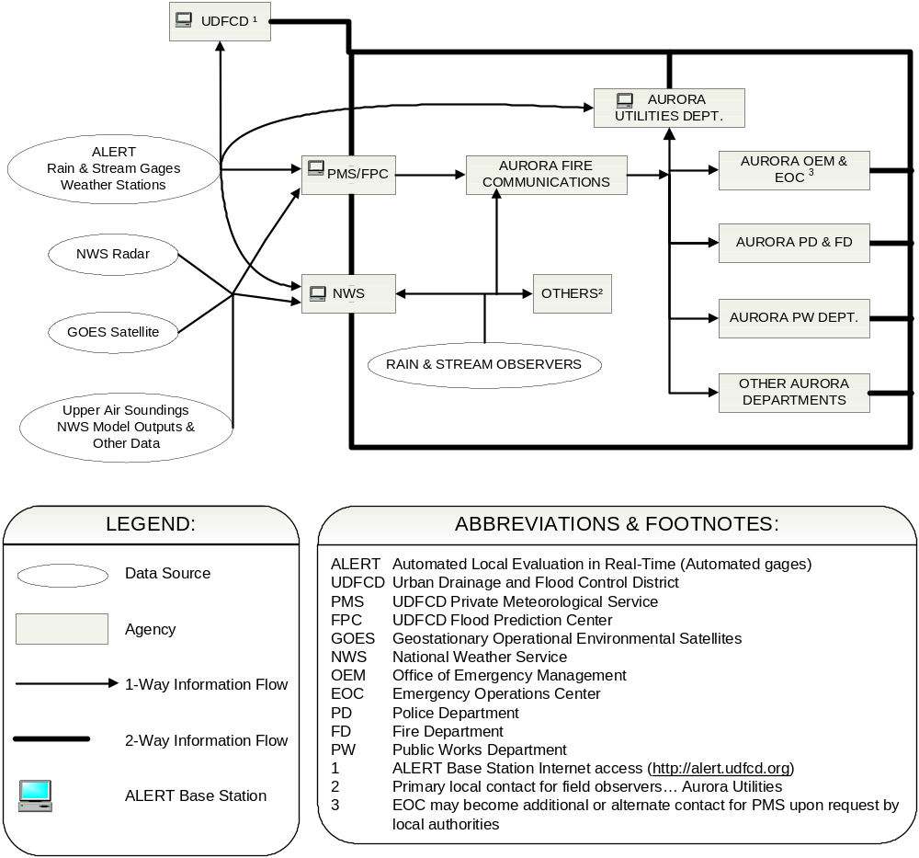

METEOROLOGICAL SUPPORT
The National Weather Service (NWS) and the private meteorological service (PMS) will provide meteorological support to the City of Aurora. Following is the process by which NWS, PMS and Aurora should coordinate, exchange information and gear up for potential flood situations with the Toll Gate Creek drainage basin:

1. NWS and PMS conduct daily weather discussions as necessary to evaluate flood potentials. PMS will prepare daily heavy precipitation outlooks from April 15 through September 15. This product is available from the Internet at http://alert.udfcd.org and may also be faxed to warning plan participants. When warranted, more detailed quantitative precipitation forecasts (QPF) and storm track predictions will be issued by PMS. Many NWS products are also available from the Internet including flood advisories, flash flood watches and flash flood warnings.
2. When weather conditions are such that flash flood producing rains could develop, PMS will relay a MESSAGE 1 by phone to Aurora Fire Communications. A MESSAGE 1 that requires priority handling will be identified as a "RED FLOOD ALERT" message.
3. NWS and PMS continue their weather discussion. If the flood potential increases one of the following actions will occur:
a. NWS will issue a Special Weather Statement or Urban and Small Stream Flood Advisory through normal channels (NAWAS, weather wire, weather radio) and/or PMS will send a MESSAGE UPDATE to MESSAGE 1 (RED FLOOD ALERT if warranted) to Aurora; or
b. NWS will issue a Flash Flood Watch through normal channels (NAWAS, weather wire, weather radio) and PMS will send MESSAGE 2 to Aurora; or
c. PMS will send a MESSAGE 2 to Aurora by phone indicating an increase in flood potential.
4. Observers will be designated and consideration will be given toward activating the Aurora Emergency Operations Center (EOC).
5. Regular coordination between NWS, PMS and Aurora will continue. Should the Aurora EOC be activated, PMS and NWS shall be notified immediately and regular coordination will include the EOC as a focal point. The Aurora Fire Department may request that all PMS communications be re-directed to their EOC.
6. When conditions warrant, NWS will issue a Flash Flood Warning through normal channels and PMS will send a MESSAGE 3 to Aurora. PMS may issue a MESSAGE 3 prior to the issuance of a NWS warning if PMS feels that a life-threatening flood is imminent.
7. Aurora will continue to monitor the situation and will begin public dissemination of warnings when necessary. PMS will continue to send MESSAGE UPDATES as warranted.
8. When the hazard has passed, PMS will send a MESSAGE 4 to Aurora.

Throughout all of the above activities NWS and PMS will coordinate as necessary. It must be remembered that events may occur so rapidly that it may not be possible to carry out all of the above steps. Personnel on duty must be prepared for this possibility and must pick up the process as best they can.

The following page provides a brief description of each PMS message and their intended uses. Subsequent pages contain the standard message forms used by Aurora for documenting and relaying direct PMS communications. These message forms should be used to insure rapid flow of information with minimum chance for error.
MESSAGE DESCRIPTIONS

MESSAGE 1 (Nuisance Flood Advisory)
This advisory message is to inform key people that weather conditions are such that nuisance flooding could develop later in the day—impacting streets, low-lying areas, normally dry gulches, small streams, and the recreational trails located along these small drainage channels. Mud/rockslides are the primary concern for the mountains and foothills. It will be issued by PMS after consultations with NWS. If PMS considers the threat imminent, the message will be identified as a RED FLOOD ALERT (RFA).

MESSAGE 2 (Flash Flood Watch)
This advisory message is to inform key people that either a Flash Flood Watch has been issued by NWS or PMS believes that weather conditions are such that a life-threatening flash flood may occur later in the day. Significant stream flooding and property damage is possible. PMS will add any additional information that is available.

MESSAGE 3 (Flash Flood Warning)
This warning message will be issued to inform key people that a Flash Flood Warning has been issued by NWS or PMS feels that a life-threatening flash flood is imminent. Significant stream flooding and property damage is expected. PMS will add any additional information that is available. This warning message should be disseminated as quickly as possible.

MESSAGE UPDATE
This message will be used by PMS to update any of the previous messages. For example, this message can be used to narrow a watch or warning area as more information becomes available, or to provide more site-specific data and direction during an event. If PMS considers the threat imminent, the message will be identified as an RFA.

MESSAGE 4 (All Clear)
This message cancels the flood potential status. It is issued by PMS after consultation with NWS and other entities involved with direct PMS communications.

ABBREVIATIONS: NWS...National Weather Service PMS...Private Meteorological Service

NOTES: F2P2 messages are used to notify local governments of potential (MESSAGE 1 and 2) and imminent (MESSAGE 3 and RFA) flood threats. All F2P2 messages are designed for internal use and not intended for the general public. Standard message forms are completed by the meteorologist and sent by fax or email to designated communication fan-out points prior to making contact by telephone. Each county warning point or designated recipient follows their respective protocol for subsequent dissemination of messages.

An RFA is used when PMS believes that a nuisance flooding rainstorm is imminent and expected to primarily impact streets, low-lying areas, creek-side trails, etc. This type of flooding is generally considered a low risk to life and property. When a MESSAGE 2 is in effect, RFA may be used with a MESSAGE UPDATE to indicate imminent nuisance flooding that does not warrant a MESSAGE 3. When a MESSAGE 3 is in effect, RFA may be used with a MESSAGE UPDATE when an approaching storm is expected to cause nuisance flooding outside the warning area. Due to the short lead-time nature of the RFA, it should be disseminated as quickly as possible.
RED FLOOD ALERT: yes no Received By
(circle one) Date
Priority dissemination if yes Time

MESSAGE 1
(Internal Alert)

This is _____________________________________ meteorologist
(business name) (name )

Please prepare to fill in the blanks on UDFCD/F2P2 Form M-1 concerning the possibility of flooding later today.

We have determined that the potential for flooding exists for

from until .
Prime time for flooding is from until .
(time) (time)

The most likely areas to be impacted by flooding are (check appropriate items):

Mountain Canyon Streams & Floodplains

Urban Streams & Floodplains

Urban Streets, Intersections & Low Lying Areas

Other (describe)

The potential risk to life and property is (check appropriate item):

Low Moderate High

This message is not intended for public dissemination. Please pass this information along to affected emergency response organizations (police, fire, public works, etc.) within your area.

Also, please take appropriate actions to prepare for possible flooding.

Further information will be provided to you as it becomes available.
AUTOMATIC RED FLOOD ALERT Received By
Date
Priority dissemination Time

MESSAGE 2
(Flash Flood Watch)

This is _____________________________________ meteorologist
(business name) (name )

Please prepare to fill in the blanks on UDFCD/F2P2 Form M-2 concerning the threat of flash flooding later today.

Use message OPTION (circle one): A B

OPTION A
The National Weather Service has issued a Flash Flood Watch for

which means that flash flooding is possible within the watch area.
This watch is valid from until .
(time) (time)

We concur/disagree (circle one) with NWS watch and advises

OPTION B
We have determined that the possibility of a life-threatening flash flood exists for

from until .
(time) (time)

Please pass this information along to affected emergency response organizations (police, fire, public works, etc.) within your area.

Also, please take appropriate actions to prepare for possible flooding.

Further information will be provided to you as it becomes available.

AUTOMATIC RED FLOOD ALERT Received By
Date
Priority disseminATION Time

MESSAGE 3
(Flash Flood Warning)

This is _____________________________________ meteorologist
(business name) (name )

Please prepare to fill in the blanks on UDFCD/F2P2 Form M-3 concerning an imminent flash flood.

Use message OPTION (circle one): A B

OPTION A
The National Weather Service has issued a Flash Flood Warning for

which means that flash flooding is imminent or has been reported within the warning area.
This warning is valid from until .
(time) (time)

OPTION B
We have determined that an imminent danger of a life-threatening flash flood exists for

from until .
(time) (time)

Please expedite this information to affected emergency response organizations (police, fire, public works, etc.) within your area.

Also, please take appropriate actions to deal with this flood threat and warn the public.

Further information will be provided to you as it becomes available.
RED FLOOD ALERT: yes no Received By
(circle one) Date
Priority dissemination if yes Time

MESSAGE UPDATE

This is _____________________________________ meteorologist
(business name) (name )

Please prepare to fill in the blanks on the UDFCD/F2P2 Form M-U concerning updated information on the threat of local flooding.

This is an update to Message(s) concerning possible
flooding for .

We advise

Please pass this information along to the emergency response organizations you have previously notified.

Also, please take appropriate action in response to the current flood potential.

Further information will be provided to you as it becomes available.
Received By
Date
Time

MESSAGE 4
(All Clear)

This is _____________________________________ meteorologist
(business name) (name )

Please prepare to fill in the blanks on UDFCD/F2P2 Form M-4.

The potential for flooding in
has passed.

Message Number(s) are rescinded.

We will keep you advised of any changes.

Please pass this information along to the emergency response organizations you have previously notified.

FLOOD THREAT RECOGNITION AND WARNING PROCESS
The first element of a local flood warning system is the ability to detect and evaluate a flood threat in its early stages and make the decision to warn before flood damages or deaths occur. The second element is the dissemination of the warning to the public at risk. The third element is the public response to the warning. This section deals with the first two elements relative to Toll Gate Creek including a step-by-step illustration of how the early flood threat recognition and warning process is intended to function.

Detection and Evaluation of the Flood Threat

The earliest recognition of a potential flood threat for the Toll Gate Creek basin will be a heavy precipitation forecast by a meteorologist. The private meteorological service (PMS) retained by Urban Drainage and Flood Control District (UDFCD) provides the meteorological support for this plan among other responsibilities. This service supplements National Weather Service (NWS) activities by focusing its support for the six-county geographically area comprising UDFCD and tailoring communications to the individual concerns of each local government within this area. Section VI describes the meteorological support provided by PMS and NWS.

PMS forecasts are coordinated with NWS Weather Forecast Office at Boulder and provided to Aurora Fire Communications for subsequent dissemination to affected departments including the Aurora Utilities Department who has the primary overall flood management responsibility for the City of Aurora. Participating organizations will take appropriate preparedness actions in accordance with respective internal procedures.

Eleven automated rain gages and eight stream gages within the Toll Gate Creek basin will transmit rainfall and stream stage data to four ALERT base stations located at PMS, NWS, UDFCD and Aurora Utilities. PMS also has access to other meteorological data from weather radar, satellites, upper air soundings and weather stations. PMS will use this data and the decision aids in Section III to predict flood potentials and update local officials concerning anticipated flood problems at specific locations.

The Emergency Operations Center (EOC) may be activated at Aurora. The decision to activate the Aurora EOC for flood situations rests with the Utilities Department Manager of Wastewater Operations. EOC personnel will have the opportunity to analyze current ALERT data, interact directly with PMS and NWS and use the decision aids provided in Section III. EOC personnel may access the ALERT system via PC/phone modem connection to UDFCD's base station or from the Internet. EOC personnel may also assume the primary flood prediction role should communication links with PMS and NWS fail. Aurora officials and NWS are responsible for making decisions concerning public warning.

Section VIII provides further discussion regarding procedures and general responsibilities of the principle organizations involved with this flood warning plan.

Dissemination of the Warning

Dissemination of warning information to the public will be accomplished through the electronic media and by Aurora officials. Dissemination by the media may be channeled through NWS by local authorities or the media may be contacted directly. NWS will use NAWAS, METS, NOAA Weather Wire, NOAA Weather Radio and/or EAS at their option to issue the public warning. Section IV describes the various methods for disseminating flood warnings and advisories to the public.

The City of Aurora may also provide flood warnings directly to the public at risk within their jurisdiction according to internal procedures. Standardized messages to be used by local governments are included in Section IX.

Step by Step Procedure

The following step-by-step procedure is an idealized summary of how the flood threat evaluation and warning process is supposed to function. THE USER MUST BE AWARE THAT THE SYSTEM WILL NOT ALWAYS FUNCTION AS PLANNED. THE USER MUST BE PREPARED TO FUNCTION WITHIN THE FRAMEWORK OUTLINED HERE, EVEN IF ALL STEPS LISTED HEREIN DO NOT OCCUR OR OCCUR OUT OF ORDER.

A. Normal Operations:
1. PMS will be monitoring weather conditions on a routine basis, including appropriate coordination with NWS. It should be noted that PMS, NWS and UDFCD have an ongoing relationship which involves forecasts of flood potential for the entire Denver/Boulder metro area; and the Toll Gate Creek Flood Warning Plan is an add-on responsibility for meteorologists and other technical support personnel.
2. When weather conditions warrant, and after consultation with NWS, PMS will issue a MESSAGE 1 (messages are explained in detail in Section VI) by telephone to Aurora Fire Communications. PMS may indicate urgency by stating that the MESSAGE 1 is a "RED FLOOD ALERT" message. The term RED FLOOD ALERT is used to prompt priority internal message dissemination by emergency communications personnel and should not be confused with the "Red Flag Warning" fire weather product issued by NWS. Section V contains details regarding weather-related communications and the flow of critical information.
3. Aurora Fire Communications will forward the MESSAGE 1 to city departments and other support agencies according to internal procedures. REMEMBER THAT A MESSAGE 1 IS A FORECAST OF A POTENTIAL FOR FLOODING. IT IS NOT INTENDED FOR PUBLIC DISSEMINATION SIMPLY BECAUSE IT IS TOO EARLY TO TELL WHAT WILL ACTUALLY DEVELOP.
B. Increased Awareness:
1. PMS will continue to monitor the situation and will issue MESSAGE UPDATES (RED FLOOD ALERT if warranted) to keep local officials advised of significant changes since the previous message.
2. NWS may issue a Special Weather Statement or other appropriate communication concerning heavy precipitation through normal channels (Section IV). PMS may follow this with a MESSAGE UPDATE providing a more detailed interpretation of how this affects Aurora and the Toll Gate Creek basin.
3. Aurora Fire Communications will forward this information and each subsequent contact should follow internal procedures for updating key pre-designated people concerning the increased flood potential.
4. Contingency plans should be established to ensure that future steps in this warning plan can be carried out if needed.
C. Flash Flood Watch:
1. As the flood potential becomes more apparent or threatening, NWS will issue a Flash Flood Watch for a geographic area. The Flash Flood Watch will be issued on NAWAS, Weather Radio and Weather Wire.
2. PMS will issue a MESSAGE 2 to Aurora Fire Communications. MESSAGE 2 will not only indicate the issuance of a Flash Flood Watch by NWS but will also attempt to provide additional information concerning severity of the threat and a more definitive identification of areas at risk. PMS may also issue a MESSAGE 2 without a NWS issuance of a Flash Flood Watch if PMS feels the risk is high that a life-threatening flood may occur later in the day.
3. PMS will continue to monitor all available data and will initiate an analysis of potential flood peaks based on predicted rainfall and decision aids (Section III).
4. As additional data (including rainfall and stream gage data) becomes available, PMS will update rainfall forecasts and flood peak projections and will provide information to Aurora Fire Communications in the form of MESSAGE UPDATES.
5. Aurora officials should consider activating the EOC at this time if not done previously and maintain frequent two-way communications with PMS and NWS.
6. Local officials will send rain and stream observers to pre-determined locations. Stream gage readings and field observations will be reported to PMS and NWS through Aurora Fire Communications or EOC personnel.
7. PMS will confer as needed with NWS. When rainfall estimates or measurements, and flood peak predictions indicate an imminent flood danger; or when automated stream gages or field observations confirm the threat, a Flash Flood Warning will be issued by NWS.
D. Flash Flood Warning:
1. NWS will issue a Flash Flood Warning through NAWAS, METS, Weather Radio, Weather Wire and perhaps EAS. A Flash Flood Warning means that flooding is imminent or is occurring.
2. PMS will issue a MESSAGE 3 to Aurora. PMS may also issue a MESSAGE 3 without a NWS issuance of a Flash Flood Warning if PMS feels that a life-threatening flood is imminent.
3. Aurora should then disseminate the warning within its jurisdiction according to internal procedures using standardized messages where appropriate (Section IX).
4. PMS, NWS and stream observers will continue to monitor the situation to either confirm flooding or determine that the hazard has passed.
5. When the threat of flooding has passed (whether a flood has occurred or not), PMS will issue a MESSAGE 4.
6. If flooding has occurred, Aurora will follow their disaster response plan.
E. Other Considerations:
1. As noted above, this is an idealized scenario. It is unlikely that any flood event would be handled exactly as outlined. Each participant must be cognizant of the probable necessity to deviate from his plan in order to react to the real situation.
2. NWS is the only federal agency which can officially issue a Flash Flood Watch or Flash Flood Warning. In the event of a difference of opinion between NWS and PMS, PMS will advise Aurora of the difference of opinion as follows:
a. If PMS feels a watch or warning should be issued but NWS doesn't agree, PMS will use a MESSAGE 2 or MESSAGE 3 to inform local authorities of their forecast and prompt Aurora to make their own warning decision.
b. If NWS issues a watch or warning but PMS doesn't feel it is warranted, PMS will still issue the appropriate MESSAGE 2 or 3, but indicate their misgivings. The standard message forms in Section VI are designed to clearly indicate either concurrence or disagreement between PMS and NWS.
3. In the event of a local decision to warn, the official in charge should immediately contact NWS to avoid public confusion. Also, NWS may be the quickest means of notifying the public via the electronic news media. NWS may acknowledge the involvement of local authorities (i.e., Aurora, UDFCD, etc.) when issuing the warning.
4. Flood warnings for Toll Gate Creek and its tributaries can be issued by local officials using emergency vehicle loud speakers, door-to-door notification and other methods deemed appropriate.

PROCEDURES AND GENERAL RESPONSIBILITIES
Procedures and general responsibilities for the operational elements of this flood warning plan are contained in this section. Three points regarding these procedures need to be emphasized:

1. The operating procedure for each organization addresses only those actions and activities that organization must accomplish in order to effect a coordinated response to a flood situation within the Toll Gate Creek drainage basin.
2. Every individual responsible for the implementation of any part of this warning plan should be familiar with the entire plan.
3. This section does not contain detailed operating procedures but provides an overview of technical support activities, communications, emergency operations and general responsibilities of each participating organization. Specific task assignments and responsibilities are described in local emergency operation plans and other supplemental documents maintained by local governments. Similarly, the technical support organizations including National Weather Service (NWS) and Urban Drainage and Flood Control District (UDFCD) and their private meteorological service (PMS) routinely update their own internal operating procedures, policies and duty manuals.

National Weather Service and Private Meteorological Service

The NWS Weather Forecast Office at Boulder has the responsibility for issuing Flash Flood Watches, Flash Flood Warnings, general Flood Warnings, and many other types of weather warnings, advisories and forecasts for northeastern Colorado, including the City of Aurora, in which the Toll Gate Creek drainage basin is located. PMS has been retained by UDFCD to supplement NWS flood-related activities within UDFCD boundaries, which includes the Toll Gate Creek drainage basin. PMS is responsible for monitoring weather and flood conditions, forecasting flood potentials, issuing standardized internal messages, and directly advising local officials concerning specific flood threats. UDFCD provides PMS with access to weather radar, satellite data, lightning data and ALERT base stations, that collect real-time rain, and stream levels, and surface weather data from the Toll Gate Creek Flood Detection Network and other detection networks operating in or near the Denver/Boulder metropolitan area. PMS acquires additional meteorological data, performs their own analyses and prepares forecasts tailored to local government needs. Coordination between NWS and PMS will be as follows:

1. Coordination between NWS and PMS will be initiated by either party when it is deemed that the potential for flash flood producing storms exists. A private line at the Flood Prediction Center (FPC) located at UDFCD has been established for this purpose. NWS and PMS will consult on when to issue a MESSAGE 1 (see Section VI for MESSAGE descriptions) to Aurora Fire Communications. MESSAGE 1 will be communicated by phone. PMS personnel will establish support operations at the FPC either before or soon after a MESSAGE is issued.
2. If PMS feels that a MESSAGE 1 requires priority handling by emergency communications personnel, the message will be preceded by the statement: "THIS IS A RED FLOOD ALERT MESSAGE." The RED FLOOD ALERT message should not be confused with the "Red Flag Warning" fire weather product issued by NWS.
3. Coordination between NWS and PMS will continue at two-hour intervals or less as needed until the potential passes or a more serious situation develops. NWS may issue a Special Weather Statement or Urban and Small Stream Flood Advisory through normal channels if conditions warrant (see Section IV for discussion of NWS products).
4. If the situation is up-graded to a Flash Flood Watch by NWS, they will notify PMS and put the watch out on NOAA Weather Wire, NOAA Weather Radio, and NAWAS. After being contacted by NWS, PMS will immediately issue a MESSAGE 2 to Aurora.
5. If PMS feels the flood potential has increased but NWS does not want to issue a Flash Flood Watch, PMS can either issue a MESSAGE UPDATE to Aurora indicating an increase in flood potential or upgrade the message status to a MESSAGE 2 if they feel a life-threatening flood potential exists.
6. Following receipt of a MESSAGE 2 or MESSAGE UPDATE, Aurora should pass along any rainfall or other data available to them and inform PMS and NWS of such observations.
7. Communications between NWS, PMS and Aurora will continue as needed. Should the Aurora EOC be activated, the responsible local government agency can request that PMS communications be redirected to the EOC.
8. If the situation is up-graded to a Flash Flood Warning by NWS, they will notify PMS and put the warning out on NOAA Weather Wire, NOAA Weather Radio, NAWAS and METS. After being contacted by NWS, PMS will immediately issue a MESSAGE 3 to Aurora. PMS can also issue a MESSAGE 3 without a NWS Flash Flood Warning if PMS believes a life-threatening flood is imminent.
9. PMS can issue a MESSAGE UPDATE to affected local governments at any time an update of the current message in effect is warranted but the next higher or lower message is not appropriate.
10. Local government officials may recognize the equivalent of a Flash Flood Warning, independent of NWS or PMS, if they feel the situation warrants. NWS and PMS should be immediately advised of this circumstance.
11. Local government officials may decide on their own to evacuate the floodplain, close roads or take some other appropriate emergency action. NWS and PMS will be informed of the situation immediately. NWS will disseminate this information over their communications network wherever possible.
12. Consultations between NWS, PMS, Aurora and other flood warning plan participants should continue as needed until the potential has passed or a flood is occurring.
13. When NWS and PMS agree that the potential has passed, PMS should issue a MESSAGE 4 to Aurora.

PMS will have forecaster(s) on duty from 7 AM until 10 PM each day. If a flash flood potential exists at 10 PM, PMS will continue to staff the FPC until the potential has ended. If weather conditions change after 10 PM and a potential flood situation develops, NWS will notify the PMS duty person. This individual will respond to the FPC and begin the coordination process described above.

City of Aurora

The Aurora Utilities Department is the primary agency responsible for initiating emergency activities relative to potential flooding on Toll Gate Creek. The Utilities Department Manager of Wastewater Operations makes the decision to activate forces, including the activation of Aurora's Emergency Operations Center (EOC), based on the flood potential contained in the weather forecast. When activated, inter-agency coordination will follow Aurora's Incident Command System (ICS). The Manager of Wastewater Operations serves as the Incident Commander for flood emergencies.

The following pages contain excerpts from Aurora's emergency operations plan - flash FLOOD annex which summarize the general responsibilities of key flood response agencies:
Figure VIII-32 Excerpt: Aurora – EOP - Flash Flood Annex (August 1992)

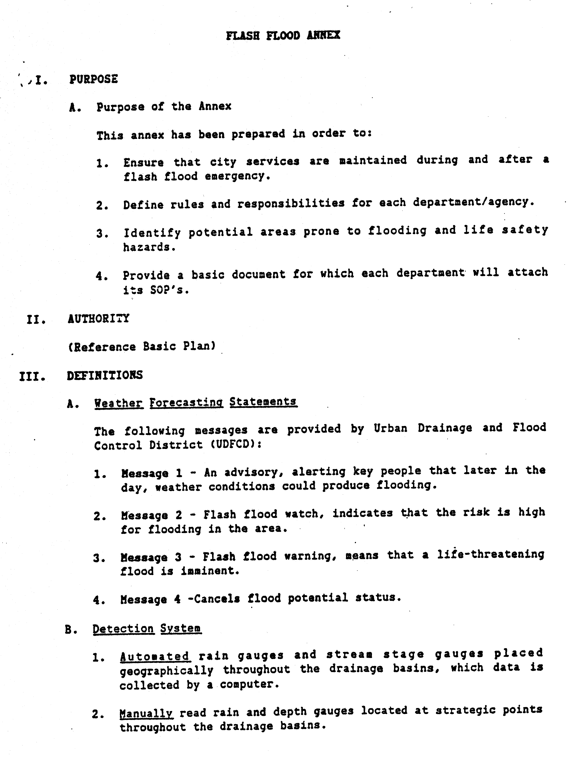
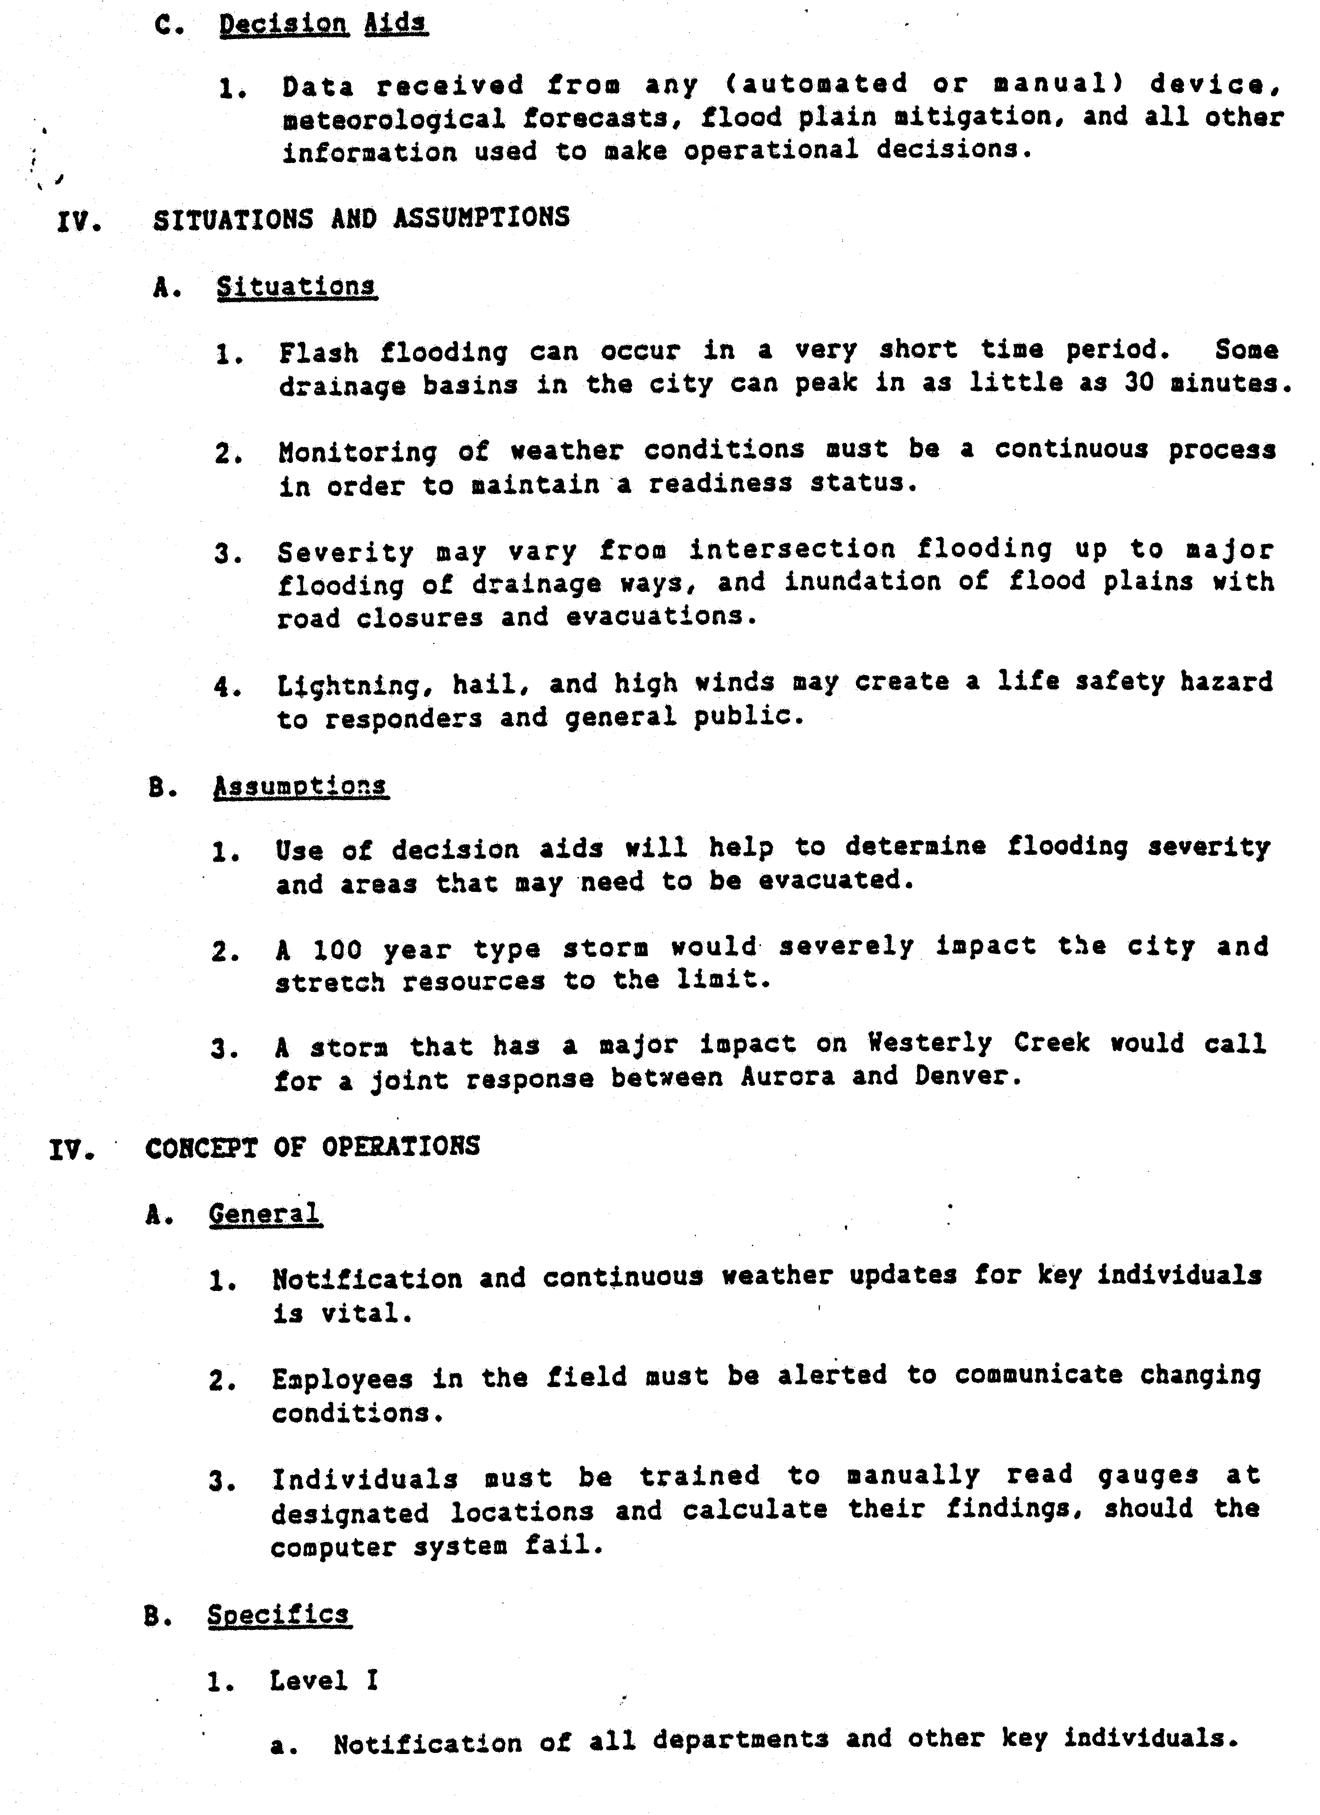
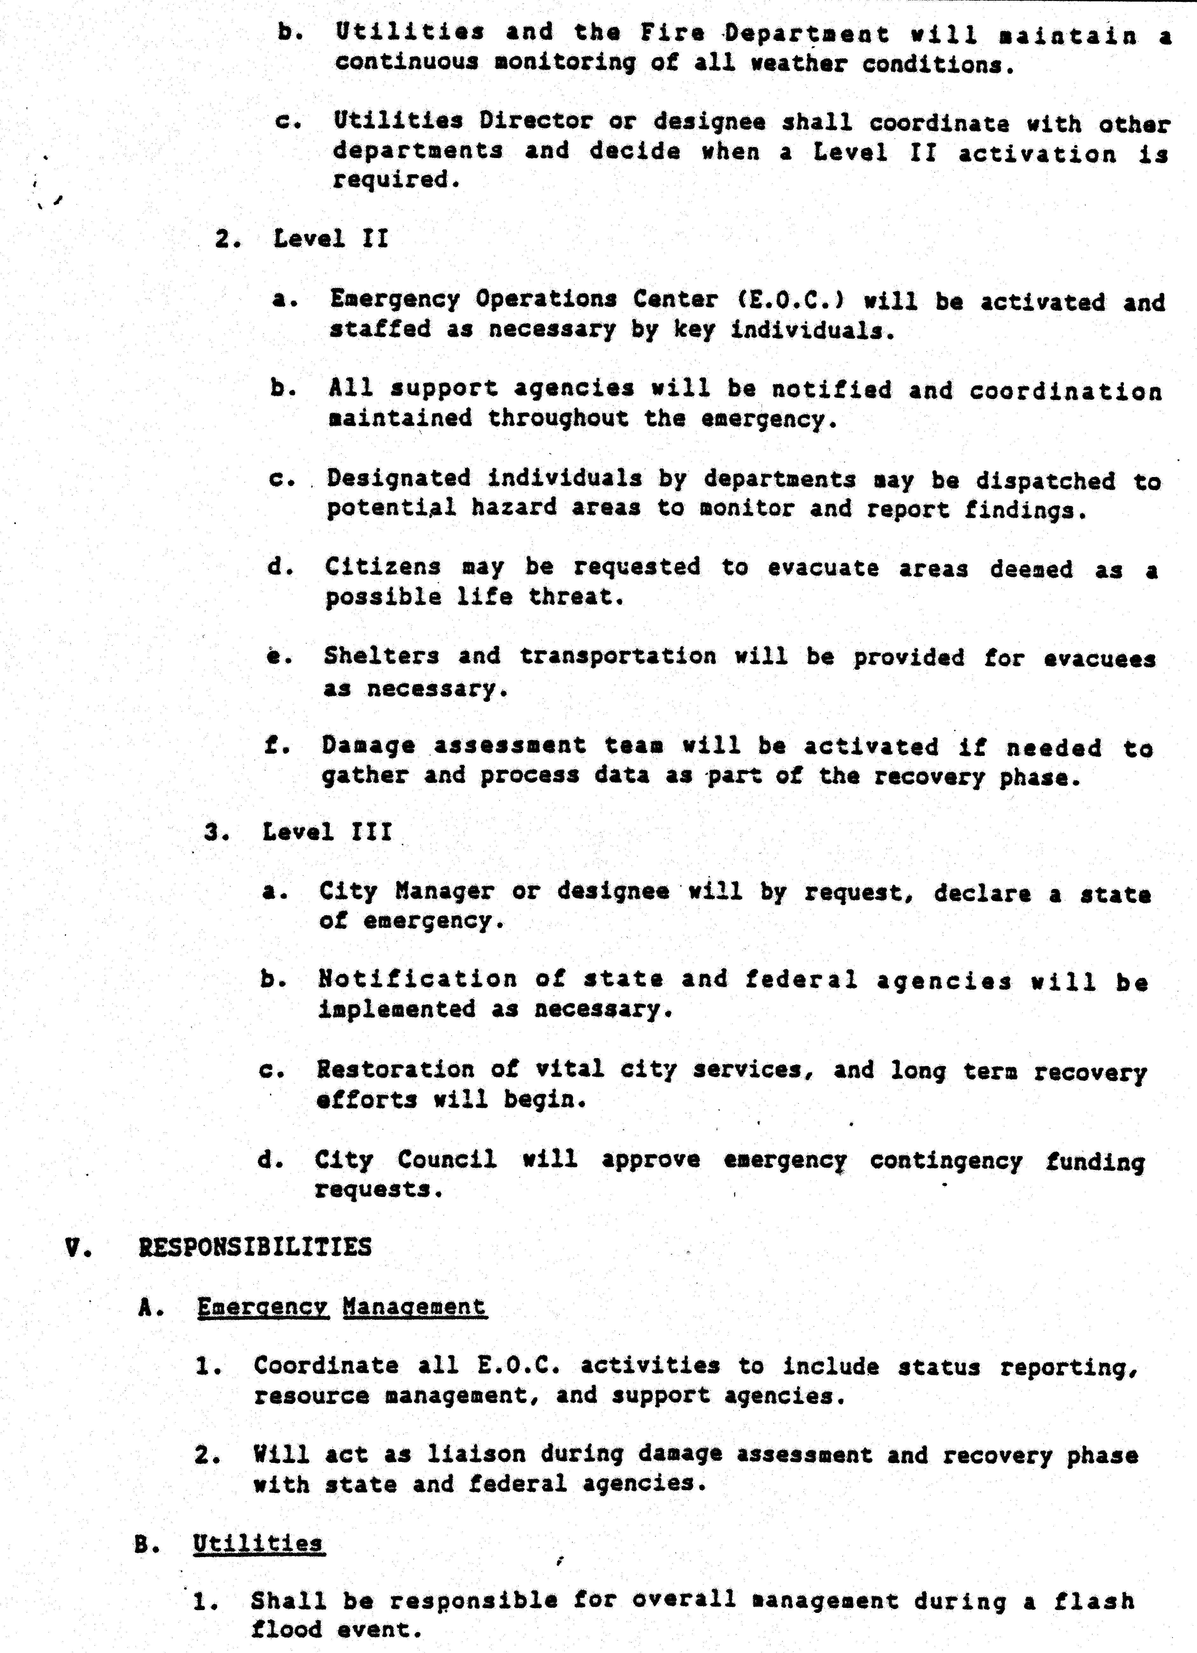
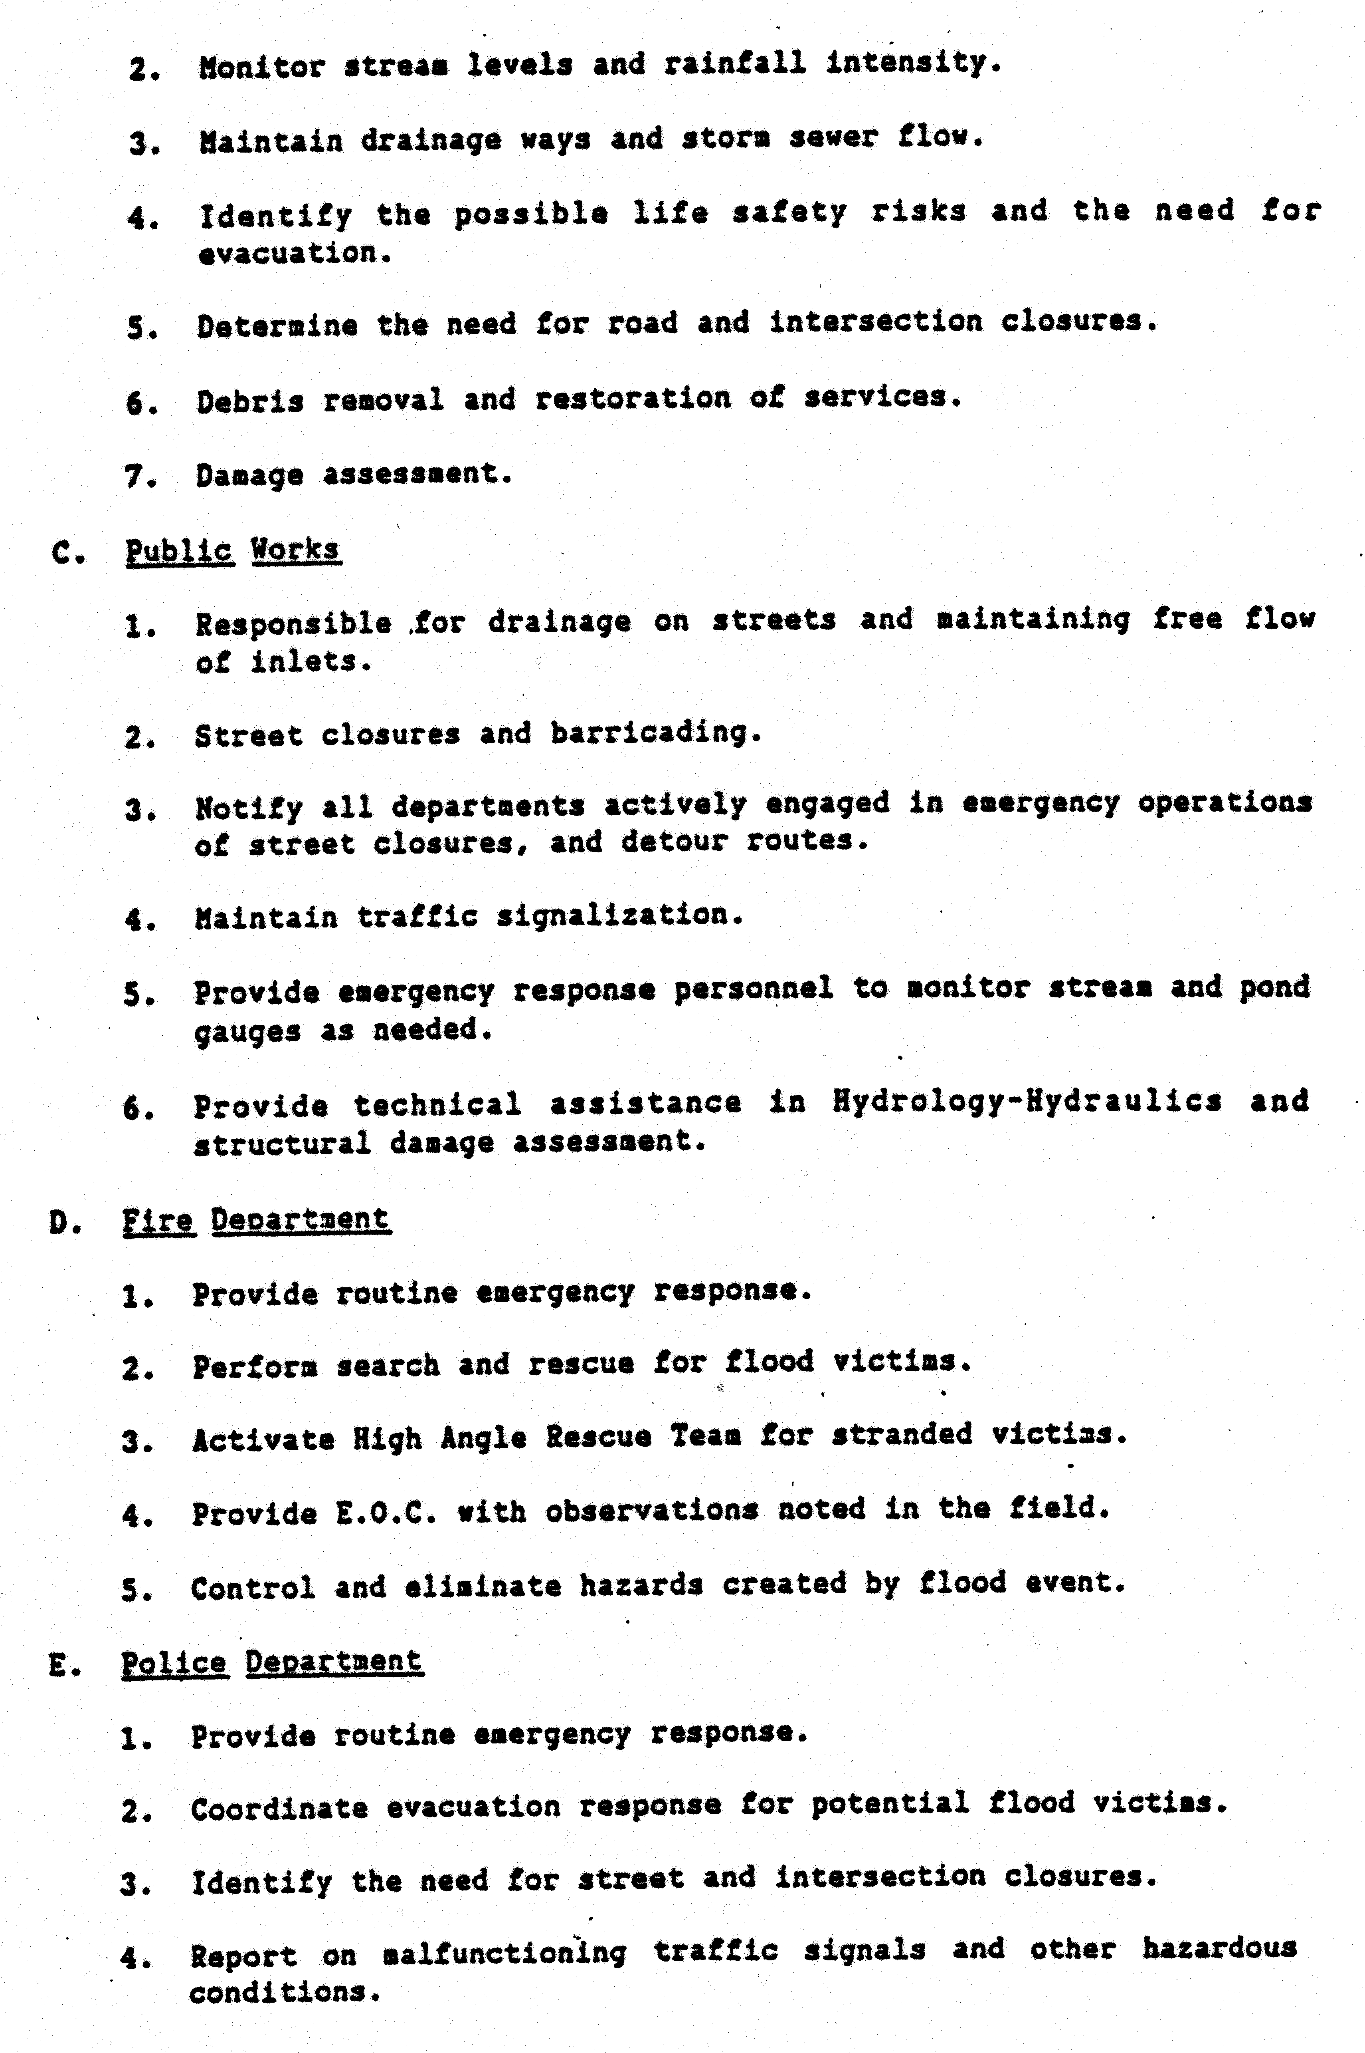
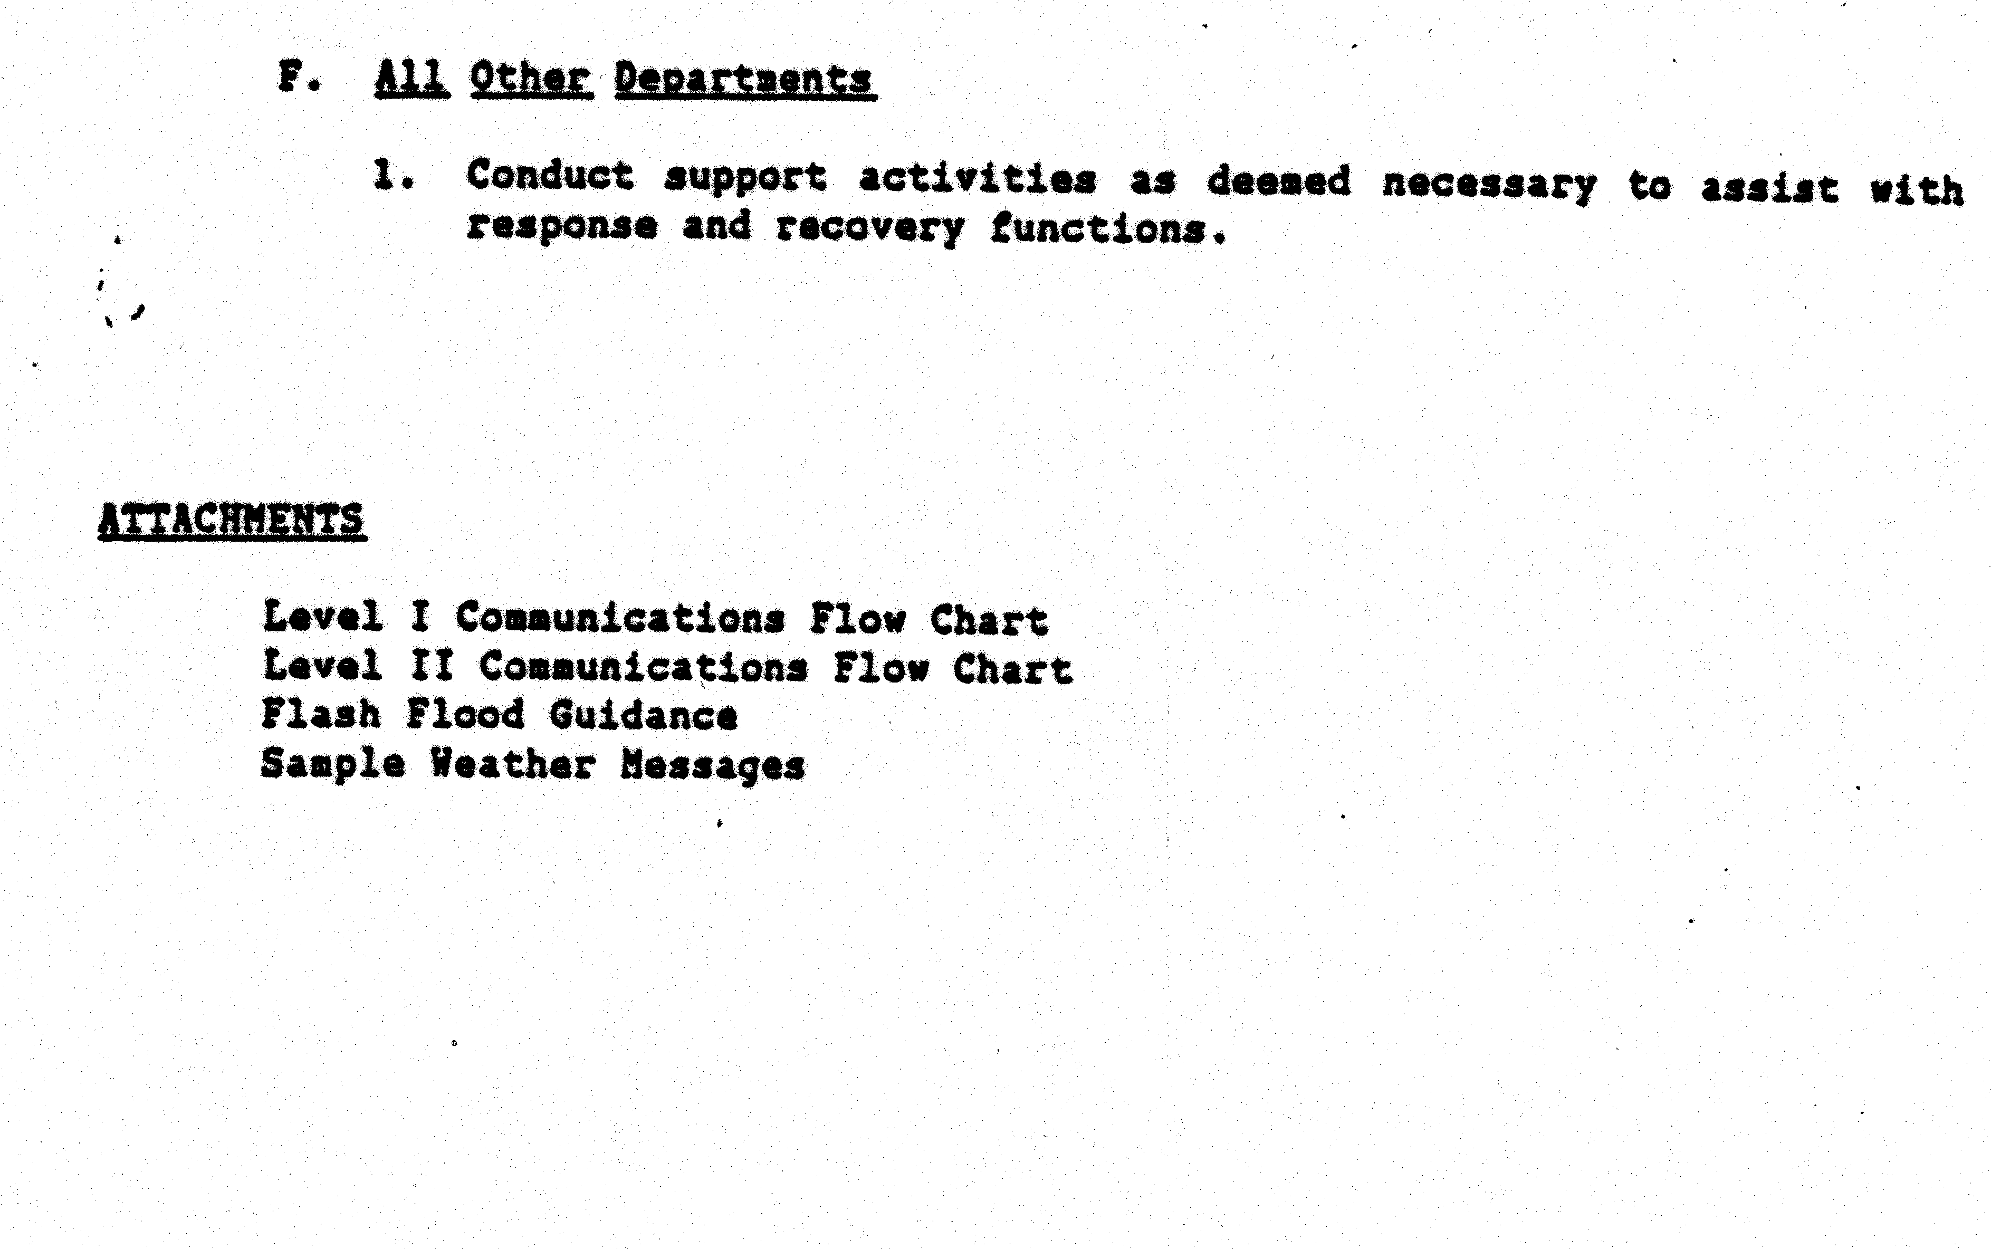

PUBLIC DISSEMINATION
first response of many people when they hear a warning is to try to confirm it from another source. Therefore, it is very important that all public messages present the same information. The messages in this Section are written to insure that consistent information is given from all possible sources. Public messages will be disseminated by the designated public information officer (PIO) whenever possible according the local emergency operation plans and standard agency procedures. The final message wording is the responsibility of the PIO or local official in charge.
This Section contains two types of messages:
1. Messages provided to the media or broadcast directly to the public; and
2. Messages used by public address systems or emergency vehicles circulating through the floodplain.

The following messages are fill-in-the-blank formatted. Inserted information will be provided by local authorities.

CITIZEN ALERT MESSAGE A1

The following message may be used when the National Weather Service has issued a Flash Flood Watch:

THE NATIONAL WEATHER SERVICE HAS ISSUED A FLASH FLOOD WATCH FOR

(geographic area)
A FLASH FLOOD WATCH MEANS FLOODING IS POSSIBLE WITHIN THE WATCH AREA. PERSONS IN THE WATCH AREA ARE ADVISED TO PREPARE FOR POSSIBILE FLASH FLOODING, KEEP INFORMED, AND BE READY FOR QUICK ACTION IF FLASH FLOODING IS OBSERVED OR A FLASH FLOOD WARNING IS ISSUED.

CITIZEN ALERT MESSAGE A2

The following message may be used if the National Weather Service has not issued a Flash Flood Watch but local government officials believe that flash flooding is possible:

PERSONNEL
(local government agency or agencies)
HAVE DETERMINED THAT A FLASH FLOOD IS POSSIBLE WITHIN

(geographic area)
PERSONS WITHIN THIS AREA ARE ADVISED TO PREPARE FOR POSSIBLE FLASH FLOODING, KEEP INFORMED, AND BE READY FOR QUICK ACTION IF FLASH FLOODING IS OBSERVED OR A FLASH FLOOD WARNING IS ISSUED.

EVACUATION MESSAGE

The following message may be used if a decision has been made to warn people in the floodplain to evacuate:

THE WARNS
(responsible agency)
THAT FLOODING WILL BEGIN AT AT
(location)
APPROXIMATELY .
(estimated time)
HAS URGED EVERYONE IN THE
(person in authority)
FLOOD HAZARD AREAS TO EVACUATE THE AREA IMMEDIATELY. PERSONS EVACUATING THE AREA SHOULD MOVE AWAY FROM THE CREEK. DO NOT ATTEMPT TO OUT-RUN A FLOOD IN YOUR VEHICLE. DISPLACED PERSONS SHOULD GO TO
. (Add any confirmed reports of flooding or heavy rainfall). (place)
DO NOT ATTEMPT TO CROSS A FLOODED AREA ON FOOT OR IN YOUR VEHICLE.

SUPPLEMENTAL (check appropriate statements):

DO NOT ENTER BARRICADED AREAS.

ABANDON YOUR VEHICLE IMMEDIATELY WHEN WATER RISES ABOVE THE ROAD ON WHICH YOU ARE DRIVING.

IF YOU ARE DRIVING IN A MOUNTAIN CANYON, ABANDON YOUR VEHICLE IMMEDIATELY AND CLIMB TO HIGH GROUND.

EMERGENCY VEHICLE/PUBLIC ADDRESS MESSAGE

The following message may be used over public address systems or by emergency vehicles circulating in the floodplain:

THIS IS
(emergency service agency)
FLOODING WILL BEGIN AT AT
(location)
APPROXIMATELY .
(estimated time)

HAS URGED EVERYONE IN THE FLOOD
(person in authority)
HAZARD AREAS TO EVACUATE THE AREA IMMEDIATELY. PERSONS EVACUATING THE AREA SHOULD MOVE AWAY FROM THE CREEK. DO NOT ATTEMPT TO OUT-RUN A FLOOD IN YOUR VEHICLE. DISPLACED PERSONS SHOULD GO TO
. (Add any confirmed reports of
(place)
flooding or heavy rainfall.) DO NOT ATTEMPT TO CROSS A FLOODED AREA ON FOOT OR IN YOUR VEHICLE.

SUPPLEMENTAL (check appropriate statements):

DO NOT ENTER BARRICADED AREAS.

ABANDON YOUR VEHICLE IMMEDIATELY WHEN WATER RISES ABOVE THE ROAD ON WHICH YOU ARE DRIVING.

MEDIA CONTACTS
Each year, prior to the flood season, the Urban Drainage and Flood Control District (UDFCD) will inform the news media of the flood hazard associated with Toll Gate Creek and other tributaries. The media will be requested to publicize the hazard by providing information about this flood warning plan, including steps occupants of the hazard area should take when a flash flood warning is issued.

UDFCD will also, on an annual basis, work with local public information offices to make the broadcast media aware of how the sample advisory and warning messages contained in Section IX may be used.

ANNUAL REVISIONS AND PRACTICES
Each year, prior to the beginning of the active flood season, the Urban Drainage and Flood Control District (UDFCD) will issue appropriate revisions to this document, after consulting with affected emergency managers and other appropriate local officials. If no revisions are needed, UDFCD will inform plan holders, accordingly.
UDFCD will also schedule at least one annual practice exercise. The exercise may take various forms including tabletop simulations, message dissemination/communication tests, functional exercises involving field operations, combinations of the preceding examples, or a less complex orientation meeting. The exercise may be publicized by local public information offices or by UDFCD to further increase public awareness of the flood hazard and help attain the desired public response when flash flood warnings are issued.

