BEAR CREEK FLOOD WARNING PLAN

TABLE OF CONTENTS
I. INTRODUCTION I-1
II. THE DRAINAGE BASIN II-1
Drainage Basin Description II-1
Existing flood control facilities II-3
Flood History II-4
Flood Hydrology II-10
Flooding Extent (100-Year Floodplain) II-14
III. DECISION AIDS III-1
General III-1
The Decision Making Process III-3
Problem Areas III-8
IV. REQUIRED ELEMENTS OF THE WARNING PLAN IV-1
DETECTION AND EVALUATION OF THE FLOOD THREAT IV-1
DISSEMINATION OF WARNINGS, WATCHES AND ADVISORIES TO THE PUBLIC IV-2
RESPONSE OF THE PUBLIC TO THE WARNING IV-5
V. COMMUNICATIONS V-1
VI. METEOROLOGICAL SUPPORT VI-1
VII. FLOOD THREAT RECOGNITION AND WARNING PROCESS VII-1
Detection and Evaluation of the Flood Threat VII-1
Dissemination of the Warning VII-2
Step by Step Procedure VII-2
VIII. PROCEDURES AND GENERAL RESPONSIBILITIES VIII-1
National Weather Service and Private Meteorological Service VIII-1
Jefferson County Sheriff's OFFICE VIII-3
Jefferson County Emergency Management VIII-4
Jefferson County DEVELOPMENT AND TRANSPORTATION VIII-4
Jefferson County R1 School District VIII-5
Fire Districts VIII-5
Individual Weather Spotters VIII-5
General Administration & Logistics VIII-5
Foothills Fire Protection District and Incident Command VIII-6
Town of Morrison VIII-10
City of Lakewood VIII-12
IX. PUBLIC DISSEMINATION IX-1
X. MEDIA CONTACTS X-1
XI. ANNUAL REVISIONS AND PRACTICES XI-1

BEAR CREEK FLOOD WARNING PLAN

LIST OF FIGURES

Figure II-1 Bear Creek Watershed II-2
Figure II-2 Park Avenue Bridge over Bear Creek in Morrison II-8
Figure II-3 Canon Street Bridge over Bear Creek in Morrison II-8
Figure II-4 Colorado Hwy 74 over Mount Vernon Creek in Morrison at Bear Creek II-8
Figure II-5 Bear Creek Flood Levels on Side Wall of Store in Morrison Between Market
Street and Mount Vernon Street, Downstream of Mount Vernon Creek. Historic
Water Mark Depicts Level of 1938 Flood II-9
Figure II-7 Bear Creek 100-year Flood Hydrograph II-13
Figure II-7 Bear Creek Below Cub Creek (ID 2233) II-15
Figure II-8 Bear Creek Above Cold Spring Gulch (ID 2243) II-15
Figure II-9 Rosedale (ID 2253) II-16
Figure II-10 Cub Creek Below Blue Creek (ID 2273) II-16
Figure II-11 Bear Creek Above Morrison (ID 2333) II-17
Figure II-12 Red Rocks (ID 2373) II-17
Figure III-1 ALERT Flood Detection Network III-4
Figure III-2 Mountain Stream Flash Flood Guidance III-6
Figure III-3 100-Year Floodplain Boundary at Idledale and Morrison III-10
Figure III-4 Flood Hazard Areas below Bear Creek Lake III-11
Figure III-5 Typical ALERT Stream Gage Graphics III-12
Figure V-1 Internal Communications Flow Chart V-3

LIST OF TABLES
Table II-1 Historic Bear Creek Peak Flood Discharges (cfs) II-5
Table II-2 Automated Gage Network Peak High Water Measurements II-5
Table II-3 Summary of Rain and Snowmelt Flood Potential II-10
Table II-4 Automatic Stream Gages Lead Time in Minutes for Indicated Flood Velocities in fps II-11
Table II-5 Discharge Summary for Bear Creek II-12
Table III-1 ALERT System Summary III-5
Table III-2 Urban Flash Flood Guidance III-5
Table III-3 Convective Storm Characteristics (All depths in inches) III-6

INTRODUCTION
This flood warning plan for the Bear Creek drainage basin is viewed as an annex or appendix to each local government's emergency operations plan. As such, it provides a set of operational procedures to be carried out during a flood on Bear Creek, Mount Vernon Creek and other tributary streams upstream of Bear Creek Dam and Lake. This plan does not apply to Turkey Creek. The Bear Creek drainage basin is located primarily in Jefferson County with the primary flash flooding threat impacting the communities of Evergreen, Kittredge, Idledale, Morrison and Lakewood as well as unincorporated Jefferson County. Therefore, planning and emergency response must be a multi-jurisdictional effort.
The Bear Creek Flood Warning Plan is designed primarily to reduce the potential for loss of life resulting from flash floods on Bear Creek and its tributaries upstream of Bear Creek Lake. This includes flood hazard areas located outside of defined flood plains. The Bear Creek Flood Warning Plan addresses this possibility by recognizing critical rainfall thresholds capable of causing this type of problem. The Urban Drainage and Flood Control District (UDFCD), Jefferson County, the City of Lakewood, the Town of Morrison, and the National Weather Service (NWS) collaborated in preparing this plan. UDFCD acknowledges the valuable contributions of many individuals that assisted in this effort.
Users of this plan should be aware of the area-wide meteorological support services provided through UDFCD's Flash Flood Prediction Program; the weather and flood forecast information available via the Internet, fax, pager and email communications; and the real-time rainfall and stream stage data from the automated flood detection network known as the ALERT System.
Plan holders should read the entire plan carefully to be aware of all of its elements. They should also understand the following paragraph excerpted from Agreement No. 89-02.04 between UDFCD and Jefferson County, the City of Lakewood and the Town of Morrison:
The Parties believe that the early flood detection system contemplated by this Agreement will be useful as a first step in developing a flood warning system. They recognize, however, that the possibility of inadvertent error in design or failure of equipment to function may prevent the system from operating perfectly at all times. Therefore, nothing contained herein may be construed as a guarantee of the system or its operation, or create any liability on the part of any party or its directors, officers, employees or agents for any damage that may be alleged to result from the operation of or failure to operate the system or any of its component parts.

THE DRAINAGE BASIN
This section provides an overview of the watersheds and flood hazards associated with Bear Creek including descriptions of the drainage basin, historic floods, flood hydrology, and flooding extents. Much of the information in this section of the warning plan was excerpted from the following flood studies:
Urban Drainage and Flood Control District, City and County of Denver, City of Lakewood, City of Sheridan, Jefferson Co., Flood Hazard Area Delineation, Bear Creek, prepared by Gingery Associates Inc., December 1979.

Federal Emergency Management Agency, Digital Flood Insurance Rate Map (DFIRM) and Flood Insurance Study, August 16, 1995.

Drainage Basin Description
Bear Creek, which rises in the mountains southwest of Denver, is a left bank tributary of the South Platte River. The total drainage area at the mouth is 261 square miles of which 164 square miles are upstream of Morrison. The basin, shown in Figure II-1, includes parts of Jefferson, Clear Creek and Park Counties, and ranges in elevation from 5,780 feet at Morrison to 14, 264 feet at Mt. Evans. Idledale, Kittredge and Evergreen are towns located in Jefferson County along Bear Creek upstream of Morrison.
Major tributaries entering Bear Creek below Evergreen Lake include: Cub Creek, Troublesome Creek, Swede Gulch, Cold Spring Gulch, Sawmill Gulch at Idledale and Mount Vernon Creek at Morrison. Bear Creek flows into Bear Creek Lake just east (downstream) of the Dakota Hogback geologic formation at Morrison. This facility is a major flood control reservoir constructed and operated by the U.S. Army Corps of Engineers. East of the Hogback, Rooney Gulch enters Bear Creek Lake from the north and Turkey Creek enters the lake from the south. The City of Lakewood Parks Department is responsible for public safety in the park area surrounding Bear Creek Lake.
Figure II-1 Bear Creek Watershed

Existing flood control facilities
A number of flood control and storm drainage improvements have been constructed since the first flood warning plan was prepared in 1977. These facilities have changed the hydrologic response of the drainage basin and significantly reduced the flood hazard in certain areas.
Evergreen Dam is a 380’ long, 34’ high structure located on the main stem of Bear Creek above Cub Creek at Evergreen, forming a 40-acre lake known as Evergreen Lake. This reservoir is not a flood control facility but it does impound 670 acre-feet of water.
The construction of Bear Creek Dam just downstream of Morrison has greatly affected the peak discharge of the 8.2 mile Bear Creek study reach. Designed by the Army Corps of Engineers, the dam provides a flood control reservoir that intercepts flows from 239 square miles of the total 261-square mile drainage basin. This flood control reservoir, with some 110,000 acre feet of storage behind a 190-foot high embankment, has drastically reduced the flood potential for lower Bear Creek. The Special Flood Hazard Information Report for Bear Creek shows a 100-year discharge of 30,000 cfs near the reservoir site prior to reservoir construction. Recent calculations using a release probability curve developed from a theoretical operation scheme estimated a 100-year release of 1,000 cfs from the reservoir.

Flood History
Information on historical flooding in the Bear Creek basin has been obtained from the following sources:
1. Flood Plain Information, Metropolitan Region, Denver, Colorado, Volume III Summary Report Bear and Clear Creeks, South Platte River Basin, and Volume III Technical Appendix, Bear and Clear Creeks, South Platte River Basin, U.S. Army Corps of Engineers (USACE), Omaha, Nebraska, January 1966.
2. Floodplain Information, Bear Creek and Mt. Vernon Creek, Morrison, Colorado, USACE, October 1971.
3. Special Flood Hazard Information Report, Bear Creek, Denver Metropolitan Area, USACE, December 1972.
4. NOAA, National Climatic Data Center, Flood Event Record Details.

Additional historic flood information was obtained from the Jefferson County Department of Emergency Management and the Canyon Courier newspaper in Evergreen, Colorado.
Since the 1860’s, there have been 24 known instances of floods in the Bear Creek basin that collectively have caused 45 deaths and considerable property damage. These floods occurred in 1866, two in 1878, 1885, 1886, 1893, 1894, 1896, 1903, 1907, 1908, two in 1921, 1923, 1925, 1933, 1934, 1938, 1946, two in 1957, 1965, 1969 and 1973. Most of the floods were caused by runoff from intense rainstorms during the summer months. However, early season floods have resulting from rainfall runoff coinciding with snowmelt flows. The Bear Creek at Morrison stream gage, located upstream of Mount Vernon Creek, measured its record flow of 8,600 cfs (estimated) on July 24, 1896. The peak discharge for Bear Creek during the 1938 flood was estimated to be 9,230 cfs at Morrison with most of the runoff coming from Mount Vernon Creek (USACE Floodplain Information Report, Bear Creek and Mt. Vernon Creek, Morrison, Colorado, 1971). There are no gage records for Mount Vernon Creek. The total drainage area at the Bear Creek at Morrison gage is 164 square miles. Mount Vernon Creek enters Bear Creek downstream of this gage and has a drainage area of only 9.4 square miles. The headwaters of Mount Vernon Creek are at Genesee where I-70 begins its climb into the mountains along Mount Vernon Canyon. The south side of Lookout Mountain also drains into Mount Vernon Creek. At the Dakota Hogback the creek turns south, passing through Red Rocks Park and continuing to its mouth at Morrison, where a very narrow, confined stream channel exists.
The stream gage at Sheridan, located at Lowell Blvd., has measured Bear Creek flows continuously since 1927. The Morrison gage has partial records dating back to 1888 and continuous records since 1922. Table II-1 lists the largest floods recorded at these gaging stations since 1927. Comparison of the gage records reveals a large variance in peak discharges for each flood event. In 1933, 1934 and 1938, the storms were concentrated in the foothills and mountains of Bear Creek, and the resulting flood peaks attenuated between Morrison and Sheridan. For the other flood dates shown in Table II-1, the majority of runoff occurred from watershed areas downstream of Morrison or from Turkey Creek. Thus the peak flows for these floods were greater at Sheridan than Morrison. Turkey Creek was the known principle contributor for the 1957, 1965, 1969 and 1973 events. The flood of 1973 was the last significant event in the Bear Creek basin.

Table II-1 Historic Bear Creek Peak Flood Discharges (cfs)

DATE | MORRISON | SHERIDAN
July 7, 1933 | 8,110 | 3,000
August 9, 1934 | 4,620 | 1,300
September 2, 1938 | 6,200 | 2,810
August 21, 1957 | 1,640 | 2,560
July 25, 1965 | 1,030 | 2,900
May 7, 1969 | 2,340 | 8,150
May 6, 1973 | 1,480 | 3,750

Table II-2 Automated Gage Network Peak High Water Measurements

Station | ALERT  ID | Peak Stage  (ft) | Peak Flow  (cfs) | Date
Evergreen Lake | 2223 | 0.9 | 680 | June 18, 1995
Bear Cr below Cub | 2233 | 7.1 | 1,350 | August 24, 1992
Cold Spring Gulch conf | 2243 | 2.6 | 700 | June 9, 1995
Rosedale | 2253 | 4.6 | 1,780 | June 18, 1995
Cub Cr below Blue | 2273 | 2.3 | 180 | June 7, 1997
Morrison | 2329 | 6.4 | 885 | June 9, 1995
Red Rocks Park | 2373 | 2.3 | 60 | April 21, 1993

The 1971 USACE report characterizes Bear Creek floods as rapid concentrations of runoff, sharp peak discharges and rapid flood recession. The peaking time for floods on Bear Creek at Morrison is about 3 to 5 hours after the causing rainfall, while floods on Mount Vernon Creek can peak between 1 and 3 hours. Several local residents stated that during the Mount Vernon Creek flood of 2-3 September 1938, it was about 1.5 to 2 hours from the time the flood reached Morrison until the water had receded enough to permit travel on Main Street. A large flood on Bear Creek at Morrison due to intense rainfall could last up to 12 hours and the duration of flooding could be extended even more in the case of coincident high snowmelt runoff.
Some major past floods on Bear Creek and Mount Vernon Creek are described to illustrate the dangerous flood potential at Morrison. One of the earliest reports concerns a storm on 21-23 May, 1876, reported by the Denver Tribune on June 5 of that year; "... informs us that he has never seen such destruction in the region as resulted from the late storm. He spent some days in the valleys of Soda and Bear Creeks and their tributaries and found new gullies worn to the depth of 20 feet in the action of the raging torrents." Another report stated that a widespread storm on 29 May through 1 June 1894, in the vicinity of Morrison, produced a flood that caused the loss of bridges, railroad tracks, houses, and destroyed the highway in the canyon. Descriptions of some more notable flood events follow:
1896, July 24, 1896. Intense rainfall on 24 July 1896 centered on Cub Creek, a tributary of Bear Creek near Evergreen. "Without a moment's warning the largest flood that ever came down Bear Creek struck Morrison about 8 o'clock tonight (July 24), sweeping everything in its path ... although the water came down through the town nearly 3 feet deep in the main street, the buildings in the business section all withstood it"(Rocky Mountain News, July 25, 1896, quoted in "Floods in Colorado," U. S. Department of Interior, W.S. Paper 997). Twenty-seven lives were lost in the flood (available records do not indicate where the deaths occurred) and severe damages were reported from Evergreen to the mouth of Bear Creek. No rainfall records of this flood are available. The peak flow on Bear Creek at the Morrison gaging station was estimated at 8,600 cfs, which is the flood of record for the gage. The most recent hydrologic studies indicate that this flood would have a one in 40 chance of occurring in any year. It is not known to what extent Mount Vernon Creek contributed to the Morrison flooding.
1933, July 7-8. "Five persons known dead ... property damage of unestimated degree and nearly all the highway between Mt. Morrison and Idledale ruined, is the toll up to date of one of the most devastating floods last Friday afternoon (July 7) ever to visit the Bear Creek Watershed. ... A cloudburst at about 1 o'clock in the neighborhood of Idledale sent a wall of water down Saw Mill Gulch leading to Bear Creek, and another raging torrent down Vernon Creek. ... The Vernon Creek waters reached a height of 15 feet ... in the narrow passage between the business houses. … The Highway up beautiful Bear Creek Canyon between Mt. Morrison and Idledale is practically ruined"(Jefferson County Republican, quoted in "Floods in Colorado," U. S. Department of Interior, W.S. Paper 997). The peak discharge at Morrison was 8,000 cfs on Bear Creek and estimated as 1,500 cfs on Mount Vernon Creek.
1934, August 9. The flood of 9 August 1934 in the Bear Creek basin was caused by cloudburst-type rainfall near Kittredge and at the head of Mount Vernon Creek. Six lives were lost and much property damage resulted. It was reported that Mount Vernon Creek ran higher than the previous year and much of the canyon roadway was destroyed. Damage to Morrison was reduced because the Bear Creek peak flow passed through the town before the Mount Vernon Creek high water arrived.
1938, September 2-3. A widespread thunderstorm that began over the eastern slope of the Front Range on 30 August became most intense in the Morrison area on 2 September. An unofficial report stated that 7.9 inches fell just north of Morrison in six hours. The heaviest rainfall centered on the divide between Bear Creek and Mount Vernon Creek. The peak discharge on Bear Creek at Morrison above Mount Vernon Creek was 6,200 cfs. From post flood measurements the Mount Vernon Creek peak discharge was estimated at 9,230 cfs at a point 1/2 mile upstream from Morrison. From statements by local residents it appears that the peak discharge on Mount Vernon Creek reached Morrison at about 7 p.m., preceding that on Bear Creek by 1/2 hour. Six persons drowned when trapped in their automobile between Morrison and Kittredge. Damages in the basin were estimated at $450,000. If Morrison had not been warned, or if the flood had occurred late at night, the number of deaths would likely have been considerably higher. The photograph on page II-10 (Figure II-5) shows the relative level of this flood compared with the 100-year flood level. Note that this flood appears to have exceeded today’s regulatory flood elevation by as much as four feet.
1946, August 24. On August 24, 1946, a heavy rain near Idledale caused Bear Creek to overflow. A Morrison woman was swept from her stranded car and drowned.
1957, August 21. On the afternoon of 21 August 1957, thunderstorms occurred over the Bear Creek basin with heavy rain and hail beginning about 1 p.m. east of Squaw Pass and northwest of Evergreen. At most locations the rain stopped within an hour. The Mount Vernon Creek peak discharge at Morrison was estimated at 1,000 cfs at 2:30 p.m., and 1,640 cfs on Bear Creek at about 3 p.m. While most damages from Bear Creek occurred downstream of Morrison, Mount Vernon Creek left debris on the grounds of six or seven residences in Morrison, flooded a garage and a used car lot, and broke a water main. State Highway 8 at Morrison was closed upon warning of the flood. Later, portions of the highway were flooded by both streams.
1965, July 25. On 23-24 July 1965, heavy rains over the headwaters of Bear Creek caused minor flooding throughout its length. Most damages occurred downstream of Morrison. A peak discharge of 1,030 cfs was measured for Bear Creek at Morrison on July 25, 1965.
1969, May 7. Heavy rains from 4-8 May 1969 resulted in flooding in the Bear Creek basin with most damages occurring downstream from Morrison. A weather station at Morrison reported a total storm rainfall of 11.27 inches, with a maximum daily amount of 5.77 inches. Unofficial rainfall amounts in the basin varied from 6.7 inches to 11.8 inches during the 5-day storm period. The peak flow for Bear Creek at Morrison was 2,340 cfs on May 7, 1969. The following 1969 newspaper clipping also provides interesting accounts of the 1896 floods on Bear Creek at Morrison and Tucker Gulch at Golden.
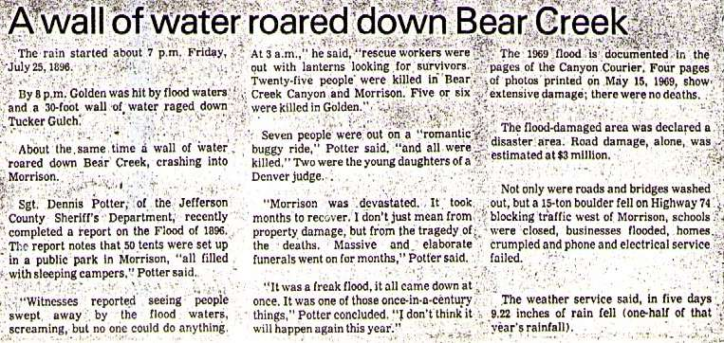

Flood Elevations in Morrison
The following photographs (Figures II-2 through II-5) were taken from the Morrison Flood Insurance Study. Each photo depicts the 100-year flood level at various locations in Morrison. Figure II-5 also shows the approximate high water mark for the 2-3 September 1938 flood.

Figure II-2 Park Avenue Bridge over Bear Creek in Morrison
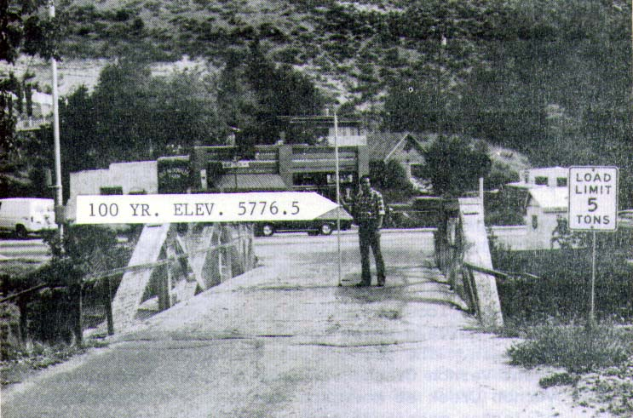

Figure II-3 Canon Street Bridge over Bear Creek in Morrison
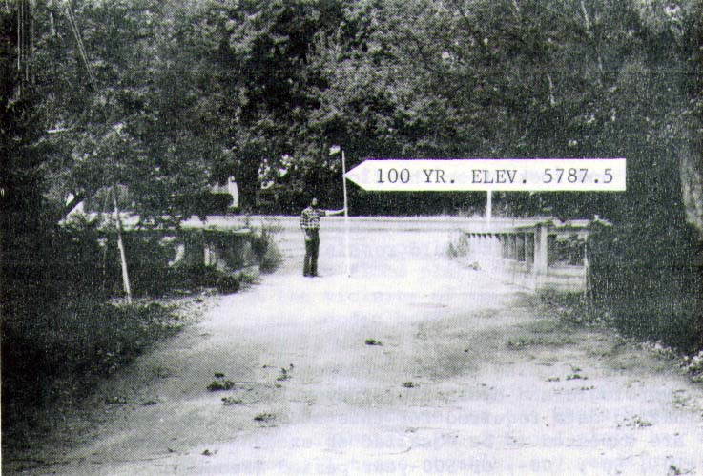

Figure II-4 Colorado Hwy 74 over Mount Vernon Creek in Morrison at Bear Creek
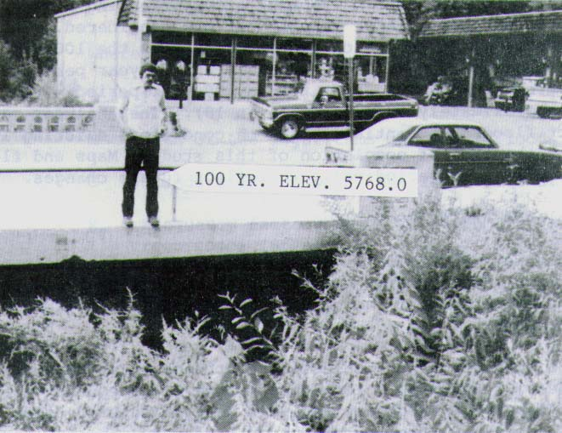

Figure II-5 Bear Creek Flood Levels on Side Wall of Store in Morrison Between Market Street and Mount Vernon Street, Downstream of Mount Vernon Creek. Historic Water Mark Depicts Level of 1938 Flood
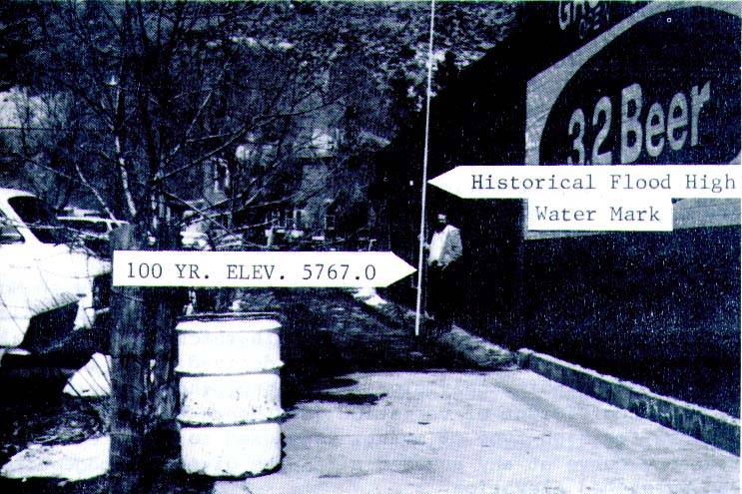

Flood Hydrology
It is important to remember that many different combinations of rainfall and runoff are possible. The information presented herein is considered reasonable for planning purposes, but is not intended as the only rainfall/runoff scenario possible.
the following documents contain additional hydrologic data, flood photos, historic flood descriptions, floodplain delineations and other pertinent information, and should be considered supplemental to this flood warning plan:
1. UDFCD, Flash Flood Warning Planning, Bear Creek, prepared by UDFCD, GRD Weather Center and Leonard Rice Consulting Water Engineers, January 1981.
2. UDFCD, Flood Hazard Area Delineation, Southern Jefferson County, prepared by PRC Engineering Consultants, Inc., December 1981.
3. UDFCD, Flood Hazard Area Delineation, Bear Creek, prepared by Gingery Associates, Inc., December 1979.
4. FEMA, Flood Insurance Study, Unincorporated Jefferson County, prepared by Gingery Associates (August 1983), revised July 4, 1989.
5. FEMA, Flood Insurance Study, Town of Morrison, prepared by PRC Engineering Consultants, Inc., June 1, 1982.

Snowmelt Flood vs. Rainfall flood Potential
To evaluate the snowmelt vs. rainfall flood potential at Morrison, Idledale, Kittredge and Evergreen, a discharge-frequency relationship at each location was established for both types of events. The Flood Insurance Study for Jefferson County, Colorado, originally prepared by PRC Engineering Consultants, Inc., provided the most complete hydrology study for Bear Creek. Included in that report was an estimate of discharge-frequency relationships for both snowmelt and rainfall floods at the Morrison stream gage. The study procedures were extended to develop the desired data and the results are summarized in Table II-4.
Table II-3 Summary of Rain and Snowmelt Flood Potential
Location | Drainage  Area  (mi²) | Return Period & Discharge (cfs)  Rainfall Events |  |  |  |  | Return Period & Discharge (cfs)  Snowmelt Events
Location | Drainage  Area  (mi²) | 10-yr | 50-yr | 100-yr | 500-yr | 10-yr |  | 50-yr | 100-yr | 500-yr
Morrison | 164 | 2,180 | 8,130 | 13,490 | 39,850 | 600 |  | 1,080 | 1,310 | 1,940
Idledale | 158 | 2,130 | 7,940 | 13,180 | 38,930 | 590 |  | 1,060 | 1,290 | 1,910
Kittredge | 139 | 1,970 | 7,330 | 12,170 | 35,930 | 560 |  | 1,000 | 1,220 | 1,800
Evergreen | 105 | 1,650 | 6,150 | 10,200 | 30,130 | 490 |  | 890 | 1,070 | 1,590

Anticipated Warning Times
Tables II-5 summarizes the estimated warning times that the automated stream gages provide to downstream areas. Lead times are given for three flood wave velocities of 12, 15 and 18 feet per second (fps). The value of 15 fps is assumed to be a reasonable estimate, but times based on 12 and 18 fps velocities are included to illustrate how flood travel times can vary. The lead times shown do not factor in the times required for data analysis and decision-making.
Table II-4 Automatic Stream Gages Lead Time in Minutes for Indicated Flood Velocities in fps
ALERT Gage |  | MORRISON |  |  | IDLEDALE |  |  | KITTREDGE |  |  | EVERGREEN
& I.D. Numbers | FPS | 12 | 15 | 18 | 12 | 15 | 18 | 12 | 15 | 18 | 12 | 15 | 18
Rosedale #2253 |  | 106 | 85 | 71 | 83 | 66 | 55 | 51 | 41 | 34 | 33 | 26 | 22
Cub Creek at Blue #2273 |  | 98 | 78 | 65 | 74 | 60 | 50 | 42 | 34 | 28 | 24 | 19 | 16
Evergreen Lake #2223 |  | 74 | 59 | 49 | 51 | 40 | 34 | 18 | 15 | 12 | -- | -- | --
Bear Creek below Cub #2233 |  | 73 | 59 | 49 | 50 | 40 | 33 | 17 | 14 | 12 | -- | -- | --
Cold Spring Gulch #2243 |  | 38 | 30 | 25 | 14 | 12 | 10 | -- | -- | -- | -- | -- | --
Red Rocks Park #2373 |  | 12 | 9 | 8 | -- | -- | -- | -- | -- | -- | -- | -- | --

A hydrologic analysis was completed by the Omaha District of the Army Corps of Engineers to establish the peak discharges for the 10-, 50-, 100-, and 500-year recurrence intervals in Bear Creek below Bear Creek Dam.
The newly constructed Bear Creek Dam and Reservoir intercepts flows from 239 square miles of the total 261-square mile drainage basin. This flood control reservoir, with some 110,000 acre feet of storage behind a 190-foot high embankment, has drastically reduced the flood potential for lower Bear Creek. The Special Flood Hazard Information Report for Bear Creek shows a 100-year discharge for 30,000 cfs near the reservoir site prior to reservoir construction. Recent calculations using a release probability curve developed from a theoretical operation scheme estimated a 100-year release of 1,000 cfs from the reservoir.
The 22-square mile drainage area below Bear Creek Dam still has the potential of generating damaging runoff flows during a cloudburst event over the lower basin. No applicable runoff records are available through this reach because of the recent construction of the dam.
Therefore, discharges for the 22-square mile drainage area below the dam were developed by using the Environmental Protection Agency’s Storm Water Management Model (SWMM) with modifications by the Missouri River Division of the U.S. Army Corps of engineers. These discharges were computed by assuming full basin development. The amount of impervious area was based on field investigations in 1977, which indicated that about 12.7 percent of the lower basin would be impervious. Infiltration rates were assumed to 0.5 inch per hour, and depression storage was estimated at 0.18 inch for pervious areas. These are values determined from previous studies in the Denver area.
The rainfall depth for the 100-year event was obtained from the NOAA Atlas for Colorado. A one-hour duration was considered critical with a rainfall depth of 2.37 inches.
The results of this hydrologic analysis are presented in Table II-5. Although the 100-year frequency discharge has been largely reduced by the construction of Bear Creek Reservoir, the discharge generated in the lower basin alone, for this event, is sufficiently large to cause overbank flooding in several areas along the creek. This magnitude of discharge would be expected in a rapidly developing urbanized area, such as lower Bear Creek.
Table II-5 Discharge Summary for Bear Creek

These studies account for the recent changes in detention facilities and determine the peak discharges for the 2-, 5-, 10-, 50-, and 100-year floods at various points along the creek. The hydrograph for the 100-year event and the water surface profile plots for the 100-year event are provided below.

Figure II-7 Bear Creek 100-year Flood Hydrograph

Flooding Extent (100-Year Floodplain)
The 100-year floodplain and floodway have been delineated along Bear Creek from the western reaches of the watershed to its confluence with the South Platte in the east. The limits of the 100-year floodplain and floodway represent the area in which development is often regulated to prevent increases in water levels and increased damages during a flood. Federal and state agencies such as the Federal Emergency Management Agency (FEMA) and the Urban Drainage and Flood Control District use the floodplain and floodway delineations as a mechanism to identify areas particularly prone to damage from flooding and to oversee development activities in these floodplains.
The basis for this floodplain and floodway delineation is the hydrology, which has been summarized in an earlier section of this report. The delineation assumes full basin development, based on land use and zoning projections provided by the affected communities, and existing channel conditions. A hydraulic analysis has been performed for the 100-year discharge, the results of which were used to plot the 100-year floodplain. The floodway has been computed for the 100-year event based on a maximum half-foot and one-foot rise in the energy grade line or water surface elevation, whichever was greater.
The U.S. Army Corps of Engineers HEC-RAS computer program was used to delineation the 100-year floodplain. The program was used to analyze the hydraulic response of the streams and floodplains using existing channel cross sections. The computational procedure used in the model is the Standard Step Method with the assumptions that the flow is steady, gradually varied, one dimensional, and slopes are relatively small. Major input parameters include digitized cross sections, roughness coefficients, channel lengths between sections, and flow rates. Bridges and culverts were simulated using surveyed field data input into the model. Flow in the channel was assumed sub-critical except near drainage structures; therefore a mixed flow regime was used to calculate the water surface elevations. Values of Manning's roughness coefficient "n" were estimated for the channel and the left and right overbanks along the channel based on field observations.
Flow through structures is sometimes partially blocked during high flood flows due to debris accumulation. Most of the structures modeled had large openings, which reduces the amount of debris caught. Based on the size of the structures, and field observations, and District approval, an area reduction coefficient was not used in the model.
The 100-year floodplain for the existing channel condition, which includes the detention capacities of various facilities, is provided. The 100-year water surface elevations and floodplain limits determined in the study represent estimates based on updated hydrology, future development, and current channel geometry in the basin. As a result, the delineation may differ from the floodplain limits identified in earlier studies. It should be noted that flooding of many areas will begin for floods more frequent than the 100-year flood. Those areas are described below and are further discussed with the decision aids in Section III. The following images show the extent of the 100-year floodplain near each HFP.

Figure II-7 Bear Creek Below Cub Creek (ID 2233)

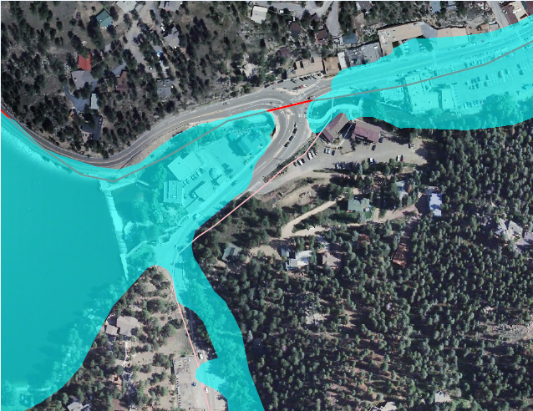
# 2223
Evergreen
Parkway
# 2233

Figure II-8 Bear Creek Above Cold Spring Gulch (ID 2243)

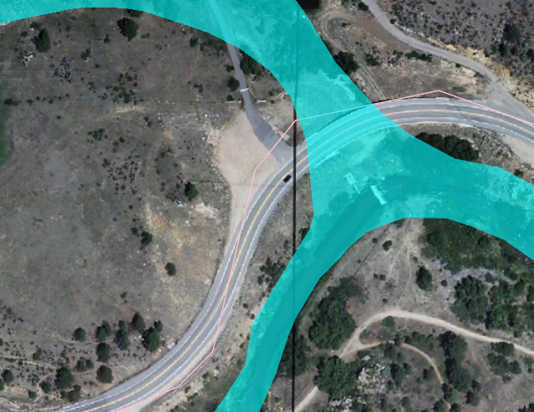
# 2243
Bear Creek Road
Figure II-9 Rosedale (ID 2253)

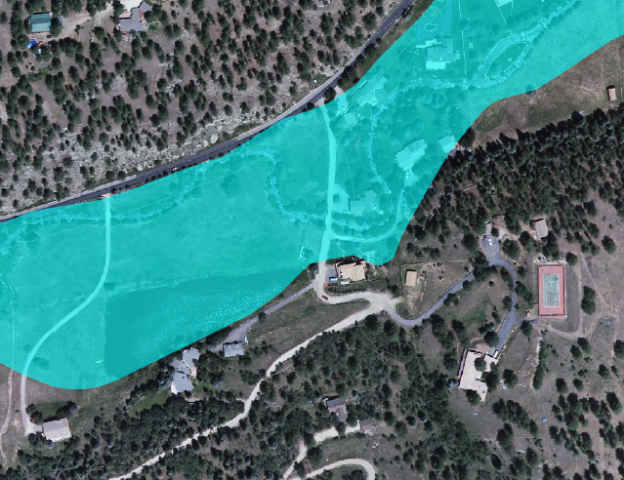
Meadow Brook Ln
Upper Bear Creek Road
# 2253

Figure II-10 Cub Creek Below Blue Creek (ID 2273)

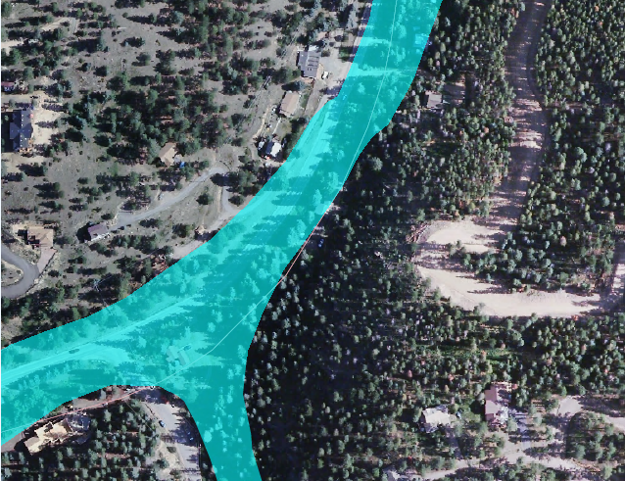
Brook Forest Rd
# 2273
Figure II-11 Bear Creek Above Morrison (ID 2333)

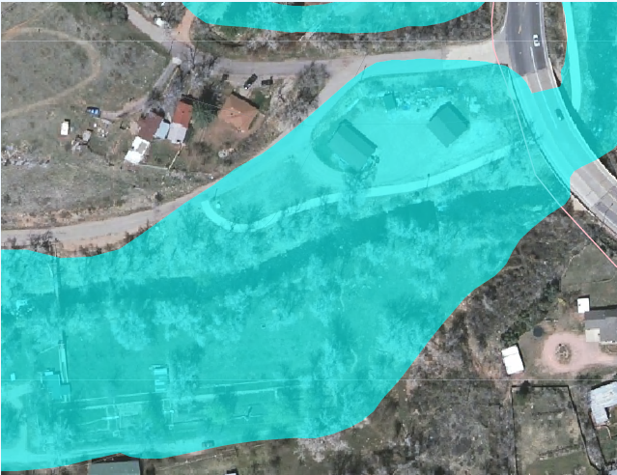
Bear Creek Ave
# 2333

Figure II-12 Red Rocks (ID 2373)

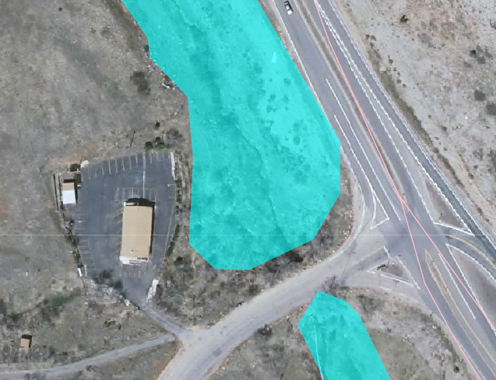
Alameda Pkwy
# 2373
Alameda Pkwy

DECISION AIDS

General
A private meteorological forecasting service (PMS), retained by Urban Drainage and Flood Control District (UDFCD) will use decision aids for issuing appropriate messages in accordance with standard operating procedures and the supplemental information contained in this flood warning plan. Flood conditions can be anticipated from the forecast. Measured rainfall and the site-specific decision aids and urban flash flood guidance are provided herein. Updates to the decision aids included with this warning plan will be made as experience is gained and more data become available.
The ALERT system is an automated flood detection network consisting of self-reporting rain, stream, weather, and reservoir gages that relay data using battery-powered VHF radios. The ALERT network in the basin consists of multiple stations that measure rainfall, stream, weather, and reservoir information. These gages are part of a much larger network operated by UDFCD. ALERT receiving base stations located at UDFCD’s main office and the UDFCD Flood Prediction Center (FPC) collect and display data from the ALERT network in real-time. The UDFCD base stations also host web services that allow users to view information over the Internet. Rainfall and stream level alarms will alert users of threatening conditions. Alarm notifications can be emailed automatically to warning plan participants. Data from the gaging network are used to update flood peak forecasts, estimate flow arrival times and predict flood impacts at specific locations.
PMS is responsible for monitoring the FPC base station, evaluating the real-time data and updating forecasts with the use of available decision aids. Simplified charts, tables, computer graphics and hydrologic models are the principle decision aids used to forecast flood conditions for specific problem areas. Sections IV through VIII contain additional information concerning PMS operations and responsibilities.
Flood warning plan participants and local emergency response personnel have access to the current PMS forecast (pager, email, fax, or Internet…http://f2p2.udfcd.org). ALERT gage data are available from Internet websites maintained by UDFCD (http://alert.udfcd.org and http://alert2.udfcd.org). Individuals should make their own assessments of the flood threat by using the gage data, the PMS and NWS forecasts and any observations obtained from field personnel (police, sheriff, fire, public works, etc.) or other reliable sources. Close coordination with public safety agencies should be maintained throughout this process.
The following decision aids are contained in this section of the warning plan:
ALERT Flood Detection Network. This map shows the location of all ALERT gaging stations within the basin and in surrounding areas.
ALERT System Summary. This table provides basic information regarding each gage in the drainage basin.
Urban Flash Flood Guidance. This table provides very basic rule-of-thumb guidance to associate forecast or measured rainfall amounts with the type of flooding produced from heavy rainstorms that occur over urban areas.
Convective Storm Characteristics. This table is used to estimate the frequency of either forecast or measured point rainfall. Both the total rainfall and intensity columns need to be carefully considered in making this estimate. This table is designed for use by trained technical personnel (hydrologists and hydro-meteorologists). In translating an estimate of precipitation frequency into a flood prediction for a specific point, the user must also estimate the spatial distribution of rain from the ALERT gages, radar, or detailed quantitative precipitation forecast (QPF); and then calculate either a total basin average or contributing drainage area relative to storm size. Hydrologic Forecast Point (HFP) Guidance can then be used to predict flooding for specific locations.
Mountain Stream Flash Flood Guidance. This figure provides very basic rule-of-thumb guidance to associate forecast or measured rainfall amounts with the type of flooding produced from heavy rainstorms that occur over mountain areas.
Approximate Flood Hazard Areas. This map shows the approximate flood hazard areas. Brochures prepared from these GIS maps are distributed annually by the District to residences and businesses located in or near the respective floodplains.
Stage Sensor Computer Graphics. Real-time displays of current water levels and basin rainfall have been developed for ALERT base station operations. These displays update automatically as data are received. Each graphics template provides information regarding local problem areas, historic floods, flood frequency data, alarm levels, elevation data and structure dimensions.

The Decision Making Process
The earliest indication of a potential problem will likely be the forecast from PMS. When significant rainfall is forecast, PMS will provide a Quantitative Precipitation Forecast (QPF) which will estimate probabilities for various amounts of precipitation and identify the most likely problem areas. If Bear Creek is included in the heavy precipitation forecast area, the decision maker should check Figure III-2, Table III-1, and Table III-2 to determine if the forecast rainfall will cause problems. If no problems are anticipated based on this review, a normal level of vigilance should be maintained. However, if the decision aids indicate a flood hazard potential, a higher level of awareness should be maintained.
Once rainfall has begun and the gages are reporting rainfall amounts, a further analysis of the potential hazard can be made. By determining the heavier rainfall amounts (both measured and projected), estimating the size of the basin area affected and calculating the maximum average 1-hour/10-square mile basin rainfall; updated projections of the flood hazard can be made. Periodic projections should be made until the storm has passed and problems have either occurred or the threat no longer exists.
The final confirmation that the drainage basin is indeed responding to significant rainfall is the rising stage measured by the ALERT stream gages and field reports from police, fire, public works personnel, or other reliable sources. Although it is tempting to wait for this final confirmation, doing so will severely limit the time available to warn floodplain occupants and dispatch emergency personnel to critical areas.
Once the decision has been made that a significant flood hazard exists, it is imperative that the warning and response elements of this plan be implemented.

Figure III-1 ALERT Flood Detection Network

Table III-1 ALERT System Summary

ID | Station Name | Install Date | Elev (ft) | Location (Lat./Long.)
2190 | Squaw Mountain (Weather) | 2000/06/01 | 11,400 | 39:40:52 N 105:29:44 W
2210 | Hiwan Golf Club (Weather) | 1991/04/09 | 7,650 | 39:40:20 N 105:20:49 W
2220 | Evergreen Lake (Stage) | 1992/06/03 | 7,085 | 39:37:53 N 105:19:20 W
2230 | Bear Creek below Cub Cr (Precip/Stage) | 1991/04/09 | 7,020 | 39:37:56 N 105:19:16 W
2240 | Cold Spring Gulch Conf (Precip/Stage) | 1991/04/25 | 6,655 | 39:39:58 N 105:16:31 W
2250 | Rosedale (Precip/Stage) | 1992/05/07 | 7,310 | 39:38:17 N 105:22:50 W
2260 | Brook Forest (Precip) | 1992/05/14 | 8,340 | 39:34:55 N 105:23:52 W
2270 | Cub Creek below Blue Cr (Precip/Stage) | 1992/05/12 | 7,560 | 39:35:34 N 105:20:38 W
2280 | Kinney Peak (Precip) | 1993/11/20 | 7,770 | 39:36:04 N 105:17:46 W
2310 | Genesee Village (Precip) | 1991/04/09 | 7,360 | 39:42:07 N 105:15:50 W
2320 | Choke Cherry Reservoir (Repeater) | 1992/04/23 | 7,850 | 39:41:46 N 105:16:29 W
2330 | Bear Creek at Morrison (Precip/Stage) | 1993/11/22 | 5,790 | 39:39:11 N 105:11:43 W
2340 | El Rancho (Precip) | 1993/10/04 | 7,680 | 39:42:06 N 105:19:47 W
2350 | Idledale (Precip) | 1992/05/07 | 6,740 | 39:40:14 N 105:14:29 W
2360 | Indian Hills (Precip) | 1992/05/07 | 7,375 | 39:38:13 N 105:15:49 W
2370 | Red Rocks Park (Precip/Stage) | 1992/10/27 | 6,090 | 39:40:49 N 105:11:50 W

Table III-2 Urban Flash Flood Guidance

FORECAST RAINFALL | FLOOD POTENTIAL | RECOMMENDED ACTIONS
Total Amt less than 1.0” | Streets, low-lying areas, intersections | Prepare for routine nuisance flooding
Total Amt = 1.0 to 2.0” | All of the above plus small streams, bankfull | Prepare for flooding of frequent problem areas
Total Amt = 2.0 to 3.0” | All of the above plus floodplain inundation | Prepare for street closures
Total Amt more than 3.0” | Major overbank flooding expected | Prepare for floodplain evacuations
Note: Rainfall amounts and guidance information apply to short duration storms (<= 1-hour) | Note: refer to basin flood warning plans for site specific data | Note: use judgment on when to warn public, maintain contact with meteorologist

Table III-3 Convective Storm Characteristics (All depths in inches)

Rainfall  Frequency / Probability | 10-minute  Rainfall Depth | 30-minute  Rainfall Depth | 1-hour  Rainfall Depth | 2-hour  Rainfall Depth
2-year / 50% | 0.4 | 0.8 | 1.0 | 1.2
5-year / 20% | 0.5 | 1.0 | 1.4 | 1.6
10-year / 10% | 0.6 | 1.2 | 1.6 | 1.9
25-year / 4% | 0.7 | 1.4 | 1.9 | 2.2
50-year / 2% | 0.8 | 1.6 | 2.2 | 2.6
100-year / 1% | 1.0 | 1.9 | 2.6 | 3.0
NOTES:
1) For "rainfall frequency" to equal "flood frequency," the coverage of rainfall must be over the entire upstream basin.
2) Tables III-2 and III-3 were developed to provide generalized guidance for estimating flood conditions in urban areas and for small streams draining less than 10 square miles. Site-specific guidance should be used where appropriate.
Figure III-2 Mountain Stream Flash Flood Guidance

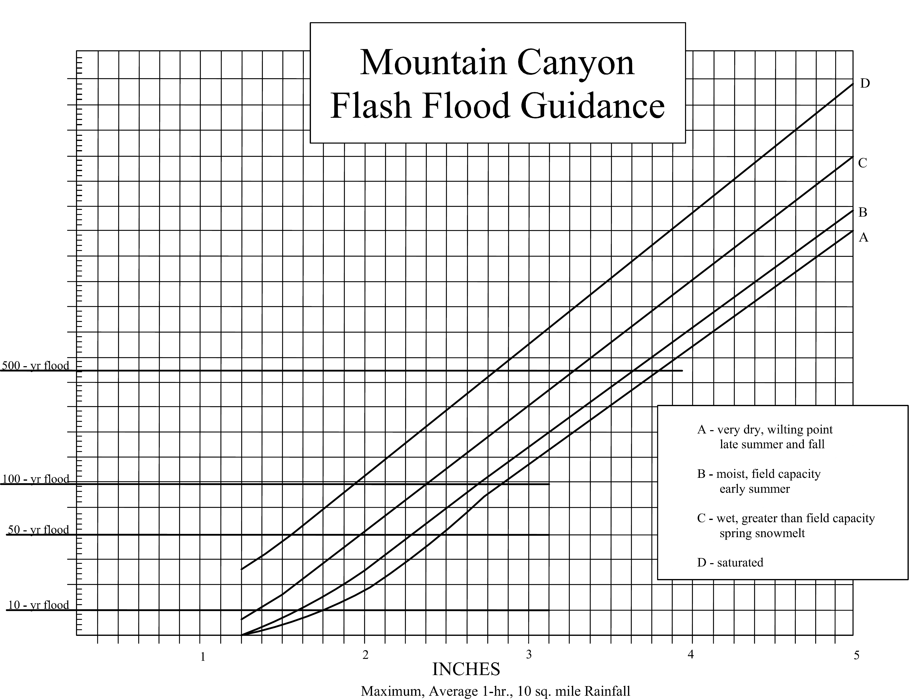
Estimate the 1-hour, 10 mi² average rainfall by using the mean value of the highest ALERT rainfall amount and the next highest nearest neighbor gage,

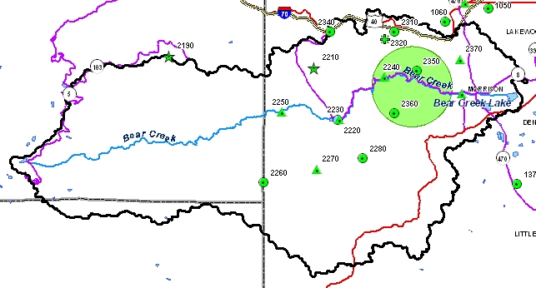
NOTE: The green-shaded ellipse above represents a 10 square mile area.
Problem Areas
This warning plan is geared toward overbank flooding from the main channels within the Bear Creek drainage basin. The user should be aware that intense rainfall can overwhelm the local storm drainage system and cause minor flooding outside any identified flood hazard area.
The approximate outlines of the 100-year floodplains are presented in this report. Brochures prepared from these maps are distributed annually by the Urban Drainage and Flood Control District to addresses located in or immediately adjacent to the 100-year floodplains.

South Platte River to South Federal Boulevard
Upstream from the South Platte River to South Federal Boulevard, approximately 2,000 cfs spills out of Bear Creek and runs in a southeasterly direction through the South Park Mobile home Court and the Englewood Municipal Golf Course, eventually flowing into the Platte River, south of the confluence of Bear Creek. Flood depths in the region of the trailer park can range anywhere from 1 to 3 feet, depending on land topography. Water velocities are relatively low due to limited conveyance through the park.
Generally on the north bank of the creek, the flow is contained in the channel, except for a small area where it breaks out and inundates some commercial storage buildings.

South Federal Boulevard to Hampden Avenue
Between South Federal Boulevard and South Lowell Boulevard, the 100-year floodplain inundates several private residences on both the north and south banks, including an area in the Kon-Tiki Mobile Home Park upstream from South Irving Street. The channel is restricted through this reach with 3,300 cfs of the total 8,150 cfs flowing in overbank areas. A small portion of the flow continues north down south Federal Boulevard and eventually ponds underneath the overpass at highway 285. At the South Federal Boulevard crossing, water spills across a section of this street north of Bear Creek and back into the channel a short distance downstream.
A small concrete bicycle bridge at South Irving Street has little effect on the floodplain. The bridge at South Lowell Boulevard creates a large backwater area which extends across Hampden Avenue and joins a sheet flow area from flooding through the Bear Valley Shopping Center. This backwater area can reach depths of up to 3 feet during a 100-year flood event.
From Bear Valley Park to Hampden Avenue, the 100-year floodplain ranges from approximately 600 to 900 feet in width. This large floodplain is caused by a wide, shallow channel with mild slopes, together with flat, grassy overbanks. No buildings are affected by the floodwaters in this reach.
At Lowell Boulevard, flood discharges spill sideways across Hampden Avenue for a distance of approximately 400 feet upstream of the bridge. This flow spills into a backwater area created by Lowell Boulevard on the street east of Hampden Avenue on the south. This backwater area also receives flood waters that flow along the north side of Hampden Avenue from the Bear Valley Shopping Center. A maximum flow of 150 cfs will spill from this backwater area across Lowell Boulevard and the Lowell/Hampden Intersection and continue downstream along Hampden Avenue.

Hampden Avenue to South Wadsworth Boulevard
Between South Sheridan Boulevard and Hampden Avenue, the 100-year flood is generally contained in the channel. However, large flooding upstream of the Sheridan bridge causes weir flow over South Sheridan Boulevard creating a large sheet flow area through Bear Valley Shopping Center. Average depths in this sheet flow area range from 6 inches to 1 food through the parking lot and creek. However, a portion of the flow drains east along the north side of Hampden Avenue until it reaches the backwater area at South Lowell Boulevard.
In the reach from South Sheridan Boulevard to South Wadsworth Boulevard, the 100-year flow is confined in the channel and open overbank areas with two exceptions. Along Gray Street and again along Golden Way, the flow breaks out from the channel and flows north along these roads. Several single family residences are affected by these floodwaters.
At Sheridan Boulevard, very shallow overflows will cross the street into Bear Valley Shopping center. Immediately upstream of the Sheridan Boulevard bridge, the calculated water surface elevation is below the minimum roadway elevation at which spill would occur. However, this calculated water surface elevation reflects high-velocity flow in the main channel. In the left overbank, low velocities indicate a higher water surface elevation. Therefore, the total energy was used to plot the floodplain and to calculate the overflows.
The estimated overflow discharge at this location is 250 cfs. Most of this overflow drains back into Bear Creek from the shopping center parking lot. About 100 cfs flows east from the parking lot and is conveyed along the north side of Hampden Avenue.
The 100-year floodplain immediately upstream of the Estes Street bridge is barely confined by a small ridge along the north side of the stream. Immediately upstream of the bridge for about 100 feet, however, some waters will flow to the north and spill across Estes Street during the 100-year event. Water surface elevations in this overbank area will not correspond to those in the main channel. The spill discharge is approximately 300 cfs.

South Wadsworth Boulevard to Bear Creek Dam
Much of the floodprone areas upstream from South Wadsworth Boulevard to South Kipling Street are very wide with widths up to 1,000 feet. A large flooding area upstream of South Wadsworth Boulevard is caused by backwater from the bridge crossing. The water ponds up behind South Wadsworth Boulevard, reaching depths of 1 to 2 feet before flowing over the road just south of the channel. Very little development exists in this area, and therefore very few structures are in the floodplain.
From South Kipling Street to Bear Creek Dam, the floodplain narrows down to widths between 100 and 300 feet. Land in this area for the most part is undeveloped. No structures are in the floodplain along this reach.
Figure III-3 100-Year Floodplain Boundary at Idledale and Morrison

Figure III-4 Flood Hazard Areas below Bear Creek Lake

Figure III-5 Typical ALERT Stream Gage Graphics

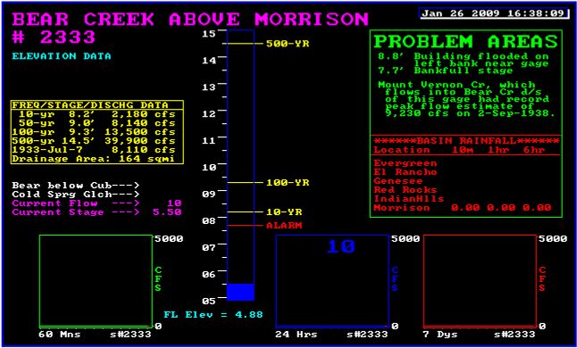

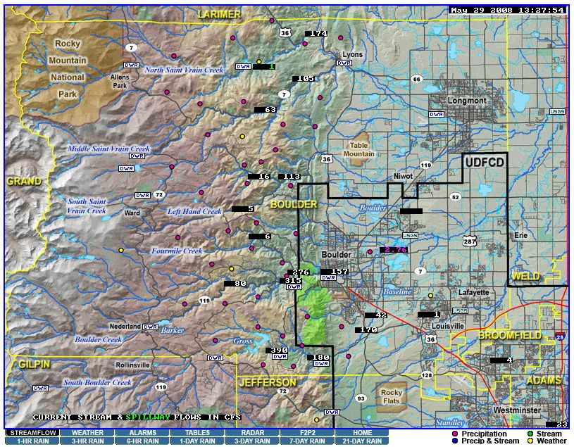
Note: Graphic displays like the one above for ALERT stream gages may be viewed by clicking on flow rate or water level values on the streamflow map – http://alert2.udfcd.org/cgi-bin/gdview?tpt=map21qweb

REQUIRED ELEMENTS OF THE WARNING PLAN
A complete flood warning plan consists of three basic elements

1. Detection and evaluation of the flood threat.
2. Dissemination of the flood warnings to the public.
3. Response of the public to the warnings.

All three parts must function properly or the warning plan will fail. The main purpose of the warning plan is to minimize the potential for loss-of-life. Public safety agencies will make decisions concerning floodplain evacuations and road closures. Individuals must also make appropriate decisions to protect themselves and their families. In some instances, a limited amount of emergency floodproofing by property owners can be accomplished. For residences and businesses along Bear Creek and Mount Vernon Creek, a flash flood warning would not likely provide enough lead-time to safely effect damage prevention measures such as sandbagging. Emergency property protection would probably be limited to turning off main gas and electricity connections.

The following pages provide a brief description of each of the three required elements listed above relative to this flood warning plan for Bear Creek.

DETECTION AND EVALUATION OF THE FLOOD THREAT

The Bear Creek early flood threat detection and evaluation element consists of the following items:

ORGANIZATIONS, RESOURCES AND PROCEDURES

1. The National Weather Service (NWS) Weather Forecast Office at Boulder and their NEXRAD Doppler Radar stations located at Denver, Cheyenne and Pueblo.
2. A private meteorological firm (PMS) retained by Urban Drainage and Flood Control District (UDFCD) to coordinate with NWS; collect and analyze all pertinent weather and flood data; prepare daily heavy precipitation outlooks; provide affected jurisdictions with early notification of flood potentials; and update jurisdictions as conditions change.
3. The Jefferson County Sheriff's Department Communications Center (JCC) that receives and disseminates all incoming weather and flood information. JCC is the primary communications link between PMS, NWS and other flood warning plan participants.
4. Communication arrangements defined to insure adequate communications between all parties at all times. Primary communications are by telephone. Amateur radio operators may be contacted to provide backup communications.
5. Standard messages used by PMS to provide information to JCC for relay to affected jurisdictions. PMS also communicates urgent "RED FLOOD ALERT" messages directly to the Lakewood Police to prompt priority dissemination and preparedness actions on their part.
6. Emergency Operation Centers (EOCs) in Jefferson County and Lakewood activated in a pre-emergency mode to gather and analyze information concerning the flood potential; maintain contacts with meteorologists, hydrologists and other support personnel; take early preparedness actions; mobilize field resources; and make warning decisions.
7. A Flood Prediction Center (FPC) at UDFCD that is staffed by PMS when flood potentials exist.
8. Officials from Jefferson County, Morrison, Lakewood and volunteer fire districts who receive all critical weather and flood information and respond according to their respective internal procedures.
9. Field personnel from various response agencies (Sheriff, police, fire districts, public works, road and bridge, and others) dispatched to pre-determined monitoring locations to report rainfall amounts, stream and reservoir water levels, and general flood conditions to appropriate jurisdictions.
10. Internal procedures and operating guidelines that are maintained, practiced and routinely updated by each participating local government agency, forecast service and support organization.

Equipment, Data Sources and Decision Guidance

1. Satellite imagery display equipment located at NWS and PMS enabling meteorologists to see approaching weather systems and estimate local arrival times.
2. Automated weather stations used to forecast flood potentials and predict storm development and movement.
3. Data communications equipment, computers and software used to collect and analyze pertinent upper air and surface data.
4. Radar product display equipment at NWS and PMS enabling meteorologists to evaluate current weather conditions; update heavy precipitation forecasts; estimate rainfall amounts at specific locations; predict storm movement, duration, and areal coverage; refine flood predictions; and anticipate specific flood problems.
5. Automated rain and stream/reservoir water level gages that transmit real-time data from the Bear Creek basin to base stations located at PMS, NWS and UDFCD.
6. Decision aids that are used to quickly analyze the real-time data, refine forecasts and predict specific flood impacts.

DISSEMINATION OF WARNINGS, WATCHES AND ADVISORIES TO THE PUBLIC

Several ways exist to disseminate flood warnings, watches and advisories to the public. The delivery of public flood warnings is dependent, to a large extent, upon the electronic news media (i.e., radio and television) with NWS being primarily responsible for the initial release of the warning and its content. Local governments are also responsible for disseminating public warning information within their political boundaries.

Three basic types of flood information are disseminated to the public:

1. Advisory (meaning that nuisance flooding or flooding of a "less serious" nature is either possible or occurring);
2. Watch (meaning that weather conditions are such that a hazardous flood may occur); and
3. Warning (meaning that a flood that poses a significant threat to life or property is either occurring, is imminent, or has a very high probability of occurrence).

The above types of information can be issued by NWS, the local governments or both.

NWS uses the following products to convey flood information to the public and to cooperating agencies:

1. Special Weather Statement. This frequently issued statement may contain advisory information indicating a potential for heavy precipitation and possible flooding. It is also used to amplify watches, warnings, and advisories by reinforcing the message, indicating what is expected, and outlining appropriate response actions.
2. Urban/Small Stream Flood Advisory. This advisory is typically used to indicate that minor nuisance flooding of small streams, streets, intersections and low-lying areas is imminent or occurring.
3. Flood/Flash Flood Watch. This product means that flooding or flash flooding is possible within the geographic area described, but that the occurrence is neither certain nor imminent.
4. Flood/Flash Flood Warning. This product means that hazardous flooding or flash flooding is imminent or occurring within the geographic area described.

All NWS products described above will be disseminated using NOAA Weather Radio and NOAA Weather Wire. Flash flood watches, warnings, and urban/small stream flood advisories will also be disseminated over NAWAS. The use of METS is limited to flash flood warnings and other warning products.

Local governments can initiate flood warnings and provide the public at risk with emergency information prior to an NWS issuance. PMS messages, current rain and stream level data from the ALERT system, and manual field observations can be used by officials for making warning decisions (refer to Sections III and VI). Local warnings can be disseminated over METS. NWS will receive the information from METS and re-transmit the information as necessary and practicable. Also, NWS can be contacted directly by local governments with additional dissemination requests.

The following presents a brief description of the several public dissemination methods mentioned in the above paragraphs along with some other available warning options:

1. National Warning System (NAWAS). NAWAS consists of full-period, private line voice circuits. NWS uses NAWAS to disseminate flood advisories, flash flood watches and warnings to "Warning Points" in Colorado. One 24-hour "Warning Point" in this system is the Jefferson County Sheriff's Department Communications Center (JCC).
2. Metropolitan Emergency Telephone System (METS). This is a telephone network to which government agencies and the media can subscribe. JCC, the Jefferson County Department of Emergency Management and NWS can quickly pass information to the media subscribers for broadcast on radio and TV. NWS uses METS for warnings, but not for watches or advisories.
3. NOAA Weather Wire. This is a satellite or Teletype-based communications system over which NWS can pass information to local governments or media subscribers for broadcast.
4. NOAA Weather Radio. This is a radio station operated by NWS (Frequencies: 162.550, 162.475, and 162.450 MHz). Special weather radio receivers or scanners can be purchased by anyone who is interested.
5. Emergency Alert System (EAS). The EAS consists of radio, television, and cable outlets throughout the United States who are linked together to provide live broadcasts of presidential messages during times of national emergency. On a voluntary basis, the system may also be used for broadcasting state and local emergency warnings and information. Locally, radio station KOA (850 AM) is the primary entry point for the system. Jefferson County and NWS have input capability into the system along with the Colorado State Patrol and the Colorado Office of Emergency Management.
6. Automated Emergency Call System. This telephone notification method, also known as the Emergency Preparedness Network, uses the 9-1-1 Qwest phone number database to automatically dial and warn homes and businesses within affected areas concerning floods and other emergencies. The system is capable of handling up to 1200 calls per minute.
7. Cable Television Interrupt. This warning method is used by communications personnel to voice over-ride all cable TV programming for emergency messages.
8. Outdoor Warning Systems. A fixed-location outdoor siren/voice warning system in Lakewood will be used to warn people in and near the floodplain of an approaching flash flood and advise occupants to evacuate.
9. Emergency Vehicles. When a decision to evacuate the floodplain has been made, local law enforcement agencies and fire departments may dispatch vehicles to circulate through assigned portions of the floodplain using sirens and mobile public address systems to advise occupants to evacuate. Standard messages to be used on the public address systems are given in Section IX.

Once the decision to warn and/or evacuate has been made, it is necessary to quickly and efficiently disseminate the warning to floodplain occupants, motorists and others at risk. Dissemination should be made by as many different means as possible, but care should be taken to insure that warnings from different sources are similar in content. The warning message should clearly communicate the danger and recommend specific protective actions. Bear Creek flood warnings can be issued by the broadcast media, by loud speaker equipped vehicles, and by Lakewood's fixed-location outdoor siren/voice warning system. Confirmation of the initial warning is desirable whenever possible. People tend to seek confirmation before reacting to a warning.

All warning dissemination agencies, including the broadcast media, should have copies of the standard warning messages in Section IX. The media must be informed beforehand of the existing hazard and the details of the warning system; and they should be checked with periodically to insure their readiness.

RESPONSE OF THE PUBLIC TO THE WARNING

If the desired response of the people in the flood hazard area to a warning is not obtained, the whole warning plan will have failed. Cultivation of the desired response must begin well in advance of any flood threat by heightening the public awareness of the flood hazard.

These steps will be taken annually to try to cultivate the desired response:

1. UDFCD will annually mail or deliver a brochure to all occupants of the Bear Creek and Mount Vernon Creek floodplains within the District. The brochure will contain a map of the flood hazard area and provide information on steps to take prior to flooding (plan evacuation routes, buy flood insurance, etc.) and in the event of a flood warning.
2. The local governments will put a notice of the flood hazard in appropriate publications each spring before the flood season.
3. Media coverage of the flood hazard, including the annual practice of the warning plan, will be sought.

COMMUNICATIONS
Communications among personnel within participating agencies will be by normal methods now in operation. The Jefferson County Sheriff's Department Communications Center (JCC) is the primary contact for all communications concerning Bear Creek and is responsible for relaying weather and flood information to other flood warning plan participants.
During emergency operations, field personnel from one agency wishing to communicate with personnel from another agency should follow their own jurisdiction's incident command system. This will assure a system of managed communication and information flow. If an Emergency Operations Center (EOC) is activated in either Jefferson County or Lakewood, communications will include the EOC.
Primary communications between the National Weather Service (NWS), the UDFCD private meteorological service (PMS), JCC and Lakewood will be by telephone. When conditions warrant, Ham radio operators can be called into each location to establish alternate communications according to previous agreements. Jefferson County, Lakewood, Morrison and the fire districts will use assigned radio frequencies to communicate with field personnel.
PMS initiated communications require special emphasis. With JCC remaining the primary contact, Lakewood Police (via Skyview Weather in Castle Rock) may also be contacted directly by PMS when "RED FLOOD ALERT" messages are issued which require priority attention on their part. Lakewood will continue to receive PMS messages from JCC. Any participating entity may initiate calls to PMS or dispatch personnel to the appropriate EOC if more direct information exchange is desired. When an EOC is activated, local authorities may request that PMS include the EOC as an additional or alternate contact point.
The following page contains pertinent telephone numbers and radio frequencies. The "Internal Communications Flow Chart" (Figure V-1) on page V-3 illustrates the collection and dissemination of weather information from various sources and shows the intended inter-agency flow paths for data and voice communications.
TELEPHONE NUMBERS AND RADIO FREQUENCIES

Organization Phone Number Frequency
* Jefferson County Communications (JCC) 303-277-0211
Jefferson County Emergency Management 303-271-4900
Jefferson County Highways and Transportation 303-271-8480
Lakewood Police Communications 303-987-7140
emergency line 303-987-7111
Morrison Police Department 303-697-4810 or (x4620, x8752)
after hours 303-277-0211
West Metro Fire Protection District 303-969-0245 154.190
Foothills Fire Protection District 303-526-0707 45.080
Evergreen Fire Department 303-674-3411 458.950
Genesee Fire Protection District 303-526-1230 45.080
Indian Hills Fire Protection District 303-697-8739 45.080

* Skyview Weather (for relay to Lakewood) 303-688-9175

* National Weather Service (NWS)
coordination (duty forecaster) 303-494-4479
severe weather reports 303-494-2884
administration 303-494-3210
public weather information 303-494-4221

* Urban Drainage and Flood Control District (UDFCD) 303-455-6277

UDFCD Private Meteorological Service (PMS)
UDFCD Flood Prediction Center (FPC) 303-458-0789
Skyview Weather 303-688-9175
Genesis Weather Solutions 303-927-6522

Commonly Shared Emergency Radio Frequencies
CLEER "Colorado Law Enforcement Emergency Radio" 460.425
FERN "Fire Emergency Radio Network" 154.280
NLEC "National Law Enforcement Channel" 155.475

Other Radio Frequencies
NOAA Weather Radio (Denver) 162.550
NWR alternate 1 (Longmont/Mead) 162.475
NWR alternate 2 (Fort Collins) 162.450
Ham severe weather spotter network 146.940
Alternate 147.120

Websites
ALERT System (public use) http://alert.udfcd.org
ALERT System (public safety agency use only) http://alert2.udfcd.org

* Principle contact for PMS (Genesis Weather Solutions with Skyview Weather)

Figure V-1 Internal Communications Flow Chart

METEOROLOGICAL SUPPORT
The National Weather Service (NWS) and the private meteorological service (PMS) will provide meteorological support to the local governments participating in this flood warning plan. Following is the process by which NWS, PMS, Jefferson County, Lakewood and Morrison should coordinate, exchange information and gear up for potential flooding along Bear Creek and its tributaries:

1. NWS and PMS conduct daily weather discussions as necessary to evaluate flood potentials. PMS will prepare daily heavy precipitation outlooks from April 15 through September 15. This product is available from the Internet at http://alert.udfcd.org and may also be faxed to warning plan participants. When warranted, PMS will issue more detailed quantitative precipitation forecasts (QPF) and storm track predictions. Many NWS products are also available from the Internet including flood advisories, flash flood watches and flash flood warnings.
2. When weather conditions are such that flash flood producing rains could develop, PMS will relay a MESSAGE A by phone to Jefferson County Sheriff's Department Communications Center (JCC). JCC will forward the message to Lakewood, Morrison, Evergreen, Jefferson County Emergency Management and participating fire departments. A MESSAGE A that requires priority handling will be identified as a "RED FLOOD ALERT" message and will also be telephoned directly to Skyview Weather by PMS if the message is considered urgent for Lakewood. Skyview Weather is a private meteorological firm located in Castle Rock that has been retained by the City of Lakewood to provide special support services. Skyview will relay the message from PMS to Lakewood Police and other city departments according to their internal notification procedures.
3. NWS and PMS continue their weather discussion. If the flood potential increases one of the following actions will occur:
a. NWS will issue a Special Weather Statement or Urban and Small Stream Flood Advisory through normal channels (NAWAS, weather wire, weather radio) and/or PMS will send a MESSAGE UPDATE to MESSAGE A (RED FLOOD ALERT if warranted) to JCC; or
b. NWS will issue a Flash Flood Watch through normal channels (NAWAS, weather wire, weather radio) and PMS will send MESSAGE 2 to JCC; or
c. PMS will send a MESSAGE 2 to JCC indicating an increase in flood potential.
JCC will forward this message to Lakewood Police, Morrison, participating fire departments (i.e., West Metro, Evergreen, Foothills, Genesee and Indian Hills) and Jefferson County Emergency Management. PMS will contact Skyview Weather directly only when the RED FLOOD ALERT message warrants immediate action concerning Lakewood.
4. Observers will be designated within each jurisdiction and both Jefferson County and Lakewood will consider activating their respective Emergency Operation Centers (EOCs).
5. Regular coordination between NWS, PMS and JCC will continue. Should either EOC be activated, PMS and NWS shall be notified immediately and regular coordination will include the Jefferson County EOC. PMS will also communicate directly with the Lakewood EOC upon request by Lakewood Police.
6. When conditions warrant, NWS will issue a Flash Flood Warning through normal channels and PMS will send a MESSAGE 3 to JCC and Skyview Weather (for relay to Lakewood). PMS may issue a MESSAGE 3 prior to the issuance of a NWS warning if PMS feels that a life-threatening flood is imminent.
7. Jefferson County, Lakewood, Morrison and the fire departments will continue to monitor the situation and begin public dissemination of warnings when necessary. PMS will continue to send MESSAGE UPDATES as warranted.
8. When the hazard has passed, PMS will send a MESSAGE 4 to JCC.

Throughout all of the above activities NWS and PMS will coordinate as necessary. It must be remembered that events may occur so rapidly that it may not be possible to carry out all of the above steps. Personnel on duty must be prepared for this possibility and must pick up the process as best they can.

The following page provides a brief description of each PMS message and their intended uses. Subsequent pages contain the standard message forms used by JCC, Lakewood Police and Skyview Weather for documenting and relaying direct PMS communications. These message forms should be used to insure rapid flow of information with minimum chance for error.

MESSAGE DESCRIPTIONS

MESSAGE 1 (Nuisance Flood Advisory)
This advisory message is to inform key people that weather conditions are such that nuisance flooding could develop later in the day—impacting streets, low-lying areas, normally dry gulches, small streams, and the recreational trails located along these small drainage channels. Mud/rockslides are the primary concern for the mountains and foothills. It will be issued by PMS after consultations with NWS. If PMS considers the threat imminent, the message will be identified as a RED FLOOD ALERT (RFA).

MESSAGE 2 (Flash Flood Watch)
This advisory message is to inform key people that either a Flash Flood Watch has been issued by NWS or PMS believes that weather conditions are such that a life-threatening flash flood may occur later in the day. Significant stream flooding and property damage is possible. PMS will add any additional information that is available.

MESSAGE 3 (Flash Flood Warning)
This warning message will be issued to inform key people that a Flash Flood Warning has been issued by NWS or PMS feels that a life-threatening flash flood is imminent. Significant stream flooding and property damage is expected. PMS will add any additional information that is available. This warning message should be disseminated as quickly as possible.

MESSAGE UPDATE
This message will be used by PMS to update any of the previous messages. For example, this message can be used to narrow a watch or warning area as more information becomes available, or to provide more site-specific data and direction during an event. If PMS considers the threat imminent, the message will be identified as an RFA.

MESSAGE 4 (All Clear)
This message cancels the flood potential status. It is issued by PMS after consultation with NWS and other entities involved with direct PMS communications.

ABBREVIATIONS: NWS...National Weather Service PMS...Private Meteorological Service

NOTES: F2P2 messages are used to notify local governments of potential (MESSAGE 1 and 2) and imminent (MESSAGE 3 and RFA) flood threats. All F2P2 messages are designed for internal use and not intended for the general public. Standard message forms are completed by the meteorologist and sent by fax or email to designated communication fan-out points prior to making contact by telephone. Each county warning point or designated recipient follows their respective protocol for subsequent dissemination of messages.

An RFA is used when PMS believes that a nuisance flooding rainstorm is imminent and expected to primarily impact streets, low-lying areas, creek-side trails, etc. This type of flooding is generally considered a low risk to life and property. When a MESSAGE 2 is in effect, RFA may be used with a MESSAGE UPDATE to indicate imminent nuisance flooding that does not warrant a MESSAGE 3. When a MESSAGE 3 is in effect, RFA may be used with a MESSAGE UPDATE when an approaching storm is expected to cause nuisance flooding outside the warning area. Due to the short lead-time nature of the RFA, it should be disseminated as quickly as possible.
RED FLOOD ALERT: yes no Received By
(circle one) Date
Priority dissemination if yes Time

MESSAGE 1
(Internal Alert)

This is meteorologist
(Business Name) (Name )

Please prepare to fill in the blanks on UDFCD/F2P2 Form M-1 concerning the possibility of flooding later today.

We have determined that the potential for flooding exists for

from until .
Prime time for flooding is from until .
(time) (time)

The most likely areas to be impacted by flooding are (check appropriate items):

Mountain Canyon Streams & Floodplains

Urban Streams & Floodplains

Urban Streets, Intersections & Low Lying Areas

Other (describe)

The potential risk to life and property is (check appropriate item):

Low Moderate High

This message is not intended for public dissemination. Please pass this information along to affected emergency response organizations (police, fire, public works, etc.) within your area.

Also, please take appropriate actions to prepare for possible flooding.

Further information will be provided to you as it becomes available.

AUTOMATIC RED FLOOD ALERT Received By
Date
Priority dissemination Time

MESSAGE 2
(Flash Flood Watch)

This is meteorologist
(Business Name) (Name )

Please prepare to fill in the blanks on UDFCD/F2P2 Form M-2 concerning the threat of flash flooding later today.

Use message OPTION (circle one): A B

OPTION A
The National Weather Service has issued a Flash Flood Watch for

which means that flash flooding is possible within the watch area.
This watch is valid from until .
(time) (time)

We concur/disagree (circle one) with NWS watch and advises

OPTION B
We have determined that the possibility of a life-threatening flash flood exists for

from until .
(time) (time)

Please pass this information along to affected emergency response organizations (police, fire, public works, etc.) within your area.

Also, please take appropriate actions to prepare for possible flooding.

Further information will be provided to you as it becomes available.

AUTOMATIC RED FLOOD ALERT Received By
Date
Priority disseminATION Time

MESSAGE 3
(Flash Flood Warning)

This is meteorologist
(Business Name) (Name )

Please prepare to fill in the blanks on UDFCD/F2P2 Form M-3 concerning an imminent flash flood.

Use message OPTION (circle one): A B

OPTION A
The National Weather Service has issued a Flash Flood Warning for

which means that flash flooding is imminent or has been reported within the warning area.
This warning is valid from until .
(time) (time)

OPTION B
We have determined that an imminent danger of a life-threatening flash flood exists for

from until .
(time) (time)

Please expedite this information to affected emergency response organizations (police, fire, public works, etc.) within your area.

Also, please take appropriate actions to deal with this flood threat and warn the public.

Further information will be provided to you as it becomes available.

RED FLOOD ALERT: yes no Received By
(circle one) Date
Priority dissemination if yes Time

MESSAGE UPDATE

This is meteorologist
(Business Name) (Name )

Please prepare to fill in the blanks on the UDFCD/F2P2 Form M-U concerning updated information on the threat of local flooding.

This is an update to Message(s) concerning possible
flooding for .

We advise

Please pass this information along to the emergency response organizations you have previously notified.

Also, please take appropriate action in response to the current flood potential.

Further information will be provided to you as it becomes available.

Received By
Date
Time

MESSAGE 4
(All Clear)

This is meteorologist
(Business Name) (Name )

Please prepare to fill in the blanks on UDFCD/F2P2 Form M-4.

The potential for flooding in
has passed.

Message Number(s) are rescinded.

We will keep you advised of any changes.

Please pass this information along to the emergency response organizations you have previously notified.

FLOOD THREAT RECOGNITION AND WARNING PROCESS

The first element of a local flood warning system is the ability to detect and evaluate a flood threat in its early stages and make the decision to warn before flood damages or deaths occur. The second element is the dissemination of the warning to the public at risk. The third element is the public response to the warning. This section deals with the first two elements relative to Bear Creek including a step-by-step illustration of how the early flood threat recognition and warning process is intended to function.

Detection and Evaluation of the Flood Threat

The earliest recognition of a potential flood threat for the Bear Creek drainage basin will be a heavy precipitation forecast by a meteorologist. The private meteorological service (PMS) retained by Urban Drainage and Flood Control District (UDFCD) provides the meteorological support for this plan among other responsibilities. This service supplements National Weather Service (NWS) activities by focusing its support for the six-county geographically area comprising UDFCD and tailoring communications to the individual concerns of each local government within this area. Section VI describes the meteorological support provided by PMS and NWS.

PMS forecasts are coordinated with the NWS Weather Forecast Office at Boulder and provided to the Jefferson County Sheriff's Department Communications Center (JCC) for subsequent dissemination. JCC's principal contacts for Bear Creek flood notifications are: Lakewood Police; Morrison Police; West Metro, Idledale, Evergreen, Indian Hills and Genesee fire districts; and Jefferson County Emergency Management. Participating organizations will take appropriate preparedness actions in accordance with respective internal procedures.

Fourteen automated rain gages and six stream gages within the Bear Creek basin will transmit rainfall data and current stream and reservoir water levels to three ALERT base stations located at PMS, NWS and UDFCD. PMS also has access to other meteorological data from weather radar, satellites, upper air soundings and weather stations. PMS will use this data and the decision aids in Section III to predict flood potentials and update local officials concerning anticipated flood problems at specific locations.

Emergency Operation Centers (EOCs) may be activated at Jefferson County and Lakewood. The decision to activate the EOCs rests with each respective jurisdiction. If either EOC is activated, participants will have the opportunity to analyze current ALERT data, interact directly with PMS and NWS and use the decision aids provided in Section III. EOCs may access the ALERT system via PC/phone modem connection to UDFCD's base station or from the Internet. EOC personnel may also assume the primary flood prediction role should communication links with PMS and NWS fail. Local authorities and NWS are responsible for making decisions concerning public warning.

Section VIII provides further discussion regarding procedures and general responsibilities of the principle organizations involved with this flood warning plan. While this plan may be useful for warning decisions throughout the Bear Creek drainage basin, it has been designed primarily for warning high risk areas along Mount Vernon Creek and Bear Creek from Kittredge and to Bear Creek Lake. This includes the towns of Morrison and Idledale, and the Bear Creek Lake Park area within the City of Lakewood.

Dissemination of the Warning

Dissemination of warning information to the public will be accomplished through the electronic media and by local government officials from Jefferson County, Lakewood and Morrison. Dissemination by the media may be channeled through NWS by local authorities or the media may be contacted directly. NWS will use NAWAS, METS, NOAA Weather Wire, NOAA Weather Radio and/or EAS at their option to issue the public warning. Section IV describes the various methods for disseminating flood warnings and advisories to the public.

Each local government may also provide flood warnings directly to the public at risk within their jurisdiction according to internal procedures. Standardized messages to be used by local governments are included in Section IX.

Step by Step Procedure

The following step-by-step procedure is an idealized summary of how the flood threat evaluation and warning process is supposed to function. THE USER MUST BE AWARE THAT THE SYSTEM WILL NOT ALWAYS FUNCTION AS PLANNED. THE USER MUST BE PREPARED TO FUNCTION WITHIN THE FRAMEWORK OUTLINED HERE, EVEN IF ALL STEPS LISTED HEREIN DO NOT OCCUR OR OCCUR OUT OF ORDER.

A. Normal Operations:
1. PMS will be monitoring weather conditions on a routine basis, including appropriate coordination with NWS. It should be noted that PMS, NWS and UDFCD have an ongoing relationship that involves forecasts of flood potential for the entire Denver/Boulder metro area; and the Bear Creek Flood Warning Plan is an add-on responsibility for meteorologists and other technical support personnel.
2. When weather conditions warrant, and after consultation with NWS, PMS will issue a MESSAGE 1 (messages are explained in detail in Section VI) by telephone to JCC. PMS may indicate urgency by stating that the MESSAGE 1 is a "RED FLOOD ALERT" message. The term RED FLOOD ALERT is used to prompt priority internal message dissemination by emergency communications personnel and should not be confused with the "Red Flag Warning" fire weather product issued by NWS. RED FLOOD ALERT flood messages that affect Lakewood will also be issued by PMS to Lakewood Police via Skyview Weather. Section V contains details regarding weather-related communications and the flow of critical information.
3. JCC will forward the MESSAGE 1 to Jefferson County Emergency Management, Morrison Police, Lakewood Police, participating fire districts, and other support agencies according to internal procedures. REMEMBER THAT A MESSAGE 1 IS A FORECAST OF A POTENTIAL FOR FLOODING. IT IS NOT INTENDED FOR PUBLIC DISSEMINATION SIMPLY BECAUSE IT IS TOO EARLY TO TELL WHAT WILL ACTUALLY DEVELOP.
B. Increased Awareness:
1. PMS will continue to monitor the situation and will issue MESSAGE UPDATES (RED FLOOD ALERT if warranted) to keep local officials advised of significant changes since the previous message.
2. NWS may issue a Special Weather Statement or other appropriate communication concerning heavy precipitation through normal channels (Section IV). PMS may follow this with a MESSAGE UPDATE providing a more detailed interpretation of how this affects Jefferson County and the Bear Creek basin.
3. JCC will forward this information and each subsequent contact should follow internal procedures for updating key pre-designated people concerning the increased flood potential.
4. Contingency plans should be established to ensure that future steps in this warning plan can be carried out if needed.
C. Flash Flood Watch:
1. As the flood potential becomes more apparent or threatening, NWS will issue a Flash Flood Watch for a geographic area. The Flash Flood Watch will be issued on NAWAS, Weather Radio and Weather Wire.
2. PMS will issue a MESSAGE 2 to JCC for relay to the other entities. PMS will also issue a MESSAGE 2 to Lakewood Police via Skyview Weather if immediate action on Lakewood's part is needed. A MESSAGE 2 will not only indicate the issuance of a Flash Flood Watch by NWS but will also attempt to provide additional information concerning severity of the threat and a more definitive identification of areas at risk. PMS may also issue a MESSAGE 2 without a NWS issuance of a Flash Flood Watch if PMS feels the risk is high that a life-threatening flood may occur later in the day.
3. PMS will continue to monitor all available data and will initiate an analysis of potential flood peaks based on predicted rainfall and decision aids (Section III).
4. As additional data (including rainfall and stream gage data) becomes available, PMS will update rainfall forecasts and flood peak projections and will provide information to JCC and Lakewood Police via Skyview Weather in the form of MESSAGE UPDATES.
5. Jefferson County and Lakewood should consider activating their EOCs at this time if not done previously and maintain frequent two-way communications with PMS and NWS.
6. Local officials will send rain and stream observers to pre-determined locations. Stream gage readings and field observations will be reported to PMS and NWS through JCC, Lakewood Police or EOC personnel.
7. PMS will confer as needed with NWS. When rainfall estimates or measurements, and flood peak predictions indicate an imminent flood danger; or when automated stream gages or field observations confirm the threat, a Flash Flood Warning will be issued by NWS.
D. Flash Flood Warning:
1. NWS will issue a Flash Flood Warning through NAWAS, METS, Weather Radio, Weather Wire and perhaps EAS. A Flash Flood Warning means that flooding is imminent or is occurring.
2. PMS will issue a MESSAGE 3 to JCC for relay to the other entities. PMS will also issue a MESSAGE 3 to Lakewood Police via Skyview Weather. PMS may also issue a MESSAGE 3 without a NWS issuance of a Flash Flood Warning if PMS feels that a life-threatening flood is imminent.
3. Each entity should then disseminate the warning within its jurisdiction according to internal procedures using standardized messages where appropriate (Section IX).
4. PMS, NWS and stream observers will continue to monitor the situation to either confirm flooding or determine that the hazard has passed.
5. When the threat of flooding has passed (whether a flood has occurred or not), PMS will issue a MESSAGE 4.
6. If flooding has occurred, the affected entities will follow their respective disaster response plans.
E. Other Considerations:
1. As noted above, this is an idealized scenario. It is unlikely that any flood event would be handled exactly as outlined. Each entity must be cognizant of the probable necessity to deviate from their respective plan in order to react to the real situation.
2. NWS is the only federal agency that can officially issue a Flash Flood Watch or Flash Flood Warning to the public. In the event of a difference of opinion between NWS and PMS, PMS will advise JCC of the difference of opinion as follows:
a. If PMS feels a watch or warning should be issued but NWS doesn't agree, PMS will use a MESSAGE 2 or MESSAGE 3 to inform local authorities of their forecast and prompt each jurisdiction to make their own warning decision.
b. If NWS issues a watch or warning but PMS doesn't feel it is warranted, PMS will still issue the appropriate MESSAGE 2 or 3, but indicate their misgivings. The standard message forms in Section VI are designed to clearly indicate either concurrence or disagreement between PMS and NWS.
3. In the event of a local decision to warn, the official in charge should immediately contact NWS to avoid public confusion. Also, NWS may be the quickest means of notifying the public via the electronic news media. NWS may acknowledge the involvement of local authorities (i.e., Jefferson County, Lakewood, Morrison, UDFCD, etc.) when issuing their warning.
4. Flood warnings for Bear Creek can be issued by local officials using emergency vehicle loud speakers, door-to-door notification and other methods deemed appropriate.

PROCEDURES AND GENERAL RESPONSIBILITIES
Procedures and general responsibilities for the operational elements of this flood warning plan are contained in this section. Three points regarding these procedures need to be emphasized:

1. The operating procedure for each organization addresses only those actions and activities that organization must accomplish in order to effect a coordinated response to a flood situation along Bear Creek, Mount Vernon Creek and other tributary streams in the Bear Creek drainage basin.
2. Every individual responsible for the implementation of any part of this warning plan should be familiar with the entire plan.
3. This section does not contain detailed operating procedures but provides an overview of technical support activities, communications, emergency operations and general responsibilities of each participating organization. Specific task assignments and responsibilities are described in local emergency operation plans and other supplemental documents maintained by local governments. Similarly, the technical support organizations including National Weather Service (NWS) and Urban Drainage and Flood Control District (UDFCD) and their private meteorological service (PMS) routinely update their own internal operating procedures, policies and duty manuals.

National Weather Service and Private Meteorological Service

The NWS Forecast Office at Boulder has the responsibility for issuing Flash Flood Watches, Flash Flood Warnings, general Flood Warnings, and many other types of weather warnings, advisories and forecasts for northeastern Colorado, including Jefferson County, in which the Bear Creek drainage basin is located. PMS has been retained by UDFCD to supplement NWS flood-related activities within UDFCD boundaries, which includes the lower portion of the Bear Creek drainage basin. PMS is responsible for monitoring weather and flood conditions, forecasting flood potentials, issuing standardized internal messages, and directly advising local officials concerning specific flood threats. UDFCD provides PMS with access to weather radar, satellite data, lightning data and ALERT base stations, that collect real-time rain, stream levels, and surface weather data from the Bear Creek Flood Detection Network and other detection networks operating in or near the Denver/Boulder metropolitan area. PMS acquires additional meteorological data, performs their own analyses and prepares forecasts tailored to local government needs. Coordination between NWS and PMS will be as follows:

1. Coordination between NWS and PMS will be initiated by either party when it is deemed that the potential for flash flood producing storms exists. A private line at the Flood Prediction Center (FPC) located at UDFCD has been established for this purpose. NWS and PMS will consult on when to issue a MESSAGE 1 (see Section VI for MESSAGE descriptions) to Jefferson County Sheriff's Department Communications Center (JCC). MESSAGE 1 will be communicated by phone and fax. PMS personnel will establish support operations at the FPC either before or soon after a MESSAGE is issued.
2. If PMS feels that a MESSAGE 1 requires priority handling by emergency communications personnel, the message will be preceded by the statement: "THIS IS A RED FLOOD ALERT MESSAGE." The RED FLOOD ALERT message should not be confused with the "Red Flag Warning" fire weather product issued by NWS. If the RED FLOOD ALERT applies to Lakewood, PMS will also contact Skyview Weather in addition to JCC (see Section V for communication details). Skyview Weather is responsible for relaying the message to Lakewood Police and other city departments (see Section VI).
3. Coordination between NWS and PMS will continue at two-hour intervals or less as needed until the potential passes or a more serious situation develops. NWS may issue a Special Weather Statement or Urban and Small Stream Flood Advisory through normal channels if conditions warrant (see Section IV for discussion of NWS products).
4. If the situation is up-graded to a Flash Flood Watch by NWS, they will notify PMS and put the watch out on NOAA Weather Wire, NOAA Weather Radio, and NAWAS. After being contacted by NWS, PMS will immediately issue a MESSAGE 2 to JCC.
5. If PMS feels the flood potential has increased but NWS does not want to issue a Flash Flood Watch, PMS can either issue a MESSAGE UPDATE to JCC indicating an increase in flood potential or upgrade the message status to a MESSAGE 2 if they feel a life-threatening flood potential exists.
6. Following receipt of a MESSAGE 2 or MESSAGE UPDATE, JCC should pass along any rainfall or other data available to them and inform PMS and NWS of such observations.
7. Communications between NWS, PMS, JCC, Lakewood and Skyview Weather will continue as needed. Should either the Jefferson County or Lakewood EOC be activated, the responsible local government agency can request that PMS communications be redirected to the respective EOC.
8. If the situation is up-graded to a Flash Flood Warning by NWS, they will notify PMS and put the warning out on NOAA Weather Wire, NOAA Weather Radio, NAWAS and METS. After being contacted by NWS, PMS will immediately issue a MESSAGE 3 to JCC and Skyview Weather (for relay to Lakewood). PMS can also issue a MESSAGE 3 without a NWS Flash Flood Warning if PMS believes a life-threatening flood is imminent.
9. PMS can issue a MESSAGE UPDATE to JCC at any time an update of the current message in effect is warranted but the next higher or lower message is not appropriate. If a MESSAGE UPDATE RED FLOOD ALERT is issued, PMS will also notify Skyview Weather directly (for relay to Lakewood).
10. Local government officials may recognize the equivalent of a Flash Flood Warning, independent of NWS or PMS, if they feel the situation warrants. NWS and PMS should be immediately advised of this circumstance.
11. Local government officials may decide on their own to evacuate the floodplain, close roads or take some other appropriate emergency action. NWS and PMS will be informed of the situation immediately. NWS will disseminate this information over their communications network wherever possible.
12. Consultations between NWS, PMS, JCC and other flood warning plan participants should continue as needed until the potential has passed or a flood is occurring.
13. When NWS and PMS agree that the potential has passed, PMS should issue a MESSAGE 4 to JCC and any active EOC.

PMS will have forecaster(s) on duty from 7 AM until 10 PM each day. If a flash flood potential exists at 10 PM, PMS will continue to staff the FPC until the potential has ended. If weather conditions change after 10 PM and a potential flood situation develops, NWS will notify the PMS duty person. This individual will respond to the FPC and begin the coordination process described above.

Jefferson County Sheriff's OFFICE

JCC has the responsibility and authority to maintain an orderly flow of information between all agencies involved in the warning plan. Specific responsibilities of JCC are as follows:

1. During normal conditions JCC will be in its normal working configuration.
2. Upon receipt of MESSAGE 1 (See Section VI for MESSAGE descriptions), duty dispatchers will immediately report to the Director of Emergency Management and notify local jurisdictions of the alert. MESSAGE 1 will not be relayed to the fire departments.
3. Upon receipt of MESSAGE 2 (NWS Flash Flood Watch or equivalent), or information indicating an increased flood potential (e.g., MESSAGE 1/RED FLOOD ALERT or MESSAGE UPDATE/RED FLOOD ALERT), entire area affected will be notified immediately by duty dispatcher. This will include the communities of Lakewood and Morrison; and the fire departments (or districts) of Foothills, West Metro, Evergreen, Genesee and Indian Hills. The Jefferson County Department of Highways and Transportation, Highway Design and Development Review Section will also be notified immediately of this situation.
4. Patrol car deployment, coordinated by the Watch Commander or Road Supervisor, may be utilized to check flood areas and report on the level of Bear Creek and Mount Vernon Creek, warn individuals in the flood hazard area and assist fire districts concerned where feasible.
5. Upon receipt of MESSAGE 3 (NWS Flash Flood Warning or equivalent), or information from other reliable sources to that effect, the Sheriff's Department will take immediate steps to secure designated and unincorporated areas involved; establish traffic control; assist with evacuation; preserve law and order; activate Field Command Post, if required; and carry out search and rescue operations as necessary.
6. If flooding occurs in an incorporated area, Sheriff's Department resources will stand by to assist municipal emergency response agencies within Jefferson County, as available and pursuant to mutual aid requests.
7. Information received from fire district weather spotters will be consolidated and forwarded to PMS and NWS.
8. The Sheriff's Department will establish a Field Command Post in the disaster area, if required, upon receipt of information that an evacuation due to floods has been initiated. Until such time that a Jefferson County command post is established, the fire district involved will be in control of its jurisdictional area. Once established, the overall control of the flood area will revert to the Jefferson County Field Command Post.
9. Aircraft control and aviation support will be coordinated through the Sheriff's Department.
10. Fire districts, the City of Lakewood and the Town of Morrison will be provided with rain and stream level information and PMS forecasts on a timely basis when potential flooding conditions exist.

Jefferson County Emergency Management

1. Upon receipt of MESSAGE 2 (NWS Flash Flood Watch or equivalent) or information to that effect from Sheriff's Department, notify the County Administrator or Board of County Commissioners, Human Services Division, Public Works Division, Health Department; and activate the Jefferson County Emergency Operations Center (EOC) if appropriate.
2. Determine resources needed for disaster area and coordinate emergency response activities with county departments.
3. Establish communications with Field Command Post and Colorado Office of Emergency Management.
4. If appropriate, notify R1 School District of designated schools required for temporary housing of flood evacuees and coordinate opening as evacuation centers.
5. Establish communications with the Lakewood Emergency Operations Center (EOC), if activated.

Jefferson County DEVELOPMENT AND TRANSPORTATION

1. Upon notification of flooding conditions, be prepared to provide crews and equipment to assist in rescue operations, provide necessary transportation, establish barricades as needed and restore county facilities in the quickest possible manner.
2. Upon activation of the Jefferson County EOC, provide a representative thereto.

Jefferson County Health and Environment

1. Upon notification of flooding conditions, provide representatives(s) on site to determine requirements for preservation of county health standards.
2. Upon activation of the Jefferson County EOC, provide a representative thereto.

Jefferson County Human Services

1. Upon notification of flooding conditions, activate resources and emergency support agencies to house, clothe and feed flood evacuees at designated evacuation centers.
2. Upon activation of the Jefferson County EOC, provide a representative thereto.

Jefferson County R1 School District
1. Upon notification of potential flood conditions, be prepared to open designated schools for use as evacuation centers when required.

Fire Districts
1. Provide information to the Jefferson County Sheriff's Department and EOC concerning all potential and actual flood conditions in jurisdictional areas on a timely basis.
2. Upon receipt of MESSAGE 1 (Internal Weather Alert), notify required personnel for potential action.
3. Upon receipt of MESSAGE 2 (NWS Flash Flood Watch or equivalent) or other warning indicators (e.g., MESSAGE 1/RED FLOOD ALERT or MESSAGE UPDATE/RED FLOOD ALERT), alert all personnel for flood observation and warning requirements within jurisdictional area. Warnings should be issued to endangered individuals and residences should a flash flood appear imminent.
4. Upon receipt of MESSAGE 3 (NWS Flash Flood Warning or equivalent) or warning from the Sheriff's Department, be prepared to evacuate threatened area by the quickest possible means. Fire District Chiefs will use own discretion when to initiate appropriate observations, warning or evacuation at any time conditions so warrant action.
5. Consolidate weather spotter information received and transmit to Sheriff's Department and the EOC, if activated, on a timely basis.
6. Provide initial search and rescue operations as required.
7. Notify Sheriff's Department immediately upon flood evacuation initiation.
8. Request Incident Management Group (IMG) assistance if necessary.

Individual Weather Spotters

1. Provide fire districts with rainfall and stream level information on a timely basis during a major rain storm or when flooding conditions exist.
2. If not under supervision of a fire district, provide such information directly to the Sheriff's Department, the Jefferson County Department of Emergency Management, the Jefferson County EOC or NWS.

General Administration & Logistics

1. All emergency response agencies will utilize their own resources until exhausted.
2. Requests for needed additional supplies, equipment and other resources will be made to Jefferson County Emergency Management.
3. Jefferson County Emergency Management will coordinate the acquisitions of all resources necessary to the existing emergency.

Foothills Fire Protection District and Incident Command

Foothills Fire Protection District has the responsibility for the warning and evacuation of the Bear Creek floodplain within its District. Specific responsibilities are as follows:

1. When notified by JCC of potential flooding, this plan will be in effect.
2. Provide information to JCC concerning all potential and actual flood conditions within the District on a timely basis.
3. Upon notification of an internal weather alert (MESSAGE 1/RED FLOOD ALERT), notify required personnel for potential action.
4. Upon notification of a flash flood watch (MESSAGE 2) or it's equivalent, alert all personnel for flood observation and warning requirements (see MESSAGE 2 ENCLOSURE).
NOTE: Implementation of this procedure requires the assignment of individual personnel to:
a. Positions by Bear Creek for observation.
b. Warn recreationalists and motorists in floodplain by sector.
c. Warn individual residents in floodplain by address.
d. Assign necessary road blocks.
Observation assignments and warnings will be assigned by Foothills Fire District Chief at his discretion when conditions so warrant action. Consideration will be given to spotting fire apparatus on both sides of Bear Creek in the event bridges are washed out. JCC will be notified immediately should evacuation be initiated.
5. Upon notification of a flash flood warning (MESSAGE 3) or its equivalent, be prepared to evacuate threatened area by best available means to include fire district personnel. Do not attempt to cross or outrun floodwaters, but climb to safe ground above the floodplain (see MESSAGE 3, STEP A and STEP B ENCLOSURES).
6. Consolidate weather spotter information received and transmit to the JCC at earliest opportunity.
7. Incident Commander will initiate search and rescue operations as necessary, and which can be accomplished safely.
8. If evacuation is initiated, Incident Commander will designate shelters above floodplain and provide for evacuees on both sides of Bear Creek, if feasible. JCC will notify the American Red Cross when evacuation is initiated.

NOTE: Evergreen communications Incident Command System (ICS) to be Foothills FPD.
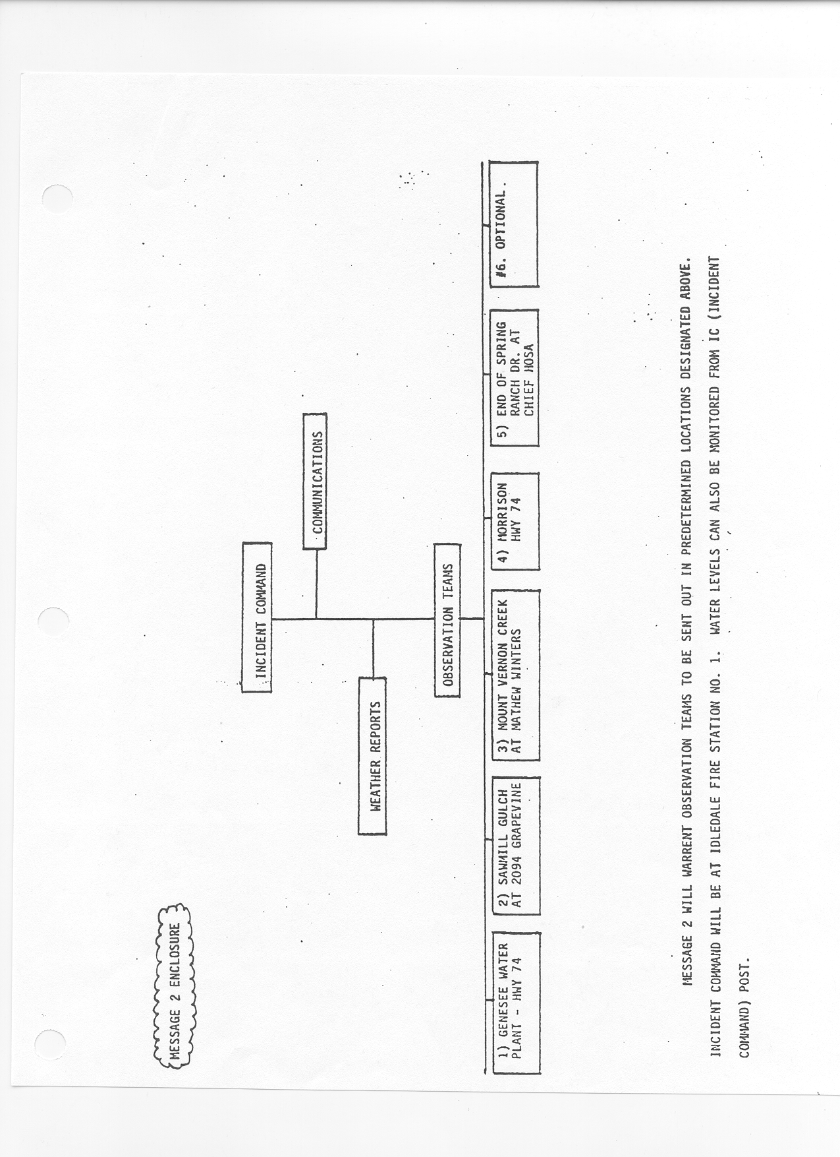
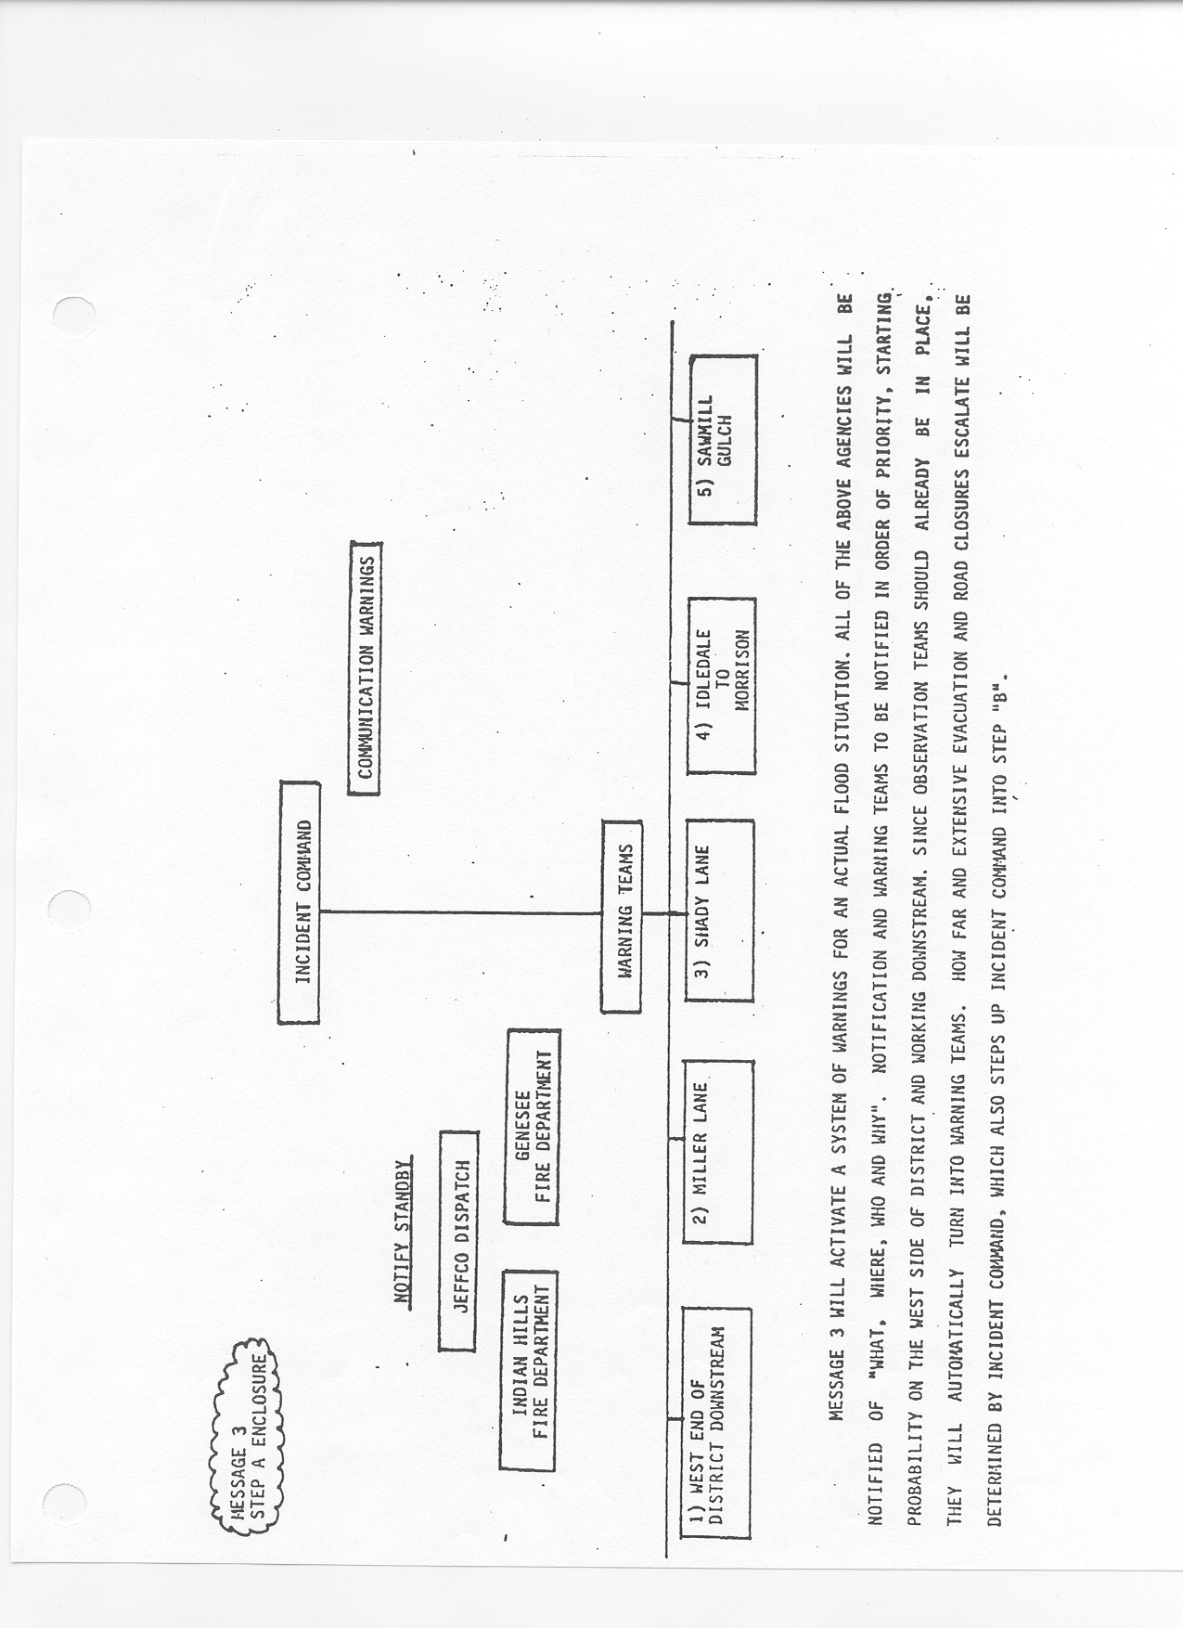
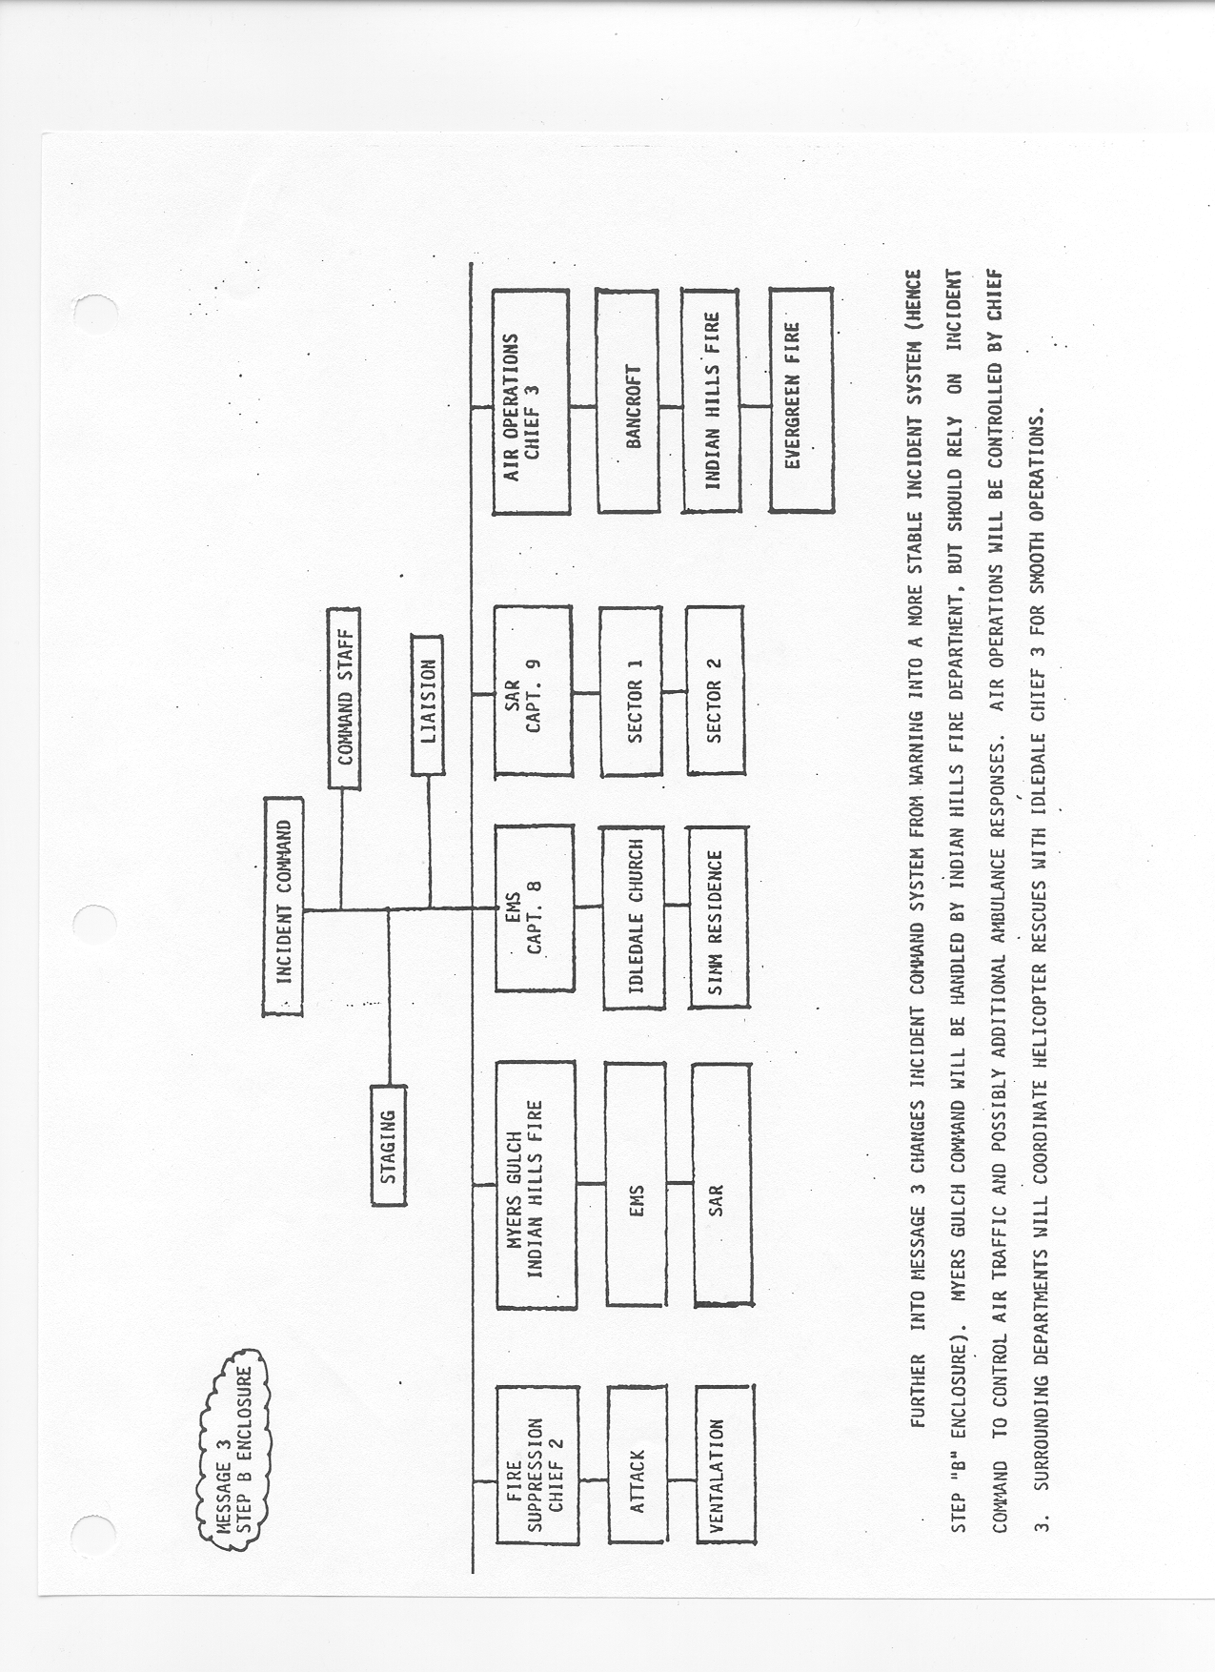

Town of Morrison
The Chief of Police has the administrative responsibility for a Bear Creek or Mount Vernon Creek flood crisis within the boundaries of the Town of Morrison. The following specific responsibilities are primarily to reduce the potential for loss of life resulting from a flash flood:
1. Action. If the Town of Morrison is notified or becomes aware of either of the following two actions, this plan will go into effect:
A. Jefferson County EOC or Sheriff's Department notifies Morrison Police Department of flood waters approaching Morrison.
B. The Town becomes aware of flooding or potential flooding conditions along Bear Creek or Mount Vernon Creek.
The Town official on duty shall notify:
(See Emergency Call List Directory for telephone numbers)
1. Police Chief
2. Mayor or Town Council Representative
3. Police Captain or Lieutenant (call or page)
4. Town Manager or Public Works Director
5. Others as deemed necessary by Mayor or Town Council Representative
2. Command. The overall control of the flooded area within Morrison will be that of the Police Chief or his designee who shall assume command. Functional responsibility for the flooded area within the Town limits will remain with the Police and West Metro Fire Protection District, and the Jefferson County Sheriff's Department. The Police Chief or his designee shall consider dispatching a representative to the Jefferson County EOC, if activated.
3. Field Command Post. Depending on flood conditions, a Field Command Post should be established at a location deemed appropriate by the on-scene officer. The highest Sheriff and/or Fire Official available shall be in charge of the Field Command Post located at Bandimere Speedway.
4. Warning. It will be the responsibility of the Morrison Police and West Metro Fire Departments to warn all residents in the floodplain, or those citizens who are, or could be, in danger from the flood waters.
5. Traffic Control. The Sheriff's Department shall assign patrol units to control traffic in and around Bear Creek and Mount Vernon Creek. The suggested traffic control locations are:
1. Intersection of Colorado Highways 93 and 26
2. Intersection of U.S. Hwy 285 and Colorado Hwy 8
3. Morrison Road and C-470 Interchange
4. Intersection of Colorado Highways 74 and 8
6. Coordination. Administration and functional command will be coordinated with neighboring jurisdictions.
7. Evacuation. Bandimere Speedway and Carmody Junior High School shall be used as evacuation and relocation centers.
8. Supplemental Resources. Requests for additional supplies, equipment, and other resources will be made to the Jefferson County Department of Emergency Management.
9. Recovery. The Red Cross and Jefferson County Emergency Management shall coordinate those activities necessary to feed, shelter, clothe, and provide medical assistance to those persons affected through resource lists available.

City of Lakewood
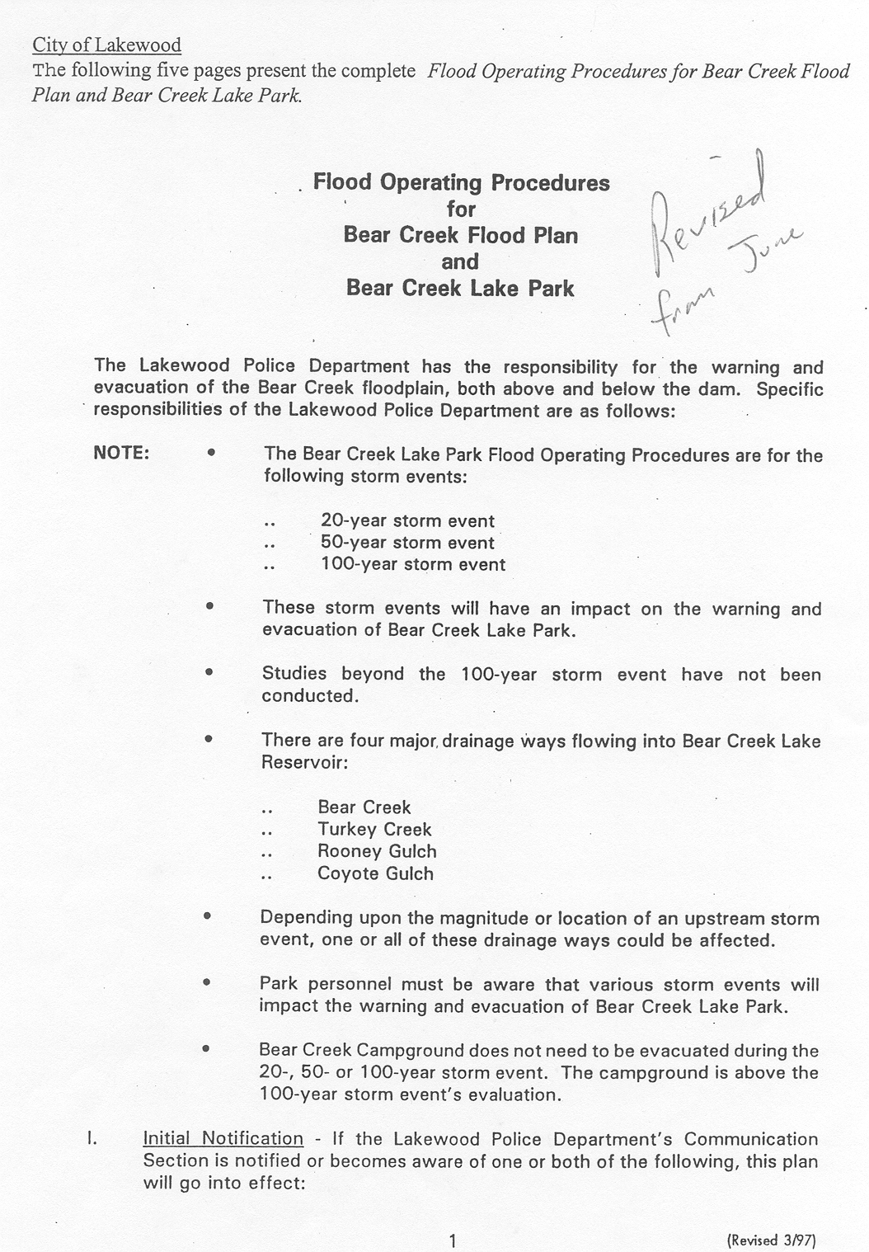
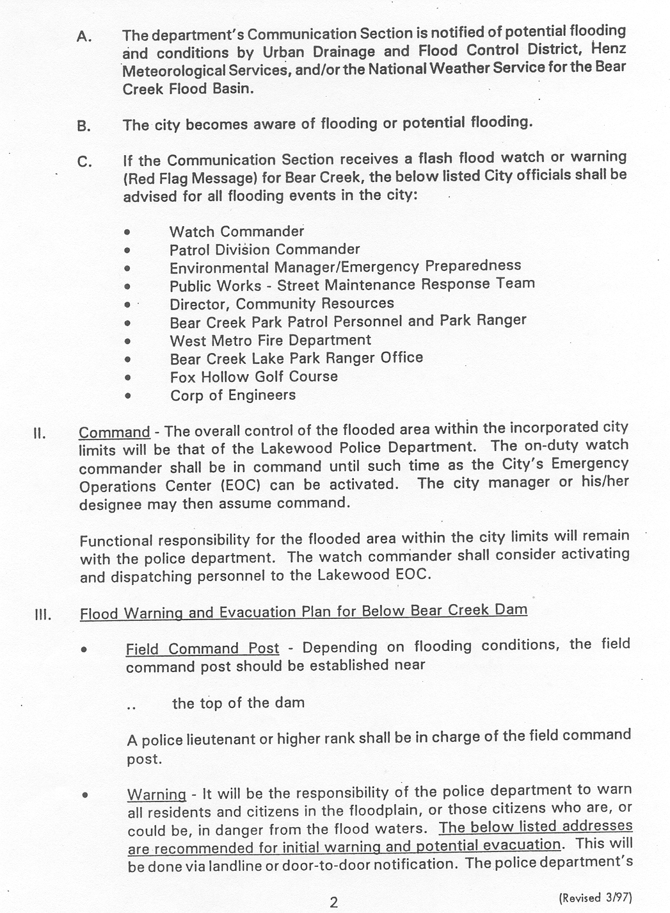
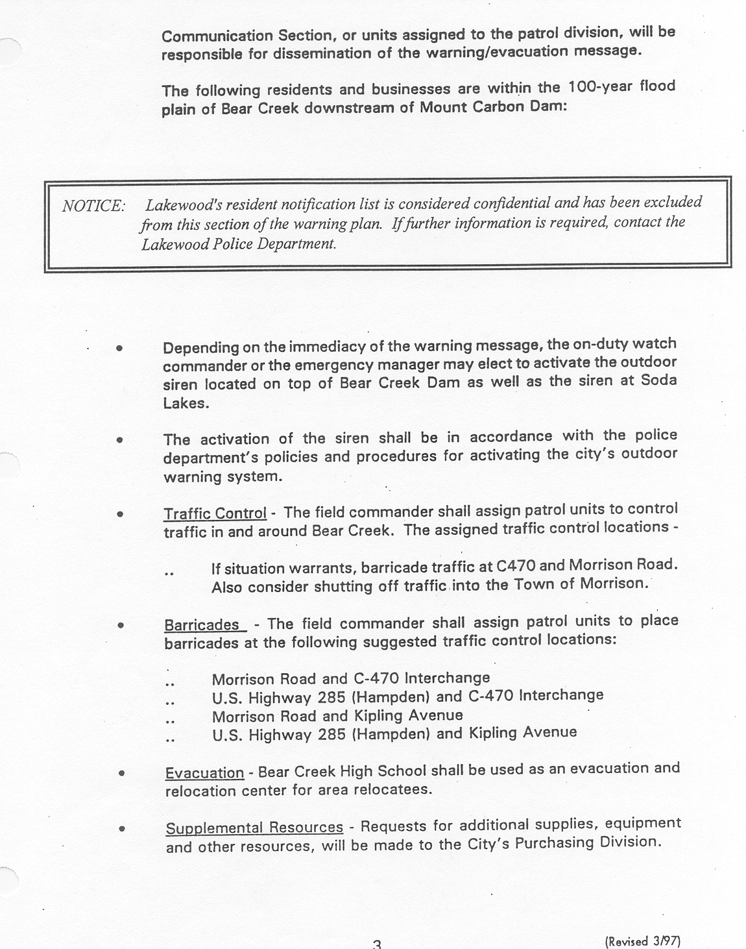
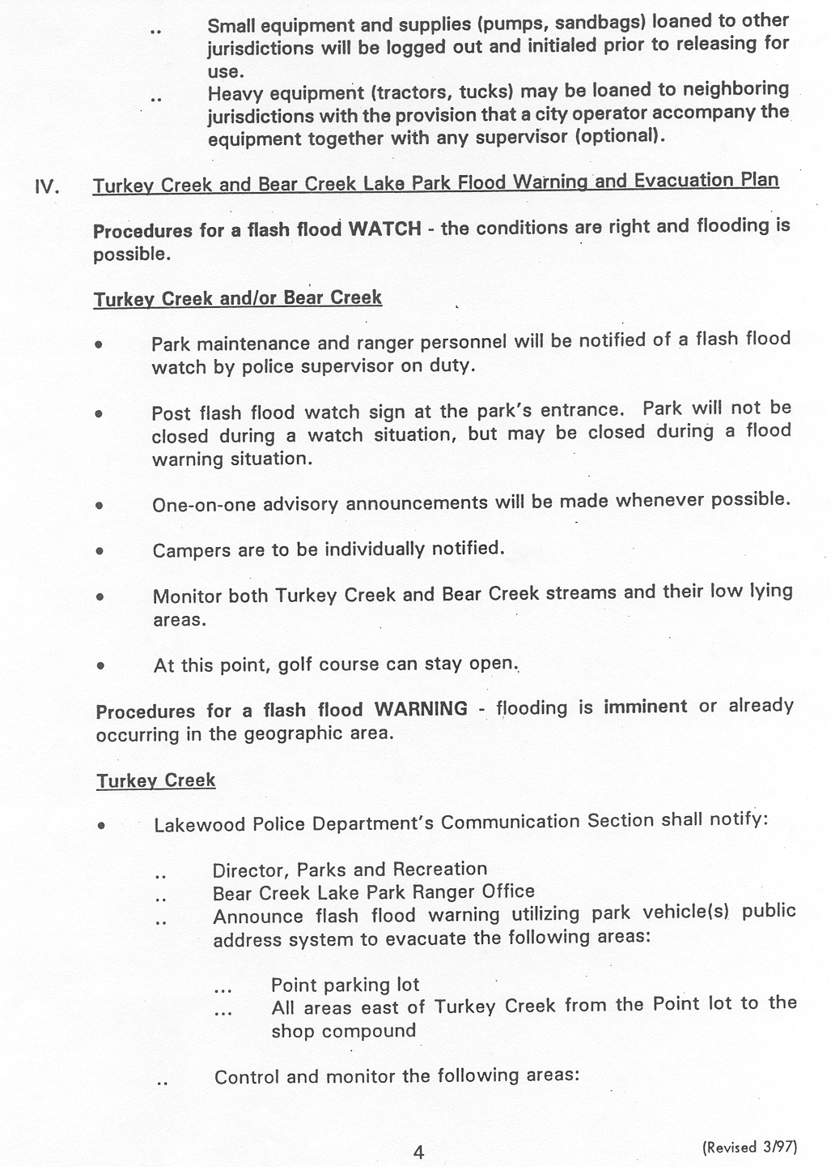
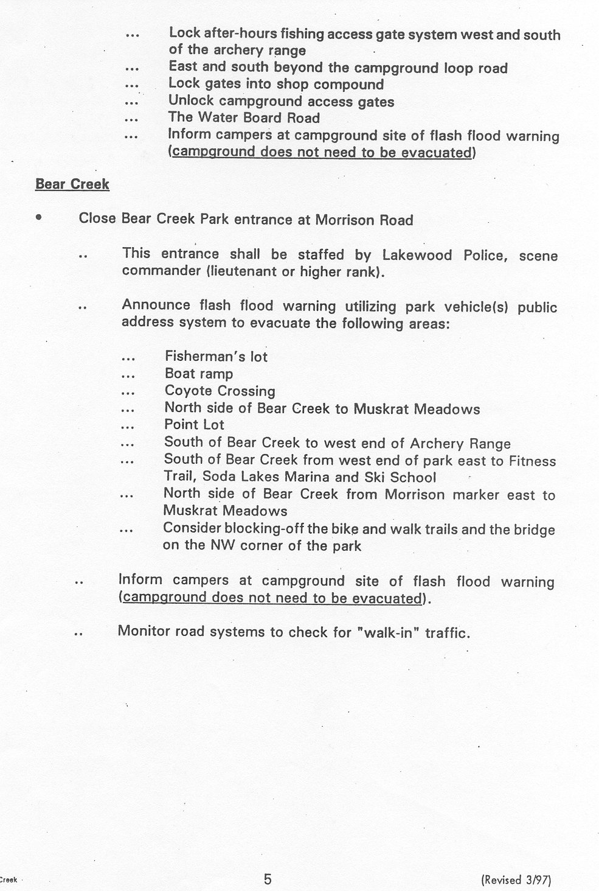

PUBLIC DISSEMINATION
The first response of many people when they hear a warning is to try to confirm it from another source. Therefore, it is very important that all public messages present the same information. The messages in this Section are written to insure that the same information is given from all official sources. The Public Information Officer (PIO) will normally be responsible for preparing public messages. The designation of a PIO representing all affected agencies will be the responsibility of the Incident Commander.

This Section contains two types of messages:

1. Messages to be broadcast to the public and the media; and
2. Messages to be used by emergency vehicles circulating through the floodplain or by existing public address systems.

The messages are written in fill-in-the-blank format. Information to fill in the blanks will be provided by local authorities from Jefferson County, Lakewood or Morrison.

CITIZEN ALERT MESSAGE A1

The following message may to be used when the National Weather Service has issued a Flash Flood Watch:

THE NATIONAL WEATHER SERVICE HAS ISSUED A FLASH FLOOD WATCH FOR

(geographic area)
A FLASH FLOOD WATCH MEANS FLOODING IS POSSIBLE WITHIN THE WATCH AREA. PERSONS IN THE WATCH AREA ARE ADVISED TO PREPARE FOR POSSIBLE FLASH FLOODING, KEEP INFORMED, AND BE READY FOR QUICK ACTION IF FLASH FLOODING IS OBSERVED OR A FLASH FLOOD WARNING IS ISSUED.

CITIZEN ALERT MESSAGE A2

The following message may be used when the National Weather Service has not issued a Flash Flood Watch but local officials feel that flash flooding is possible:

(local government agency or agencies)
PERSONNEL HAVE DETERMINED THAT A FLASH FLOOD IS POSSIBLE WITHIN

(geographic area)
PERSONS WITHIN THIS AREA ARE ADVISED TO CHECK PREPAREDNESS REQUIREMENTS, KEEP INFORMED, AND BE READY FOR QUICK ACTION IF FLASH FLOODING IS OBSERVED OR A FLASH FLOOD WARNING IS ISSUED.
CITIZEN ALERT MESSAGE B

The following message is used to warn people in the floodplain to evacuate:

THE WARNS
(responsible agency)
THAT FLOODING WILL BEGIN AT AT
(location)
APPROXIMATELY .
(estimated time) (person in authority)
HAS URGED EVERYONE IN THE FLOOD HAZARD AREAS TO EVACUATE THE AREA IMMEDIATELY. PERSONS EVACUATING THE AREA SHOULD MOVE AWAY FROM THE CREEK. DO NOT ATTEMPT TO OUT-RUN A FLOOD IN YOUR VEHICLE. DISPLACED PERSONS SHOULD GO TO
. (Add any confirmed reports
(place)
of flooding or heavy rainfall.) DO NOT ATTEMPT TO CROSS A FLOODED CREEK ON FOOT OR IN YOUR VEHICLE.

SUPPLEMENTAL (check appropriate statements):

DO NOT ENTER BARRICADED AREAS.

ABANDON YOUR VEHICLE IMMEDIATELY WHEN WATER RISES ABOVE THE ROAD ON WHICH YOU ARE DRIVING.

IF YOU ARE DRIVING IN A MOUNTAIN CANYON, ABANDON YOUR VEHICLE IMMEDIATELY AND CLIMB TO HIGH GROUND.
EMERGENCY VEHICLE AND PUBLIC ADDRESS MESSAGE

The following message is to be used over existing public address systems and by emergency vehicles circulating in the floodplain:

THIS IS .
(emergency service agency)
FLOODING WILL BEGIN AT AT
(location)
APPROXIMATELY .
(estimated time) (person in authority)
HAS URGED EVERYONE IN THE FLOOD HAZARD AREAS TO EVACUATE THE AREA IMMEDIATELY. PERSONS EVACUATING THE AREA SHOULD MOVE AWAY FROM THE CREEK. DO NOT ATTEMPT TO OUT-RUN A FLOOD IN YOUR CAR OR TRUCK. DISPLACED PERSONS SHOULD GO TO
. (Add any confirmed reports of flooding
(place)
or heavy rainfall.) DO NOT ATTEMPT TO CROSS A FLOODED CREEK ON FOOT OR IN YOUR VEHICLE.

SUPPLEMENTAL (check appropriate statements):

DO NOT ENTER BARRICADED AREAS.

ABANDON YOUR VEHICLE IMMEDIATELY WHEN WATER RISES ABOVE THE ROAD ON WHICH YOU ARE DRIVING.

MEDIA CONTACTS
Each year, prior to the flood season, the Urban Drainage and Flood Control District (UDFCD) will inform the news media of the flood hazard associated with Bear Creek, Mount Vernon Creek and other tributaries. The media will be requested to publicize the hazard by providing information about this flood warning plan, including steps occupants of the hazard area should take when a flash flood warning is issued.

UDFCD will also, on an annual basis, work with local public information offices to make the broadcast media aware of how the sample advisory and warning messages contained in Section IX may be used.

ANNUAL REVISIONS AND PRACTICES
Each year, prior to the beginning of the active flood season, the Urban Drainage and Flood Control District (UDFCD) will issue appropriate revisions to this document, after consulting with affected emergency managers and other appropriate local officials. If no revisions are needed, UDFCD will inform plan holders, accordingly.
UDFCD will also schedule at least one annual practice exercise. The exercise may take various forms including tabletop simulations, message dissemination/communication tests, functional exercises involving field operations, combinations of the preceding examples, or a less complex orientation meeting. The exercise may be publicized by local public information offices or by UDFCD to further increase public awareness of the flood hazard and help attain the desired public response when flash flood warnings are issued.

